OPM Business Rules Engine - Software Proposal

Abstract
The Office of Personnel Management (OPM) has a complex legacy business/financial application which contains a set of intricate rules, calculations, and user flows. The rules are interconnected, have dependent calculations, and are placed in many parts of the user flow.

Due to this, a comprehensive, mature and reliable business rules framework is needed to efficiently convert all of the algorithms/rules/calculations/states into code of a well-structured and easily extendable application. The new OPM application (SCRD) will be web-based, so the framework should easily integrate with modern web technologies.

This proposal is based on widely used, commercially proven, reliable, powerful and inexpensive (or free) business rules frameworks. The research was performed for both major web-development platforms: Java-based frameworks, and solutions for MS .NET (#C based) environment.

IMPORTANT NOTE: This is a survey of software that can be used for research purposes during the Architecture contest. It is not an endorsement of what should be used and the software has NOT been reviewed to ensure that it meets the requirements of OPM.

Approach
1) SCRD application is a serious financial program used by the USA government, so only well proven, reliable, and widely used solutions are appropriate for a business rules engine. Any software selected must have recognized commercial support that can be provided by small, medium or large companies.

2) Too costly and too powerful frameworks (that are mostly used to control all the business processes in large companies) are just an overkill here and not needed for this single business application (SCRD). It means a balanced solution is needed – powerful/reliable enough, but not too overcomplicated and not too expensive.

3) The solution should have not only business rules engine, but a workflow framework too, because the have to support complicated user flows and business processes in the application.

4) The client prefer to use Java-based solution, so this idea performs research on several Java-based frameworks. At the same time, an alternative MS Windows .NET-based solution is also provided.

Research
1) Drools
Drools is the most widely used business rules engine for Java. It implements JSR-94 (Java Rules Engine API standard) and has an enhanced implementation of Rete algorithm for an efficient matching of business rules. The framework is mature, reliable, and easy to use. It contains the following parts:
- Drools Guvnor (Business Rules Manager)
- Drools Expert (rule engine)
- jBPM (Process Workflow)
- Drools Fusion (Event processing, temporal reasoning)
- OptaPlanner (automated planning)

The framework is open-source, and backed by JBoss Community. The problem here is that there is no support for Drools – as announced on Drools web-site: “These projects have community releases from JBoss.org that come without support.” But there is RedHat Business Rules Management System (BRMS) that is just like an enterprise version of Drools with ability to get support. The system is quite costly (like $36,000 per year).

Some features of Drools/RedHat BRMS are highlighted below.

Drools has a graphical designer for business rules and it integrates with Eclipse IDE.
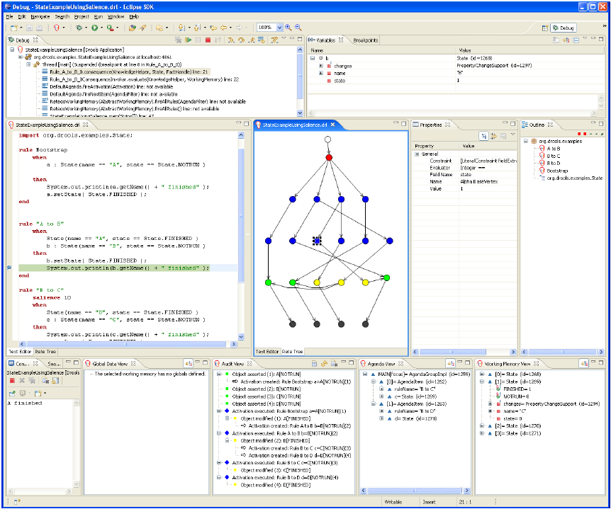

And there is a visual editor for workflows (as shown below).
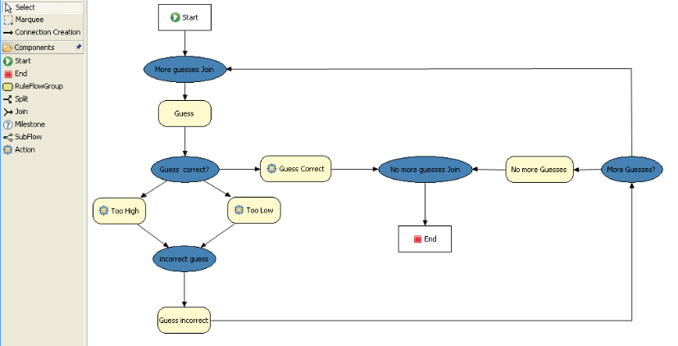

The tools supports abilities to visually construct tools (through tables, functions) and through a simple rule language. Complete integration with Java and web-technologies is provided.

There are various wizard simplifying rules creation. The framework supports modeling of events and perform temporal analysis with calendars. Comprehensive decision tables are supported.
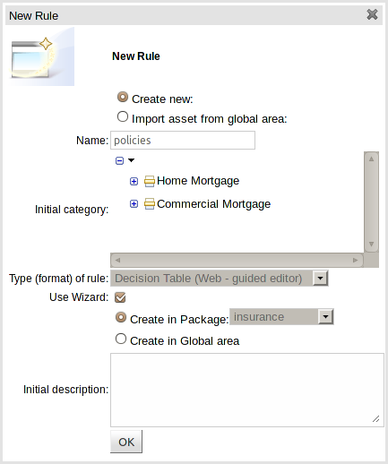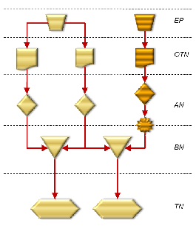

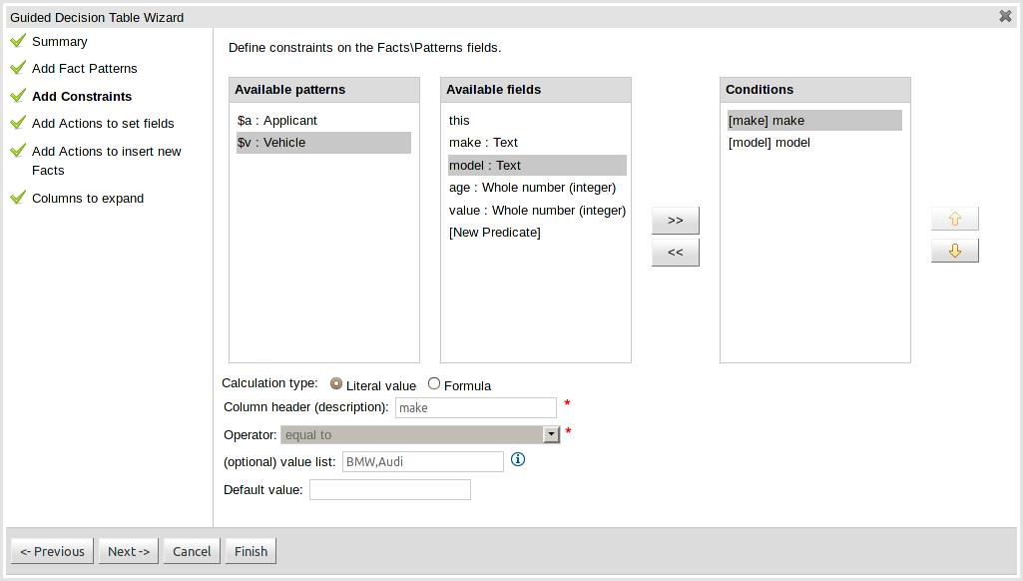

Drools fully meets the requirements for SCRD application business rules and user flows:
- It provides user-friendly visualized CRUD actions on business rules and workflows.
- It is easy to manage all the assets: rules, events, flows, states, decisions, etc.
- Powerful ability to make flexible rules of any complexity.
- Full integration with Java application and web-technologies.
Good documentation and books are available: http://www.jboss.org/drools/documentation
2) FlexRule
FlexRule is a simple and easy to use rule engine. It has a simple rule designer and a tree-based editor. A simple palette of decisions, equations, and connections for constructing rules is present.
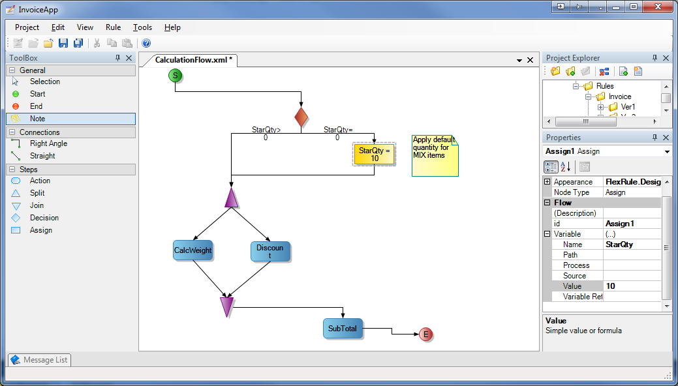

A simple constructor of workflows is available as well. The tool is for .NET framework.
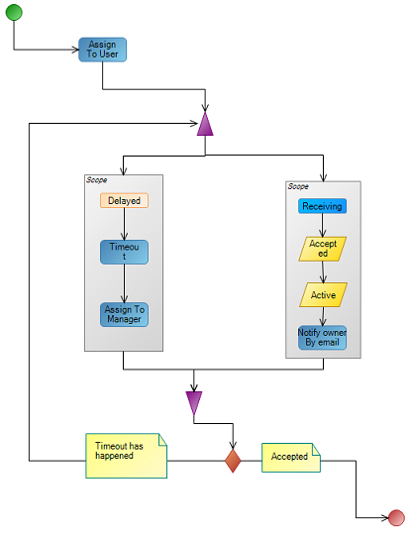
The tool is paid (from $1000 to $10,000), support service is provided ($1000 per year).
The main problems: impossible to create complex rules, the tool is not powerful, there is no community, but just not well-known Australian company producing this framework.
3) Bosch Visual Rules Modeler
There is a special business rules engine and graphical designer from Bosch: Bosch Visual Rules Modeler. The tool is fully graphical and integrated into Eclipse Java-based environment.
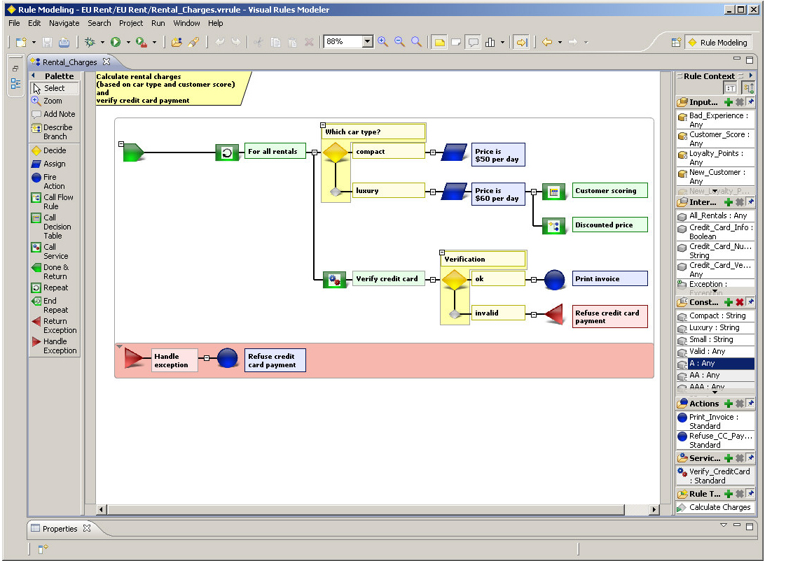

It also allows defines states and perform basic state flow modeling.
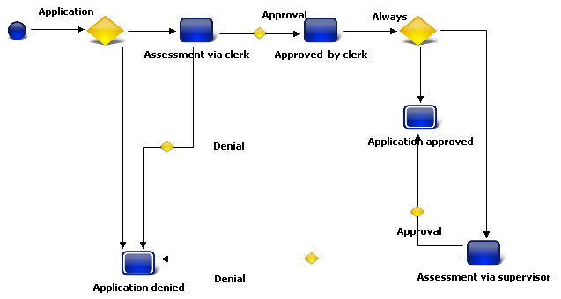
The graphical designer has a live web demo, which can be accessed from the following page.

According to the research, the tool quite primitive and the palette of rules options isn’t very powerful. Rules engine does not implement a de-facto standard Rete algorithm for rule processing, so the framework isn’t very professional. Moreover, it is commercial and not cheap.
4) MS BizTalk
There is possibility to re-use MS BizTalk server with integrated rules engine: BRE. This rule engine is quite complex and difficult for understanding by non-technical developers. The rules are mostly for business process in this solution and the developer should use a lot of coding (in C#, .NET) to define the rules. There is not enough support of workflows. And the graphical designer for business rules is not visual at all, but just allows to textually define rules and policies:
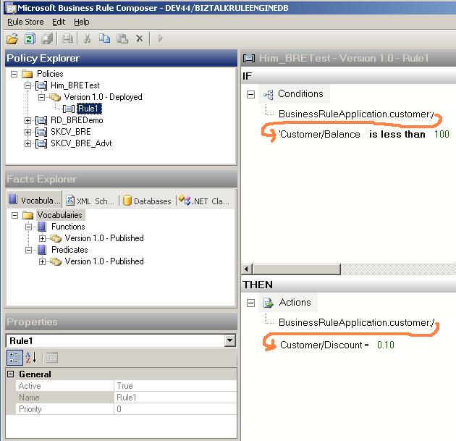

The solution is commercial and is more related to controlling basic business processes. This rule engine is not powerful enough for SCRD application.

5) Business Rule Framework Plus from SAP
SAP provides a business rule framework: http://scn.sap.com/docs/DOC-8824
The framework allows to define rules and workflows within SAP environment and the related software. Rules are mostly set through the table-based graphical interface that is not highly visually appealing.
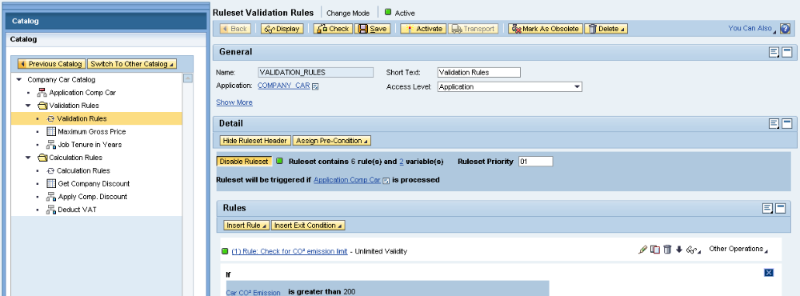

Rules are written in a specific language ABAP (from SAP), that is to custom and not suitable for OPM. Entire SAP environment is required for the framework, so it is mostly related for management of business processes in large organizations, not for a single application like SCRD.

The solution is commercial and quite expensive.

6) IBM WebShepre
IBM WebSphere Operational Decision Manager (ODM) supports management of business rules. The framework support complex rules, decision trees and tables. It is mostly related to managing business processes in large companies and is not visually attractive (just tables).
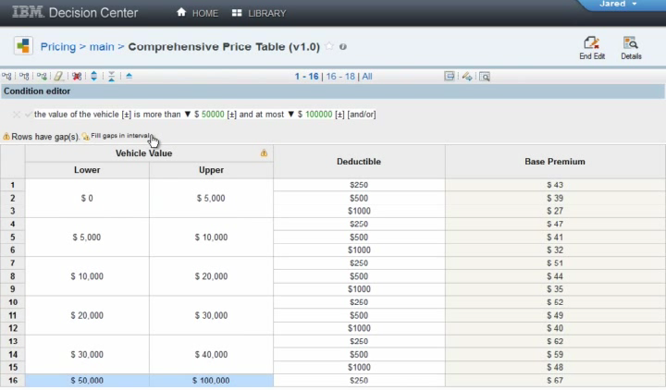
It looks workflows are not supported in this framework. The tools allows to create and edit business rules through MS Word and Excel applications.
The solution is commercial, minimum license is thousands of dollars.
7) MS Business Rule Engine and Windows Workflow Foundation
This is .NET-based solution for workflows and rules from Microsoft: http://msdn.microsoft.com/en-us/library/dd489441.aspx
There are many graphical editors, the system is visually attractive and user friendly.
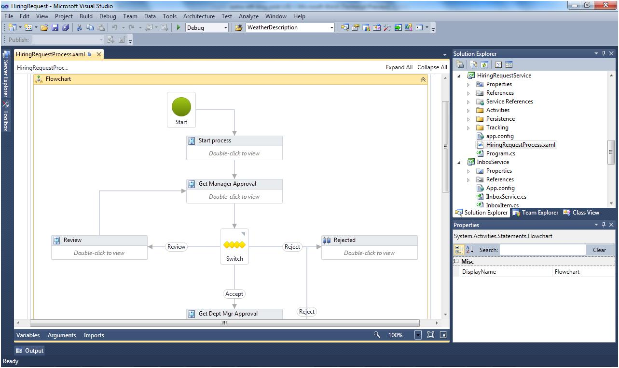

The framework supports different approaches to define workflows:
- Flowchart
- Procedural
- Sequential
- State Machine
The rules can be defined right in-place of the workflow.
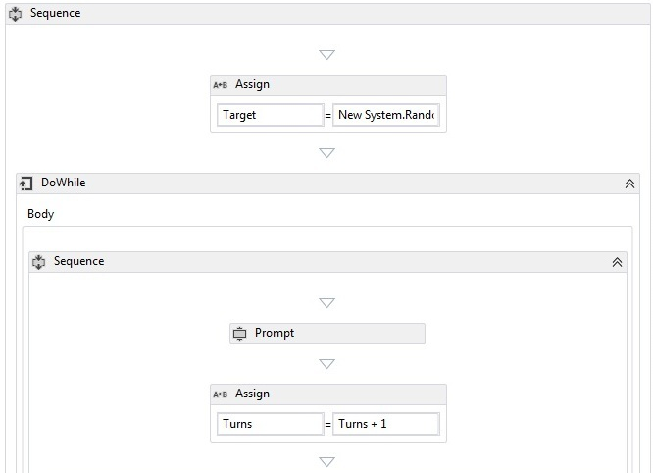
Full connectivity between workflows and the related rules is supported and integrated into MS VisulStudio IDE. This IDE and visualization quality is considered as the best from all the researched frameworks and tools.
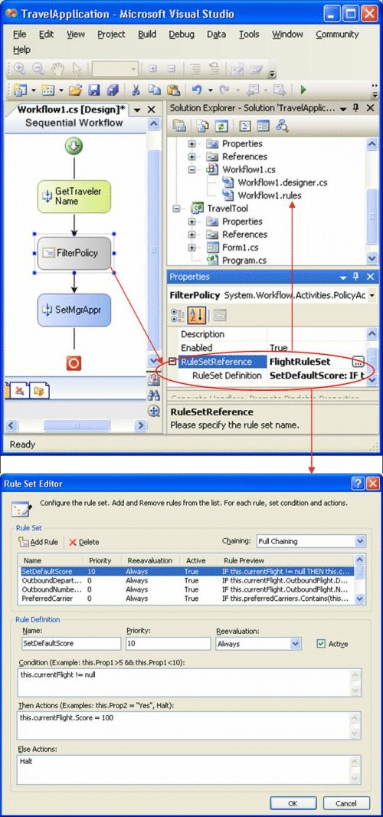

The framework from Microsoft is reliable, mature, powerful, and supports all the needed features for SCRD. The set of features is similar to the provided by Drools (please refer above). Rete algorithm was implemented for rules processing, so this framework is professional and suitable for complicated rules and algorithms.

The framework is for .NET library, so it can be used with C# language and the related environment. The framework cost is just defined by the cost of used MS VisualStudio IDE, cost of MS Windows operating system, MS SQL server and the web-server. It can be several thousands (and more) dollars. Full support from Microsoft is available. This solution is more professional than Drools and is backed by much larger company.

8) Oracle Fusion Middleware
There is a solution for business rules engine from Oracle: http://www.oracle.com/technetwork/middleware/interactive-reporting/overview/index.html

The system is extremely powerful, flexible and is mostly suitable for managing lots of business processes in large organizations. The solution is commercial and is greatly coupled with Oracle solutions. Full Java integration is provided. The cost of license is very high – up-to million of dollars, so this approach is not practical for just a single SCRD application. Highly visual graphical editors are provided as shown below.
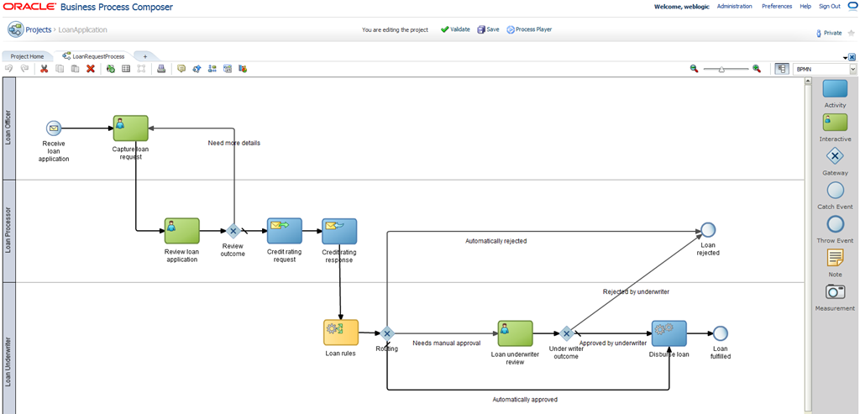

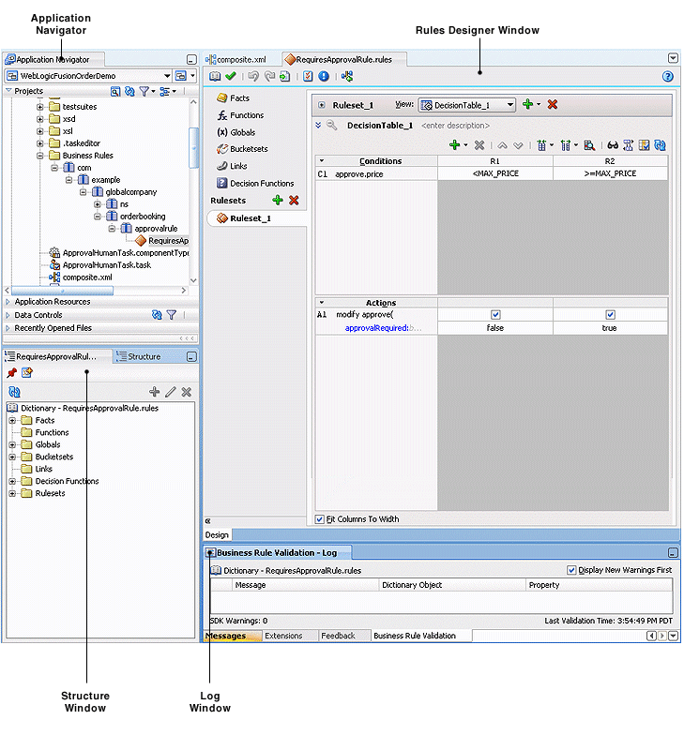

Full features rules, calculations and workflows are completely supported. Of course, a lot of support packages are available from Oracle. But again, this solution is too expensive and is like an overkill for SCRD application.

Section 508 Compliance
Actually, business rules engine and workflow frameworks are backend technologies used by developers, not by regular users of the application. So, there will be no problems with almost any engine and framework. Please note, both Drools and MS Workflow Foundation have user-friendly graphical and table editors – in Eclipse and MS Visual Studio IDEs respectively. Frontend of those IDEs are one of the best in the industry.

Not Suitable Solutions
Any solutions without a support development community are not recommended. For example, FlexRule looks simple and easy to use, but is not acceptable due to such a reason.

BizTalk rule engine is not powerful enough and not visual.

Bosch Visual Rules Modeler is a visual tool, but is quite primitive and not mature enough for this important application.

Business Rule Framework Plus from SAP is powerful and reliable, but it is too heavily coupled with other SAP environment and it is written in a very specific language (ABAP, similar to COBOL), so it is not suitable for OPM.

IBM WebSphere Operational Decision Manager is a costly solution (up-to hundreds of thousands dollars). Though it has an interesting ability for authoring and editing business rules in Microsoft Office Word and Excel

Oracle Fusion Middleware is a great technology for managing business processes in large companies, but it is too complicated for this single application (SCRD). And the solution is extremely expensive (like $1 million per year).

Summary
Drools and JBoss jBPM are the best business rules engine and workflow framework for Java according to this idea. Enterprise version (RedHat BRMS) is needed to get support from RedHat/JBoss.

MS Windows Workflow Foundation is the solution of the same quality for C# and .NET platform. It can be used if Microsoft Windows-based solution was chosen by architects.

