[TopCoder Software]
Content Creation

Content Creation Document

v1.1

06/01/2014

NASA ISS FIT – Administrator Guide

Table of Contents
1.0 Administrator Functions 3
1.1 Admin Functions in the ISS FIT App 3
1.1.1 Add UDID to Install Test App 3
1.1.2 How to Provision a UDID for the Test OTA Build 3
1.1.3 How to Manage User Profiles via the ISS FIT App: 3
1.1.4 How to View User Consumption Data in the ISS FIT Application 6
1.2 Admin Functionality via Samba Server 7
1.2.1 How to Connect to a Samba Server 7
1.2.2 Data Structure Samba Shared File Server 7
1.2.3 Upload New User Accounts to iPads 8
1.2.4 How to Manage Food Product Inventory Data 9
1.2.5 How to Retrieve Food Consumption Data 10
1.3 Configure and Install ISS FIT App / Samba Server 11
1.3.1 How to Deploy and Configure the Samba Server 11
1.3.2 How to Configure the ISS FIT App to Work with the Samba Server 13
1.3.3 How to Load Initial Data to the Samba Server 14
1.3.4 How to Remove Data from the Samba Server for a Clean Install 14
1.3.5 ISS FIT Application Configuration 15
1.3.6 Launch ISS FIT App in Xcode 15
1.4 Application Technical Details 15
1.4.1 Organization of Submission Files 15
1.4.2 Technology Overview 15
1.4.3 Libraries Used 17

Administrator Functions

Below are details on the functionality available to Administrators of the ISS FIT application. This guide will also explain deployment and configuration of the Samba server to work with the ISS FIT application.

Admin Functions in the ISS FIT App

Add UDID to Install Test App

During testing of the ISS FIT app, users will be provided a Dropbox link for an OTA build that will install the app on your iPad. In order for this install to work on your iPad, you’ll need to find your device’s Unique Device Identifier (UDID). Each iPad has a UDID, which is a sequence of 40 letters and numbers specific to your device.

To find your UDID, connect your iPad to iTunes and open the device summary tab. You’ll see details like name, capacity, software version and serial number. Click on the words “Serial Number” and the value will change to display your UDID. You may now copy the UDID by selecting Edit -> Copy from the file menu.

NOTE: This step of finding your UDID is ONLY required during testing of the ISS FIT app. Once the app is complete and available in the app store this step will no longer be necessary.

How to Provision a UDID for the Test OTA Build

After a user has provided their UDID it must be provisioned so the user can install the OTA build on their iPad for testing.

- First, navigate to the Devices section of the iOS Provisioning Portal and click "Add Devices" (full path is Apple Developer > Member Center > iOS Provisioning > Add Devices).
- Now add a name for the device and the device’s UDID (you will want to copy-and-paste this in to make sure it’s correct).
- Next, create a Provisioning Profile that includes all of your registered devices.
- In Xcode, open Organizer.
- Select the Provisioning Profiles section and select the specific profile
- Check the box "Automatic Device Provisioning"
- Finally, press the Refresh button.

NOTE: This step of provisioning a UDID is ONLY required during testing of the ISS FIT app. Once the app is complete and available in the app store this step will no longer be necessary.

How to Manage User Profiles via the ISS FIT App:

The Administrator can create and manage user profile data either using the ISS FIT application, or by applying data updates pushed from the Earth Laboratory. This help section will explain how to perform these tasks via the ISS FIT application.

New users can register for an account using the ISS FIT application itself (see 1.2 “How to Register”) on their own.

The Administrator can manage existing user profiles from the Profile page in the ISS FIT application. To access this page click on the “Profile” button on the bottom menu:

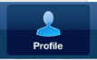

The Profile page will be displayed:

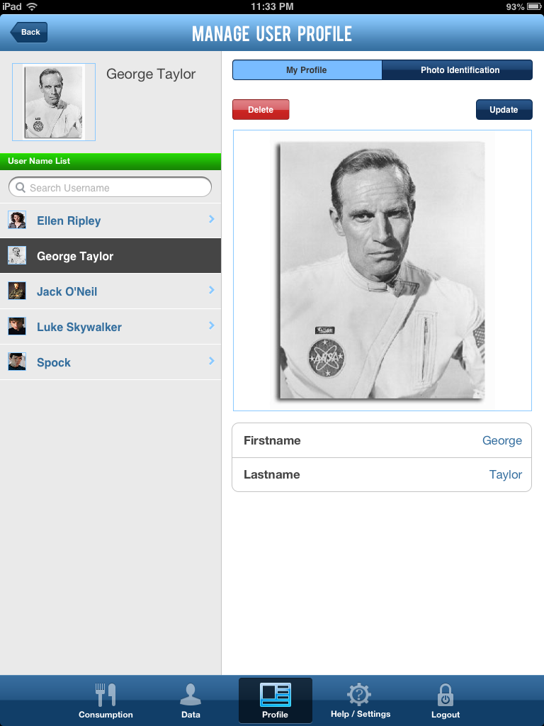

The Administrator can select the user to modify by clicking on a user name in the left menu under the “User Name List”. A user search is also available by typing in the user name you’re looking for:

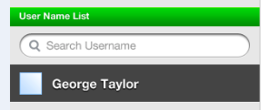

To modify a user profile, click on the “Update” button:



After you’re done making the necessary changes, click the “Save” button:



To a user profile photo you can click on the “Photo Identification” tab:

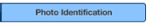

To modify the profile photo, click on the “Update” button:

An Administrator also has the ability to delete a user account using the ISS FIT application. To delete a user account click on the red “Delete” button.
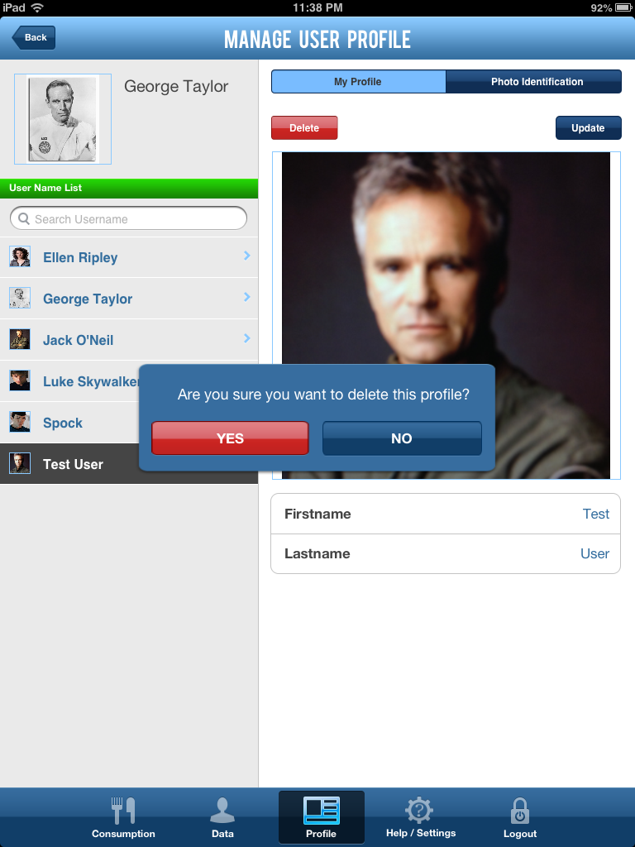

Confirm you would like to delete the account by clicking “Yes”. The selected user account will be deleted from the application.

How to View User Consumption Data in the ISS FIT Application

The Administrator can also view user food consumption data inside of the ISS FIT application itself. This functionality can be performed from the Profile page. To access this page click on the “Profile” button on the bottom menu:

The Profile page will be displayed:

Select the user to view consumption data for by clicking on a user name in the left menu under the “User Name List”. A user search is also available by typing in the user name you’re looking for:

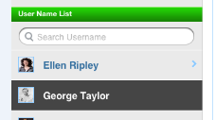

Once you have selected a user, click on the “Consumption” tab to view the selected user’s consumption data:

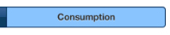

Admin Functionality via Samba Server

How to Connect to a Samba Server

Data in the ISS FIT app is synced between devices and the ground lab via a Samba server. Before using the app it’s a good idea to verify you can successfully connect to the Samba server from your device. There are a few different ways to test this connection to the Samba server.

From a Mac, open a new Finder window. Press “Command + K” to open the connect dialog box. Enter the URL for the Samba server: smb://ServerName/ShareName. Enter the credentials once you have connected. Please note, if you connect to the Samba server using Finder there will be some hidden files automatically added. These files MUST be removed after for the ISS FIT application to work correctly when syncing data (specifically, to be able to delete folders).

From Windows, you can add a network place with the url for the Samba server. For example: \\ec2-54-221-47-124.compute-1.amazonaws.com

From a Unix machine, you can use the command: smbclient //server/share -U user%password

Data Structure Samba Shared File Server

To perform some administrative tasks, the Administrator will need to send/retrieve files to/from the Samba3 Shared File Server. This will allow the Administrator to push changes to the ISS FIT application, and to retrieve data recorded using the application.

The data synchronization/exchange in the system architecture is based on exchanging files stored at the Samba3 Shared File Server using special file naming and directory conventions. The directory structure on Samba3 Shared File Server for storing the data exchange files is as follows:

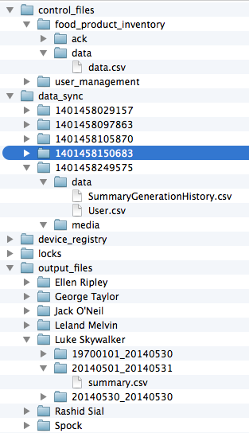

The files necessary to perform the Administrative tasks below are described in more detail under each section of this User Guide. Full details about the data exchange / synchronization process is available in the Data Services Module Architecture documentation.

Upload New User Accounts to iPads

New users may be added to the ISS FIT application by applying data updates pushed from the Earth Laboratory.

To add new users to the ISS FIT application via this data sync, the file (data.csv) should be added to the directory “/control_files/user_management/data/data.csv” on the Samba server. This file is used to upload new accounts to the iPad in advance of expeditions so that astronauts don’t have to register for the app. This spreadsheet also lists the daily targets for Fluids, Calories, Sodium, Proteins, Carbs and Fats.

To add a new user or modify an existing user, please:

1. Open data.csv
2. Add a new row and enter values for each of the columns.
3. You’ll also need to include any images that you want to appear in login in the same directory on the Samba server that you place data.csv into.

The user “data.csv” file should contain the following values in each row:

Column Index | User property
0 | User.fullName
1 | User.isAdmin
2 | User.dailyTargetFluid
3 | User.dailyTargetEnergy
4 | User.dailyTargetSodium
5 | User.dailyTargetProtein
6 | User.dailyTargetCarbs
7 | User.dailyTargetFat
8 | User.profileImage
9 | User.MaxPacketsPerFoodDaily
10 | User.profileImage
11 | Use Last Used Filter (Yes or No)

Images that go along with the data should also be added to the directory “/control_files/user_management/data/” - along with the data.csv file.

Below is an example data.csv file with user data:

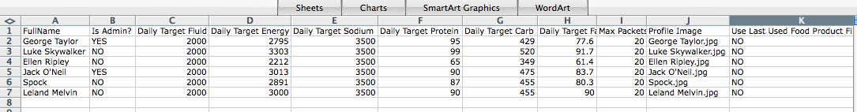

For another example, please see the file “profile_data.csv” included with this Administrator guide (just remember this example file needs to be renamed to “data.csv”).

How to Manage Food Product Inventory Data

The Food Product Inventory may be managed by pushing updates from the Earth Laboratory.

The Food Product Inventory Spreadsheet (data.csv) should be added to the directory “/control_files/food_product_inventory/data/data.csv” on the Samba server. This spreadsheet lists all of the foods products, the associated food category and country of origin, along with the nutritional values for Fluids, Calories, Sodium, Proteins, Carbs and Fats.

Images that go along with the data should also be added to the directory “/control_files/food_product_inventory/data/” - along with the data.csv file.

To add or modify the Food Inventory, please:
1. Open data.csv
2. Add a new row and enter values for each of the columns.
3. You’ll also need to include any images that you want to appear in login in the same directory on the Samba server that you place data.csv into.

Food Product Inventory data.csv File

Column Index | User property
0 | FoodProduct.name
1 | FoodProduct.categories (joined with ‘;’)
2 | FoodProduct.origin
3 | FoodProduct.barcode
4 | FoodProduct.fluid
5 | FoodProduct.energy
6 | FoodProduct.sodium
7 | FoodProduct.Protein
8 | FoodProduct.Carbs
9 | FoodProduct.Fat
10 | FoodProduct.productProfileImage
11 | FoodProduct.deleted

Below is an example data.csv file with test product data:

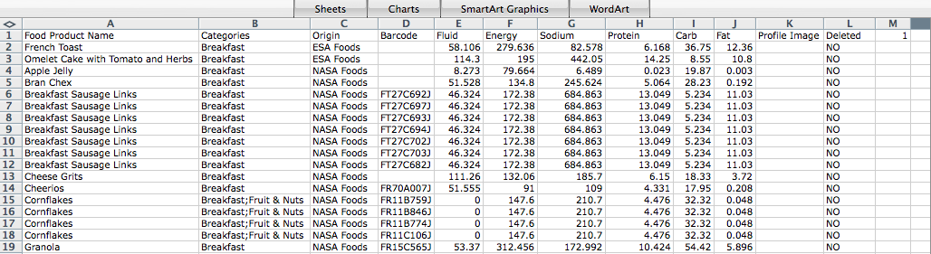

The last header column contains the data.csv version (in this case 1). This number can be used to distinguish between different file formats.

For another example, please see the file “profile_data.csv” included with this Administrator guide (just remember this example file needs to be renamed to “data.csv”).

How to Retrieve Food Consumption Data

The data synchronization/exchange in the system architecture is based on exchanging files stored at the Samba3 Shared File Server using special file naming and directory conventions.

The system will generate a food consumption summary spreadsheet file (each spreadsheet file is for one crew member) and push the file to Samba3 Shared File Server (/output_files directory).

To retrieve user data from the Samba server, the output files will be stored in the “<FIT_APP_DATA_ROOT>/output_files” directory. Each spreadsheet file is for one crew member. This directory contains output food consumption summary files to be down-linked to Earth Laboratory. There will be on folder per crew member and the file name will contain the time range of the summary file (e.g. "joe/20130331_20130406").

Food Consumption Record CSV File

A FoodConsumptionRecord object will be written as a line in the summary.csv file, with the following columns:
Column Index | User property
0 | FoodConsumptionRecord.user.fullName
1 | FoodConsumptionRecord.timestamp (in format of "yyyy-MM-dd HH:mm:ss")
2 | FoodConsumptionRecord.foodProduct.name
3 | FoodConsumptionRecord.quantity
4 | FoodConsumptionRecord.comments
5 | FoodConsumptionRecord.images
6 | FoodConsumptionRecord.voiceRecordings

Configure and Install ISS FIT App / Samba Server

How to Deploy and Configure the Samba Server

A deployed Samba Server is required to run the ISS FIT application (for data synchronization). If you already have a Samba server deployed, you can skip this step and load the data to your Samba server. If you don’t already have one, the instructions below will explain how to deploy a Samba server.

Deploy Samba Server on a VM:

1) Login to the Samba Server. After login, become the root user:
$ sudo -i

2) Download the latest Samba:
# wget http://www.samba.org/samba/ftp/stable/samba-4.0.9.tar.gz

3) Extract the source files:
# tar -xvzf samba-4.0.9.tar.gz

4) Install any necessary Samba dependencies:
# apt-get install make
# apt-get install python
# apt-get install gcc
# apt-get install python-dev

5) Build and install Samba:
# cd samba-4.0.9
# ./configure
# make
# make install

6) Create the tcsuser:
# useradd -m -ptcspassword tcsuser

7) Create the tcsuser in Samba:
# smbpasswd -a tcsuser
-> enter the password (tcspassword) twice.

8) Simplify the Samba configuration sample provided by the installer:
(/etc/samba/smb.conf). The version that is currently on the VM should do.

9) Start samba:
/etc/init.d/samba start

10) Logout:
# logout
$ logout

Deploy Samba Server Locally on Mac OSX

NOTE: This local deployment of Samba is for testing purposes only. Also, deploying Samba Server on Mac OSX is tested in OSX 10.6, but appears to be broken in 10.8.3 and later.

- Open System Preferences -> Sharing,
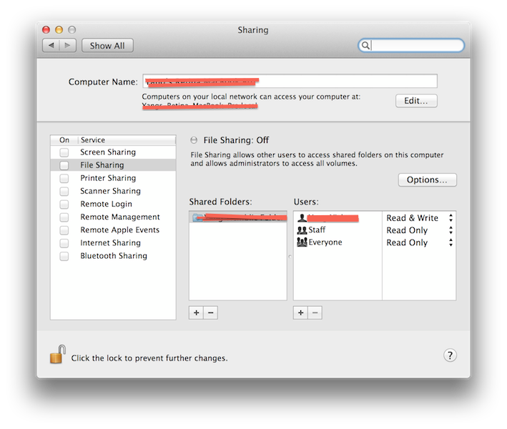
- Turn on “File Sharing”. And click “Options”, select “Share files and folders using SMB”, and select the corresponding user. Then click “Done”.
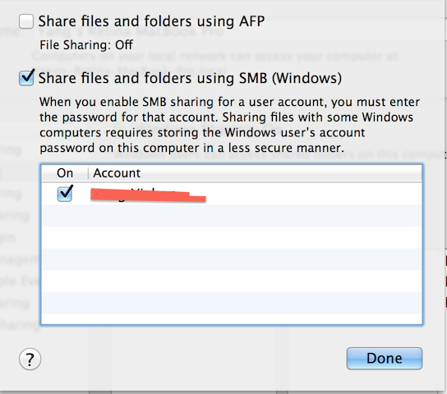

- Add the folder you want to share in “Share Folders”. Here I add an empty folder named “NASA”.
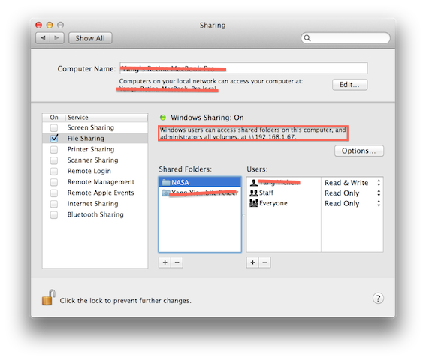
- Refer to the previous screenshot, you can find the samba server address in the red rectangle. In my case it is 192.168.1.67.
- Open test_data/TestDataConfiguration.plist, modify “SharedFileServerPath” to “smb://{your_samba_server_address}/{your_samba_share_name}”. In my case it is smb://192.168.1.67/NASA. And change SharedFileServerUsername and SharedFileServerPassword to your user’s name and password. The SharedFileServerWorkgroup’s value is usually “WORKGROUP” if you haven’t change your machine’s workgroup.
Now your local Samba server should be running for testing purposes.

How to Configure the ISS FIT App to Work with the Samba Server

You can configure the ISS FIT iPad app by accessing the iPad’s settings.

Click the Settings icon in the iPad. Look for the ISS Fit on the left pane.
Change the Sever address, user and password:

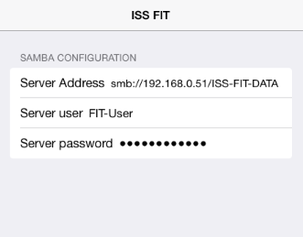

How to Load Initial Data to the Samba Server

After the Samba server is setup, please connect to the server using “Finder” on Mac so you can connect to the Samba Server in Debian VM. Open “Finder”, and press Command+K, in “Connect to Server” window, input “smb://{your_samba_server_address}/{your_samba_share_name}”. Then it will ask to input the username and password. If everything is right, you can find the connected server will be listed in left panel of Finder.

After the connection is successful, please extract the zip file from the “submission/samba” folder directly to the samba server. You can copy the zip file to the VM and login to the VM to extract the zip file. After you copy the files, set the owner to “NASA” by using “chown –R NASA:NASA *”. Below is what should be shown on samba server:

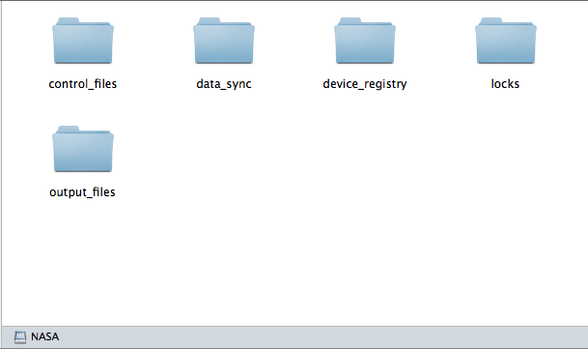

Please be careful when you use Mac Finder because it will automatically add some hidden files and make the folders undeletable. Once you use Mac Finder to show the directories, or copy files, you will need to log into the VM and remove the hidden files (with prefix “.”) for all files and folders.

TIP: To clean up the hidden files left by Finder, you can login to the Samba VM and type the following command:

find /PATH/Samba_Share_Name/ \( -name '.DS_Store' -or -name '._*' \) -delete

The file names that need to be removed are “.DS_Store” and “._.DS_Store”.

Once the data has been loaded to the Samba server, you can install the ISS FIT on an iPad device and launch it. The data on the Samba Server will automatically sync up to the iPad.

How to Remove Data from the Samba Server for a Clean Install

If you need to remove all the data from the Samba server to perform a clean install, you may do so by performing the following actions:

- You need to delete all folders in "[Samba_Share_Name]".

- Next, put the data in "[Samba_Share_Name]" directly. So in the “[Samba_Share_Name]” folder, you will see the 5 folders like control_files, data_sync, etc.

- Remove the folder “/Samba_Share_Name/data_sync/[DEVICE_MAC]” (if it exists)

Once you’ve removed the data by following the steps above, you can perform a clean install by repeating the steps described above for “Load Initial Data to the Samba Server”.

ISS FIT Application Configuration

The configuration file for the Xcode project is stored in FoodIntakeTracker/Configuration.plist.

Configuration Parameters | Value
FoodConsumptionRecordModifiablePeroidInDays | The time period (in days) within which FoodConsumptionRecord can be modified since created.  Positive Integer.
FoodConsumptionRecordKeptPeriodInDays | The time period (in days) for which the FoodConsumptionRecord's will be kept.  Positive Integer.
FoodProductLanguageModelFileName | The language model file name for food product names.  String.
GeneralLanguageModelFileName | The language model file name for general English language.  String.
LockExpirationPeriodInSeconds | The lock expiration time period (in seconds).  Positive Integer.
LocalFileSystemDirectory | The local file system directory to save the image and voice recording files.  String.
TesseractDataPath | The path for the Tesseract data.  String.
HelpData | The help data.  NSDictionary.  Keys of the dictionary are help item titles, values are the HTML file names in the bundle.
SummaryGenerationFrequency | The consumption summary generation frequency.  String. Can be "Weekly", "Monthly".
HeartbeatInterval | The interval to send lock heartbeat, in seconds.  Integer.
SummaryGenerationInterval | The interval to generate summary report, in seconds.  Integer.
SynchronizationInterval | The interval to do synchronization, in seconds.  Integer.
DataUpdateInterval | The interval to do data update, in seconds.  Integer.
DailyTargetCalories | The default daily target calories used for new registrants.
DailyTargetSodium | The default daily target sodium used for new registrants.
DailyTargetFluid | The default daily target fluid used for new registrants.
DailyTargetProtein | The default daily target protein used for new registrants.
DailyTargetCarbs | The default daily target carbohydrate used for new registrants.
DailyTargetFats | The default daily target fat used for new registrants.

In the consumptions screen, the calories for protein, carbohydrate, and fat are calculated as follows:
1. For protein and carbohydrate: 1 kcal = 4 gm
1. For fat: 1 kcal = 9 gm

The configuration file for the unit tests is stored in test_data/ TestDataConfiguration.plist.

Launch ISS FIT App in Xcode

Open FoodIntakeTracker/FoodIntakeTracker.xcodeproj in Xcode. Select a device and click run. You will see the ISS FIT app running in a real device or Simulator (based on your choice).

Application Technical Details

Organization of Submission Files

FoodIntakeTracker -- Contains the Xcode project for this application.
doc – The directory that contains deployment guide from the Frontend assembly.
doc/oldDoc – The directory that contains documents from previous assemblies.
samba – The directory that should be copied to samba server.
test_data – The directory that contains some test data. This folder is used by unit tests of services.

Technology Overview

- iOS 5.0+
- Xcode 4.6
- Objective-C 2.0
- Cocoa Touch Framework

Libraries Used

- OpenEars 1.2.5 - http://www.politepix.com/openears/
- ZXing iPhone/iPad https://github.com/zxing/zxing/tree/master/iphone
- Tesseract for iOS https://github.com/ldiqual/tesseract-ios/commits/master
- Reachability Utility https://github.com/tonymillion/Reachability
- cCSVParse https://github.com/oneblacksock/cCSVParse
- KxSMB with libsmbclient in Samba 4.0.8 https://github.com/kolyvan/kxsmb http://www.samba.org/
- BNPieChart https://github.com/tylerneylon/moriarty

