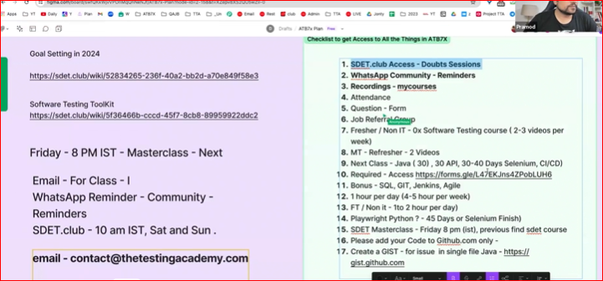

**Task for the Week 1 (6th July)**

**Task 1 :**

**Write the Test case for the Coffee Machine**

1. CCD Coffee machine
2. Bru - Latte, expresso.
3. Ingredients are given all.
4. 5 L. 5 Cups

Rest of the common requirements.

You can assume.

1. No electricity - Yes/ No.
2. Water - Yes/ No

more Q -> Req - less less -> TC less.

Excel File and Share that excel in the commnet Section.

Test Plan and Test cases.

[**https://sdet.live/project2**](https://sdet.live/project2)

Manual Testing Slide

[**https://docs.google.com/presentation/d/1JaKPvhqJ92-LaoX050PNfLVJsdVD07JZhmZXhurtIPU/edit?usp=sharing**](https://docs.google.com/presentation/d/1JaKPvhqJ92-LaoX050PNfLVJsdVD07JZhmZXhurtIPU/edit?usp=sharing)

**Task 2 :**

1. Test Plan
2. Test cases for the app.vwo.com
3. Login - Req.

[**https://docs.google.com/spreadsheets/d/131ioi2JfTWLR9f_HqS8kIMrqMu1bp30ai2_YS-PSCzA/edit?usp=sharing**](https://docs.google.com/spreadsheets/d/131ioi2JfTWLR9f_HqS8kIMrqMu1bp30ai2_YS-PSCzA/edit?usp=sharing)

