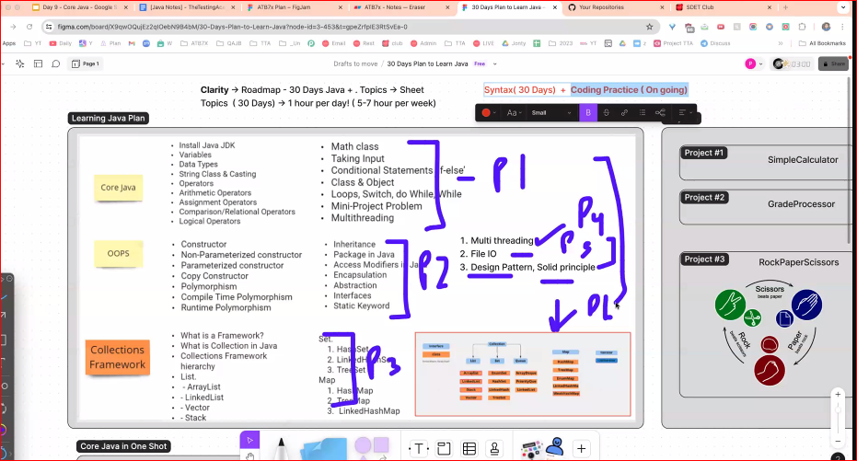

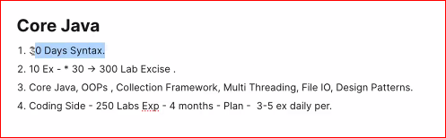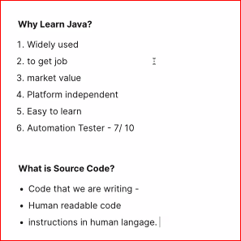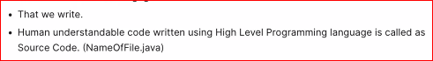

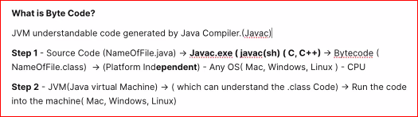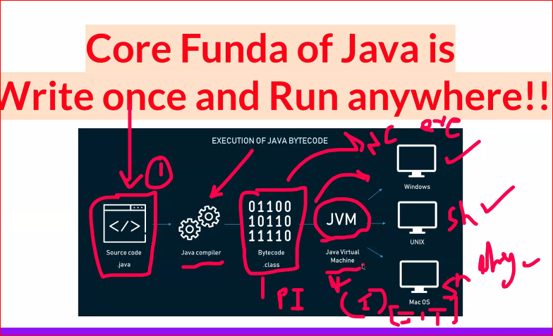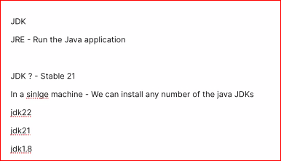

Download Java 21 & Intellij Community Edition:

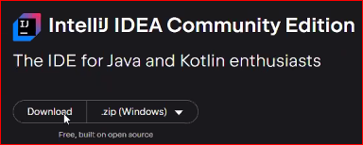

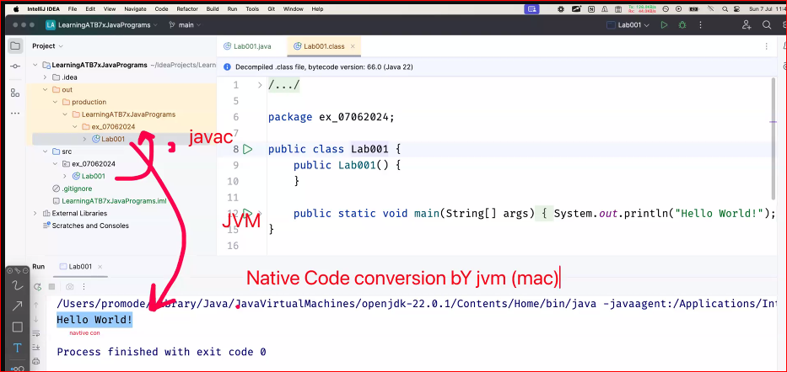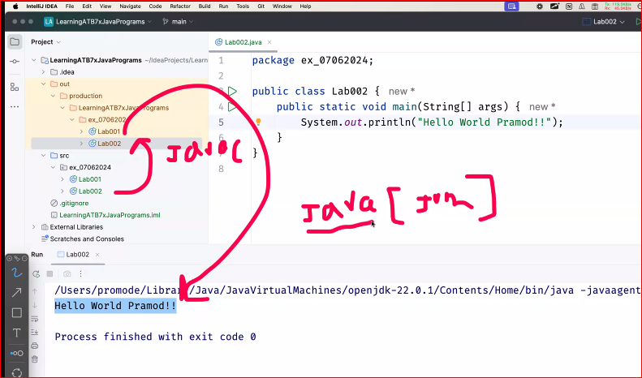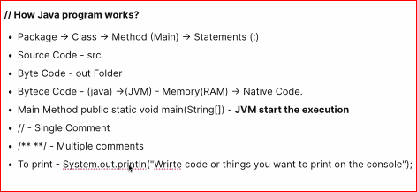

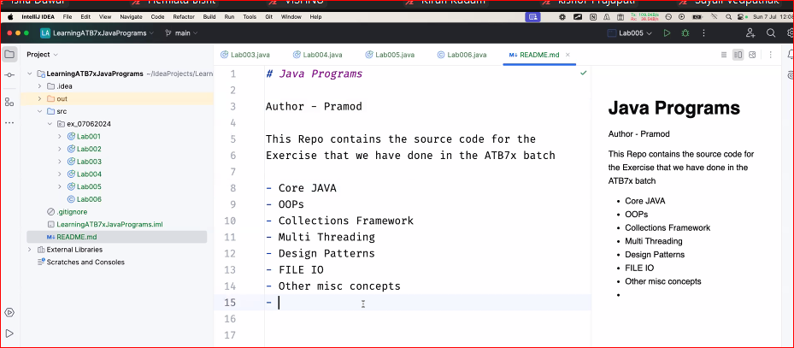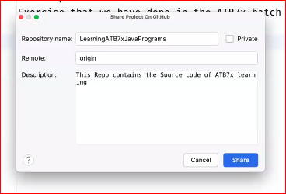

GitHub - <https://github.com/PramodDutta/LearningATB7xJavaPrograms/tree/main>

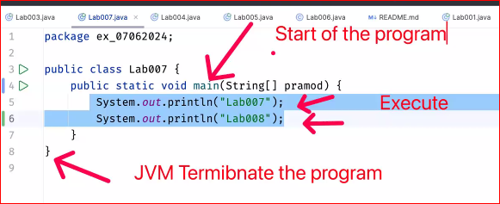

**IQ:**

**Lab001,Lab002**

1. **Parameters in Method:**

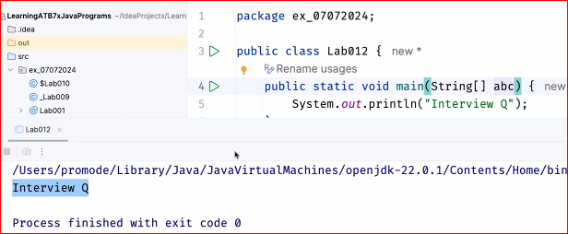

1. **can I run a class without main method – No**

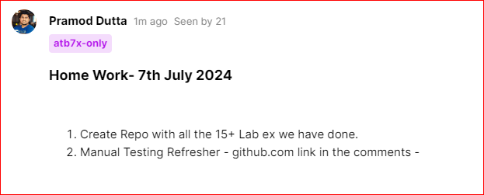

**Java Notes -** [**https://docs.google.com/document/d/1MTcTTWTKyet8lA78NifqANJq70OEDF98hoCdFbedBWc/edit?usp=sharing**](https://docs.google.com/document/d/1MTcTTWTKyet8lA78NifqANJq70OEDF98hoCdFbedBWc/edit?usp=sharing)