**How to Deploy IronDB as a DigitalOcean Droplet**

*(Developer Edition)*

The following document describes how to deploy the Iron Database on [DigitalOcean](https://www.digitalocean.com/). Create an account with DigitalOcean.

Create a new droplet based on the Docker Ubuntu 18.04. When making the droplet, tell it you will be using Docker and it will populate the option on the next screen. This will have all the tools installed that are needed for a deployment.

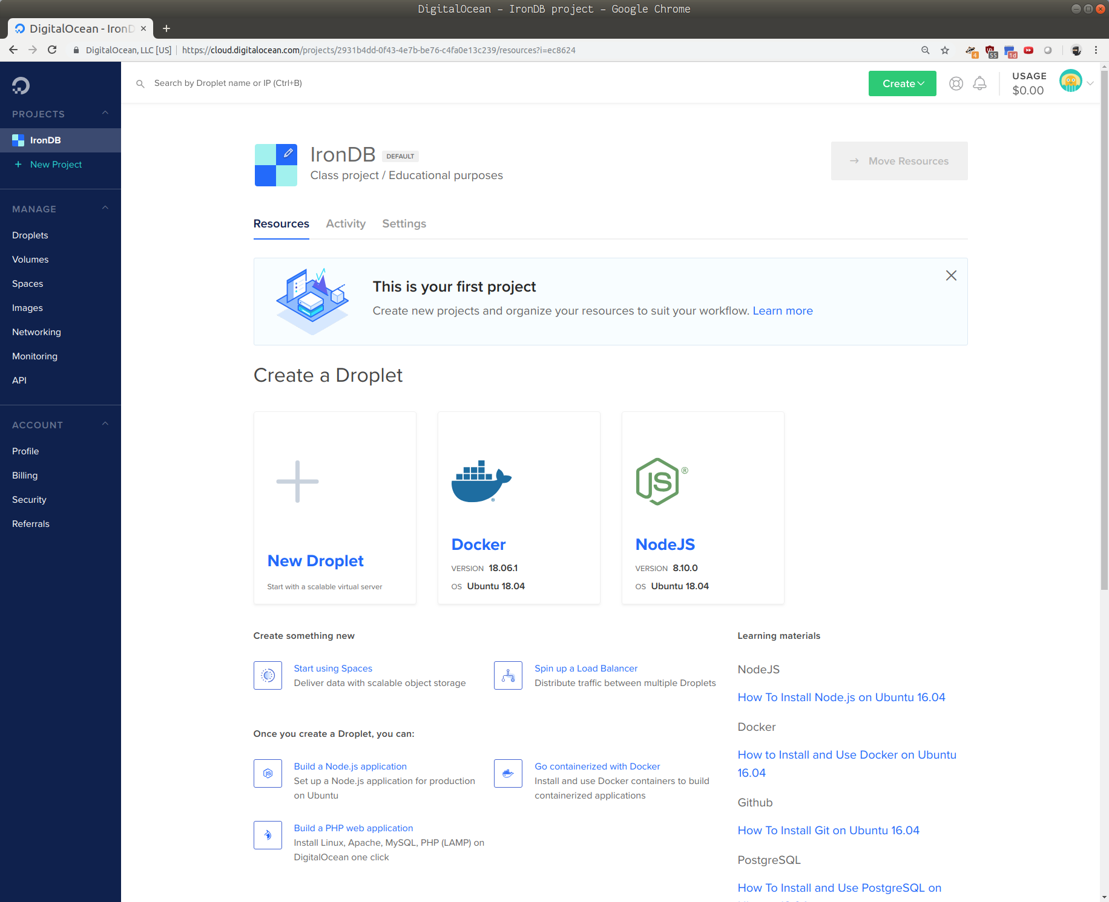

Select the appropriate droplet size, with a minimum recommendation of 2 GB RAM. If you find yourself lost at any point, head over to [the documentation](https://www.digitalocean.com/docs/droplets/how-to/create/).

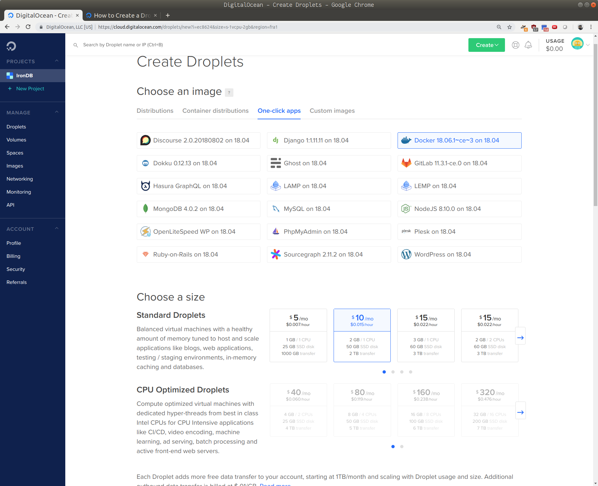

Add a SSH key. If you are using Linux or macOS, a SSH key can be made with the command ssh-keygen or use one that you have previously generated, which is often stored as ~/.ssh/id_rsa.pub

When you create your droplet it will give you an IP address, copy that.

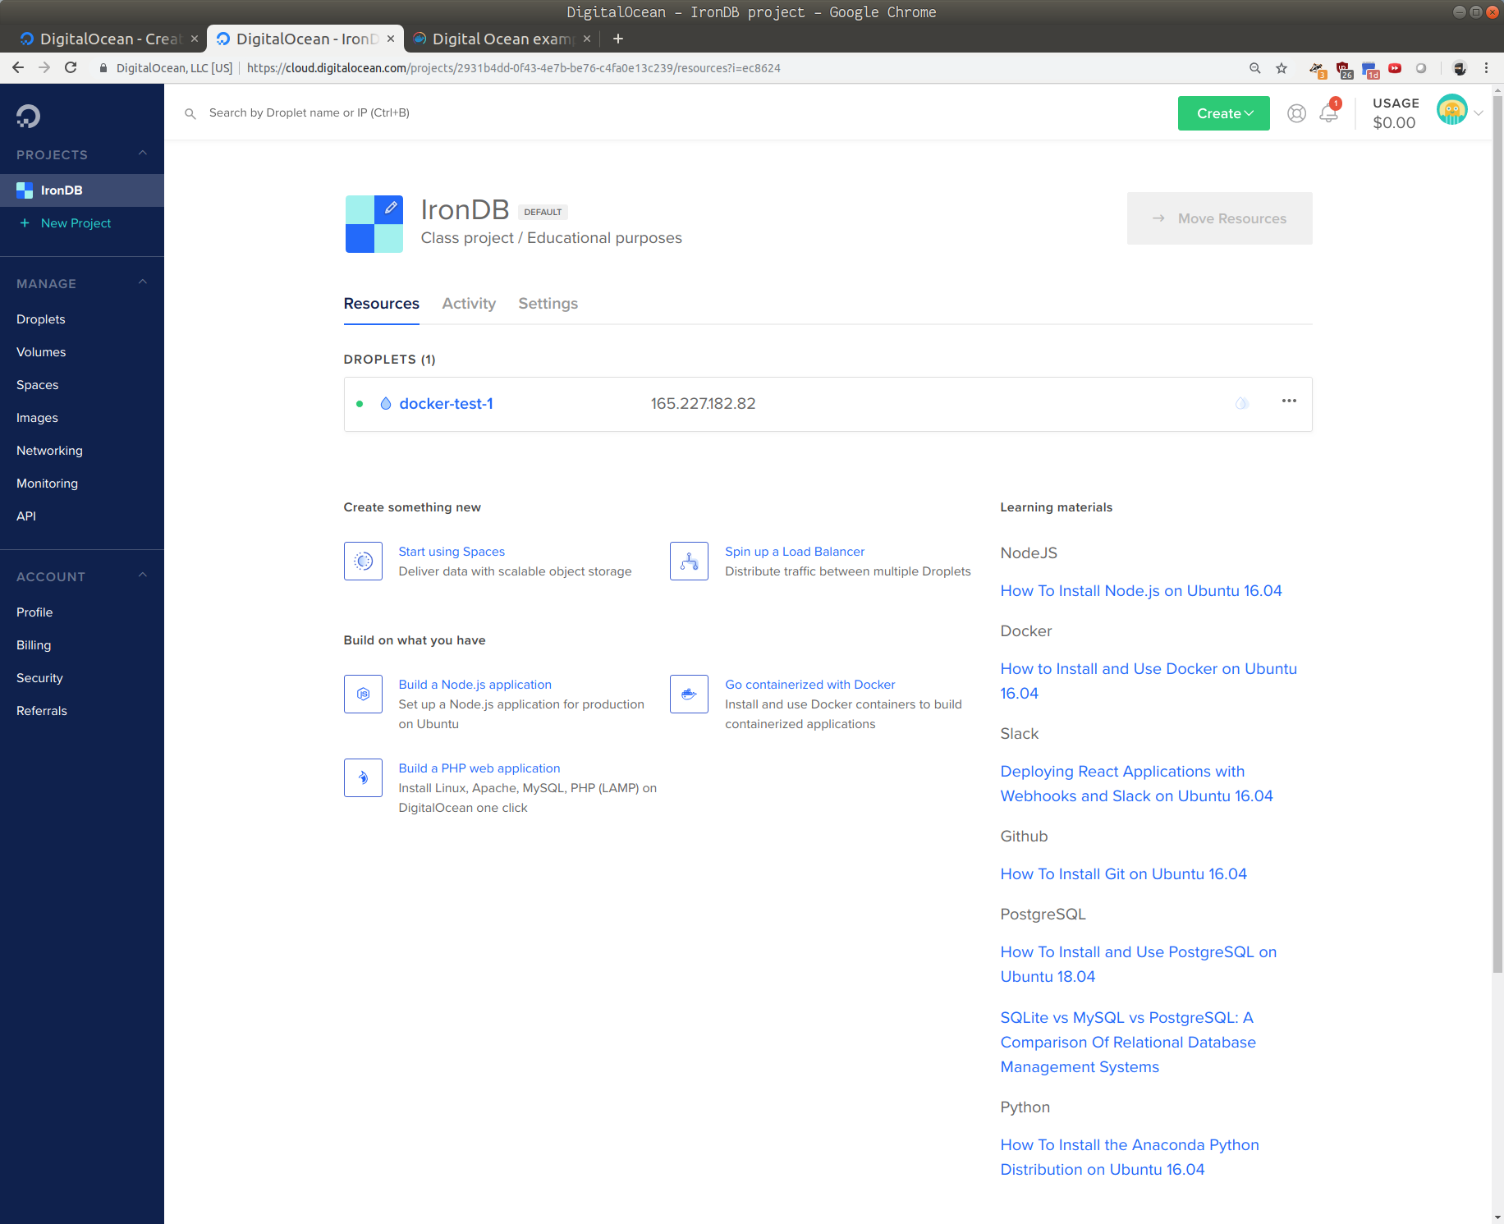

From there, open your terminal and enter the following command.

ssh root@your.ip.address

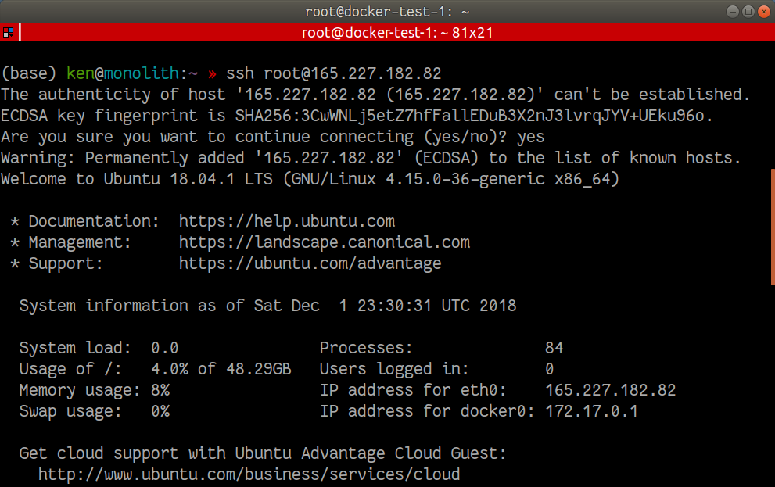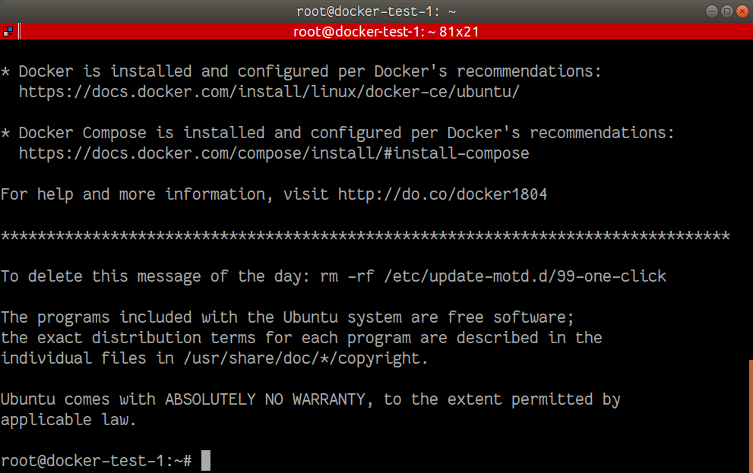

Then do the following:

git clone https://github.com/kenbonilla/irondb.git

cd irondb

./iron.sh -i

Provide a username and password for the Postgres instance. If running as a non-root user, you will be asked to enter your user password in order to install the local dependencies.

At any time, you can view the logs by the command ./iron.sh -g

To stop the containers, use ./iron.sh -s

To launch the containers, use ./iron.sh -l

For additional help with the Iron Shell, consult ./iron.sh -h