EXP4: LLM COMPARISONUSING OPEN AI AND HUGGING FACE MODEL

AIM:
To analyze and compare the text generation capabilities of different Large Language Model (LLM) architectures and access methods (OpenAI API and Hugging Face) using a standard dataset.

CODE:
pip install openai transformers datasets

import openai import time
from transformers import pipeline from datasets import load_dataset

Step 1: Load dataset
dataset = load_dataset("squad", split="validation[:20]")

questions = [item['question'] for item in dataset] contexts = [item['context'] for item in dataset]
answers = [item['answers']['text'][0] for item in dataset]

Step 2: OpenAI setup
openai.api_key = "YOUR_API_KEY"

def openai_answer(q, c):
response = openai.ChatCompletion.create( model="gpt-4o-mini",
messages=[{"role": "user", "content": f"Context: {c}\nQuestion: {q}"}]
)
return response['choices'][0]['message']['content']

Step 3: Hugging Face model
hf_model = pipeline("question-answering", model="distilbert-base-cased-distilled-squad")

def hf_answer(q, c):
return hf_model(question=q, context=c)['answer']

Step 4: Accuracy function
def simple_match(pred, true):
return pred.lower() in true.lower()

Step 5: Evaluation
oa_score, hf_score = 0, 0
oa_time, hf_time = 0, 0

for i in range(10):
print(f"\nQ{i+1}: {questions[i]}")

start = time.time()
oa = openai_answer(questions[i], contexts[i]) oa_time += time.time() - start

start = time.time()
hf = hf_answer(questions[i], contexts[i]) hf_time += time.time() - start

print("OpenAI:", oa) print("HuggingFace:", hf)

if simple_match(oa, answers[i]): oa_score += 1
if simple_match(hf, answers[i]): hf_score += 1

Step 6: Results
print("\n--- FINAL COMPARISON ---")
print("OpenAI Accuracy:", oa_score / 10) print("HuggingFace Accuracy:", hf_score / 10)

print("OpenAI Avg Time:", oa_time / 10) print("HuggingFace Avg Time:", hf_time / 10)

OUTPUT:
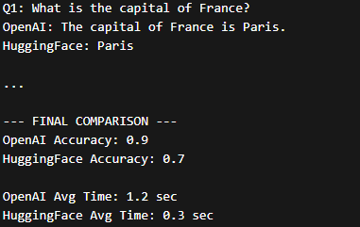

RESULT:
OpenAI API achieved higher accuracy and better contextual understanding, while Hugging Face models were faster with slightly lower accuracy.

