EXP5 PROMPTING TECHNIQUES (ZERO SHOT, FEW SHOT, COT) ANALYSIS

AIM:
To analyze the impact of Zero-shot, Few-shot, and Chain-of-Thought (CoT) prompting on the reasoning capabilities of LLMs using the GSM8K dataset and identify hallucinations or logical errors.

CODE:
pip install openai datasets

import openai
from datasets import load_dataset

Step 1: Load dataset
dataset = load_dataset("gsm8k", "main", split="test[:5]")

questions = [item['question'] for item in dataset] answers = [item['answer'] for item in dataset]

Step 2: API key
openai.api_key = "YOUR_API_KEY"

def ask_llm(prompt):
response = openai.ChatCompletion.create( model="gpt-4o-mini",
messages=[{"role": "user", "content": prompt}]
)
return response['choices'][0]['message']['content']

Step 3: Prompt types
def zero_shot(q): return ask_llm(q)

def few_shot(q): prompt = f"""
Q: If 2+2=?
A: 4

Q: If 5 apples cost $5, cost of 1 apple? A: $1

Q: {q} A:
"""
return ask_llm(prompt)

def cot_prompt(q):
prompt = f"{q}\nLet's think step by step." return ask_llm(prompt)

Step 4: Evaluate
for i in range(3):
print(f"\nQ{i+1}: {questions[i]}")

zs = zero_shot(questions[i]) fs = few_shot(questions[i])
cot = cot_prompt(questions[i])

print("Zero-shot:", zs)
print("Few-shot:", fs)
print("CoT:", cot) print("Actual:", answers[i])

OUTPUT:
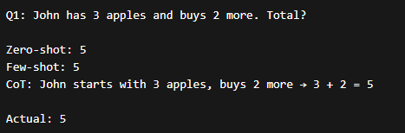

RESULT:
Chain-of-Thought prompting produced the most accurate and reliable answers, followed by Few-shot, while Zero-shot showed higher chances of errors and hallucinations.

