**C# MVC Frameworks – ASP.NET Core**

**Atanas Kambitov** **30/08/2018**

**Find My Pet App**

This is a short documentation for a simple exam application made with ASP .NET CORE in Visual Studio 2017.

The app contains everything in the project assignment description.

It has animations which load when the user scrolls down, transitions, pagination, lazy loading of data, partial views, filters, binding models, view models, OAuth External Authentication, unit test, razor pages, bootstrap stylization and more.

It has been uploaded to Github and hosted on Microsoft Azure.

Website Link : https://findmypetweb.azurewebsites.net/

GitHub Link: https://github.com/NASOKILA/FindMyPet

**Functionality description:**

This is a simple web app from which if a user is registered he can post a lost pet and find other posted lost pets.

A posted pet can be changed or deleted by his owner or by the administrator.

A user can post comment for a pet and like or dislike a created comment.

Comments can be deleted only by their creator or by the administrator.

Also users can send each other personal messages from one to another.

Messages can be send from a user personal profile page where the messages can be deleted not by their creator but by the user who received the message.

Every registered user has feedback points that he gets when a pet is found.

A pet can only be found once and when it gets found the founder receives the points for that pet and the owner receives an automatic message saying that his/her pet has been found by another user.

The feedback points depend on the type of pet that the user has found.

There are 4 main types of pets:

01.Dog - 100 feedback

02.Cat - 200 feedback

03.Bird - 300 feedback

04.Other - 50 feedback

**Users description:**

There are three types of users, **guest**, **logged in** and **admin**.

**Guest User**- A guest is a user who has not registered yet, he can only see the home, about, register and login pages.

**Home** page: It says that this is a portfolio website and it gives you the admin credentials to explore all the functionalities as administrator.

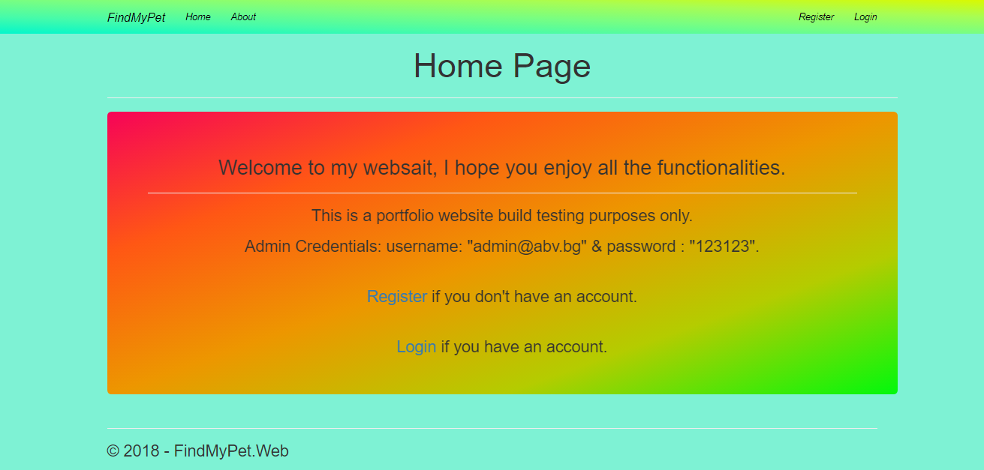

**About** page: It welcomes the user and it presents a very short description of what the app can do.

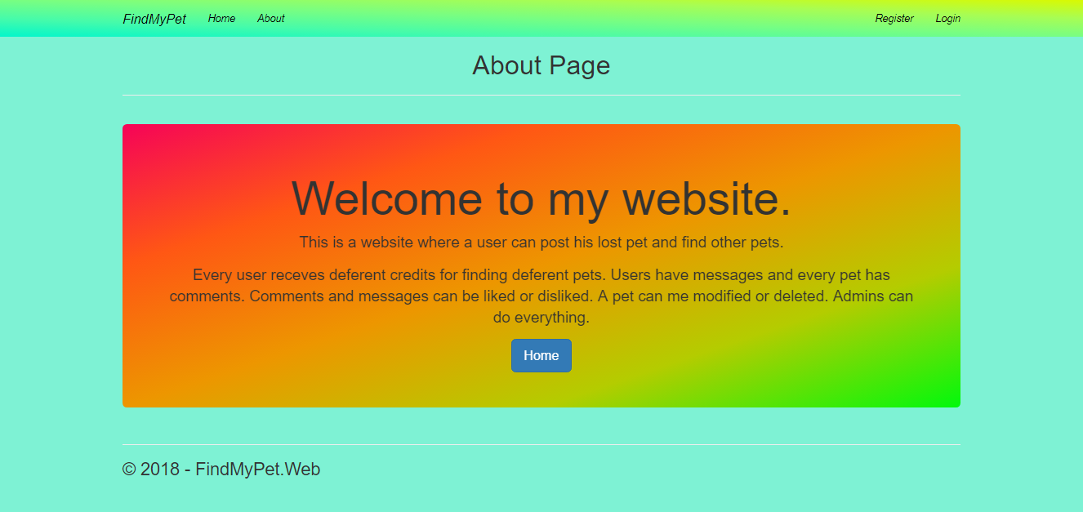

**Login** page: A user can login with email or password, he can use another service Facebook or Google and the page has links for password lost and register pages.

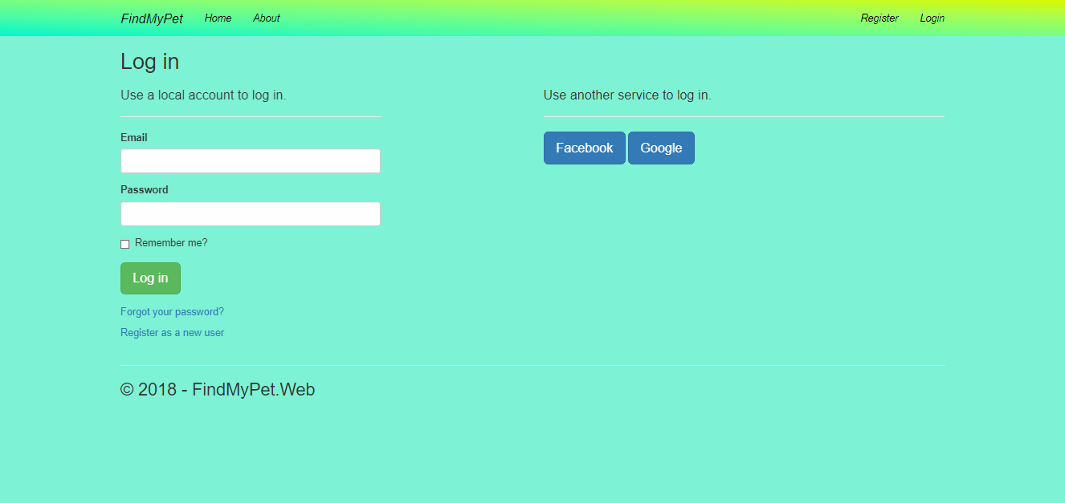

**Register** page:

A user can register and upload an avatar image for his/her profile.

The register form has validations.

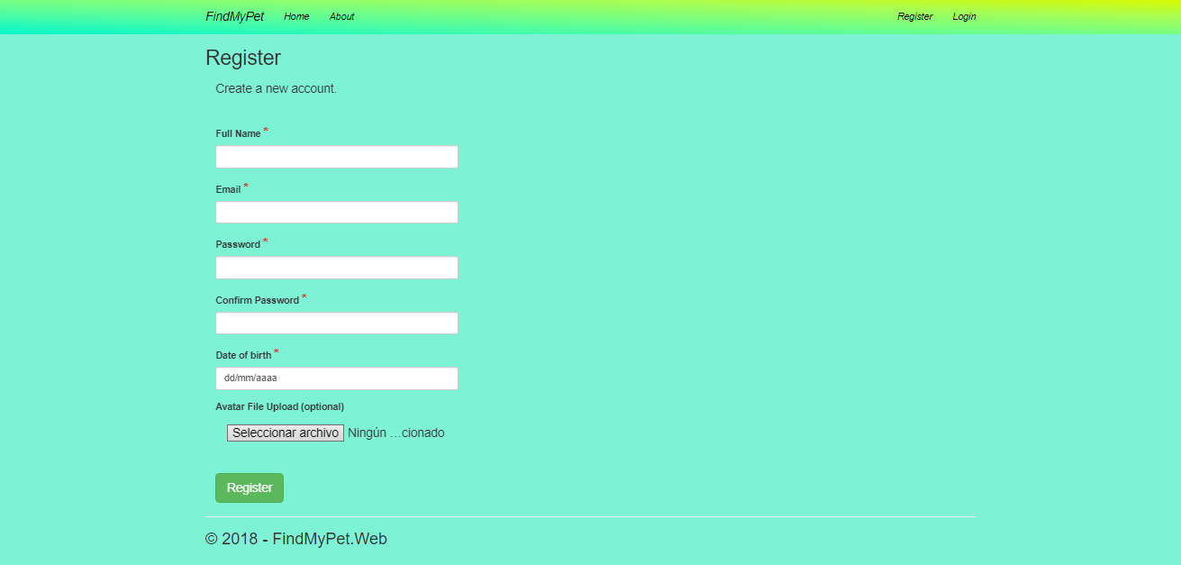

**Logged In User** - This type of user is already registered and he can not only see the home and about page in the application.

He can logout , see a list of all pets ordered by status and then by date in which the pet is declared lost.

This user can comment pets, delete only the comments which he has created, send messages to other users.

This user can also see his own profile page as well as profiles of other uses, where he can leave personal messages.

Every user can have personal messages which also can be liked or disliked by other users who visit the profile page.

A user can delete all personal messages which appear in his/her profile page.

If a user finds a pet, he is redirected to a confirmation page asking if the user is sure that he found the particular per.

Then automatically the pet status changes to “Found”, the owner of the pet receives an automatic massage that his/her pet has been found and the current user receives his/her feedback credits for founding a pet.

**All pets** page: This is the home page for an authenticated user.

This page has pagination and it shows only the 3 pets for this page.

A pet which has been found it shows up with a red background.The edit and delete buttons are only available for on pets created by the currently logged in user.

On the navigation bar the user can see additional links for **My profile** and **Create Pet** pages.

Also on the right side of the navigation there is a picture and email for the current user, these are links to the **Account** **Manage** page.

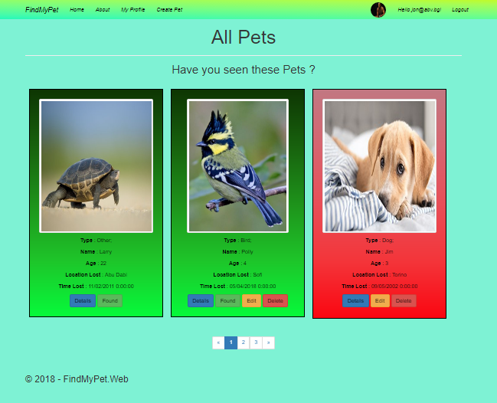

**Account manage profile** page - In this page the user can update his/her personal account.

On the left side of the page the user can see links to other account managing pages like **Password, External Logins** and **Personal Data**.

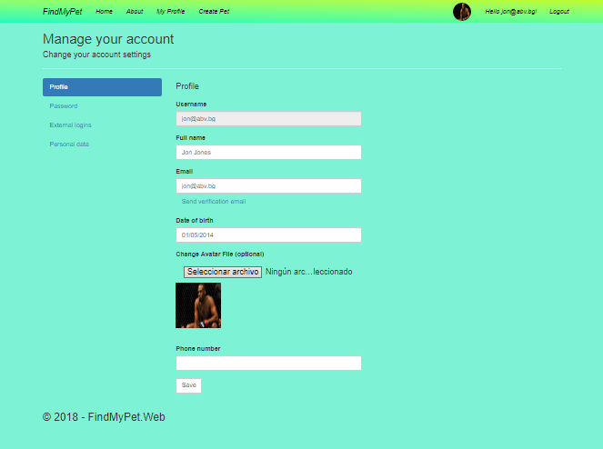

**Password** page – In this page the user can change his/her account password with a new one.

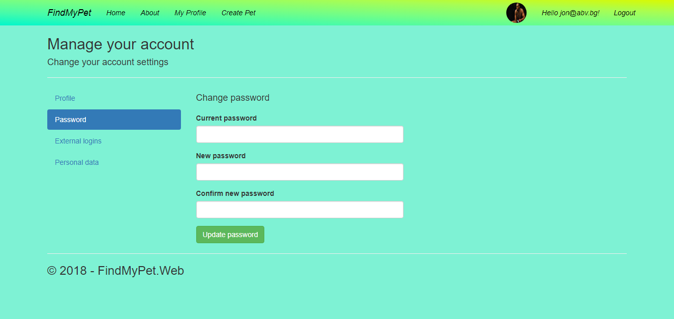

**External logins** page – In here a user can add or remove an external log in service to his/her account.

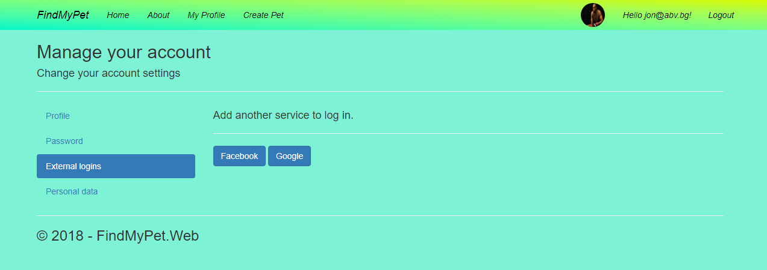

**Personal data** page – In this page the user can download ot delete it’s personal data.

When downloaded the personal data file arrives in a json format.

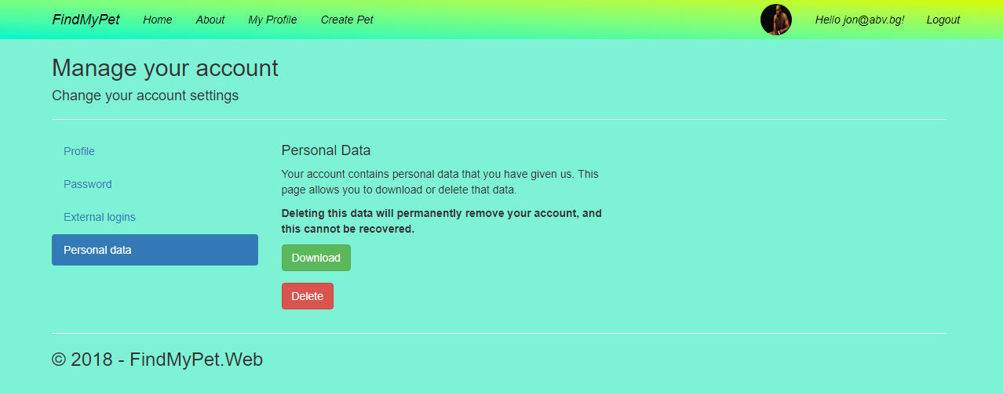

**My Profile** page – In this page the user can see his/her personal information and all messages received.

The user can delete the messages on his/her profile page, like them and dislike them.

On each message there is a link leading to the creator page of that particular message.

At the bottom of the page there is a link to the home page.

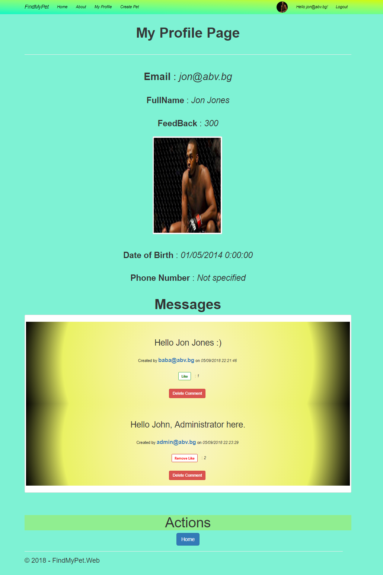

**User Profile** page – This page is very similar to the My Profile page only here the user sees the details of another user.

From here the current user has an option to send a personal massage, like or dislike other messages.

Only here the messages can be deleted only by the other user.

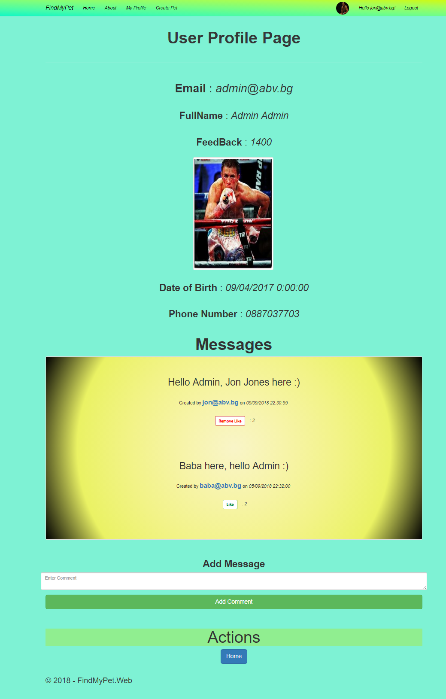

**Create Pet** page - This is a Razor Page from where the user can register a new lost pet.

It has many field validations and error messages pulp up when an input is not valid.

It has Create button and a Cancel button which redirects to the Home page.

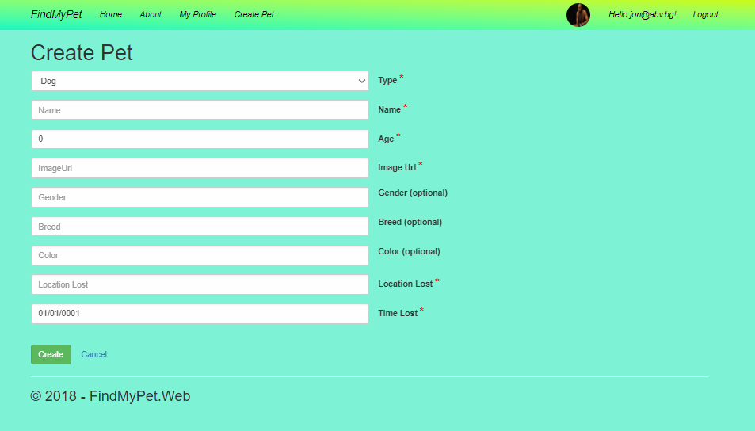

**Pet Details** page – When the user clicks on any pet image or the Details button he gets redirected to this page which shows all pet details and comments.

From here the user can like or dislike a comment, post and his own comments.

If the current user is the creator of this pet post he can see the **“Edit”** and **“Delete”** buttons. Also if the pet status is still **“Lost”** the user can see a **“Found”** button from which he can say that he found the particular pet and get credits, and a **“Back”** redirecting to Home.

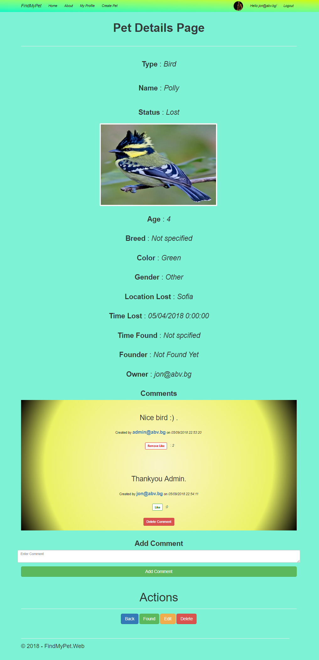

**Edit Pet** page – This is a **Razor Page** very similar to the create

page only here the user can update a pet that he owns.

The input data for that pet get’s loaded and ready to be updated.

This page also has model validations and error messages under every input.

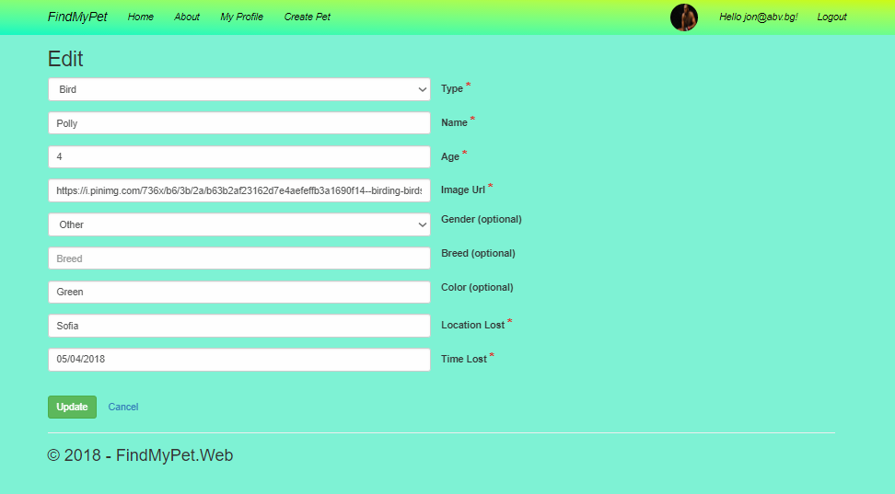

**Delete Pet** page - This is another Razor Page similar to the Edit page only here the user can delete the selected pet.

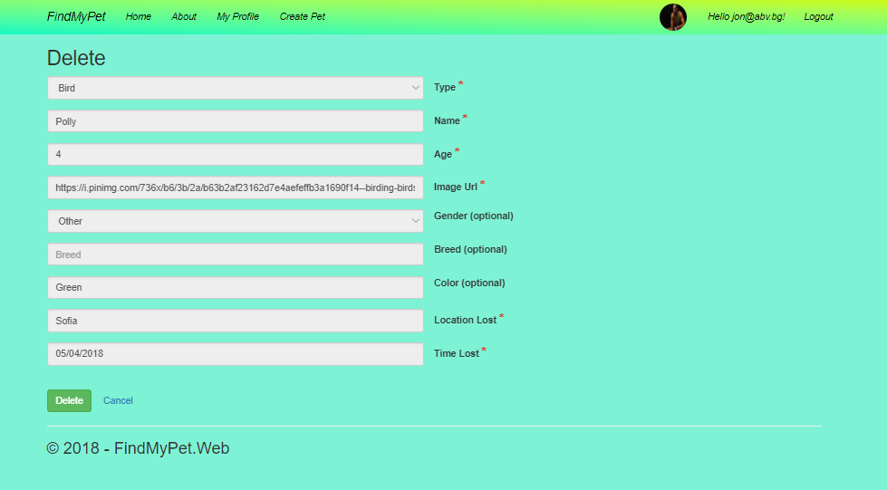

**Pet Found** page – This is a confirmation page asking the user if he found the selected pet.

There are 2 buttons at the end of the page : ”Yes” and “No”.

If the user clicks “No” he gets redirected to the **Home** page.

If the user clicks “Yes” he gets redirected to the **Pet Found Completed** page.

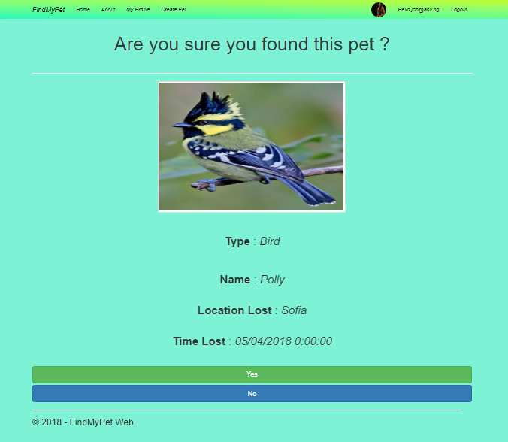

**Pet Found Completed** page – This is a simple page that congratulates the user for the pet that he found.

There is a button which redirects to the Home page.

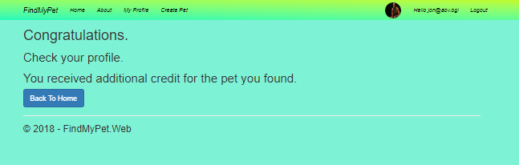

**Admin User** – This type of user has the more credentials than the rest, he can not only perform the above described actions, but he can view edit and delete all pets and also delete all comments and messages in the application.

An Admin user can also see a deferent navigation bar, it uses a special Area created for Administrators and it basically has no limitations in the website.

The Admins can see another additional page containing a table of all users.

From this page the admin can disable other users.

If a user is disabled he cannot login into his account.

**All Pets (Admin)** page - Most of the pages look the same just with deferent navigation bar which has a darker color and an additional link to **All Users** page.

In this picture we see that an admin has access the **Edit** and **Delete** buttons for all the pets even if he is not the owner of them.

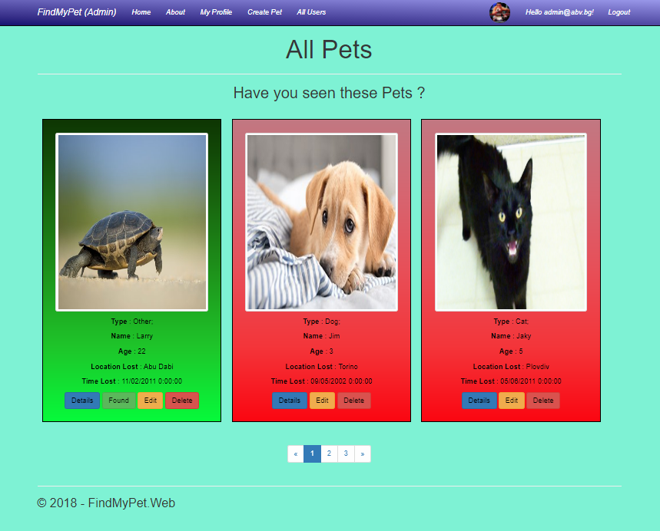

**Pet Details (admin)** page - The same goes for this page, an administrator can see the **Edit** and **Delete** buttons even if he is not the owner of the selected pet.

Also an admin can delete any comment or message in the app.

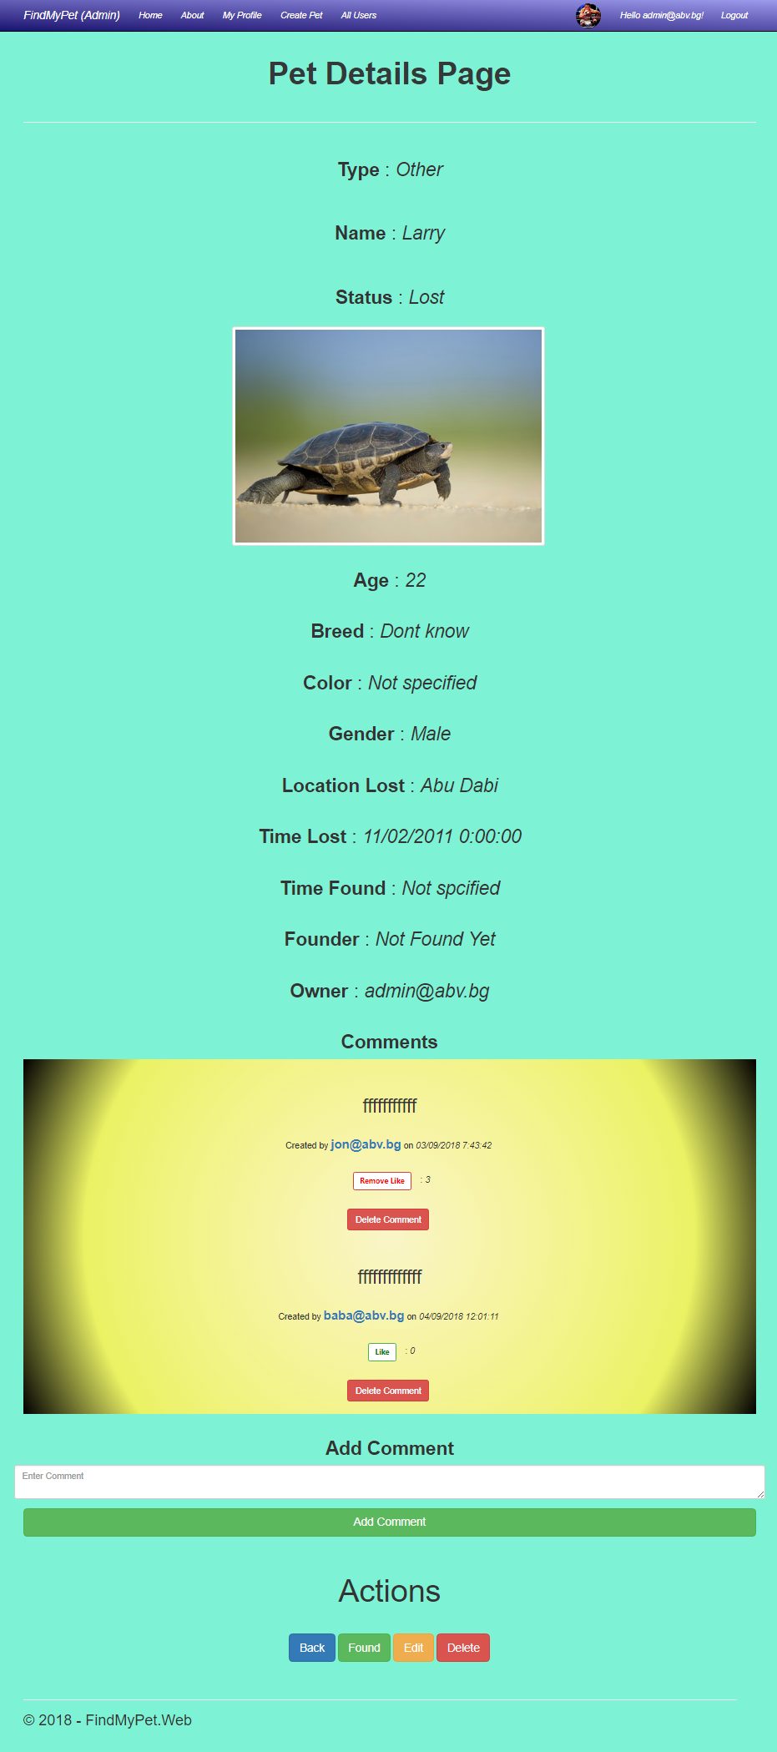

**All Users** page – This page is available only for Administrators.

From this page the Administrator can see a list of all users, he can lock a user and free an already locked user.

He can also see a details page for each individual user.

A user can be locked only for 20 minutes then automatically gets freed.

