**Atanas Kambitov**

**Web Developer**

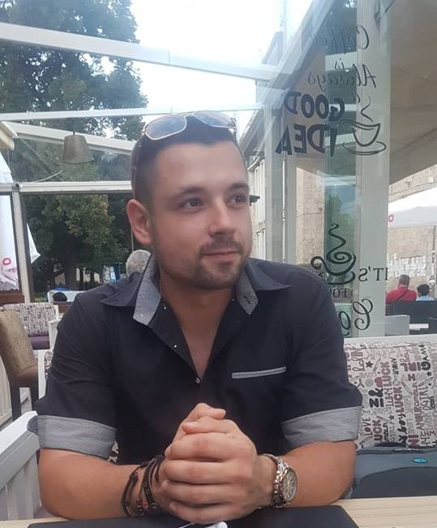

**Personal Information**

**Phone:** +359 877 80 99 49  |

**Email:** atanasskambitovv@gmail.com   |

**Country:** Bulgaria |

**City:** Blagoevgrad |

**Address:** Hriso Chernopeev 37 |

**Postal Code:** 2700 |

**GitHub:** <https://github.com/NASOKILA>

**Facebook:** <https://www.facebook.com/profile.php?id=100004882428094>

**LinkedIn:** <https://www.linkedin.com/in/atanas-kambitov-a69528162>

**Description**

I just graduated and I am looking for a new opportunity, I offer 2 and a half years of coding experience mainly in .NET, JavaScript and Front-End.

My goal is to start and grow a career in web development, specifically as a Full-Stack, Back-End or Front-End or developer.

Programming is my passion, my favorite programming languages are JavaScript and C#. I am highly motivated, focused, with a lot of will to keep learning.

I believe in hard work, desire and constant dedication.

[https://github.com/NASOKILA/oftUnihttps://github.com/NASOKILA/SoftUni](https://github.com/NASOKILA/SoftUni)

**Gallery Projects**

**.Net Core**

**Website Link:** <https://findmypetweb.azurewebsites.net/>

**Repository Link:** <https://github.com/NASOKILA/FindMyPet>

**Title:** Find My Pet

**Description:**

This is a simple web app in which a user can post his lost pet and find other lost pets.

The app has **animations** **which load when the user scrolls down, transitions, pagination, lazy loading of data, partial views, filters, binding models, view models, OAuth External Authentication, unit test, razor pages, bootstrap stylization** and more. It has been uploaded to **Github** and hosted on **Microsoft Azure**.

A posted lost pet can be changed or deleted by his owner or by the **administrator**.

Users can post comments pets and **like** or **dislike** a created comment.

Comments can be deleted only by their **creator** or by the **administrator**.

Also users can send each other **personal messages** from one to another.

Messages can be send from a user personal profile page where the messages can be deleted not by their creator but by the **user who received the message**.

Every registered user has **feedback** points that he gets when he **finds a pet**.

A pet can only be found once and when it gets found the founder receives the **feedback points** for that pet.

The founder and the owner both receive **automatic message** saying that the pet has been found.

The feedback points depend on the **type of pet** that the user has found.

There are **4** types of pets: **Dog + 100fb, Cat + 200fb, Bird+ 300fb** and **Other + 50fb**.

**Angular 2**

**Website Link:** <https://nasokila.github.io/comix-shop/>

**Repository Link:** <https://github.com/NASOKILA/Portfolio-Projects/tree/comix-shop>

**Title:** Comics Shop

**Tools:** Angular 2

**Description:**

This is simple shopping website for buying comics, build with Angular 6 in **16 hours** which holds **comics, orders, comments** and **users,** they are the main app **entities**.

The app has guest, user and admin roles.

It also has **authentication, pagination, animations, validations, notification messages** and more.

It uses **bootstrap** for styling.

The functionality of the application supports **creating**, **listing**, **editing** and **deleting** comics, orders and comments.

It persists the data into a **database at** [**www.console.kinvey.com**](http://www.console.kinvey.com).

**There is a short documentation in the specified repository**.

**ReactJS**

**Website Link:** <https://nasokila.github.io/house-shop/>

**Repository Link:** <https://github.com/NASOKILA/Portfolio-Projects/tree/house-shop>

**Title :** House Shop

**Tools :** React.js

**Description:**

The app is about buying houses,

It performs **CRUD** operations

The **app** keeps **users** (cashiers), **product entires** and **receipts**.

This app is made in 15 hours, it has guest, user and admin roles.

It also has **authentication, animations, validations, notification messag**es and more.

Itholds **houses, orders and users** they are the main app **entities**.

The functionality of the application supports **creating**, **listing**, **editing** and **deleting** houses, orders and comments.

It persists the data into a **database at** [**www.console.kinvey.com**](http://www.console.kinvey.com).

**There is a short documentation in the specified repository**.

I have other projects in my github repositories: <https://github.com/NASOKILA>.

**Front-End Pages**

<https://nasokila.github.io/Front-End-Pages/trip>

<https://nasokila.github.io/Front-End-Pages/compay>

<https://nasokila.github.io/Front-End-Pages/cars>

<https://nasokila.github.io/Front-End-Pages/laptops>

<https://nasokila.github.io/Front-End-Pages/mountains>

<https://nasokila.github.io/Front-End-Pages/form>

**Education**

**Year Trom - To Name Location**

*September 2000 - September 2005* VII High School Kuzman Shapkarev Blagovgrad, Bulgaria

*September 2005 - September 2008* Cocconato d'Asti ( Middle School ) Cocconato d'Asti, Italy

*September 2008 - September 2010* IIS Vittorio Alfieri (high school) Asti. Italy

*September 2010 - September 2012* ES Emilio Ferrari (private high school) Valladolid, Spain

*September 2012 - September 2013* Polet (Private high school) Blagoevgrad, Bulgaria

*September 2014 - September 2017* South-West University "Neofit Rilski" Blagoevgrad, Bulgaria

*September 2016 - September 2018* Software University ( SoftUni ) Sofia, Bulgaria

**Courses & Certificates**

**No. Name Date Url**

01. Programming Basics January 2017 [*https://softuni.bg/certificates/details/17773/3b649c85*](https://softuni.bg/certificates/details/17773/3b649c85)

02. Programming Fundamentals May 2017 [*https://softuni.bg/certificates/details/21229/5c478899*](https://softuni.bg/certificates/details/21229/5c478899)

03. Software Technologies July 2017 [*https://softuni.bg/certificates/details/22790/a1a31b74*](https://softuni.bg/certificates/details/22790/a1a31b74)

04. Databases Basics September 2017 [*https://softuni.bg/certificates/details/23874/9aad2178*](https://softuni.bg/certificates/details/23874/9aad2178)

05. Databases Advanced EF Core October 2017 [*https://softuni.bg/certificates/details/50892/d900f77a*](https://softuni.bg/certificates/details/50892/d900f77a)

06. Web Fundamentals (HTML/CSS) September 2017 [*https://softuni.bg/certificates/details/24650/5d5de5ee*](https://softuni.bg/certificates/details/24650/5d5de5ee)

07. JavaScript for Front-End October 2017 [*https://softuni.bg/certificates/details/50409/fbde8231*](https://softuni.bg/certificates/details/50409/fbde8231)

08. JS Fundamentals January 2018 [*https://softuni.bg/certificates/details/51623/47bc090f*](https://softuni.bg/certificates/details/51623/47bc090f)

09. JS Advanced February 2018 [*https://softuni.bg/certificates/details/52983/ca7db4f3*](https://softuni.bg/certificates/details/52983/ca7db4f3)

10. JS Applications March 2018 [*https://softuni.bg/certificates/details/54724/a860fbdf*](https://softuni.bg/certificates/details/54724/a860fbdf)

11. JS Web Node.js & Express.js May 2018 *https://softuni.bg/certificates/details/56338/4840c9ea*

12. JS Web React.js Fundamentals June 2018 *https://softuni.bg/certificates/details/56675/8f98ca20*

13. JS Web Angular.js 2 Fundamentals July 2018 *https://softuni.bg/certificates/details/57681/9b95b919*

14. C# Advanced January 2018 [*https://softuni.bg/certificates/details/51479/900fe6cc*](https://softuni.bg/certificates/details/51479/900fe6cc)

15. C# OOP Basics February 2018 [*https://softuni.bg/certificates/details/52573/5b3eb1de*](https://softuni.bg/certificates/details/52573/5b3eb1de)

16. C# OOP Advanced March 2018 [*https://softuni.bg/certificates/details/53385/a5becce5*](https://softuni.bg/certificates/details/53385/a5becce5)

17. C# Web Development Basics May 2018 *https://softuni.bg/certificates/details/57616/ba3386af*

18. C# MVC Frameworks ASP.NET June 2018 *https://softuni.bg/certificates/details/57519/8d5dfee3*

**Experience**

**Job Title Employer Location**  **Years From -To**

Prestashop & WordPress Developer  **Paolo Pavia Sofia Bulgaria**  **May 2016 - May 2017**

Student Software University Sofia Bulgaria December 2016 - September 2018

Most of the coding experience I gained is from the Softwre University in Sofia (SoftUni).

They gave me the opportunity to work on many projects, servers and applications by using different technologies, languages, and frameworks.

I have been taking courses for about 2 years now.

Feel free to check them out in the sections below together with all the certificates.

**Foreign Languages Additional Skills**

English Focus

------------------------------------- -------------------------------------

Spanish Reliable

------------------------------------- -------------------------------------

Italian Hard-working

------------------------------------- ------------------------------------

Motivated

-------------------------------------

Trustworty

-------------------------------------