**A Hybrid Network Analysis and Machine Learning Model for Enhanced Financial Distress Prediction.**

**ABSTRACT**

This research presents a hybrid model combining network analysis and machine learning to improve financial distress prediction. Utilizing ensemble learning methods such as voting classifiers and Random Forest algorithms, the model addresses the complexities of predicting financial distress with a dataset encompassing 86 features and 3,672 samples. By integrating cutting-edge machine learning techniques with effective ensemble strategies, the model aims to enhance both accuracy and reliability in identifying financially distressed entities. The study assesses the efficacy of these methods in differentiating between distressed and non-distressed entities, revealing notable improvements in predictive performance. This advancement provides valuable insights for financial analysts and decision-makers, offering a refined approach to understanding financial health indicators.

**Keywords:** Ensemble learning, voting classifiers and Random Forest algorithms.

**PROBLEM STATEMENT**

Financial distress prediction remains a critical challenge for financial analysts and decision-makers, particularly due to the complexity and volume of financial data involved. Traditional models often struggle to accurately forecast financial distress due to their limited ability to handle intricate relationships within large datasets. The problem is exacerbated by the high dimensionality of financial indicators and the need for robust methods that can distinguish between distressed and non-distressed entities effectively. Current approaches may lack the precision required to provide reliable predictions. This study addresses these issues by proposing a hybrid network analysis and machine learning model that combines ensemble learning techniques, such as voting classifiers and Random Forest algorithms, to enhance the accuracy and reliability of financial distress predictions.

**OBJECTIVE**

The objective of this project is to develop and evaluate a hybrid network analysis and machine learning model to enhance financial distress prediction. By integrating ensemble learning techniques such as voting classifiers and Random Forest algorithms with a comprehensive dataset of 86 features and 3,672 samples, the model aims to improve prediction accuracy and reliability. The project focuses on distinguishing financially distressed entities from non-distressed ones, providing deeper insights into financial health indicators, and advancing predictive performance to support informed decision-making for financial analysts and stakeholders.

**SCOPE**

This study explores a hybrid network analysis combined with machine learning techniques to enhance financial distress prediction. It focuses on applying ensemble learning methods, including voting classifiers and Random Forest algorithms, to a dataset containing 86 features and 3,672 samples. The research aims to improve the accuracy and reliability of financial distress forecasts by integrating advanced machine learning strategies with robust ensemble approaches. The study evaluates the model’s efficacy in distinguishing between distressed and non-distressed entities, offering insights for better financial health assessments and decision-making.

**MOTIVATION**

The motivation behind this study lies in the pressing need to enhance financial distress prediction amidst increasingly complex financial environments. Traditional models often fall short in accuracy due to limited predictive capabilities and reliance on simplistic metrics. By integrating hybrid network analysis with advanced machine learning techniques, this research aims to bridge these gaps. The use of ensemble learning methods, such as voting classifiers and Random Forest algorithms, promises a more robust and precise assessment of financial health, addressing the challenge of distinguishing distressed entities from non-distressed ones with greater reliability.

**EXISTING SYSTEM**

Existing financial distress prediction systems primarily rely on traditional financial indicators and machine learning algorithms to forecast potential risks. These methods often utilize standard features such as profitability ratios, liquidity measures, and leverage indicators to train models like Support Vector Machines (SVM) and other classification algorithms. However, these approaches may lack depth in capturing the intricate relationships and interactions between companies. Network analysis, while promising, is seldom integrated with machine learning in financial distress prediction, leaving a gap in leveraging network-centric insights for enhanced predictive accuracy.

**DISADVANTAGES**

**1. Limited Feature Scope:** Traditional systems rely solely on standard financial indicators, potentially missing nuanced risk factors that can affect financial stability.

**2. Surface-Level Analysis:** Methods focusing only on profitability ratios and leverage may not capture deeper, complex relationships between financial metrics and distress signals.

**3. Neglected Interactions:** Existing models often overlook the interactions between different financial indicators, which can provide critical insights into financial health.

**4. Lack of Network Insights:** The absence of network analysis in current models misses out on leveraging interconnected financial relationships for improved predictions.

**5. Inflexibility to Dynamic Factors:** Traditional approaches might not adapt well to rapidly changing financial environments, reducing their accuracy in real-time distress prediction.

**PROPOSED SYSTEM**

The proposed system integrates hybrid network analysis with machine learning to enhance financial distress prediction. It employs ensemble learning techniques, specifically voting classifiers and Random Forest algorithms, to analyze a comprehensive dataset comprising 86 features and 3,672 samples. By combining advanced machine learning methods with robust ensemble strategies, the system aims to improve prediction accuracy and reliability. It focuses on distinguishing between financially distressed and non-distressed entities, offering deeper insights into financial health indicators and significantly advancing predictive performance for financial analysts and decision-makers.

**ADVANTAGES**

**1. Enhanced Accuracy:** By leveraging ensemble learning techniques such as voting classifiers and Random Forest algorithms, the system improves prediction accuracy through the combination of multiple models' strengths.

**2. Robust Analysis:** The use of a comprehensive dataset with 86 features and 3,672 samples allows for a thorough analysis of financial distress indicators, providing a deeper understanding of financial health.

**3. Improved Reliability:** Ensemble methods increase the reliability of predictions by reducing the impact of individual model biases and variances.

**4. Advanced Insights:** The integration of hybrid network analysis with machine learning delivers more nuanced insights into financial health, benefiting financial analysts and decision-makers.

**5. Enhanced Predictive Performance:** The system's advanced techniques offer a significant boost in predictive performance, aiding in more accurate financial distress forecasting.

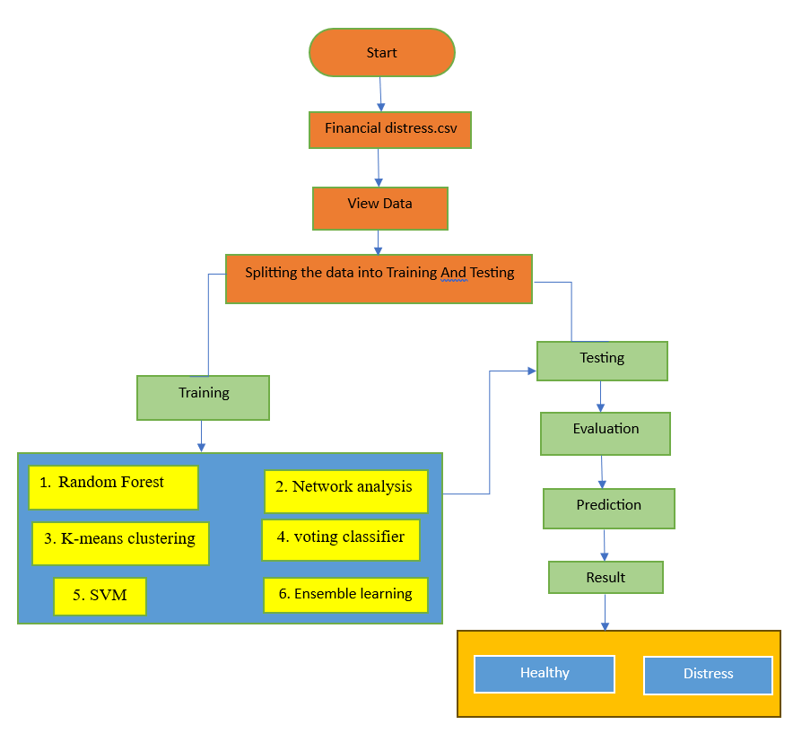

**SYSTEM SPECIFICATIONS:**

# H/W SPECIFICATIONS:

# Processor : I5/Intel Processor

* RAM : 8GB (min)
* Hard Disk : 128 GB
* Key Board : Standard Windows Keyboard
* Mouse : Two or Three Button Mouse
* Monitor : Any

**S/W SPECIFICATIONS:**

* Operating System : Windows 7+
* Server-side Script : Python 3.6+
* IDE : PyCharm / VSCode
* Libraries Used : Pandas, Numpy, Matplotlib, OS.