|  |  |  |
| --- | --- | --- |
| **Name** | **ID** | **STUDENT SIGN** |
| **RIMON NATH** | **18-38929-3** | **Rimon Nath** |

**Advance Database Management System Prerequisites II**

1. Below a scenario has been given draw the ER Diagram.

In an Ice-Cream Parlor, a customer may buy or order many ice-creams. Each customer has a unique customer id. Customer data such as customer name, phone number, card no, total purchase amount is also stored in the system. A customer can have multiple cards. An ice-cream can only be sold to or ordered by only one customer. When buying a unique transaction ID and date is stored. When ordering an order, no and delivery date is stored. The ice-creams are identified by their names. The cost price, sell price, profit, stock, flavor, manufacturer information is available in the system. The profit is calculated from the cost price and the sell price. Ice-creams are sold by employees, where each ice cream can be sold by one employee but one employee can sell many ice-creams. Each employee is identified by their own unique employee id. The system also has employee name, shift, salary, hire date, phone no, address, NID stored. Each employee works under only one manager and one manager oversees all employees of a branch. A manager works in only one branch. They have their own unique employee ID and their name, salary, hire date, phone no, address, NID are stored in the database. Managers and employees can have multiple phone numbers. Each branch has one manager. And each branch has a location and is identified by its unique branch no. All branches are outlets of one company. The company has a unique trade license no and opening date and location. Each branch has their own single account and the company has a single account. In the accounts daily profit, net profit and balance are stored. Each of the branches net profit is calculated from the ice-creams profit and the company’s net profit is calculated from all of the branches net profit. The whole company is owned by multiple owners. Among the owners there is a founder. Each of the owners are identified by their NID. Other data such as name, phone no and email are also stored in the database. The owners can have multiple phone no.

Answer 1:



1. Below an ER Diagram has been given write the scenario.

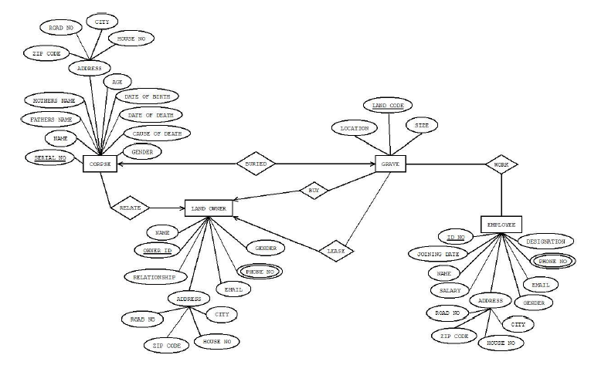

A corpse has unique serial number . Corpse data such as corpse name, father name, mother name , age, date of birth, date of death ,gender and also Address. Again address has some data like zip code ,road no, city and house no. Many corpse has relation between land owner. Again land owner has unique owner id. Owner has some data like name, gender ,email ,relationship status and multiple phone number and address with many information like zip code ,road no, city and house no. A Corpse buried a grave. Grave has unique land code ,location and size. Land owner buy many grave . Besides land owner lease many grave . in graveyard , there are working many employee. They have some information like name, joining date , designation, salary , email ,gender and multiple phone number and address with many information like zip code ,road no, city and house no. They have also unique id no.