|  |  |  |
| --- | --- | --- |
| **Name** | **ID** | **STUDENT SIGN** |
| **RIMON NATH** | **18-38929-3** | **Rimon Nath** |

**Advance Database Management System Prerequisites IV**

1. Normalize the ER Diagram given below up to 3rd Normal Form and finalize the tables that needs to be created. Then (in Oracle using SQL) write down the queries that are required to create all the tables with necessary constraints. Also insert at least 3 rows of data in each created table.

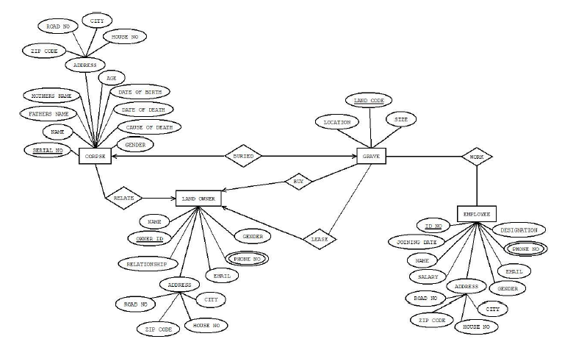

Answer Box (Normalization steps in detail as shown in Normalization Tutorial Slide + all the queries required to create the tables and insert data after Normalization):

**Buy:**

UNF:

Buy (Owner ID, O_Name, Relationship, Gender, Phone No, Email, ZIP Code, Road No, City, House No, Land Code, Location, Size)

1NF:

Phone No is a Multivalued Attribute.

1. Owner ID, O_Name, Relationship, Gender, Phone No, Email, ZIP Code, Road No, City, House No, Land Code, Location, Size

2NF:

1. Owner ID, O_Name, Relationship, Gender, Phone No, Email, ZIP Code, Road No, City, House No
2. Land Code, Location, Size

3NF:

1. Owner ID, O_Name, Relationship, Gender, Phone No, Email
2. ZIP Code, Road No, City, House No
3. Land Code, Location, Size

Table Creation:

1. Owner ID, O_Name, Relationship, Gender, Phone No, Email, **Address ID**,
2. Address ID, ZIP Code, Road No, City, House No
3. Land Code, Location, Size, **Owner ID**

**Lease:**

UNF:

Lease (Owner ID, O_Name, Relationship, Gender, Phone No, Email, ZIP Code, Road No, City, House No, Land Code, Location, Size)

1NF:

Phone No is a Multivalued Attribute.

1. Owner ID, O_Name, Relationship, Gender, Phone No, Email, ZIP Code, Road No, City, House No, Land Code, Location, Size

2NF:

1. Owner ID, O_Name, Relationship, Gender, Phone No, Email, ZIP Code, Road No, City, House No
2. Land Code, Location, Size

3NF:

1. Owner ID, O_Name, Relationship, Gender, Phone No, Email
2. ZIP Code, Road No, City, House No
3. Land Code, Location, Size

Table Creation:

1. Owner ID, O_Name, Relationship, Gender, Phone No, Email, **Address ID**,
2. Address ID, ZIP Code, Road No, City, House No
3. Land Code, Location, Size, **Owner ID**

**Work:**

UNF:

Work (Land Code, Location, Size, ID No, E_Name, Salary, Designation, Phone No, Email, Gender, Joining Date, ZIP Code, Road No, City, House No)

1NF:

Phone No is a multivalued attribute.

1. Land Code, Location, Size, ID No, E_Name, Salary, Designation, Phone No, Email, Gender, Joining Date, ZIP Code, Road No, City, House No

2NF:

1. Land Code, Location, Size
2. ID No, E_Name, Salary, Designation, Phone No, Email, Gender, Joining Date, ZIP Code, Road No, City, House No

3NF:

1. Land Code, Location, Size
2. ID No, E_Name, Salary, Designation, Phone No, Email, Gender, Joining Date
3. ZIP Code, Road No, City, House No

Table Creation:

1. Land Code, Location, Size
2. ID No, E_Name, Salary, Designation, Phone No, Email, Gender, Joining Date, **Address ID**
3. Address ID, ZIP Code, Road No, City, House No
4. **Land Code**, **ID No**

**Buried:**

UNF:

Buried (Serial no, C_Name, Father’s Name, Mother’s Name, ZIP Code, Road No, City, House No, Land Code, Location, Size)

1NF:

No Multivalued Attributes. Relation already in 1NF.

1. Serial no, C_Name, Father’s Name, Mother’s Name, ZIP Code, Road No, City, House No, Land Code, Location, Size

2NF:

1. Serial no, C_Name, Father’s Name, Mother’s Name, ZIP Code, Road No, City, House No
2. Land Code, Location, Size

3NF:

1. Serial no, C_Name, Father’s Name, Mother’s Name,
2. ZIP Code, Road No, City, House No
3. Land Code, Location, Size

Table Creation:

1. Serial no, C_Name, Father’s Name, Mother’s Name, **Address ID**
2. Address ID, ZIP Code, Road No, City, House No
3. Land Code, Location, Size, **Serial No**

**Relate:**

UNF:

Relate (Serial no, C_Name, Father’s Name, Mother’s Name, ZIP Code, Road No, City, House No, Owner ID, O_Name, Relationship, Gender, Phone No, Email, ZIP Code, Road No, City, House No)

1NF:

Phone No is a Multivalued Attribute.

1. Serial no, C_Name, Father’s Name, Mother’s Name, ZIP Code, Road No, City, House No, Owner ID, O_Name, Relationship, Gender, Phone No, Email, ZIP Code, Road No, City, House No

2NF:

1. Serial no, C_Name, Father’s Name, Mother’s Name, ZIP Code, Road No, City, House No
2. Owner ID, O_Name, Relationship, Gender, Phone No, Email, ZIP Code, Road No, City, House No

3NF:

1. Serial no, C_Name, Father’s Name, Mother’s Name
2. Owner ID, O_Name, Relationship, Gender, Phone No, Email
3. ZIP Code, Road No, City, House No

Table Creation:

1. Serial no, C_Name, Father’s Name, Mother’s Name, **Address ID**, **Owner ID**
2. Owner ID, O_Name, Relationship, Gender, Phone No, Email, **Address ID**
3. Address ID, ZIP Code, Road No, City, House No

**Temporary Tables:**

1. ~~Serial no, C_Name, Father’s Name, Mother’s Name,~~ **~~Address ID~~**
2. Address ID, ZIP Code, Road No, City, House No
3. Land Code, Location, Size, **Serial No**
4. Serial no, C_Name, Father’s Name, Mother’s Name, **Address ID**, **Owner ID**
5. Owner ID, O_Name, Relationship, Gender, Phone No, Email, **Address ID**
6. ~~Address ID, ZIP Code, Road No, City, House No~~
7. ~~Owner ID, O_Name, Relationship, Gender, Phone No, Email,~~ **~~Address ID~~**~~,~~
8. ~~Address ID, ZIP Code, Road No, City, House No~~
9. ~~Land Code, Location, Size,~~ **~~Owner ID~~**
10. ~~Owner ID, O_Name, Relationship, Gender, Phone No, Email,~~ **~~Address ID~~**~~,~~
11. ~~Address ID, ZIP Code, Road No, City, House No~~
12. Land Code, Location, Size, **Owner ID**
13. ~~Land Code, Location, Size~~
14. ID No, E_Name, Salary, Designation, Phone No, Email, Gender, Joining Date, **Address ID**
15. ~~Address ID, ZIP Code, Road No, City, House No~~
16. **Land Code**, **ID No**

**Final Table:**

1. Address ID, ZIP Code, Road No, City, House No
2. Land Code, Location, Size, **Serial No**, **Owner ID**
3. Serial no, C_Name, Father’s Name, Mother’s Name, **Address ID**, **Owner ID**
4. Owner ID, O_Name, Relationship, Gender, Email, **Address ID,phone no**
5. ID No, E_Name, Salary, Designation, Email, Gender, Joining Date, **Address ID,phone no**
6. **Land Code**, **ID No**

**Queries:**

Table Creation Queries:

1. CREATE TABLE address(addressid NUMBER(5) CONSTRAINT PK_ADDRESS PRIMARY KEY,zip NUMBER(4),roadno NUMBER(2),city VARCHAR2(15),houseno NUMBER(4));
2. CREATE TABLE owners(ownerid NUMBER(5) CONSTRAINT PK_OWNER PRIMARY KEY,O_Name VARCHAR2(50),relationship VARCHAR2(15), gender VARCHAR2(6), email VARCHAR2(30), addressid NUMBER(5) CONSTRAINT FK_ADDRESSID REFERENCES ADDRESS);
3. CREATE TABLE employee(id NUMBER(5) CONSTRAINT PK_EMPLOYEE PRIMARY KEY,E_Name VARCHAR2(50),salary NUMBER(7), designation VARCHAR2(15), email VARCHAR2(30), gender VARCHAR2(6), joining_date DATE, addressid NUMBER(5) CONSTRAINT FK_ADDRESSID2 REFERENCES ADDRESS);
4. CREATE TABLE corpse(serialno NUMBER(5) CONSTRAINT PK_CORPSE PRIMARY KEY,C_Name VARCHAR2(50),Father_Name VARCHAR2(50),Mother_Name VARCHAR2(50), addressid NUMBER(5) CONSTRAINT FK_ADDRESSID3 REFERENCES ADDRESS,ownerid NUMBER(5) CONSTRAINT FK_OWNER REFERENCES OWNERS);
5. CREATE TABLE land(landcode NUMBER(5) CONSTRAINT PK_LAND PRIMARY KEY,location VARCHAR2(20),sizeGrave NUMBER(10,2), serialno NUMBER(5) CONSTRAINT FK_CORPSE REFERENCES CORPSE,ownerid NUMBER(5) CONSTRAINT FK_OWNER2 REFERENCES OWNERS);
6. CREATE TABLE land_employee(landcode number(5),id number(5),primary key(landcode,id),foreign key(landcode) references land(landcode),foreign key(id) references employee(id));