|  |  |  |
| --- | --- | --- |
| **Name** | **ID** | **STUDENT SIGN** |
|  |  |  |

**Advance Database Management System Prerequisites IV**

1. Normalize the ER Diagram given below up to 3rd Normal Form and finalize the tables that needs to be created. Then (in Oracle using SQL) write down the queries that are required to create all the tables with necessary constraints. Also insert at least 3 rows of data in each created table.

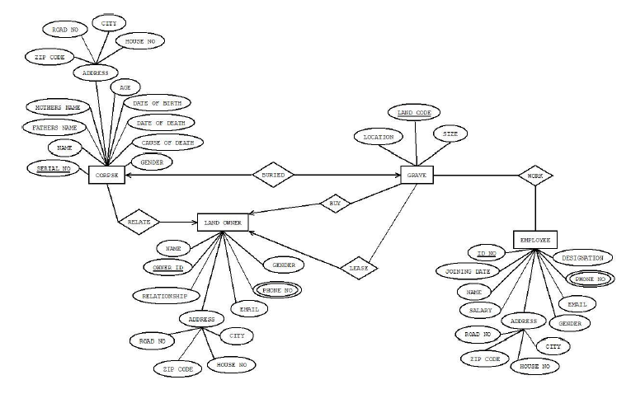

Answer Box (Normalization steps in detail as shown in Normalization Tutorial Slide + all the queries required to create the tables and insert data after Normalization):