**Data Warehousing and Data Mining**

**Project**

Task 1:

* Choose any data set (Supervised Learning).
* Apply any two classifiers(Naïve bayes,KNN,j48) from Weka on the selected data set.
* Find the Best classifier.

Task 2:

* Make one test data set from the selected supervised learning data set.
* Using the test data set test the model for one classifier.
* Show the result.

Task 3:

* Choose any data set (Unsupervised Learning).
* Apply only K means clustering Algorithm.

You need to submit a Report. The report will include the following things:

1. Introduction
2. Result
3. Discussion

**Instructions**

1. Submission Date**: April 21 ,2022**.
2. **DO NOT COPY**, **if found then you (who helped you to copy the class task) all of you will get UW.**

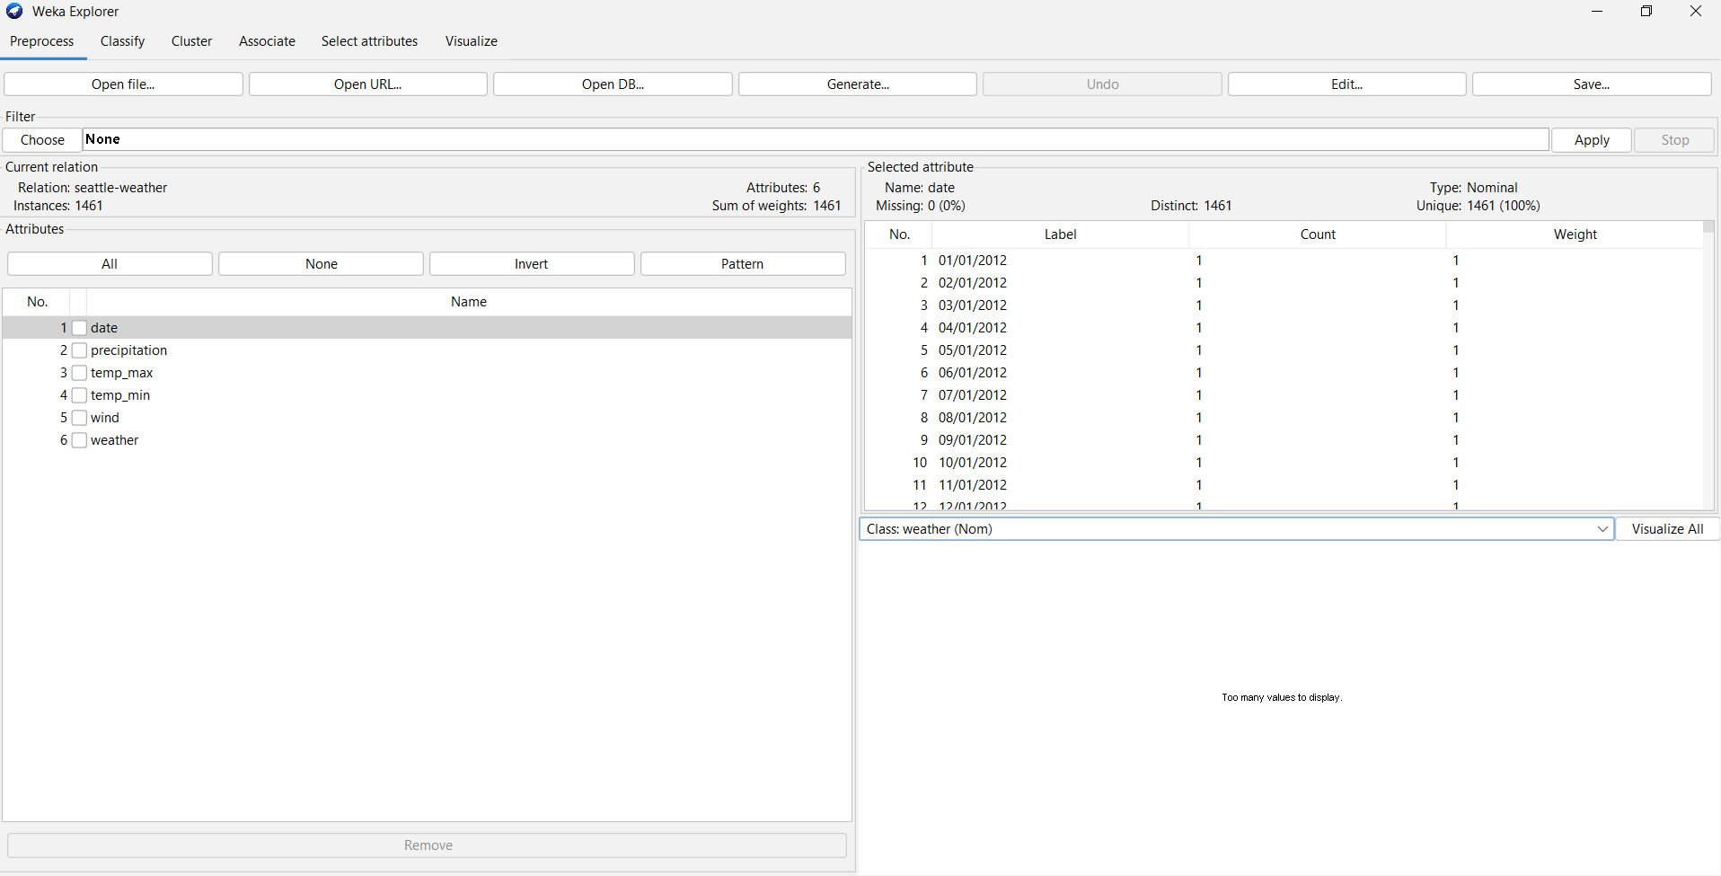

Selected Data set

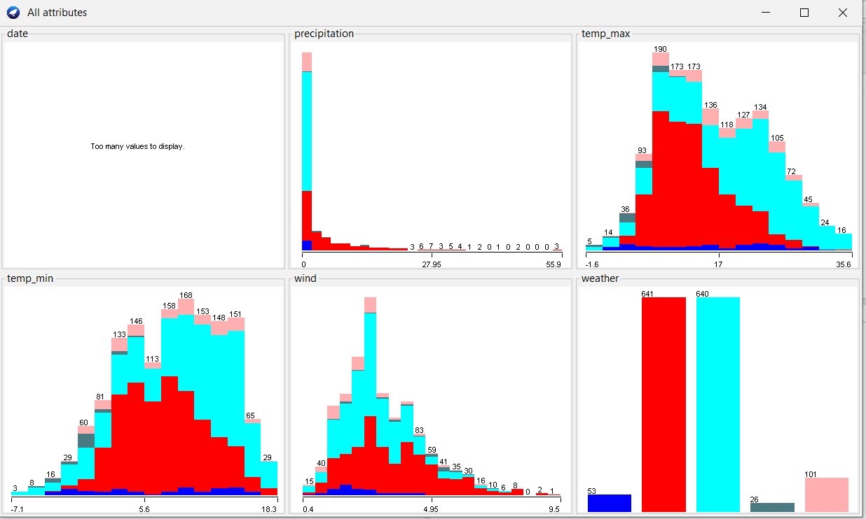

Details all attribute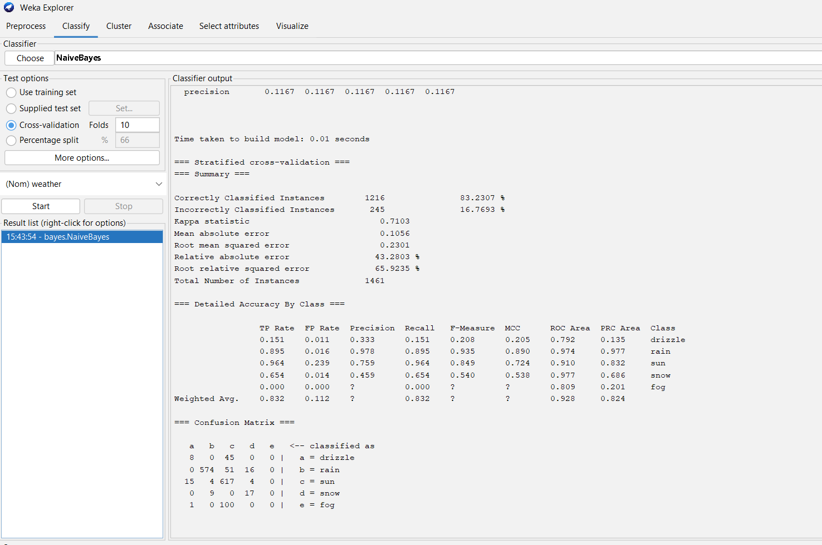

Naïve Bayes Classification

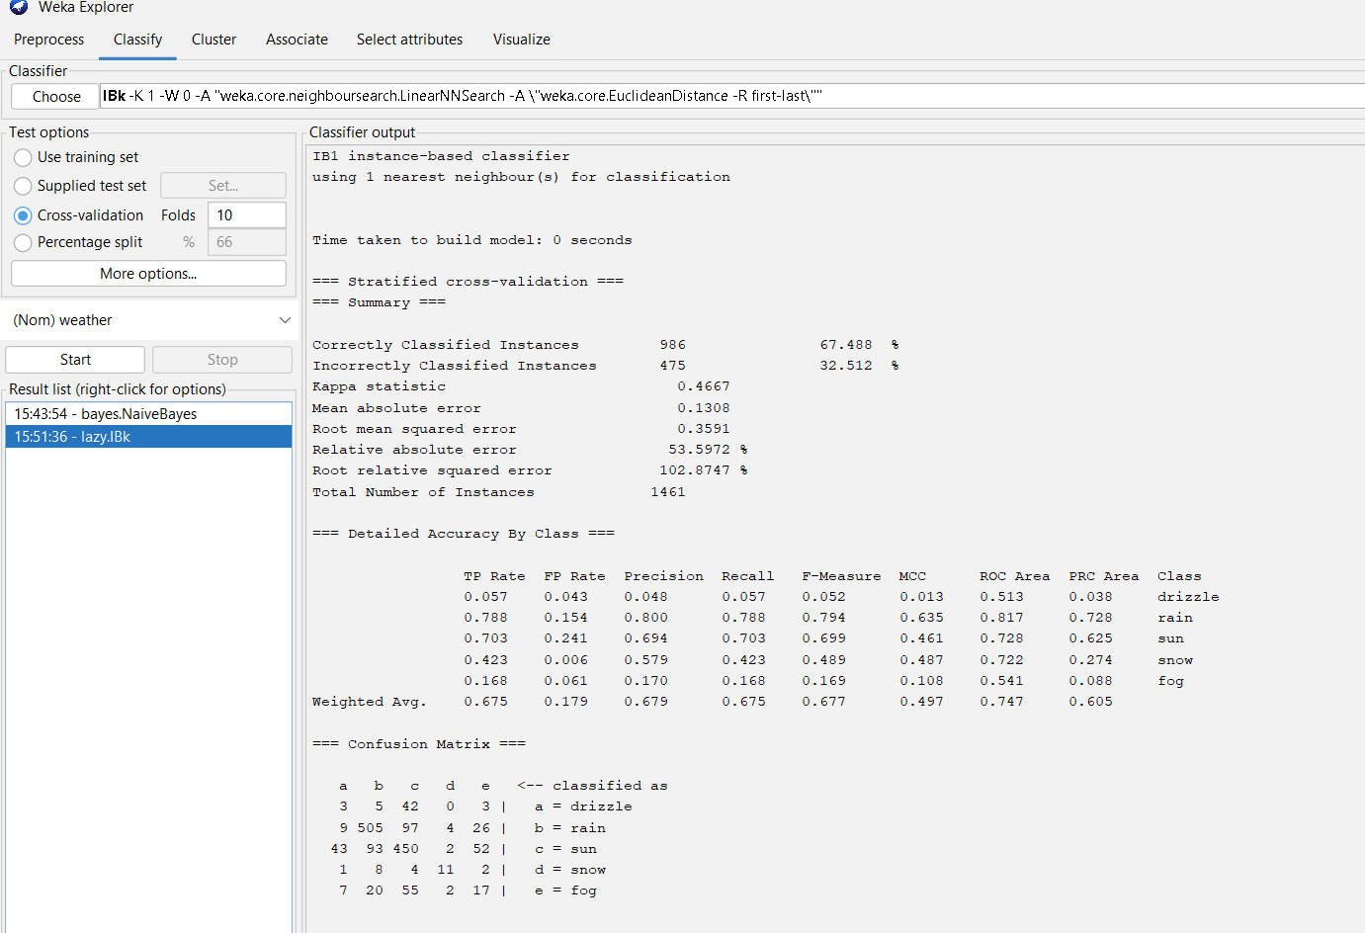

KNN Classification

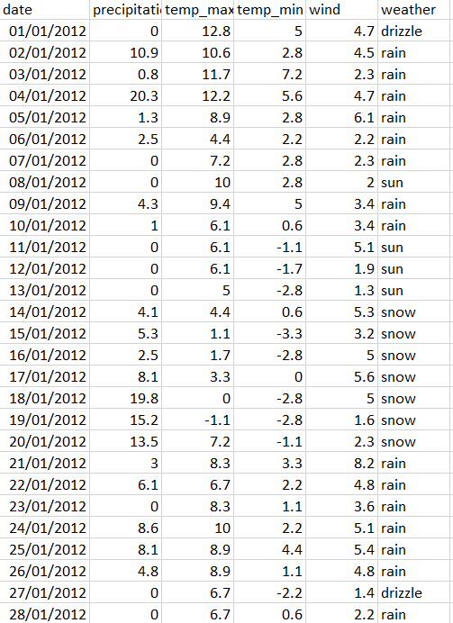

Preparing Test Data

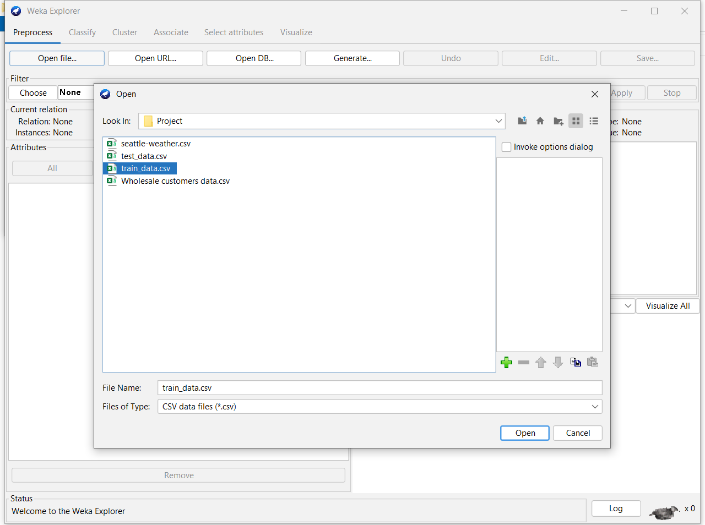

Train Data Select

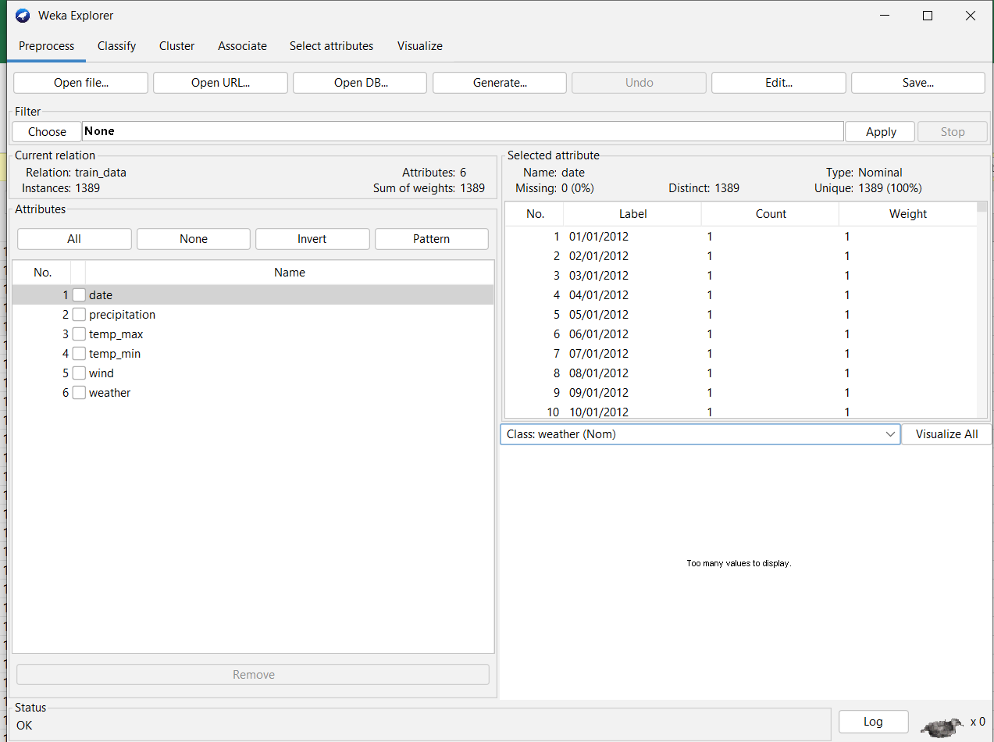

Training dataset

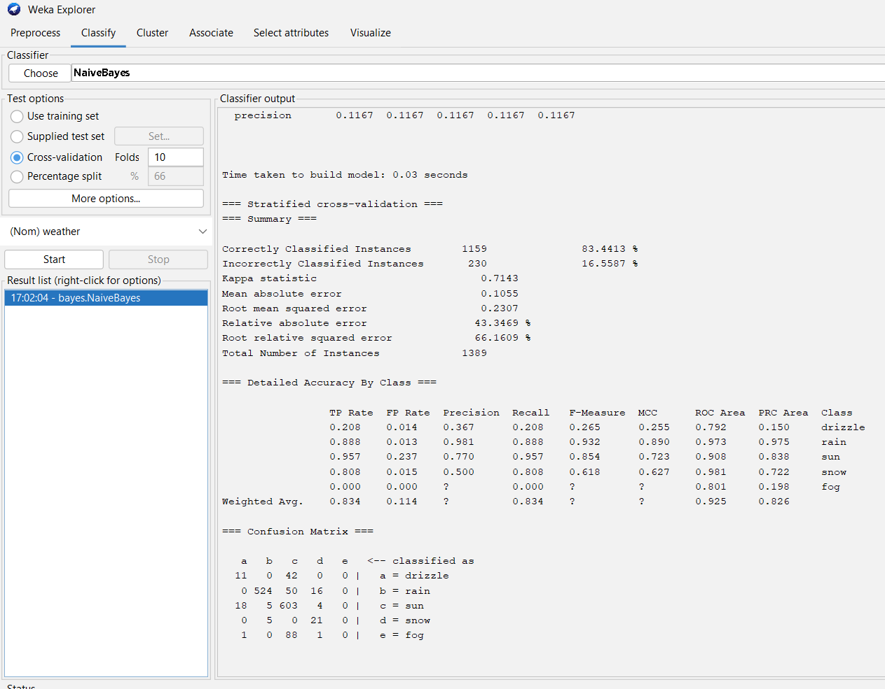

Result of training set

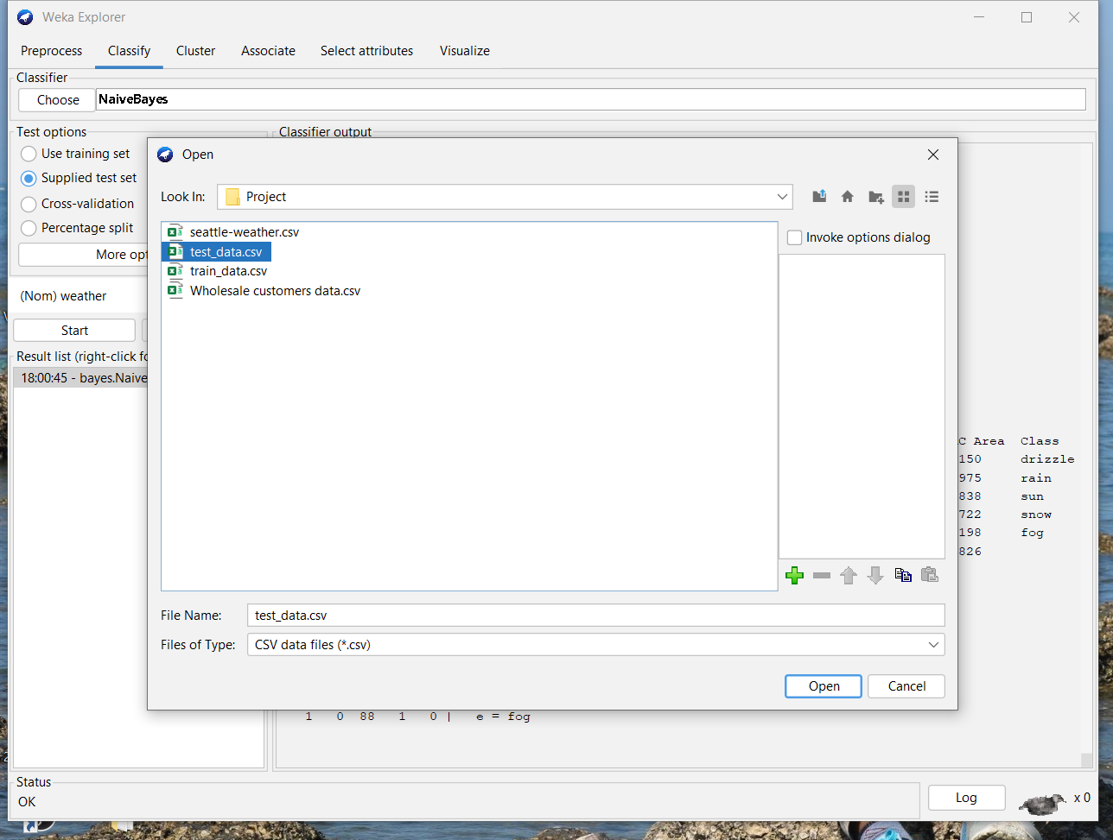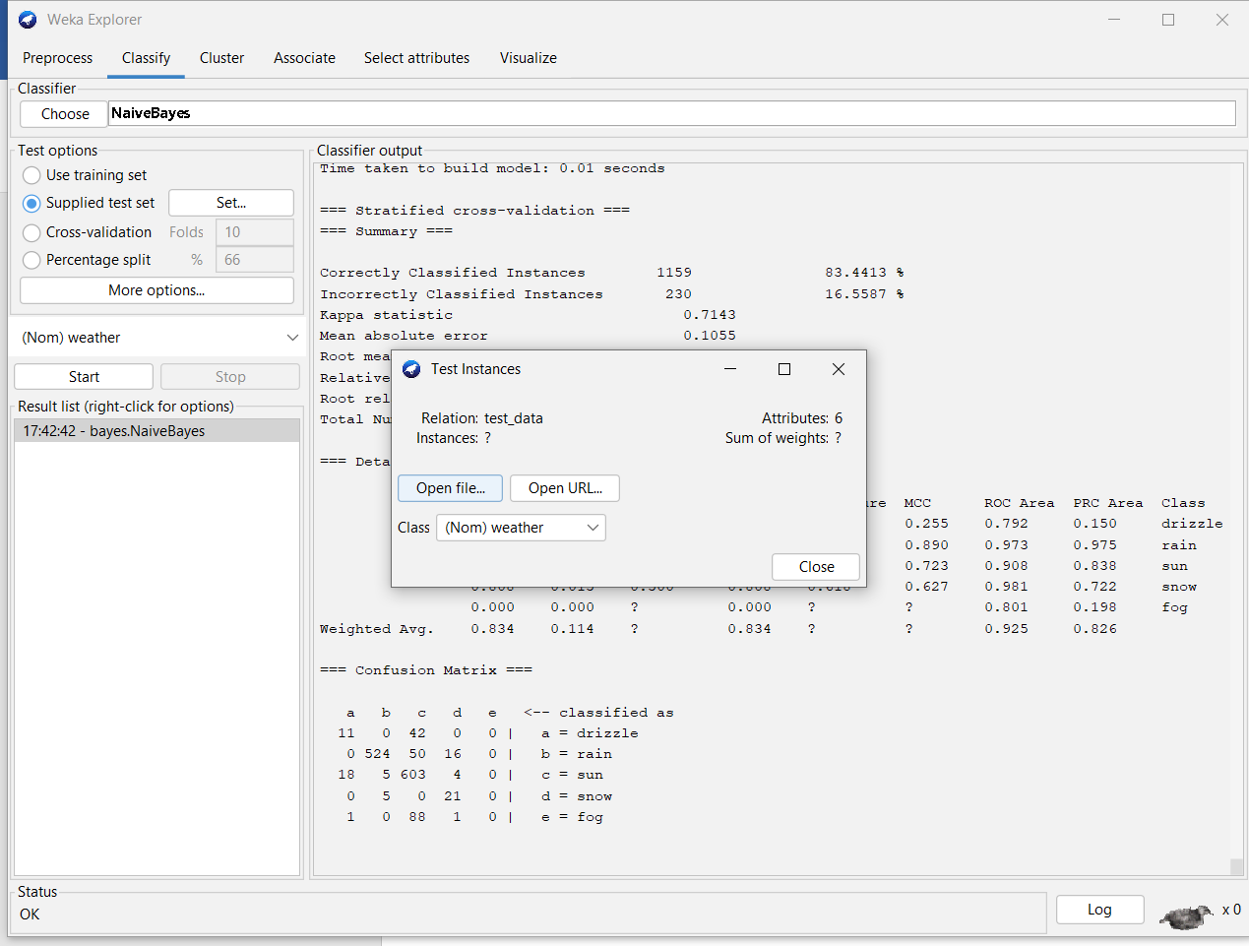

Supply test set

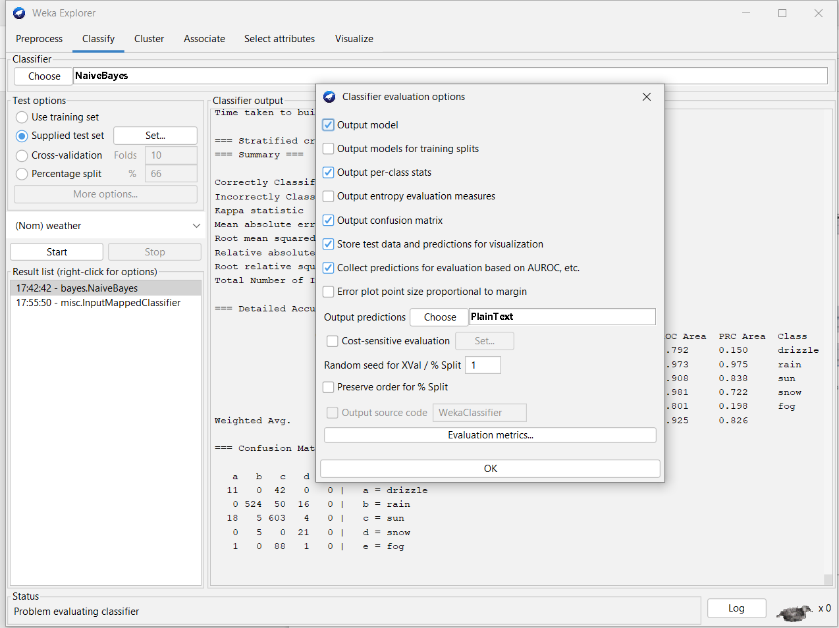

Plan Text

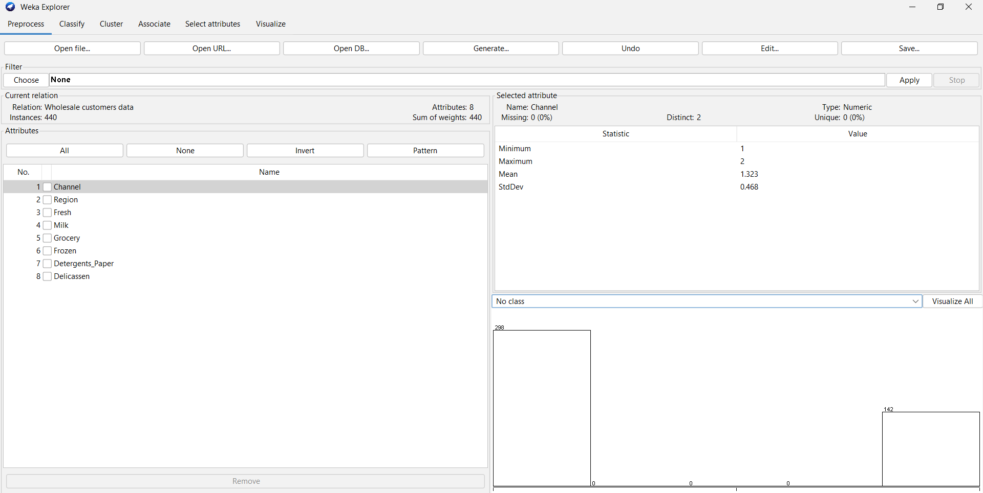

Un data

