**Abstract:** The weather has a significant impact on human health and happiness. The weather has been connected to variations in birth rates and sperm counts, as well as epidemics of pneumonia, influenza, bronchitis, and other morbidity impacts linked to pollen concentrations and high levels of pollution. Traditional weather forecasting technologies are becoming less effective and time-consuming as the climate changes rapidly these days. Also, weather depends on so many factors like temperature, entropy system, pollution in water and air, the ecosystem of animals and marine coastal, and natural disasters. To address these issues, better and more reliable weather forecasting methods are required. These forecasts have an impact on the economy and lives of people in a country. Developing a weather prediction system considering various factors mentioned above that can be used in remote areas is the main motivation of this work. This model will predict advanced updates of weather considering different fields and factors by using different machine learning methods.

**Introduction:** Natural catastrophes that occur regularly have impacted negatively our planet, putting people's lives in danger. A natural catastrophe is a sudden occurrence, such as an accident or natural calamity, that results in significant damage or several deaths. Over the last several years, a large number of catastrophic calamities have occurred all over the world. Many fatalities, disability, and shelter damage were reported, as well as tragedies of villages being ripped apart. Rainfall patterns have shifted in many regions, leading to greater floods, or heavy rain, as well as more frequent and severe heat waves. Oceans and glaciers have also changed oceans are warming and getting more acidic, ice caps are melting, and sea levels are rising. As The climate is changing at a drastic rate nowadays, which makes the old weather prediction methods less effective and more hectic due to different indicators factor. And as predictions affect a nation’s economy and the lives of people, improved and reliable weather prediction methods are required. Weather forecasting and prediction include gathering and communicating information about future weather conditions based on meteorological measurements. Climate predictions with a lead time of more than two weeks are referred to as long-range or extended-range forecasts.

Computer models are used by meteorologists to forecast the weather. And processing power has advanced significantly. The capacity to predict the weather over a few days is still restricted by three factors: the amount of data available, the time available to study it, and the complexity of weather occurrences. Other than that, the nature and reliability of communication systems available for forecast dissemination and the makeup and requirements of the user community also create problems in predicting the weather perfectly. And the models are a bit expensive too.

A complicated memory module such as the Gated Recurrent Unit (GRU) or Long Short-Term Memory is not required. In LSTM, training takes longer, requires more memory, and is simple to overfit. While GRU models still have issues with slowdown convergence and low learning efficiency, resulting in excessive training time and even under-fitting.

The main goal of this project is to create a low-cost, dependable, and effective weather forecasting program in Python utilizing the machine learning concepts of KNN and RNN. KNN was used for weather prediction and finding its accuracy. An RNN is used for the prediction of an individual parameter. By this, we also can predict long-term Forecasting trends of weather and its different parameter that can be used in remote areas as well.

**Literature Review**:

Here we used a couple of algorithms to predict the weather and discuss the mechanism of these algorithms.

The KNN algorithm is a simple supervised machine learning technique that may be used to handle classification and regression problems. It's simple to set up and comprehend, but it has the disadvantage of becoming noticeably slower as the amount of data in use grows. The key benefit of KNN over other algorithms is that it can be used to classify several classes.

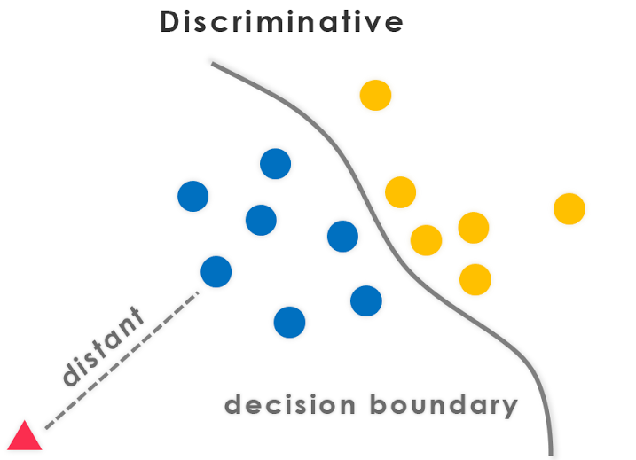

The figure of Discriminative Technique with KNN

KNN is a good method to use if the data has more than two labels or if you need to classify the data into more than two categories. Because it represents the conditional probability of a sample belonging to a specific class, KNN is a discriminative algorithm. Consider how one comes to the KNNs decision rule to see what I mean. Discriminative Classifiers figure out which features in the input are the most beneficial for distinguishing between the various classes. The K Nearest Neighbor (KNN) algorithm is a basic deterministic locating algorithm that is commonly used in fingerprinting. The performance of the KNN can be greatly enhanced by using the right selection algorithm.

RNNs are one kind of neural network that can be used to data model sequence. RNNs, which are derived from feedforward networks, behave in the same way as human brains do. Simply said, recurrent neural networks can anticipate sequential data in a way that other algorithms cannot. RNNs are a sort of neural network that is both powerful and robust, and they are one of the most promising algorithms now in use because they are the only ones with internal memory. "Whenever a sequence of data exists, the temporal dynamics that link the data are more important than the spatial content of each individual frame." Lex Fridman is a writer who specializes in science fiction and fantasy fiction (MIT).

The information in a feed-forward neural network flows in just one direction: from the input layer to the output layer, passing through the hidden layers. The data travels across the network in a straight line, never passing through the same node twice.

Feed-forward neural networks have no recollection of the data they receive and are poor predictors of what will happen next. A feed-forward network has no sense of order in time because it just considers the current input. Except for its training, it has no recollection of anything that transpired in the past.

An RNN's information is looped back on itself. It evaluates the current input as well as what it's learned from prior inputs before making a decision.

**TYPES OF RNNS**

* One to One
* One to Many
* Many to One
* Many to Many

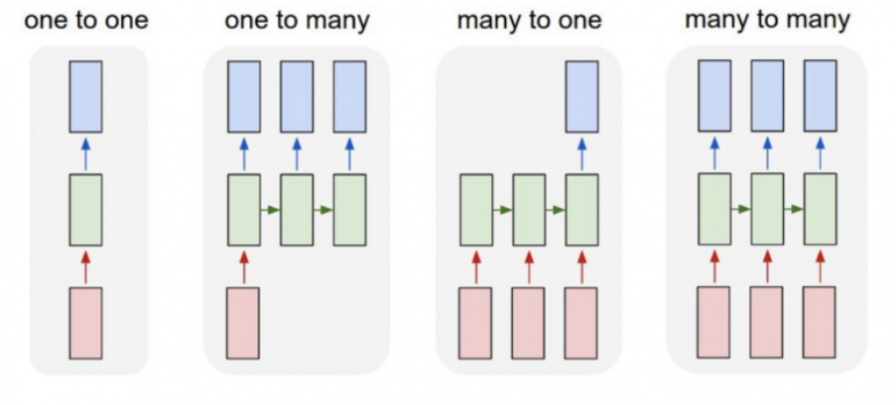

Ref:

1. [Onel Harrison](https://onelharrison.medium.com/?source=post_page-----6a6e71d01761--------------------------------),’ Machine Learning Basics with the K-Nearest Neighbors Algorithm’, Sep 11, 2018,[online].Available: [Machine Learning Basics with the K-Nearest Neighbors Algorithm | by Onel Harrison | Towards Data Science](https://towardsdatascience.com/machine-learning-basics-with-the-k-nearest-neighbors-algorithm-6a6e71d01761#:~:text=Summary,that%20data%20in%20use%20grows.)

2. [Akanksha Malhotra](https://medium.com/@akankshamalhotra24?source=post_page-----1045f499d8cc--------------------------------),’ Generative Classifiers V/S Discriminative Classifiers’, Oct 1, 2019,[online].Available: [Generative Classifiers V/S Discriminative Classifiers | by Akanksha Malhotra | Medium](https://medium.com/@akankshamalhotra24/generative-classifiers-v-s-discriminative-classifiers-1045f499d8cc)

3. Niklas Donges,’ A Guide to RNN: Understanding Recurrent Neural Networks and LSTM Networks’, July 29, 2021

Updated: August 17, 2021,[online].Available: [Recurrent Neural Networks (RNN): What It Is & How It Works | Built In](https://builtin.com/data-science/recurrent-neural-networks-and-lstm)

# Piu: [Ed Burns](https://www.techtarget.com/contributor/Ed-Burns),’ machine learning’,[online].Available: [What Is Machine Learning and Why Is It Important? (techtarget.com)](https://www.techtarget.com/searchenterpriseai/definition/machine-learning-ML)

1. [what is knn classifier in machine learning - Google Search](https://www.google.com/search?q=what+is+knn+classifier+in+machine+learning&oq=what+is+knn&aqs=edge.3.69i57j0i512l7j69i64.8141j0j1&sourceid=chrome&ie=UTF-8)
2. [What is a discriminative classifier? - Google Search](https://www.google.com/search?sxsrf=ALiCzsbaP4Um1SiOS-C29zAyqYnF8fHXsw:1651225608831&q=What+is+a+discriminative+classifier?&tbm=isch&source=iu&ictx=1&vet=1&fir=FPqZeL0DJeAUYM%252CSp8ULoZ5IMj5AM%252C_&usg=AI4_-kQbVaLed-s1c00Ji7JDn8AhPA-xgA&sa=X&ved=2ahUKEwjwhefe_rj3AhVOyjgGHTVnB7IQ9QF6BAgLEAE&biw=1536&bih=754&dpr=1.25#imgrc=aAycdW-pLhS0xM&imgdii=M90N_If0SzDz5M)
3. [Recurrent Neural Networks (RNN): What It Is & How It Works | Built In](https://builtin.com/data-science/recurrent-neural-networks-and-lstm)