README & Manual

Contents

[How to get the program working 2](#_Toc4160131)

[Doctor 3](#_Toc4160132)

[\*In order for a doctor to check patient medical records: 3](#_Toc4160133)

[In order for a doctor to update patient medical records: 3](#_Toc4160134)

[\*In order for a doctor to request access to a patient’s medical records (via patient’s family doctor): 3](#_Toc4160135)

[\*In order for a doctor to grant/deny medical record access to a requesting doctor: 3](#_Toc4160136)

[In order for a doctor to schedule patient-requested appointments: 3](#_Toc4160137)

[\*In order for a doctor to grant/deny patient-requested prescription refill permits: 3](#_Toc4160138)

[\*In order for a doctor to write new prescriptions: 3](#_Toc4160139)

[Patient 4](#_Toc4160140)

[In order for a patient to request an appointment with a specific doctor: 4](#_Toc4160141)

[\*In order for a patient to check their own medical records: 4](#_Toc4160142)

[\*In order for a patient to grant/deny medical record access to a requesting doctor: 4](#_Toc4160143)

[\*In order for a patient to request a phone call with a specific doctor: 4](#_Toc4160144)

[\*In order for a patient to request a refill permit for an expired/previous prescription: 4](#_Toc4160145)

[Pharmacy 5](#_Toc4160146)

[Links 6](#_Toc4160147)

[Chat logs (IM/SMS only) 7](#_Toc4160148)

# How to get the program working

1. Download Zip file & unzip
2. Double click on “DocPatSystem.csproj” in the DocPatSystem-master folder.
3. Click Run on Visual Studio.

No other steps are necessary because I assumed Chris did not do his pharmacy project. So I felt like there was no reason not to add my pharmacy project for you.

Once the project is running you will see the login page. From here you go to the other parts of the program. (It is currently not working as intended, as it uses if-statements to login and not database user/pass) So just enter the following depending on what user you want to be.

Username

* Doctor Login = (blank)
* Patient Login = “Pat”
* Pharmacy Login = “Pharm”

From here I will show you how to do things in my program *(if that part not working I will put a \* by it).*

# Doctor

Login to Doctor user by having nothing in the username text box and click the login button.

## \*In order for a doctor to check patient medical records:

1. Click on the “Patient Medical Records” tab
2. Click on the “View/Edit” button.
3. This should display the selected patients medical record, but I could not figure out how to the ID from the dataGridView.

## In order for a doctor to update patient medical records:

1. Click on the “Patient Medical Records” tab
2. Click on the “Add New patient” button
3. A new window will popup, once you enter the records click on the “Save New Patient Record” button.

(WARNING: THERE IS ONLY 2 PEOPLE IN THE DATABASE AS PATIENT, SO NO NEW RECORDS CAN BE MADE UNLESS THE OLD RECORDS ARE DELETED, OR ADD NEW PATIENTS)

## \*In order for a doctor to request access to a patient’s medical records (via patient’s family doctor):

1. Click on the “Patient Medical Records” tab
2. Click on the patient you would like to have access to.
3. Click on the “Request Access” button.

## \*In order for a doctor to grant/deny medical record access to a requesting doctor:

1. Click on the “Patient Medical Records” tab
2. Click on the “View/Edit” button.
3. Click on the “Access” button

## In order for a doctor to schedule patient-requested appointments:

1. Click on the “Appointments” tab
2. Click on the “Make New Appointment” button
3. Fill out form
4. Click on the “Make An Appointment” button to make the auto-confirmed appointment.

## \*In order for a doctor to grant/deny patient-requested prescription refill permits:

1. Click on the “Refill Request” tab
2. Click the prescription
3. Click the button “Acept”/”Deny”

## \*In order for a doctor to write new prescriptions:

1. Click on the “New Prescription” tab
2. Enter info needed.
3. Click “Add To Prescription ----> ” button
4. Repeat steps 2 & 3 if needed.
5. Once done, click on the “Send Request” button/

# Patient

Login to Patient user by having Pat in the username text box and click the login button.

## In order for a patient to request an appointment with a specific doctor:

1. Click on the “Make An Appointment” tab
2. Fill it out and click on the “Request An Appointment” button.

## \*In order for a patient to check their own medical records:

1. Click on the “My Medical Records” tab

## \*In order for a patient to grant/deny medical record access to a requesting doctor:

1. Click on the “My Medical Records” tab
2. Click on the “Access” button
3. Click on the “Grant”/”Deny” button

## \*In order for a patient to request a phone call with a specific doctor:

1. Click on the “Call A Doctor” tab

## \*In order for a patient to request a refill permit for an expired/previous prescription:

1. Click on the “Refill Medication” tab
2. Click on the medicine you want refilled
3. Click on the “Request Refill” button.

# Pharmacy

# Links

<https://github.com/NATHANiELxM/DocPatSystem> - Where the project is on github.  
  
<https://drive.google.com/drive/folders/1X_8A2hTilGE6is6EumqCCrZLp1zQ88Zf> - Google Drive, where we started work on the project and where most supporting documents can be found.

# Chat logs (IM/SMS only)

**Cheech \***

Had duplicates for you when I created this group Ryan, so just chose both just in case. I’ll add Nathan once he sends info

**DEC 12, 7:49 PM**

Avatar

**Ryan Smith**

Ok. I figure we would get to the room about 10 ish and just hammer it out for however long it takes.

**DEC 12, 10:04 PM**

Avatar

**Cheech \***

Works with me, hopefully Nathan will email me back tomorrow

**DEC 13, 11:45 AM**

Avatar

**Ryan Smith**

I'll be to the room soon. My alarm never went off

Cheech \* changed their avatar

**DEC 13, 11:51 PM**

Avatar

**Cheech \***

Added you in here Nathan

Avatar

**Nathan Murphy**

Yes, it is neat, it sends a text to my phone too. How did you two do in the final? I got an 85 myself.

Avatar

**Ryan Smith**

I did ok.  
When are we meeting tomorrow for the project

**DEC 14, 12:09 AM**

Avatar

**Nathan Murphy**

I won't be able to, I still have some work to do including some assignments in this class. But after tomorrow I will be free.   
What are we doing first?   
do you need a list of what interacts with the database?   
I have not looked in the drive since the powerpoint, is it up to date?   
Off the top of my head, I know we still need to add more to the gui.   
after we get the gui and the system working there is a few more diagrams to do and a manual

**DEC 14, 12:18 AM**

Avatar

**Ryan Smith**

If anyone can show up tomorrow just try to, I'm leaving tomorrow so I would like to meet to at least talk about what were doing.

And maybe get a bit of work done

**DEC 14, 12:34 AM**

Avatar

**Nathan Murphy**

When will you be back?  
If you two meet up and want me to work on a certain part let me know and I can work on it this weekend.   
If you don't decide on anything I was thinking I would work on the gui and start on a little of the user manual, the instructor acted like the gui better be really good since we have more time for it. I was going for more of an app on a phone look while every other teams tried to use the entire screen so I guess it is all going to be overhauled sadly. and the other teams used some other box than a data-list box, or whatever we are using which made all of the data lined up and pretty.

Avatar

**Ryan Smith**

I won't be back until next semester.

**DEC 14, 12:41 AM**

Avatar

**Cheech \***

I’m going to my roommates graduation in the morning so I’ll try and meet after that. I will check the doors around 8am whenever I drop him off to see if Wallace is unlocked. I thought we were meeting thursdays and fridays over the break?

Avatar

**Ryan Smith**

I meant yesterday and today. I'm going back to my town to work for the break. I can't come up here every Thursday and Friday.

**DEC 14, 1:07 AM**

Avatar

**Ryan Smith**

Look. If someone can meet me at Wallace so we can at least figure something out, that would be great

**DEC 14, 2:33 AM**

Avatar

**Cheech \***

Look. Getting aggravated isn’t going to get anything finished, any quicker. Try to be clearer with how you word things before you send your messages. Both Nathan and I completely misunderstood what you meant, and were under the impression you were preposing to meet every Thursday and friday over the break (starting next week, because of other finals projects assignments labs work etc.).   
  
We all want to get the project finished as quick as the next guy, but it’s the last week of school and people do have other stuff going on. Cheng said we have all winter break to complete the assignment. That’s a month and a half. I’m sure me and Nathan can figure out a solid schedule for meeting up and relaying the message to you, via whatever form of communication becomes easiest (which I’m assuming will probably be this). Again, I will swing by Wallace and make sure the labs are available around 8am, and I will fill you in from there.

Avatar

**Ryan Smith**

I wasn't getting aggravated. I was just saying at the very least I would like to be able to talk to someone face to face about where we go from here.

**DEC 14, 10:09 AM**

Avatar

**Cheech \***

No doubt, and both Nathan and I have explained our situations and we are in the same boat that you are in. I Checked the labs a little bit ago and they are open but have weird hours because it’s friday and the last day. I’m at graduation now but will let you know when I’m done and we can try to meet up!

**DEC 16, 5:56 PM**

Avatar

**Nathan Murphy**

What days are you two free this week? Idk If you was still wanting to do Thursdays and Fridays, but we could meet up sooner if you want.

Avatar

**Ryan Smith**

I won't be free at all to go back to EKU. we could make a github and share changes there.

Avatar

**Nathan Murphy**

Alright, would you make that and invite us?   
I know you can't come, but if you was free we could maybe group call or something so it would be like you was here

**DEC 26, 9:26 AM**

Avatar

**Ryan Smith**

I'm creating the Github for our project and will upload the files tonight. We need to jump into this thing before the next semester comes close. I'll work on connecting to the database

**JAN 4, 7:31 AM**

Avatar

**Ryan Smith**

Are you guys still there?

**JAN 4, 4:33 PM**

Avatar

**Nathan Murphy**

Yeah, sorry I have not been doing much untill recently. But it is coming along now, i can upload it tonight/tomorrow morning. You wanted it on github right?

**JAN 4, 6:24 PM**

Avatar

**Ryan Smith**

Yeah. Github would be best

**JAN 5, 8:50 PM**

Avatar

**Nathan Murphy**

So I have no idea how to work GitHub but here it is. Check it out asap so you guys can give me feedback. <https://github.com/NATHANiELxM/DocPatSystem>

For now, you can login as "Dr" or "Pat" for Doctor or Patient system respectively to see it and get a feel for it

**JAN 5, 9:16 PM**

Avatar

**Cheech \***

Database is fully up and finished, all of our tables are the ones starting with crn

Which is just all of our initials, that way they are all grouped together

Going to go ahead and update the graphs as much as possible tonight and then whatever I don’t finish on the report tonight I will finish up tomorrow during the day

**JAN 7, 12:49 AM**

Avatar

**Cheech \***

Uploaded sample data to the database, I can create a github repo tomorrow for us if you want to send all the code to me

**JAN 7, 1:06 AM**

Avatar

**Nathan Murphy**

Whats a repo? Its all uploaded to github, if you want me to upload it on google drive i can

**JAN 8, 8:29 PM**

Avatar

**Ryan Smith**

Can you give me the github link so I can do my part to edit it

Avatar

**Cheech \***

A repo is just a repository, that’s what GitHub calls folders basically. What’s the name of the thing on github so I can also check out the code. Make sure you create a branch to work on the project, and then once you’re finished editing the code you can merge that branch back in with the main code once you know it’s all working properly. That way we aren’t all just editing the main branch and overwriting each other’s work.

Also, I know I mentioned it already, but all of our tables for the project begin with crn\_   
If you have any questions or recommendations about the way the data is set up and connected, feel free to ask!

**JAN 8, 8:59 PM**

Avatar

**Nathan Murphy**

<https://github.com/NATHANiELxM/DocPatSystem>   
  
it is also in the google drive, zipped up under the same name.

Avatar

**Cheech \***

What are each of you guys working on so I don’t work on the same thing?

**JAN 8, 9:17 PM**

Avatar

**Nathan Murphy**

I got stuck on a few things, and will need help getting it to code.   
Which are: functioning log-out button, functioning search for the doctor records, an active call screen (if you guys think it should be in there.) That is all I can remember off the top of my head.   
  
If that sounds easy to either one of you, let me know that you got it and I can work on the Manuel.  
  
and Ryan the files are as follows.   
login.cs --> docHome.cs or patHome.cs  
doc tabs: appointment, callReq, newScript. patientRecords refillReq  
patient tabs: makeAppPat, makeCall, myRecords, refillmeds

and I have comments one pretty much every page, Please read them.

**JAN 8, 11:35 PM**

Avatar

**Ryan Smith**

Sounds good. I'll mainly be working on creating the connecting to the database

**JAN 9, 12:15 PM**

Avatar

**Cheech \***

Sounds good man, I’ll check out and work on the code today! I can try to fix the logout button problems as well as the searching records

**JAN 9, 4:56 PM**

Avatar

**Ryan Smith**

Any idea where I can find an older version of MySQL. visual studio won't work with version 8

**JAN 10, 1:17 PM**

Avatar

**Cheech \***

It’s Heidi sql that we are using, there are instructions for downloading and connecting to on blackboard.

MySQL is just a different type of dB management system, all of our tables are in the csc340\_db in Heidi sql, and then all of our tables are the ones beginning with crn\_

**JAN 10, 1:19 PM**

Avatar

**Cheech \***

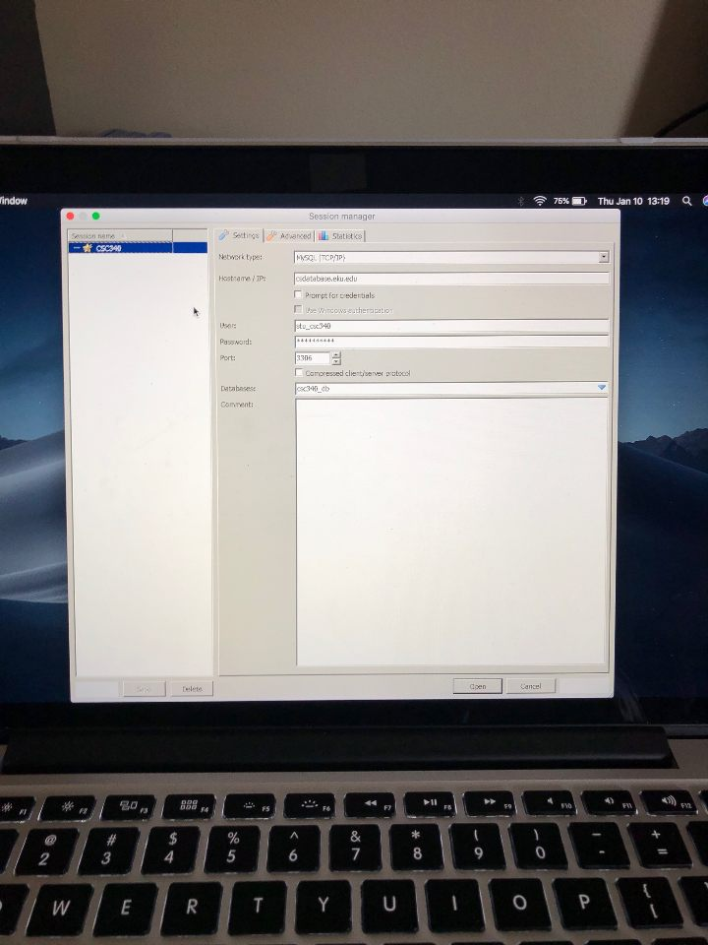

Avatar

**Ryan Smith**

Abd you can connect to that using visual studio?

Avatar

**Cheech \***

Yep, MySQL is just a different relational database manager, Heidi is a lot easier and the whole class used Heidi, all of their tables are still in the database as well so we can reference them if we have issues.

That picture is the info you need for connecting, let me check what the password is for it, once second

Avatar

**Ryan Smith**

And the code he gave us will allow us to grab and add info from the databases through Heidi sql

?

Avatar

**Cheech \***

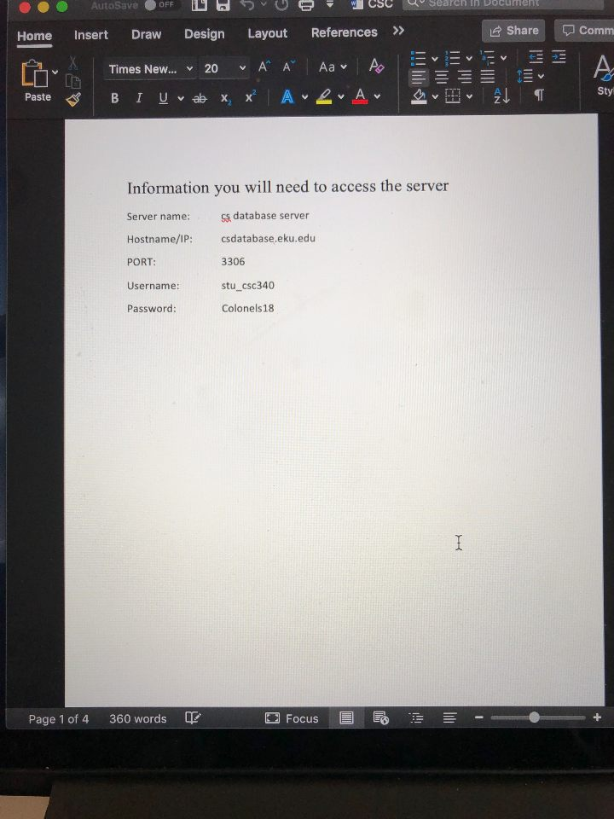

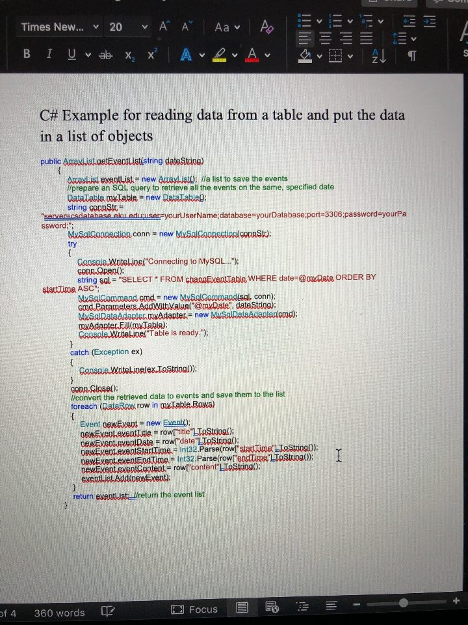

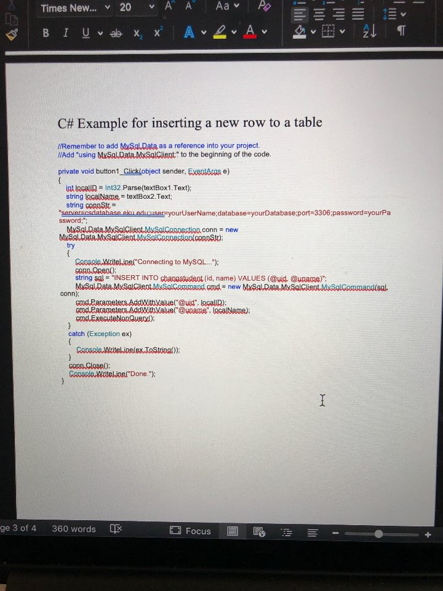

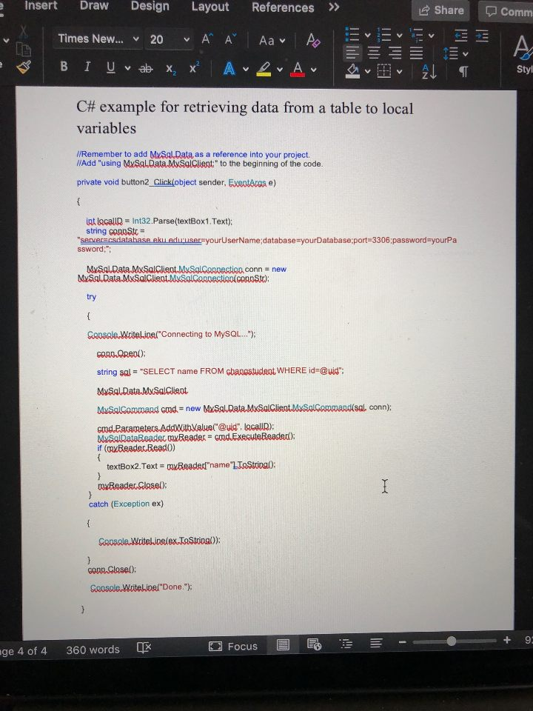

Avatar

**Ryan Smith**

I'll give it a try when I get home. Not sure why I've been having trouble with it.

I'll let you know then.

Avatar

**Cheech \***

Sounds good! I will take a look at the code now and check it out

These are all of our tables, the ones with stars by them

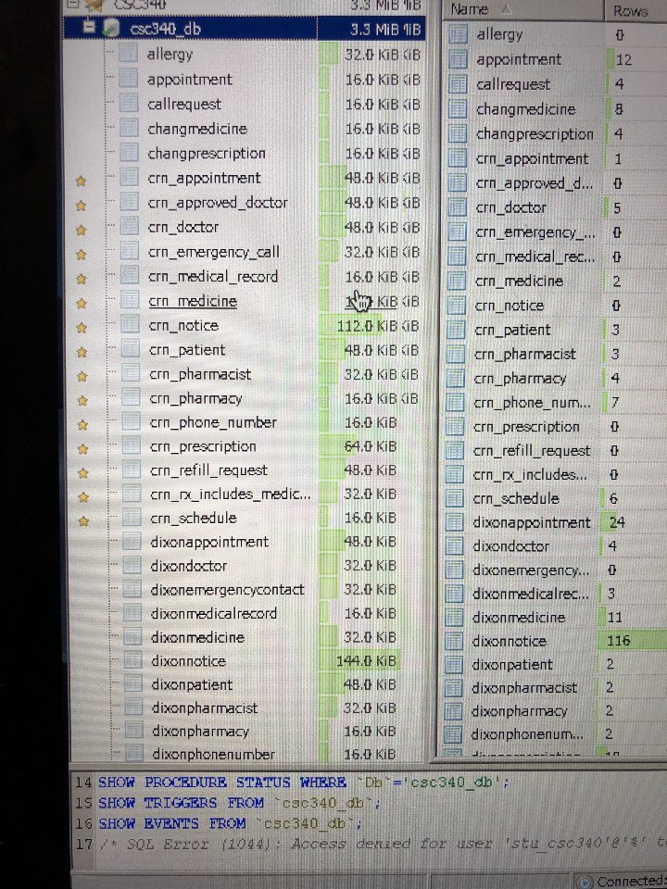

Avatar

**Ryan Smith**

Got it. All of that is good I just couldn't connect with MySQL and the professor said it was because of the version and an older version would work. But I can't find an older version of it.

**JAN 10, 3:49 PM**

Avatar

**Cheech \***

Just uploaded the most up to date version of the Req Spec report to the google drive, I’ll finish the rest of the diagrams as well as update the ER diagram and Table Schema here shortly, just taking a break for a bit! I’ll let you guys know when the diagrams and report is completely finished!

Also, haven’t gotten around to checking out the code but I will do that as well... just been working on making the report look official and making sure it’s filled with important information!

**JAN 11, 2:17 PM**

Avatar

**Nathan Murphy**

Have you guys turned in the incomplete grade agreement form? What did you all put for the due date? I was about to complete and turn in the form but I wanted to make sure it was the same as you two.

**JAN 11, 2:23 PM**

Avatar

**Ryan Smith**

I'm just going to put December 15

**JAN 11, 10:30 PM**

Avatar

**Cheech \***

I’ll put December 15 as well

Avatar

**Nathan Murphy**

um, you guys mean January right?

Avatar

**Cheech \***

Also, I’m trying to code for retrieving and inserting data in to the database, but notice none of the text boxes have been inserted in to the code... I don’t have a Microsoft so I can’t edit the code using the GUI but if one of you could just go through all of the designer.cs files and click on everything that needs to be interacted with (that way the code is automatically inserted in to the .cs files) and then merge it in to the main branch on github I can try to work on getting info flowing between the dB and system

But yes

Like double click on all of the text boxes so there is code in the cs files just like there is code for all of the buttons in the cs files

Avatar

**Nathan Murphy**

sure I can do that, no one is editing the code currently right?  
If I click it, the action it will put will be onClick or onDoubleClick is that what you want?

**JAN 11, 10:59 PM**

Avatar

**Nathan Murphy**

okay, check out that pull request to see if it is want you was wanting, and if it was go ahead and combine them

**JAN 11, 11:20 PM**

Avatar

**Cheech \***

Yeah that way once someone selects something in the text boxes or data boxes they can click the button and the button will communicate with the text box and blah blah blah, but I’ll check out the pull request now

I’m not seeing the pull request on here

Avatar

**Nathan Murphy**

[NATHANiELxM/DocPatSystem](https://github.com/NATHANiELxM/DocPatSystem/compare/NATHANiELxM-patch-1?expand=1" \t "_blank)

[github.com](https://github.com/NATHANiELxM/DocPatSystem/compare/NATHANiELxM-patch-1?expand=1" \t "_blank)

**JAN 11, 11:34 PM**

Avatar

**Cheech \***

Are you able to give access to us so we can push our changes to the code from our computers as well? And yeah your code looks good! Just merge your branch in to the master!

Avatar

**Nathan Murphy**

Yeah if you give me your username to whitelist

**JAN 12, 12:51 AM**

Avatar

**Cheech \***

cheech5

**JAN 12, 12:26 PM**

Avatar

**Ryan Smith**

Ryan\_Smith98

**JAN 12, 12:40 PM**

Avatar

**Nathan Murphy**

is it something else Ryan?

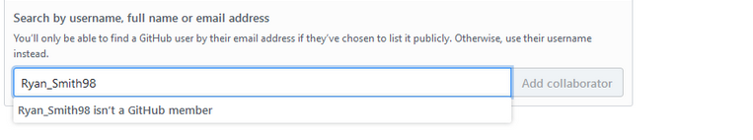

Avatar

**Ryan Smith**

Smitty1998

Avatar

**Nathan Murphy**

Alright, got it, you both are on there now

**JAN 12, 12:49 PM**

Avatar

**Ryan Smith**

ok, and im trying to connect and its not working, it wont allow the connection to take place

Avatar

**Nathan Murphy**

is it giving an error?

Avatar

**Ryan Smith**

no, but it fails when trying to form the connection

**JAN 12, 12:56 PM**

Avatar

**Nathan Murphy**

well man I am pretty clueless, Cheech was checking it out last night, maybe he knows how to help

Avatar

**Cheech \***

Are you plugging in all of our table information and what not? Those templates he has are just for accessing the dB, I’m pretty sure you have to read through and plug in our information in order for his code to work for our tables

**JAN 12, 1:09 PM**

Avatar

**Ryan Smith**

right now im just trying to connect to the database in general, trying to draw info from it and place that into a random text box

Test.exe Error: 0 : Unable to connect to any of the specified MySQL hosts.

here is an error

**JAN 14, 4:46 PM**

Avatar

**Ryan Smith**

Chang said that we should have about 1 month to di the final. Let's set up a time to get together and do that.

I'll send my schedule to you all later. But Tuesday and Thursday will be best.

**JAN 14, 6:26 PM**

Avatar

**Nathan Murphy**

I have classes from 12:30 to 6 on TR  
one class MW from 2:30-4:30

**JAN 14, 8:13 PM**

Avatar

**Cheech \***

I only have classes tuesdays and thursdays from 930-1230 so I can meet pretty much whenever, I have commented and made some additions to the code but am still having issues pushing/committing them. I’ll be in the lab tomorrow as well as Wednesday so we can most definitely meet up and finish this project. The labs were closed basically all break so now that they are open I’ll be able to actually use the desktops instead of my Mac.

Here is my schedule for the rest of this week:

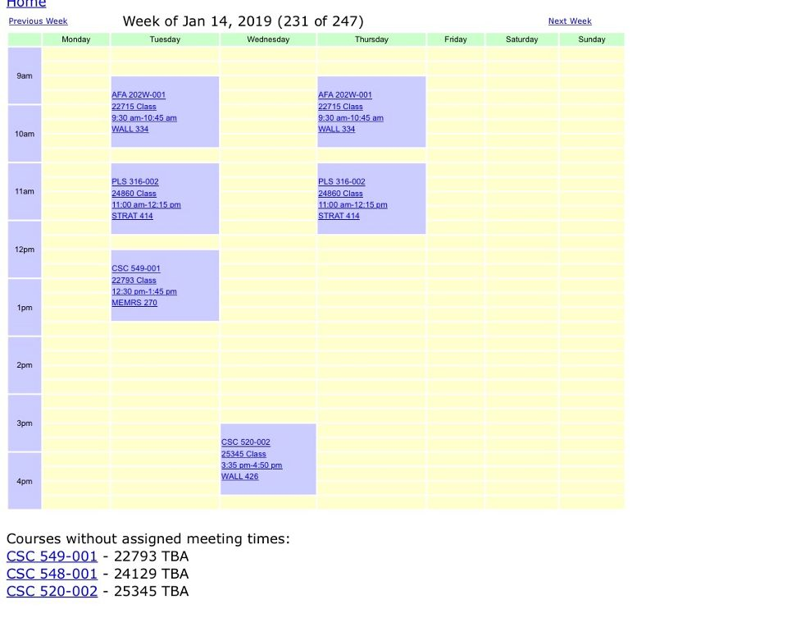

**JAN 15, 12:07 PM**

Avatar

**Ryan Smith**

I should be good around sometime after 4

**JAN 15, 1:33 PM**

Avatar

**Cheech \***

Sounds good

**JAN 15, 4:40 PM**

Avatar

**Ryan Smith**

I'm at the lab

**JAN 15, 4:51 PM**

Avatar

**Cheech \***

Letting my dog out and then heading to the lab, which room number?

Avatar

**Ryan Smith**

430

**JAN 17, 1:33 AM**

Avatar

**Nathan Murphy**

Sorry for the late text, but make sure you guys fill out that form and get it signed by Chang today or tomorrow. March 4th is the due date

**JAN 17, 4:11 PM**

Avatar

**Nathan Murphy**

Did you guys turn in the incomplete grade form yet? I was just trying to make sure you have, tomorrow is the deadline

**JAN 17, 4:30 PM**

Avatar

**Cheech \***

I did not but I am turning it in first thing in the morning, does Chang just have to sign it and then we turn it in to him?

**JAN 17, 4:35 PM**

Avatar

**Nathan Murphy**

Chang and wong(and dean?); but yeah after he signs it he will take it to the others. Or he did for me

**JAN 17, 4:44 PM**

Avatar

**Cheech \***

Okay definitely, I don’t have class tomorrow so I will run that over to him and make sure that it’s signed and what not.

**JAN 24, 7:45 PM**

Avatar

**Nathan Murphy**

I got an email Tuesday stating that my "I" grade is now an "F". What about you guys?

Avatar

**Cheech \***

Yeah so did I, I tried to email Wong about it and did not get a reply. I submitted by paper friday morning to the lady at the front desk in wongs office

Avatar

**Nathan Murphy**

I just now sent an email to chang/wong, I'll let you know if they reply.   
I'm thinking it was just an automated thing, and that it can still be changed if we get it done. or I really hope so that is.

This was in an older registrar email: "Please note that should we receive an Incomplete Grade Agreement after changing outstanding incompletes to F grades, we will certainly honor receipt of the agreement and change the grade back to an Incomplete as long as a Change of Grade form is also received with the Department Chair and College Dean’s signature."   
  
So I think we are good bros // just an unneeded scare and stress.

**FEB 27, 11:16 AM**

Avatar

**Ryan Smith**

Have you made any progress on the assignment. It's due within the next week

**FEB 27, 12:30 PM**

Avatar

**Nathan Murphy**

No, not really, unless you connected it to the database. I just thought you was too busy so I've just been working on my individual project because I was behind on that.

**FEB 27, 12:46 PM**

Avatar

**Ryan Smith**

What about the report? Has anyone worked on that?

**FEB 28, 6:04 PM**

Avatar

**Ryan Smith**

If any of you guys can please meet me in the computer lab I think it's Room for 444 In about 15 minutes II there and I want to work as a group

**FEB 28, 7:22 PM**

Avatar

**Nathan Murphy**

I just got home, I might can Tomorrow or the weekend. I am an hour away so you'll have to let me know ahead of time.

**FEB 28, 7:39 PM**

Avatar

**Ryan Smith**

That's fine. I will only have a few hours tomorrow open, but this weekend I want to get together and see what we can get done. Probably at the library because it's open.

**FEB 28, 9:56 PM**

Avatar

**Ryan Smith**

Can you guys at least make it to the library on the weekend?

**MAR 1, 1:45 PM**

Avatar

**Nathan Murphy**

Yes, but you might want to email or call Chris to make sure he can/knows about it

**MAR 1, 1:52 PM**

Avatar

**Cheech \***

Yep

**MAR 1, 2:18 PM**

Avatar

**Ryan Smith**

Great. I dont know anywhere on campus that will have computer with the programs we need to well need to bring out own systens

What time will and where will me meet?

**MAR 2, 3:50 AM**

Avatar

**Cheech \***

Just now getting off work so let me know when you all are going to meet

**MAR 3, 6:26 PM**

Avatar

**Nathan Murphy**

I guess we can meet Monday in the Wallace lab, I have a test at 2, but I can meet before and/or after it.

Avatar

**Cheech \***

Yeah I have an exam in CSC548 tomorrow that I have been studying for all day today but he said sometime this week so let’s meet tomorrow after our exams and work on it

**MAR 4, 5:12 PM**

Avatar

**Nathan Murphy**

Want to meet this evening? If it is not due today it has to be pretty close right?

Sent - Mar 4, 5:12 PM

**MAR 4, 7:55 PM**

Avatar

**Nathaniel Murphy**

Hey Chris, just letting you know that Ryan "gave up" and it is just me and you for the project now. And Chang said that we have until Friday evening.Maybe we can meet up tomorrow after classes to sort this out a little bit. Just let me know.

Avatar

**Cheech \***

Yep I am good with that, I had two finals today so that’s my bad on forgetting to text you. You and I can wrap it up this week and work on our individual projects as well if need be!

**MAR 4, 8:49 PM**

Avatar

**Nathaniel Murphy**

Its alright, I know its get stressful with two test on the same day, hope you did well.   
That text was mostly for Ryan because I was waiting out side his class to talk to Chang.   
I felt like it was rude of him to never tell us he gave up (both times). I had to find out from Chang because he was ignoring me (us?)

**MAR 5, 12:25 PM**

Avatar

**Nathaniel Murphy**

I only have one class today, from 2 - 3:15   
If you can we can meet up sometime then.   
  
Because This is a direct message I do not get this as a text so if you need to get a hold of me my number is 606-416-9464

**MAR 5, 3:38 PM**

Avatar

**Nathaniel Murphy**

Well I am in the lab, I was making sure you are able to download it from github. And it is working from there.  
Like all of the GUI is done (even the stuff I was waiting to be connected first). And I was starting to get it connected, but there needs to be more data in the database (I was too scared to try an add first). uh and maybe there needs to be an addition or two to the schema (like maybe default pharmacy for medical records)

to open it from github (after you download/uncompress) just click on DocPatSystem.csproj

Avatar

**Cheech \***

Okay for sure, I’ve been meeting with Zhang for my Cap stone project but I will head over there in a second and work on it. I will add the stuff that is necessary and then upload it to GitHub. Ill add some stuff to the DB to make it run smoother as well, I thought I sent you a message on here earlier but I guess I never actually hit the send button.

**MAR 6, 1:10 PM**

Avatar

**Nathaniel Murphy**

I have one class today that ends at 4:30, It is in Whalin and I'll probably stay there in the labs after class for a bit

**MAR 6, 1:20 PM**

Avatar

**Cheech \***

Okay for sure, if you want to walk over to the computer lab next to java we can work in there whenever you’re finished

**MAR 6, 3:36 PM**

Avatar

**Cheech \***

Grabbing food and then heading back to the java city lab

**MAR 6, 3:53 PM**

Avatar

**Cheech \***

Headed up to lab to set up now, I’ll be in the geek lab by java city

**MAR 6, 4:38 PM**

Avatar

**Cheech \***

So java city doesn’t have visual studio and you aren’t able to download the right copy, you want to meet over at Wallace 426??

**MAR 6, 4:47 PM**

Avatar

**Nathaniel Murphy**

sure, just go to the java lab. I'll be there in a few minutes

Avatar

**Cheech \***

Ah shoot, I just sat down in Wallace 426

Lab 445 now

**MAR 7, 5:47 PM**

Avatar

**Cheech \***

Hey I completely forgot about my night class tonight, it’s a hybrid class so we only meet once a month. I have that from 6-845 tonight but I will be at the library/lab after class let’s out

**MAR 7, 6:25 PM**

Avatar

**Nathaniel Murphy**

Alright I am in 430;  
If you can't make it let me know, if not I will be waiting

**MAR 7, 9:13 PM**

Avatar

**Nathaniel Murphy**

Well man I guess I am going home. I was able to get patient records to show and add new patient.   
The add new patient only works with the number of patients we have in the DB (2) but I added some info to my medical record because I did not have one.   
Maybe tomorrow we can meet sometime?

**MAR 8, 12:21 PM**

Avatar

**Nathaniel Murphy**

Hey, I am in the lab across from Chang's office if you are wanting to meet

Avatar

**Cheech \***

Yep I’m in a class right at the moment because of this 2 hour delay and then I was going to head over there!

**MAR 8, 2:15 PM**

Avatar

**Nathaniel Murphy**

Are you able to come today?

**MAR 8, 2:31 PM**

Avatar

**Cheech \***

Yeah I’m about to head that way, if you don’t feel like waiting you can upload the latest version to github and then I’ll work on it once I get to the lab. Wasn’t supposed to have any classes today and then this 2-hour delay messed up the schedule of my class for today that got scheduled last second for CSC520 since it’s a hybrid class

**MAR 8, 2:43 PM**

Avatar

**Nathaniel Murphy**

I'll upload it, but I will be here until 4

**MAR 8, 3:34 PM**

Avatar

**Nathaniel Murphy**

Well we get another week to work on it, idk if you want to meet up on break or not.   
t

The more I work on this the more I see changes for the database, I'll try make a list of thins that might need to be changed. Of course changing this will change all of the diagrams so we will have to update them too afterwards

**MAR 8, 3:52 PM**

Avatar

**Nathaniel Murphy**

I was about to get the doctor cases/notices working so that you can see the list and can make a new notice. But I am going to go a little early because I am hungry. I will make that list before the night is over.

I was   
able\* (not about)

**MAR 9, 12:05 AM**

Avatar

**Nathaniel Murphy**

I was wanting to talk to you about the DB today, but the list I have for changes are below. There are some I would more rather have your opinion on it.   
  
~move dateOfBirth from patient to medical record.  
~add ssn, name to medical record table.  
~doctor phone\_number is not the FK in the table -- but it might be best to leave it that way and take away the FK in the patient out. then delete emergency call and phone number table  
~can't add new medical records, add more patients  
  
And I was hoping that you might have figured out the log-in. To get the data from the DB the way it is suppose to from some items (like notice recipient/sender and only seeing what is to/from current user)   
As of right now, I can't get data from the DB at my house, but Chang emailed (which I will forward to you now)me a new example that is suppose to work from home, but I have not tried it yet.

**MAR 9, 7:09 PM**

Avatar

**Cheech \***

Okay yeah I’ll work on it heavy over break, I need to finish this presentation proposal for 520 by the end of today so I’m trying to crank that out right now!

^^^ that was supposed to send yesterday but did not for whatever reason

**MAR 13, 5:16 PM**

Avatar

**Cheech \***

I’m going to try and get up to the library/lab tomorrow around 8am and just stay there most of the day, or until the library closes at 430pm. Feel free to join, but if you have conflicts that’s completely fine! I’ll be doing the same thing on friday!

**MAR 15, 9:51 PM**

Avatar

**Nathaniel Murphy**

Hey, sorry I have not talked, I have not been on my computer for a few days, I had a funeral to attend Tuesday and have had a stomach bug since then. Maybe we can meet Sat or Sun, just let me know if you can/ want to.

**WED, 5:04 PM**

Avatar

**Nathaniel Murphy**

Hey, I am in room 445 in Wallace if you want to meet, I will probably be here until dark

**THU, 3:14 PM**

Avatar

**Nathaniel Murphy**

I will be here this evening, if you want to meet. I will let you know what room I end up in.   
We are suppose to present it to him on Friday.

**THU, 6:01 PM**

Avatar

**Nathaniel Murphy**

I am in room 430 today.

**11:12 AM**

Avatar

**Nathaniel Murphy**

I am in 455 today if you was wanting to meet up, today is the last day.

Sent - 11:12 AM