

**Department of Mathematics and Statistics**

**COLLOQUIUM**

**Tuesday, November 24th, 2015**

4:00 – 5:00 pm, Adel Mathematics Bldg., Room 164

(refreshments at 3:45)

Thomas Dunn

*NAU Alumnus*

*and*

*PhD Candidate, Bemidji State University*

An Overview of Multiplicities and Reductions

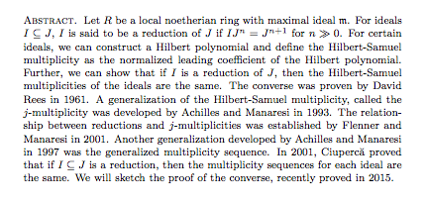

Algebra Combinatorics Geometry and Topology (ACGT) Seminar meets every Tuesday, 12:45 – 1:45 pm, AMB 164.

Applied Math Seminar (AMS) will meet Thursday December 3rd and 10th, 12:45 – 1:45 pm, AMB 164.

Wilson Lough will be speaking on his research.

Friday Afternoon Undergraduate Mathematics Seminar (FAMUS) meets Fridays, 3pm, AMB 164.