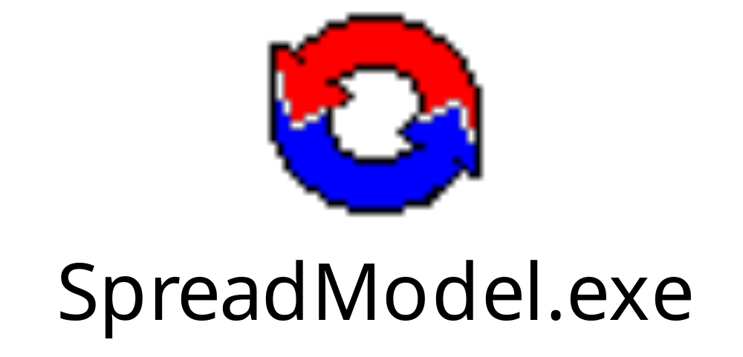Spreadmodel User’s Guide

Table of Contents
Table of Contents 2
Definitions 4
Chapter 1 – Introduction and Installation 5
Introduction to Spreadmodel 5
Technical specifications 5
Required software 5
Contents of CD 5
Installation instructions 5
Chapter 2 - Getting started - Model overview 6
Opening Spreadmodel 6
Interactive buttons 6
File 6
Setup / Parameters 7
Run 8
Output/Windows 9
Help 9
Charts as input parameters 9
Choosing the disease to be modeled 11
Chapter 3 - Launching a simulation 12
Setting up the simulation using “Start Setup” 12
Deciding on the number of replications to run 12
General description of session 13
Rules for simulations 13
Outputs to include 13
Setup Units – setting up the population dataset 14
Add units randomly positioned in a circle 15
Add units randomly positioned in a polygon 16
Import units from a text file 16
View/Edit existing units 16
Go to next section 16
Choosing the production types combinations 16
Disease parameters 17
How to model carrier state? 18
Surveillance/Detection 18
Contact parameters 18
Direct contact 18
Indirect contact 19
Movement control 19
Vaccination 20
How to model failure of vaccine? 21
Destruction 21
Airborne 22
Infecting herds 23
Randomly infected units 23
Economics 23
Interactive/Advanced 23

Table of Figures
Figure 1. Picture of opening screen in Spreadmodel version 3.0 showing the five major interactive buttons. 7
Figure 2. Picture of screen showing the “File” button options in Spreadmodel 3.0. 7
Figure 3. Picture of screen showing “Setup/Parameters” options in Spreadmodel 3.0. 8
Figure 4. Picture of screen showing “Run” button options in Spreadmodel 3.0. 9
Figure 5. Picture of screen showing “Output/Windows” button options in Spreadmodel 3.0. 10
Figure 6. Picture of probability density function chart showing the duration of the latent period in Spreadmodel 3.0. 11
Figure 7. Picture of relational chart showing the unit destruction capacity by day in Spreadmodel 3.0. 12
Figure 8. Picture of “Start Setup” screen from Spreadmodel 3.0. 13
Figure 9. Picture of “Outputs to include” screen in Spreadmodel 3.0. 14
Figure 10. Picture of the “Setup Units” window in Spreadmodel 3.0. 16
Figure 11. Picture of the “Add units in a circle” window in Spreadmodel 3.0. 16
Figure 12. Picture of the “Disease” window in Spreadmodel 3.0. 18
Figure 13. Picture of the “Contact” window in Spreadmodel 3.0. 19
Figure 14. Picture of “Movement control” relationship chart. The values entered are close to 1 for the whole duration of the epidemic, reflecting no movement control. 21
Figure 15. Picture of “Vaccination” window used in Spreadmodel 3.0. 21
Figure 16. Picture of the “Destruction” window in Spreadmodel 3.0. 22
Figure 17. Picture of the “Airborne” window in Spreadmodel 3.0. 23
Figure 18. Picture of the “Infection” tab under the “Interactive/Advanced” option. 24

Definitions
Simulation:
Scenario:
Iteration:
Model:
Unit:

Chapter 1 – Introduction and Installation

Introduction to Spreadmodel

This application is used to simulate the spread of diseases in animal populations. The herd/flock is the unit of concern and disease may spread from herd to herd. It is a state-transition, stochastic, spatial model that uses daily time-steps. Herds are classified into states (susceptible, latent, contagious, etc…) and each day the model will evaluate if a herd remains in its state or changes state following either a natural progression of the disease or an event that leads to exposure and infection. Because this model is stochastic - it accounts for chance and random events - a number of simulations will be required to obtain a distribution of the results. Increasing the number of simulations will increase the precision of the results. To obtain more information on the application itself, you may read the following paper:
Schoenbaum and Disney.

Many assumptions are included in this model, and these should be taken into consideration when interpreting the results of simulations. This model should not be used as a predictive tool to localize infected areas during an outbreak. Rather, it should serve as a tool for preparedness against disease outbreaks.

Technical specifications

This model was programmed in Delphi 7.0 with true compiler creating an EXE file. It uses add-on components by Diamond to utilize Microsoft Access 2000 databases.

Required software

Microsoft Access and Diamond Access components provided with model.

Contents of CD
Spreadmodel version3.0
MS Access file: “ParamOutput”.
Diamond Access components: Setup 1, Setup 2.

Installation instructions
Insert the Spreadmodel CD into your CD drive and install the Model. It will automatically be installed in C:\ProgramFiles\USDA\Spreadmodel. Also save the “ParamOutput” file in that folder.

Chapter 2 - Getting started - Model overview

Opening Spreadmodel

An icon should be in place in your startup menu under “Start / All programs / Spreadmodel”. Click on this to open Spreadmodel. To go through the different features of the model, the Microsoft Access (MS Access) file “ParamOutput” found in “Start / All programs / Spreadmodel” must be opened. This file contains all the input and output parameters for the model. To open this file, click on the “File” button, then “Open” and then select the “ParamOutput” file. Because any time a parameter is changed it overwrites the original values in the “ParamOutput” file, it is recommended to create a copy at first opening to ensure that the default values are available for future reference.

Interactive buttons

When Spreadmodel is opened, a tool list appears at the top of the screen. There are five buttons to choose from: File, Setup / Parameters, Run, Output / Windows, Help. Below are explanations for each of the functions available.

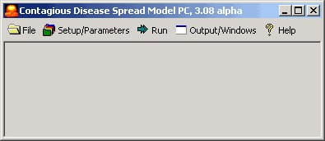
Figure 1. Picture of opening screen in Spreadmodel version 3.0 showing the five major interactive buttons.

File
Is used to:

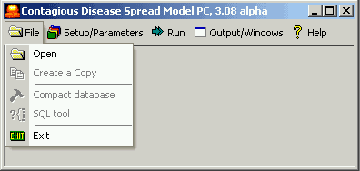
Figure 2. Picture of screen showing the “File” button options in Spreadmodel 3.0.

  - “Open” an MS Access file to run the model. Every time a file is opened, what is changed in the parameters and outputs is automatically saved. This means that the user does not have to save the results in the end.
  - “Create a copy” will be used in the following situation: to start another scenario with the current parameters in place. If the user wants to save the results of simulations, but wants to change a parameter and run other simulations, a copy needs to be created. The new copy will be loaded and then the parameter may be changed. The results of the previous simulation will be stored in the previous Access file.

Note: if a parameter is changed and a simulation started, the results of the new simulation will overwrite the previous results. A copy of the scenario should be made prior to changing parameters if the user wishes to keep the results.

  - “Compact database” is used when the MS Access file becomes too large. A window will appear when opening such a file that will suggest compacting the database. Clicking “Ok” to that suggestion will automatically compact the database and a “Compact database was successful” message will appear. By selecting “Compact database” the user may compact the database manually.

  - “SQL” tool is the way to search through the database for information. The user may do a query in the database by selecting the table and fields in which the information may be located.

  - “Exit” closes Spreadmodel. There is no need to save the results of simulations since they are automatically included in the database.

Setup / Parameters

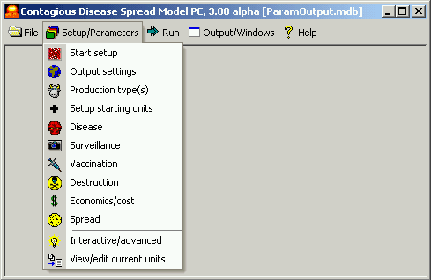
Figure 3. Picture of screen showing “Setup/Parameters” options in Spreadmodel 3.0.

There are three categories of function:

  - Setup: by selecting “Start Setup”, the user will be taken through all the parameters step by step in order to prepare the simulation.

  - Parameters: General information about the simulation, disease specific parameters, control measures, surveillance and economic parameters are entered by production type.

  - Interactive: These are advanced functions that can be used during simulations.

Run

Is to be selected to launch a simulation. There are two main options to choose from which each have three sub-options.

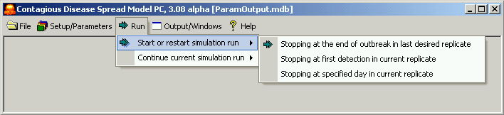
Figure 4. Picture of screen showing “Run” button options in Spreadmodel 3.0.

- Start or Resart a simulation:

  - The model can run until the end of the outbreak, defined by the absence of incubating or contagious herds, the completion of vaccination and/or destruction activities, the absence of replicates to run, or when the stop button is pressed;

  - The model can run until the first herd is detected in the current replicate;

  - The model can run for a specified number of days in the current replicate.

- Continue current simulation: when a simulation is stopped, either after the first herd is detected or the specified number of days have elapsed, the simulation may be started and continued from that point on by selecting the “restart” the simulation after the run button is pressed.

  - The model can run until the end of the outbreak, defined as when there are no more incubating or contagious herds, when all vaccination and/or destruction activities have been completed, when there are no more replicates to run or when the stop button is pressed;

  - The model can run until the first herd is detected in the current replicate;

  - The model can run for a specified number of days in the current replicate.

Output/Windows
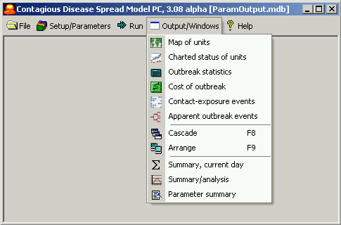
Figure 5. Picture of screen showing “Output/Windows” button options in Spreadmodel 3.0.

  - Maps of herds and charts or herd status, by herd: these are available throughout the simulation to follow the spread of disease in the population. To increase the speed of simulation runs, close these windows.

  - Outbreak statistics, by day: to show the results of simulations by day. When selected, the dataset will appear. Information about the spread of disease, the control measures, surveillance by day is shown. This is where the user would track the flow if infected farms and the effect of control measures and availability of resources.

  - Cost of outbreak by day: same as the outbreak statistics but only shows the cost of the outbreak by day.

  - Events, by day:

  - Summary, current day:

  - Summary/analysis:

  - Parameter summary:

  - Cascade:

  - Arrange:

Help
“About this program” shows the contact information for the Author of the Model. A “What’s this?” function will allow the user to

Charts as input parameters

A number of input parameters are entered as charts, either probability density functions (PDF) or relational charts (REL). When PDF charts are used, the model will pick out a value from the X-axis based on a random number for the area under the curve. In relational charts, the value chosen is dependant on the X-axis that gives a unit of time for example, that automatically relates to a Y-axis. There is no stochasticity with relational charts.

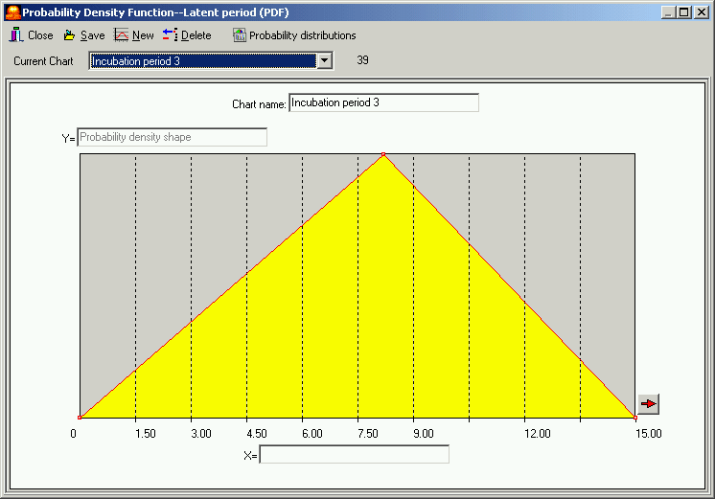
Figure 6. Picture of probability density function chart showing the duration of the latent period in Spreadmodel 3.0.

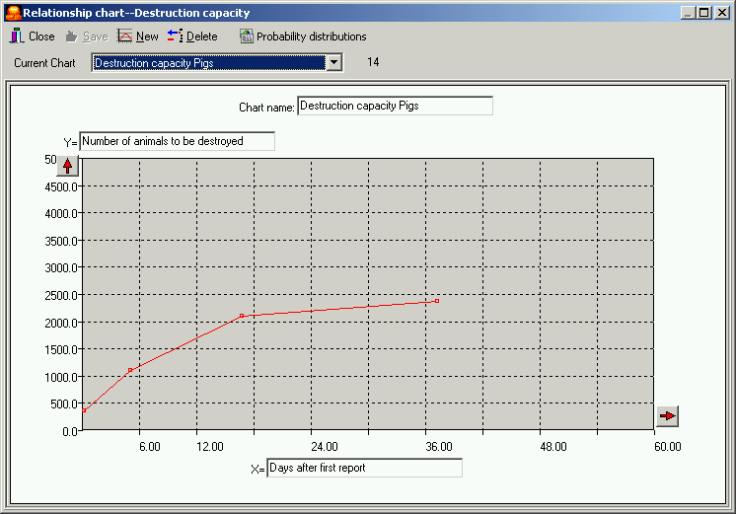
Figure 7. Picture of relational chart showing the unit destruction capacity by day in Spreadmodel 3.0.

If a simulation lasts longer than the last value specified on the X-axis, the last Y-axis value specified will be used for the remainder of the simulation. In Figure 7, the last value is 2364 units. This value will be used past 37 days where the last value is enteted.

To create a new chart, select “New” and then enter the information by following the steps. By clicking on “Close”, the changes made to the chart will be saved.

To change the shape of the charts, the user may click and drag already existing points, or add or delete points using the interactive buttons to the right of the chart. The user may also import an already existing distribution or use statistical distributions built into the model by clicking on “Probability Distributions”. In the case where a statistical distribution is chosen, the Model will ask for the parameters describing the distribution.

Choosing the disease to be modeled

Spreadmodel gives the option to model many different diseases. You may choose from a list located ______.

Mark – how is this going to work? Are we going to have the list of diseases with default input parameters or will it be simply generic and the user will have to figure it out?

Chapter 3 - Launching a simulation

Once Spreadmodel is opened (see instructions in Chapter 2) and a copy of the “Paramoutput” file was created and saved under a different, you may then proceed with the setup of simulations.

Setting up the simulation using “Start Setup”

Select the “Start Setup” function under the “Setup/Parameters” button. This will take the first-time user through all the different parameters windows that need to be completed to run a successful simulation.

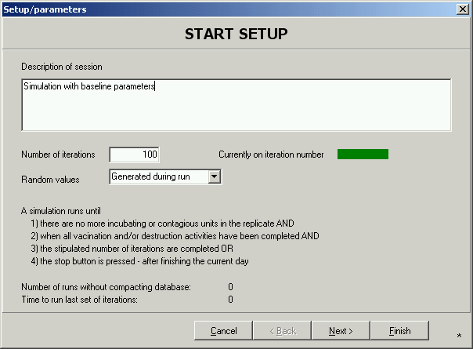
Figure 8. Picture of “Start Setup” screen from Spreadmodel 3.0.

Deciding on the number of replications to run

Because of the stochastic aspect of the model, it is necessary to run a number of iterations in order to obtain results in the form of distributions. The more iterations are run, the more precise the results should be. However, depending on the size of the dataset and the speed and memory of the user’s computer, these iterations may take a long time to run. Enter the number of iterations in the “Number of iterations” box.

Note: a minimum of 3 replicates must be entered for the simulation to start.

General description of session

You may also enter a general description of the simulation, notes on the parameters or control measures used etc… This may be useful to keep track of what is included in a scenario when a multitude of simulations are run from the same dataset and only a few parameters are changed.

Rules for simulations

The rest of the “Start Setup” window describes the rules that are followed by the Model to stop the simulation. Once the information has been entered, you may proceed to the following window by pressing the “Next” button. Information will automatically be saved.

Outputs to include
The results of the simulation are stored in the Access file that contains all the input parameters. The Model allows you to view results of the simulation and to export these results. Under the “Outputs to include” window shown in Figure 10, you may decide the type of output you would like to obtain at the end of the simulation. Automatically, the Model will show the map of the outbreak, the chart of the status of the units and the outbreak statistics by day. This is required for the model to run, and therefore will always be available to the user.

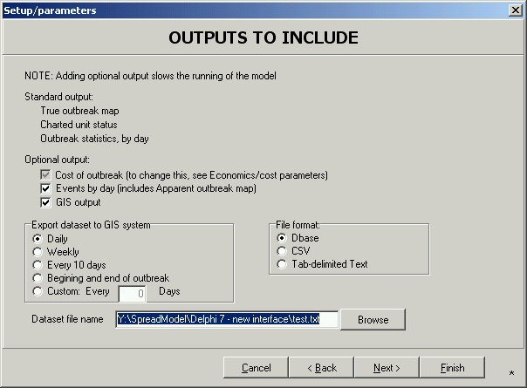
Figure 9. Picture of “Outputs to include” screen in Spreadmodel 3.0.

The Model will keep track of all interventions made to control the outbreak and will add the total cost. By selecting “Cost of outbreak”, you will be able to track the cost of the control measures applied during the outbreak.

It is also possible to obtain the events that occurred by day. Need more information.

Maps of herds by status (latent, infectious, immune, depopulated) can be exported to be viewed in a GIS software. You may select the frequency of these exports and will need to select the file type, name and destination. Note that frequent exports may slow down the speed of simulations.

Exit this window by clicking “Back”, “Next” or “Finish” and save the data or “Cancel” to close without saving.

Setup Units – setting up the population dataset

At this point, the user will need to determine what kind of population will be used in the simulation: either actual (imported file) or hypothetical (created by the Model in this section). Figure 10 shows the window under “Setup Units” that will help the user identify the situation. Here are a series of questions to consider before choosing options in this window:

- Do you have a population dataset or will you use a hypothetical population?

- Does your population dataset have unit sizes, production types, latitude, and longitude in that order?

- If the dataset does not include the unit sizes, do you have a distribution or a mean, minimum and maximum to create unit size charts in the model?

- If the dataset includes production type, did you code it with numbers or do you have them spelled out?

- If the dataset does not include location of units (latitude, longitude), do you have a shape file (polygon) where you would like to randomly distribute the herds in your dataset?

- If you do not have a population dataset, do you have a shape file (polygon) or will you use the circle shape area available in the model?

The first two options in this window relate to a hypothetical population while the third option allows the user to import a dataset.

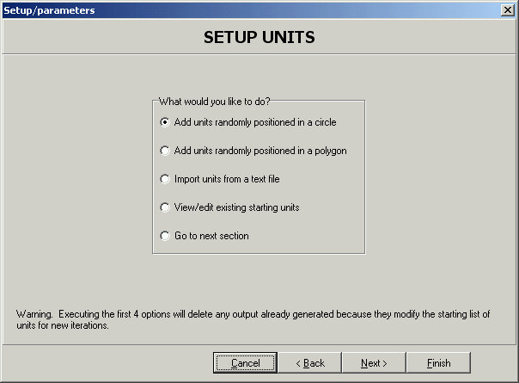
Figure 10. Picture of the “Setup Units” window in Spreadmodel 3.0.

Add units randomly positioned in a circle

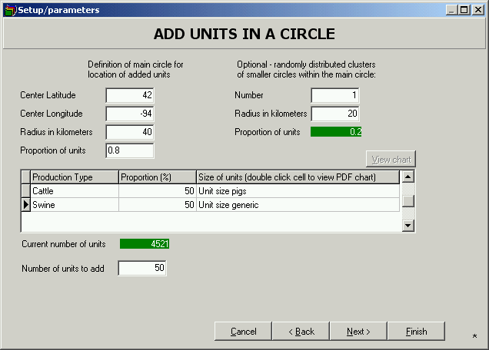
Figure 11. Picture of the “Add units in a circle” window in Spreadmodel 3.0.

This section allows the user to create a hypothetical population that will be distributed in a circle. The user will enter the center latitude and longitude of the circle and will specify the size of the circle by entering the radius. A proportion of units that will be distributed within that general circle must be entered. If no clusters are used in the population, then the general circle will include 100% of the units. If clusters are distributed among the general circle, then a proportion <100% should be entered.

Clusters are smaller circles that will be randomly distributed within the general circle. All clusters will be of the same size if more than one is included. These may mimic dense unit areas within a general population.

The table found in this window includes the production types that were entered in the Production Type(s) section. These may not be edited unless the user is in the Production Type(s) section. The user must specify the proportion of each production type that will make up the general population. The sum of the proportions entered must equal 100%. If not, an error message will appear. The next column contains information required by the Model to generate herd sizes in the population. This information is entered in a PDF format (see the “Charts as inputs” section for instructions p.10) by production type. The user must enter a distribution of herd sizes that the Model will use to randomly assign herd sizes. You may use one chart for all production types by highlighting the chart under Current chart in each of the production types.

Finally, the user must specify the total number of units to add in the population by entering a value in the “Number of units to add” box. The current number of units shows the number of units that are already in the population. This should be 0 when the user has not imported a population dataset, or has not pressed on the “Next”, “Back” or “Finish” buttons. When these buttons are pressed, the information entered in this section is saved and the population will be created based on the parameters entered in this section.

Add units randomly positioned in a polygon
If the user would like to create a hypothetical population in a specific area (Country, county, State/Province etc…) a shape file that contains the geographical attributes of this area can be imported into the Model. The units will be added randomly within this area.

The first step in this section is to import the shape file by clicking on the “Import Polygon” button. More than one polygon may be entered and a number will be assigned to each in the grid. Units will be added………need more information.

Import units from a text file
This is where a user may import a file that contains the data for an actual population. The text file should be imported with the following columns: “Production Type”, “UnitSize”, “Lat”, “Long”. Values must be entered in all columns and for all herds for the model to be able to import. If you do not have values for herd size, it is recommended that you assign a value for all units and then generate random herd sizes from a chart in the Model.

To assign random herd size, how will we do this?

View/Edit existing units
Selecting this option will allow the user to view the MS Access population database. Each unit will be assigned to the susceptible state when first entered and when no simulations have been run. It is possible to change the state of a unit (to change to incubating, for example), or to evaluate the status of a unit following a simulation run. The user also has the option of exporting or making a copy of the dataset.

Go to next section
Allows the user to skip this section and go to the “Production type(s) Combinations” window.

Choosing the production types combinations

Because direct, indirect and airborne spread does not exclusively take place between units of the same production type, the model needs to simulate the spread between different production types.

The model automatically lists all the possible combinations in the window under “Choose from All Combinations of Production Types”. The user will add combinations in the simulation by highlighting the desired combinations and clicking on “Add”.

The user may also wish to create the combinations manually by highlighting the types under the “Match Production Types to Create Combinations” and then clicking on “Add”. The unit of origin is located in the left column while the recipient unit is located in the right column.

To remove combinations, highlight the combination in the “Production Type Combinations” column and then click on “Remove”.

Note: remember to include combinations between same production types.

Once this step is finished, click on “Next” to access the “Disease” window. By clicking the “Next”, “Back” or “Cancel” buttons, the information entered will automatically saved.

Disease parameters

For each of the production types, the user must select the duration of the “latent”, “shedding subclinica”, “infectious”, and “immune from infection” periods at the unit level by entering data into PDF charts (see the “Charts as inputs” section for instructions p.10). The Model will randomly select a value in these charts based on the distribution entered.

Note: these values are not the same as the ones in textbooks describing what takes place at the animal-level. For example, if an animal is becomes infectious 4-6 days post-infection, at the herd level, this may be 10 days (to allow within-herd transmission) to allow the whole herd to be considered infectious.

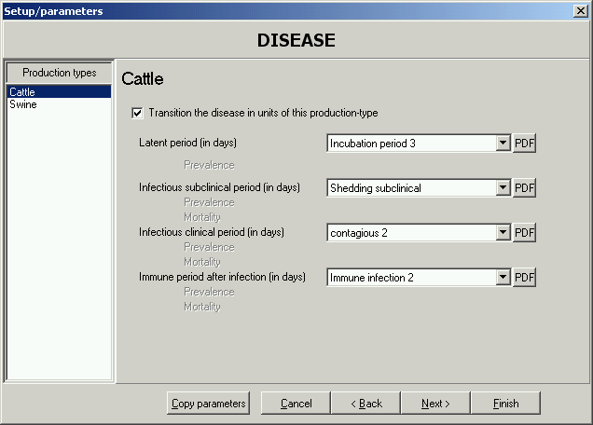
Figure 12. Picture of the “Disease” window in Spreadmodel 3.0.

To select a production type, highlight the name in the left window. The name of the production type will appear in the right section of the window. The charts for all periods can be viewed by clicking on the “PDF” button to the right of the chart box. Then choose the necessary parameters. Save all the charts with a name that includes the production type since charts for all production types are always visible.

Select the “Copy parameters” button to copy a set of parameters to all production types if you wish to have all the same parameters for all production types.

Click “Next” to access the “Surveillance” page. By clicking on the “Back”, “Next” or “Close” buttons, the information entered in this page will automatically be saved.

How to model the carrier state?
These would be units that remain infectious without clinical signs instead of transitioning from “infectious with clinical signs” to “immune from infection”,. By adding a small proportion of herds with an extended infectious period in the “Infectious period” this could reflect units that will never become immune. The ability of carrier units to transmit infection is still not proven. But if one wanted to model with some units remaining infectious for a long period of time, this is how to approach the problem.

Surveillance/Detection
The first option is to decide whether surveillance will be included in the simulation. If not, units will be detected only when clinical signs are reported to the regulatory authorities. When surveillance/detection is selected, resources will be used to test units for detection of disease/virus.

Need more information.

Contact parameters

For each production type combination, the user must indicate contact parameters.

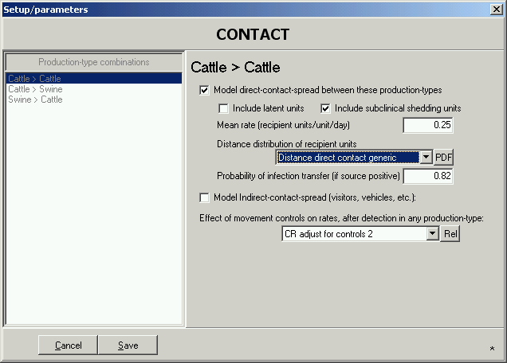
Figure 13. Picture of the “Contact” window in Spreadmodel 3.0.

Direct contact

Occurs through the movement of infected animals to other units. The “Mean rate” reflects the rate at which groups of animals are bought and sold. Only units that have not been detected are allowed movements, unless movement restrictions are in effect. Any time a herd is detected, it is automatically placed under quarantine and cannot sell or purchase groups of animals. This rate plus the rate of indirect contact comprise what is classically called the “contact rate”.

The recipient herds will be chosen based on their distance from the infected unit. The number of shipment received per unit will depend on the unit size. Larger units will tend to receive more shipments than smaller units.

Sales and purchases of animals are simulated in a random fashion based on the distance from the selling operation. This distance of sales is represented by a distribution function, the “Distance distribution of recipients units”, and can be modified with the PDF button. This chart can be created by importing a distribution, selecting points and creating a chart or choosing one of the pre-built probability distributions under the “Probability Distributions” button.

The “Probability of infection transfer” answers the question: “If a sale was made to another unit, what are the odds that the recipient units come down with infection?”. It accounts for some shipments not containing any infected animals as not all units/shipments are as infectious as others. Again, the user may select to copy parameters for all combination types, or may enter different parameters for production types.

Indirect contact

The “Mean rate” reflects the rate at which units have contact with potential fomites/vectors of the disease. The recipient units in this case are labeled as secondary contact units. The mean rate reflects the number of secondary contact units per infected herds per day. This rate plus the rate of indirect contact make up what is classically called the “contact rate”.

As is the case with direct contact, secondary contact units are selected based on their distance from the infected unit and the unit size (larger units have a greater chance of having indirect contact as compared to smaller herds). This distance is entered in the “Distance distribution of contact units”, and can be modified with the PDF button. This chart can be created by importing a distribution, selecting points and creating a chart or choosing one of the pre-built probability distributions under the “Probability Distributions” button.

The “Probability of infection transfer” is the probability that contact will result in infection given that a secondary unit is exposed through an indirect route (e.g., fomite).

Movement control

It is possible to simulate the implementation of movement controls in the area under study. It is important to note that detected units will be automatically placed under quarantine and will not have any direct contact with other units. What about indirect contact and airborne?

The “Effect of movement control on rates after detection” (see figure 14) is entered into a relational algebraic chart. The chart shows the multiplicative adjustment made to the contact rate, by day since the first unit was detected. Each day following detection of the first infected unit, the contact rate will be multiplied by the value found in the chart. A value close to 1 has little effect on the contact rate, while a value closer to 0 will reflect effective movement control.

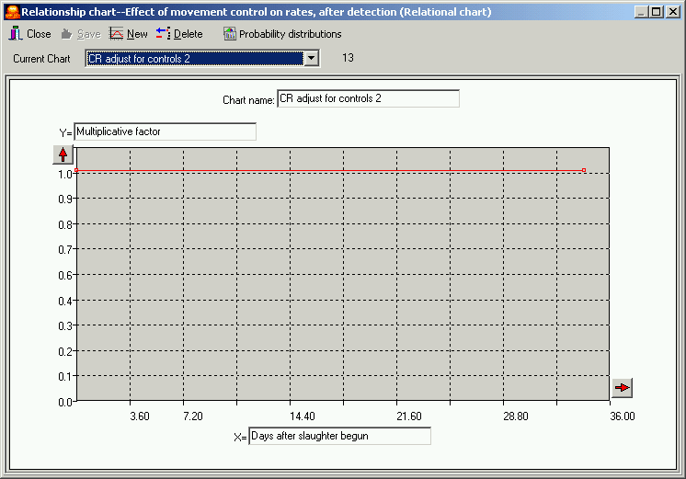
Figure 14. Picture of “Movement control” relationship chart. The values entered are close to 1 for the whole duration of the epidemic, reflecting no movement control.

Vaccination
The vaccination window offers the option of vaccinating or not vaccinating units during the simulation. When vaccination is selected, the following window appears (Figure 15).

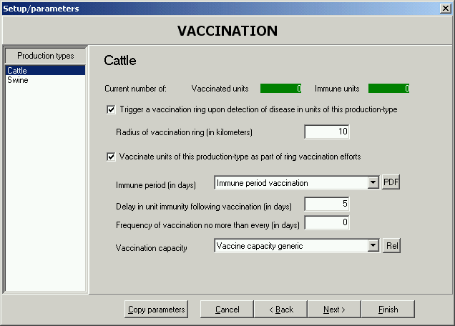
Figure 15. Picture of “Vaccination” window used in Spreadmodel 3.0.

The duration of the “Immune period” resulting from vaccination must be entered. Like the other periods used in the model (see Disease), values must be entered as a PDF chart. The duration of the immune period can be entered separately for the production types, or by selecting copy parameters, they can be copied to all production types.

The “Delay in unit immunity” represents the number of days required after the unit was vaccinated to become immune to infection. The “Immune period” will determine how long the unit will remain immune to infection.

How to model vaccine failure
In both cases, this means that the herd will be infectious. In the case of carriers, it has not been proven that they may transmit infection. In a small percentage of units, vaccination may fail and lead to infection of this unit with transmission to other units.

By including a small proportion of herds with very short immunity (0.1 – 1 day) in the PDF chart, a small proportion of units will not achieve immunity and will be susceptible to infection.

Destruction

This window reflects the different depopulation strategies that can be used during the simulation. Detected infectious units must be destroyed during the simulation. It is also possible to pre-emptively destroy herds that have had direct contact with an infected in the last specified number of days. Selecting the “Within kilometers of infectious units” will allow ring destruction of units in the specified vicinity of infectious units. Finally, it is possible to destroy units that have had indirect contact with infectious units in the last specified number of days.

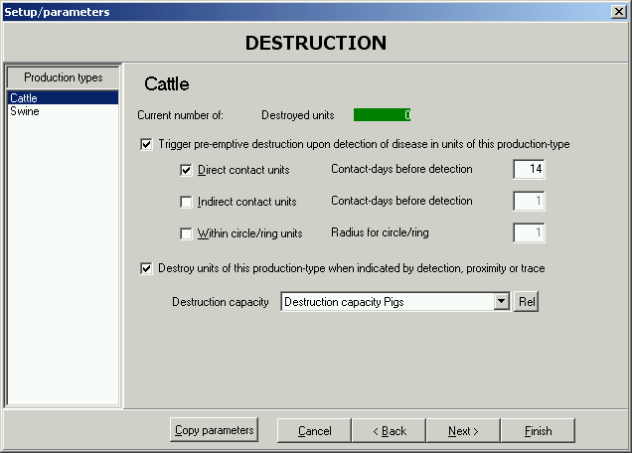
Figure 16. Picture of the “Destruction” window in Spreadmodel 3.0.

In order to identify the units to destroy, the Model must be able to trace units that have been exposed to infectious units. The Model keeps track of the last three exposures that a unit may have had, even if it did not result in infection.

Slaughter may begin after a delay of a number of days that the user can specify. This is to simulate the regulatory authority’s required time to get organized to destroy the first herd. This delay is entered into the “Begin destroying _ days after detecting the first infectious unit of any production type”. Destruction capacity is also a factor that can delay the ability to destroy units on any given day. The PDF chart for destruction capacity shows the resources available for the destruction of units by days since the beginning of the destruction campaign started.

Units will be destroyed on a first-come first-serve basis and in priority order from top to bottom of the “Destruction” window, given the destruction capacity entered. When capacity is limited, infectious herds detected will have priority. Others will be placed on a “holding for destruction” list.

Airborne
Some production types are more sensitive than other to aerosol transmission while others are efficient at shedding virus in the air. Airborne transmission will occur if a unit is shedding and if a recipient unit is available. This will depend on the production type, the distance between the units, and the size of the unit shedding the virus.

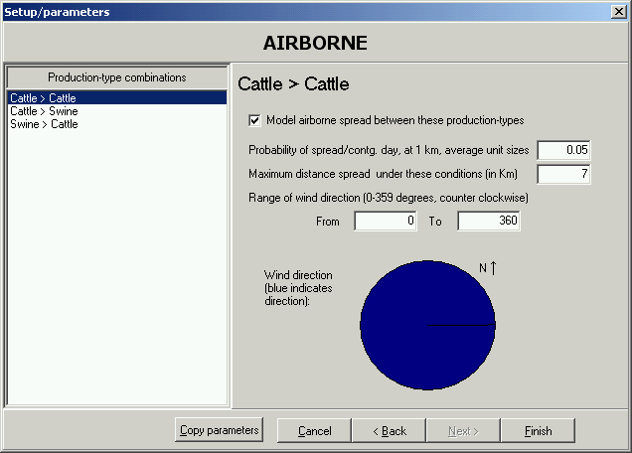
Figure 17. Picture of the “Airborne” window in Spreadmodel 3.0.

The first value to enter is the “Probability of Spread per infectious unit, per day at 1km for an average unit size”. A risk gradient is set up depending on the distance among, and the size of, the units. The maximum distance of spread of the infection via aerosol will depend on the climatic conditions. These are not modeled here and the user is asked to enter an estimated value by production type. Finally, the angle of wind direction is the scope of airborne exposure that is an area between two angles entered by the user. The area is determined by a counter-clockwise direction from the first angle. For example, if 0 and 90 are entered, exposures are in an area from due east to due north of each contagious unit. 0 = East, 90 = North, 180 = West, 270 (or-90) = South.

Infecting herds
When starting the simulation, the dataset must contain one or more units that are either incubating or infectious. There are two ways to do this:

- Infect one or multiple units randomly;
- Infect specific units in the dataset.

Randomly infected units
Under “Setup/Parameters”, select the “Interactive/Advanced” option. Click on the “Infection” tab. Figure 18 will open:

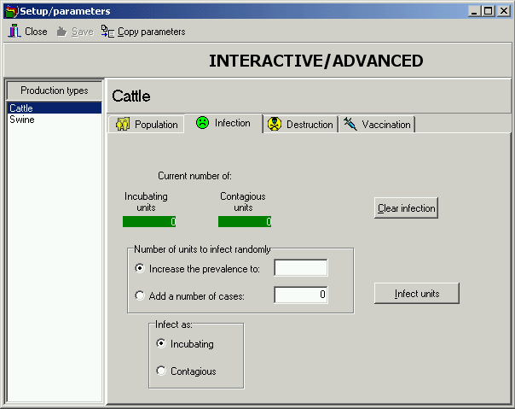
Figure 18. Picture of the “Infection” tab under the “Interactive/Advanced” option.

The user may infect one or more units by entering the number in the “Add a number of cases” box. Then, select the appropriate state in the “Infect as” box. Once these informations are entered, click on the “Infect units” button. The selected number of units will be randomly infected in the dataset.

Another option is to infect units up to a certain prevalence. The prevalence is entered in the “Increase the prevalence to” box. Then, select the appropriate state in the “Infect as” box. Once these informations are entered, click on the “Infect units” button. Units in the population will be infected at the specified prevalence.

Economics

Interactive/Advanced

Error: Reference source not found
Step 1 – Preparing the population dataset
User has a dataset
User will use a hypothetical dataset
Contains Unit Sizes
Yes
No
No further action required
Will need to generate in the model. Enter a value in that column and import into Model
Production types
Coded with numbers in dataset
Not coded, name only in dataset
Will need to enter names in section “Production Type(s)”
No further action required
Location of herds
Included in dataset: Lat and Long
No further action required
Not available in dataset
Use circle shape area and generate hypothetical herd locations

User imports polygon(s) and generates hypothetical herd locations
Use “Add units in a circle” function. Will generate locations, herd sizes and production type by proportion.
User imports polygon(s) and generates fictional herd locations and herd size.
Figure 19. Diagram representing the different options for simulating disease spread in Spreadmodel.

