Request for comments

RFC20051110NH: Within-unit prevalence

1st draft: N. Harvey, November 10, 2005
2nd draft: Revisions made by C. Dubé following December 15, 2005 conference call.

Applies to: Model description v1.0.3

Type of change: New feature, for next major version

Summary: This RFC proposes adding a disease prevalence curve to simulate intra-unit spread.

Justification: Requested in the document Action plan for Sharcspread Team following QUADS modelling workshop, Canberra, March 8-10 2005 (sent to N. Harvey by C. Dubé on 8 Apr 2005) to “include some items that are necessary for testing policy strategies in Canada.”

Change: This change applies to Section 3 (Disease). This new text is to be added between the 2nd and 3rd paragraphs:

While in the Latent, Infectious Subclinical, and Infectious Clinical states, a chart is used to determine the prevalence, or proportion of animals infected, on a given day. The chart is stretched to cover the total number of days spent in these states, and the prevalence value for a particular day is obtained by interpolating at the middle of that day (Figure 2).

Change: This new figure is to be added to Section 3 (Disease).

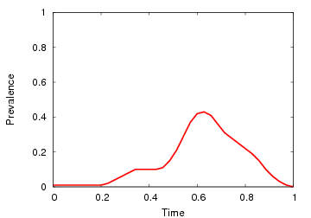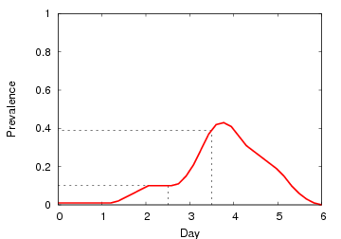
Figure 2. Example of a prevalence curve (left) stretched to fit 6 days in diseased states (right).
The values for day 3 and day 4 are interpolated as shown.

Subsequent figures would be renumbered appropriately.

Change: This change also applies to Section 3 (Disease). Proposed new text is highlighted:

Disease parameters
Parameters specified for each production type:
- latent period (days) 
- infectious subclinical period (days)
- infectious clinical period (days)
- natural immune period (days)
- prevalence (0-1) vs. days since the start of the latent period 

Change: This change applies to Section 4.1 (Direct contact spread), step 3(e). Current text to be deleted is struck out, proposed new text is highlighted:

If r < (probability of infection given exposure) × (prevalence in source unit) P, the probability of infection given exposure, turn B Latent after a shipping delay.

Change: This change applies to Section 4.3 (Airborne spread), step 1(c)iii. Proposed new text is highlighted:

Compute the probability of infection P = HerdSizeFactor(A) ×  prevalence in A × DistanceFactor(A,B) × probability of infection at 1 km × HerdSizeFactor(B).

End of changes

Outputs are not listed in the model description document, but to accompany these changes I suggest providing (to complement the existing outputs “number of units in each state” and “number of animals in each state”) an “average prevalence” output, defined as the number of animals in a diseased state (prevalence × unit size) in all diseased units, divided by the total number of animals in all diseased units.

To discuss: How should prevalence be applied to detection? Should the prevalence value replace the probability of detection based on clinical signs?

Attachment: excerpt from Action plan for Sharcspread Team following QUADS modelling workshop, Canberra, March 8-10 2005.

List of features to be included in Sharcspread:

- Intra-unit spread:

Using a modified Reed-Frost model, generate prevalence curves by production type and by size of units. For all shipments that take place, the probability of transmission will be multiplied by the proportion of animals infected based on the Reed-Frost generated curve.

Probability of transmission of infection by direct contact for a shipment = probability of transmission of infection * proportion of animals infected in the herd.

All state-transitions can remain the same, with the model selecting the duration of the various disease states. The Reed-Frost curve is applied on top of that duration.

