Request for comments

RFC20051114NHb: Alternate direct/indirect contact algorithm

1st draft: N. Harvey, November 14, 2005

Applies to: Model description v1.0.3

Type of change: New feature, for next major version

Summary: This RFC proposes adding an alternate contact algorithm similar to the one used in Ausspread.

Justification: Requested in the document Action plan for Sharcspread Team following QUADS modelling workshop, Canberra, March 8-10 2005 (sent to N. Harvey by C. Dubé on 8 Apr 2005). This algorithm eliminates the “edge effect” and also allows for tracking “out of study area” movements.

Change: This change applies to Section 4.1 (Direct contact spread). Current text to be deleted is struck out, proposed new text is highlighted:

4.1. Direct contact spread

The simulation of Two choices of algorithms for direct contact – movement of animals among units – are provided. The first works as follows:

On each day,
- Look up a multiplier to adjust the rate of movement of animals based on the number of days since the first detection of the disease. Use this multiplier to scale the movement rate. This approximates applying movement-controls over the course of an infection spreading through the population of units.
- For each unit A,
  - Check whether A can be the source of an infection. That is, is it Latent, Infectious Subclinical, or Infectious Clinical, and not quarantined? (Infectious Clinical is always a source. Latent and Infectious Subclinical are optionally a source.)
  - If A cannot be a source, go on to the next unit.
  - Sample a number N from a Poisson distribution whose mean is the movement rate (adjusted by 1 above).
  - Create N shipments from A.
- For each shipment,
  - Sample a number, distance, from the movement distance distribution.
  - From all units that can be the target of disease exposure (that is, those that are not Destroyed or are the source), choose the unit B whose distance from the source is closest to distance. If several possible targets are the same distance from the source, choose one randomly, giving preference to larger units (a unit with twice as many animals is twice as likely to be chosen).
  - If B is not Susceptible, the shipment has no effect on the disease state but is recorded as an exposure; go on to the next shipment.
  - Generate a random number r in [0,1), that is, from 0 up to but not including 1.
  - If r < P, the probability of infection given exposure, turn B Latent after a shipping delay.

The alternate direct contact algorithm replaces step 3 with:

- For each shipment,
  - Sample a number, distance, from the movement distance distribution.
  - Sample a number, direction, from the movement direction distribution.
  - Determine the location loc that is found by traveling distance km from the source with an initial heading of direction. Draw a circle around loc with the radius given in the parameters; this is the “search area.”
  - From all units in the search area that can be the target of disease exposure (that is, those that are not Destroyed or are the source), choose the unit B that is closest to loc. If several possible targets are the same distance from loc, choose one randomly, giving preference to larger units (a unit with twice as many animals is twice as likely to be chosen).
  - If a suitable target unit B was found,
    - If B is not Susceptible, the shipment has no effect on the disease state but is recorded as an exposure; go on to the next shipment.
    - Generate a random number r in [0,1), that is, from 0 up to but not including 1.
    - If r < P, the probability of infection given exposure, turn B Latent after a shipping delay.
  - If no suitable target unit was found,
    - Check whether loc falls inside a named area of interest outside of the study area. If so, record the shipment as having gone to that area.

Change: This new figure is to be added to Section 4.1 (Direct contact spread).

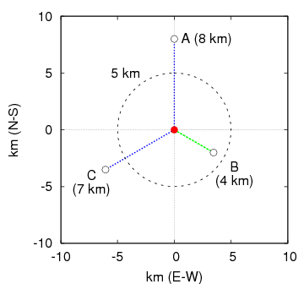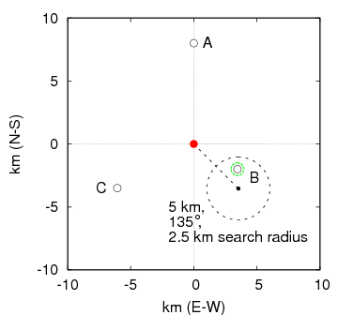
Figure 2. Two alternative contact spread algorithms. Left: the model chooses a movement distance of 5 km, and unit B receives the shipment (at 4 km from the source, it is the closest to a 5 km movement). Right: the model chooses a distance of 5 km and a direction of 135º, and unit B receives the shipment (it is the only unit within the search area).

Subsequent figures would be renumbered appropriately.

Change: This change also applies to Section 4.1 (Direct contact spread). Proposed new text is highlighted:

Parameters for direct contact spread
Parameters for each pair of production types:
- Mean rate of movement (recipient-units for shipments per source-unit per day)
- movement distance (km) 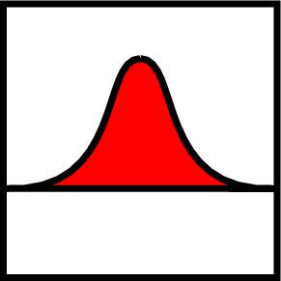
- movement direction (degrees)
- radius of search area (km)
- shipping delay (days)
- probability of infection given exposure
- movement rate multiplier vs. days since the first detection 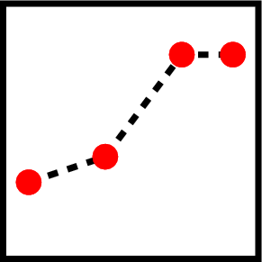
- optionally, 1 or more areas of interest outside of the study area (GIS outlines, each with a name)

End of changes

Attachment: excerpt from Action plan for Sharcspread Team following QUADS modelling workshop, Canberra, March 8-10 2005.

List of features to be included in Sharcspread:

...

6. Edge effect:

We should explore Graeme’s procedure for keeping track of movements out of the area. We should also discuss the Laurence Livermore’s approach.

Graeme goes around this problem using the following method: when a distance of movement is picked, the model will randomly “create” a point at that distance in any one direction. Then, it will look for a suitable recipient farm in the area of that point. If there are no farms, it records the movement as gone out of the study area and does not look for another suitable farm.

