Request for comments

RFC20051114NHc: Seasonality

1st draft: N. Harvey, November 14, 2005

Applies to: Model description v1.0.3

Type of change: New feature, for next major version

Summary: This RFC proposes adding a seasonal effect whereby direct and/or indirect contact rates can be adjusted cyclically.

Justification: From statement of work (sent from C. Dubé to N. Harvey on 8 Apr 2005):

Because data collection in Ontario will most likely take place in the summer, we should have in place a weighting applied to mimic increases or decreases of contacts by season.

Change: This change applies to Section 4.1 (Direct contact spread). Current text to be deleted is struck out, proposed new text is highlighted:

The simulation of direct contact – movement of animals among units – works as follows:

On each day,
- Look up a multiplier mult_{season} to adjust the rate of movement of animals based on the number of days since the simulation began. Treat the chart as though it wraps around, for example, if the chart extends for 90 days, then on the 91st day of the simulation, return to using the multiplier value for day 1. This multiplier approximates the differences in movement rates by season.
- Look up a multiplier mult_{control} to adjust the rate of movement of animals based on the number of days since the first detection of the disease. Use this multiplier to scale the movement rate. This multiplier approximates applying movement-controls over the course of an infection spreading through the population of units.
- For each unit A,
  - Check whether A can be the source of an infection. That is, is it Latent, Infectious Subclinical, or Infectious Clinical, and not quarantined? (Infectious Clinical is always a source. Latent and Infectious Subclinical are optionally a source.)
  - If A cannot be a source, go on to the next unit.
  - Sample a number N from a Poisson distribution whose mean is the movement rate × mult_{season} × mult_{control}.
  - Create N shipments from A.

Subsequent items in the list would be renumbered appropriately.

Change: This change also applies to Section 4.1 (Direct contact spread). Proposed new text is highlighted:

Parameters for direct contact spread
Parameters for each pair of production types:
- Mean rate of movement (recipient-units for shipments per source-unit per day)
- movement distance (km) 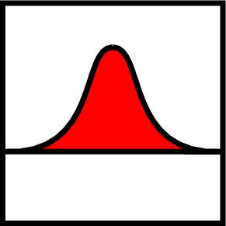
- shipping delay (days)
- probability of infection given exposure
- movement rate multiplier vs. days since the first detection 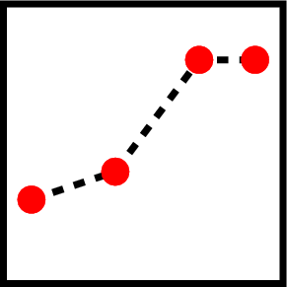
- movement rate multiplier vs. days since the start of the simulation (cyclical)

End of changes

Attachment: excerpt from Action plan for Sharcspread Team following QUADS modelling workshop, Canberra, March 8-10 2005.

List of features to be included in Sharcspread:

...

7. Seasonality:

Because data collection in Ontario will most likely take place in the summer, we should have in place a weighting applied to mimic increases or decreases of contacts by season. For example, if doing collection in the summer, can ask producers if the frequency of various contacts increases or decreases in the fall, winter or spring. Then, the baseline contacts would be entered in the model, but a weighting can be applied to simulate spring conditions. We need to discuss if the model should “know” what day of the year it is so that is a simulation did run into a new season, it would know and would apply the new weighted contact rates.

