Request for comments

RFC-200600503ARa: Detection parameters

1st draft: A. Reeves, May 3, 2006

Applies to: Model description v1.0.6 (applicable to NAADSM 3.0)

Type of change: Clarification

Summary: The proposed changes clarify the description of the two relational functions used for disease detection.

Justification: In recent versions of the model specification document, the distinction between the two relational functions used for disease detection has been made much more clear: one function gives the probability of observing clinical signs, while the other gives the probability of reporting a unit once clinical signs have been observed. The overall chance of detection is the product of these two probabilities (see Figure 5-1 in the model specification document).

This distinction is not quite as clear in the list of parameters for disease detection or in the NAADSM/PC user interface. The purpose of this RFC is simply to bring consistency to all of these components.

Change: This change affects the list of parameters in section 5 (immediately following Figure 5-1) of the model specification. Existing text is struck out, proposed new text is highlighted. Language used in the NAADSM/PC interface will be updated appropriately.

Detection parameters
Parameters for each production type:
- probability of detection observing clinical signs in a unit vs. days the unit has been Infectious Clinical 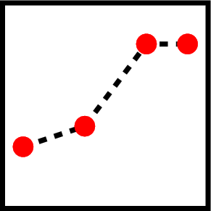
- probability of reporting a unit with observed clinical signs vs. days since the first detection

The parameters are given separately for each production type, to account for the possibility that signs of disease may be more obvious in animals of certain production-types, e.g., signs may be reported more rapidly in intensive swine production systems versus cow-calf operations on pastures.

End of changes

