Request for comments

RFC20070212BM: Fire-Break

1st draft: B McNab Feb. 12, 2007 (after group discussion & request from Caroline)

Applies to: Model code and description v3.2 ?

Type of change: New feature

Summary: Expanding on previous group discussion….
Add the ability to create a reasonably fixed ring, band or “wall” of no susceptible animals (no fuel) to serve as a “fire break”. With options, by production type, to vaccinate, destroy (or remove?) animals from the area.
The area could be defined by one of two (or both?) methods:
A) Establishing a closed band, at an inner- and an outer-radius, from the index or group of cases, let this band expand similar to current zones but only when cases are detected outside the original band, or
B) Entering latitude and longitude of “corners” for polygon(s), where all units within the polygon are vaccinated, or destroyed (or removed ?)
See figures below
Justification: Establishing a reasonably fixed “fire-break” that does not change shape until cases cross it (yet give modeler considerable flexibility in the original design of the fire-break), is a control tool that policy-makers would like to model.
Change: Core programming for this tool might ultimately be used to replace existing programming for ring (circle) destruction and vaccination or even zones, to provide more flexibility in their modeling

A) Band or Concentric Ring Approach
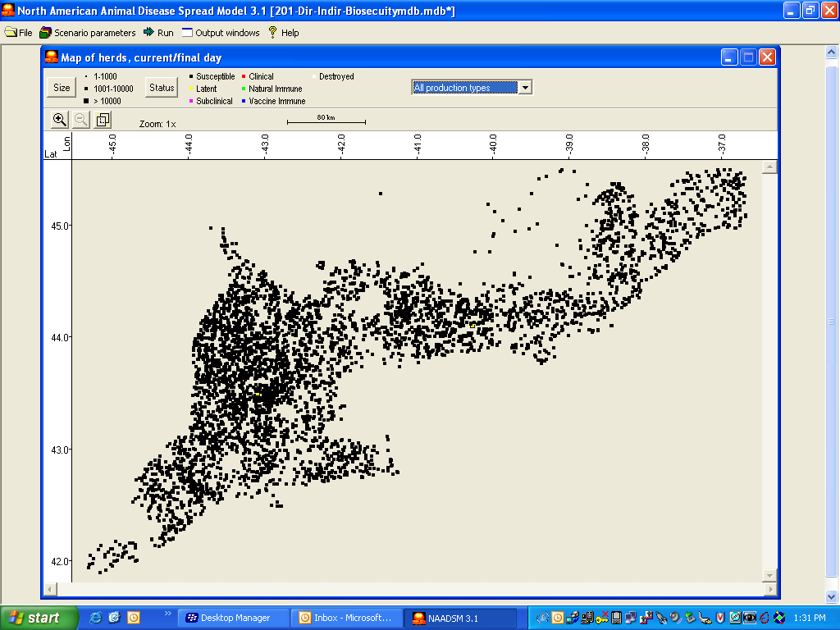
B) Polygon approach

