Request for comments

RFC-20070313AR: Eliminating the “edge effect” and tracking contacts movements outside of a study area without introducing new parameters

1st draft: A. Reeves, May 3, 2006 (Initially circulated March 3, 3007)

Applies to: A future version of NAADSM

Type of change: Addition to the existing model specification

Summary:
This document describes a mechanism that could be used to eliminate the “edge effect” without introducing new parameters or rewriting the movement generation algorithm currently used in NAADSM. This proposal is a potential alternative RFC-20051114NHb (Alternate direct/indirect contact algorithm).

Justification:
The “edge effect” is the concentration of contacts going to units near the edges of a study area. This effect, which is an artifact of the contact generation algorithm currently used in NAADSM, has two major drawbacks: 1) units near the edges of a study area are far more likely to be affected by disease than units in the interior of the study area, and 2) it is not possible to simulate or track the potential movement of disease to areas outside of the movement area.

RFC-20051114NHb (Alternate direct/indirect contact algorithm) describes a procedure by which the “edge effect” might be ameliorated. This procedure introduces a “movement direction probability density function” for each production type, used to define the predominant direction of movement for contacts initiated by units of that type. RFC-20051114NHb also introduces the concept of a “search area”. As proposed by the RFC, a point location is identified based on the distance and direction of a movement. Then, a “search area” is created around this point location. If eligible units are found within this search area, a contact occurs.

There are some drawbacks associated with the use of the movement direction distribution, and it may introduce undesirable artifacts of its own. While units exist within a geospatial framework, production types do not. Consider the situation shown in Figure 1 below. There are two production types: a “source” type and a “sink” type, with a high rate of contact from units of the source to the sink. Four source units are located equidistant but in different directions from a sink unit. All five units are within an arbitrarily hexagonal region of interest.

If movements for the source type are defined to occur in a primarily northwesterly direction, contacts from source units A, C, and D will only rarely be directed toward the sink unit. A very high proportion of movements from units C and D will be dropped, because there is no eligible sink unit in the indicated direction. Similarly, a very high proportion of movements from unit A will be directed out of the study area, even though a suitable target for these contacts is within the region of interest.

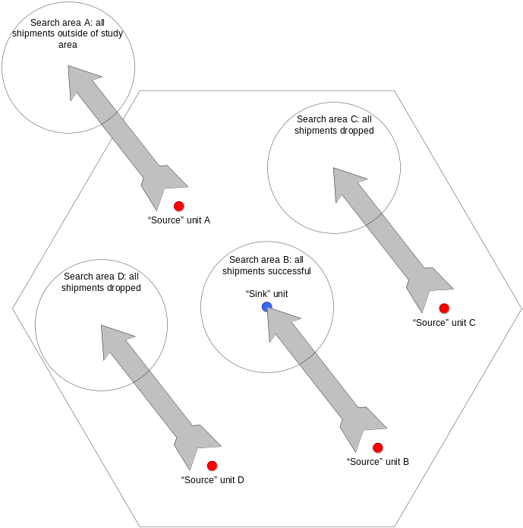

Figure 1. The problem of directionality associated with movements of all units of a production type. Imposing directionality based on production type could prevent the occurrence of reasonable, realistic movements.

Leaving aside the complications associated with a movement direction distribution function, an additional problem can occur. While the approach of using a “search area” may reduce the occurrence of the edge effect, such effects are not eliminated. Consider the example shown in Figure 2. Two search areas of equal size are shown, which are equidistant from a source of contact (shown in green). According to the procedure outlined in RFC-20051114NHb, the single unit contained in the search area shown on the left will have as great a chance of receiving the contact as the four units in the search area on the right combined.

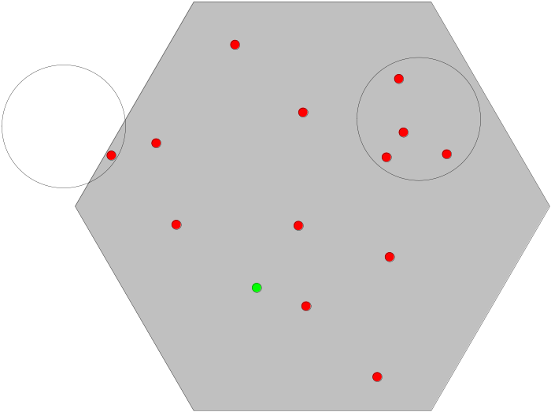

Figure 2. Search areas and the edge effect.
What follows is a description of a method that should avoid the problems described above, without major revision of the contact algorithm currently found in NAADSM. As an added advantage, this method requires no new parameters, except for the coordinates of the polygon which define the area of interest.

Change: This change applies to Section 4.1 (Direct contact spread). Current text to be deleted is struck out, proposed new text is highlighted:

4.1. Direct contact spread

The simulation of direct contact – movement of animals among units works as follows:

On each day,
- Look up a multiplier to adjust the rate of movement of animals based on the number of days since the first detection of the disease. Use this multiplier to scale the movement rate. This approximates applying movement-controls over the course of an infection spreading through the population of units.
- For each unit A,
  - Check whether A can be the source of an infection. That is, is it Latent, Infectious Subclinical, or Infectious Clinical, and not quarantined? (Infectious Clinical is always a source. Latent and Infectious Subclinical are optionally a source.)
  - If A cannot be a source, go on to the next unit.
  - Sample a number N from a Poisson distribution whose mean is the movement rate (adjusted by 1 above).
  - Create N shipments from A.
- For each shipment,
  - Sample a number, distance, from the movement distance distribution.
  - Determine the proportion of the area of the circle defined by radius distance centered at the coordinates of the source unit A which lies within the bounds of the region of interest (see Figure 4.2)
  - Generate a random number q in [0,1), that is, from 0 up to but not including 1.
  - If q < proportion:
    - From all units that can be the target of disease exposure (that is, those that are not Destroyed or are the source), choose the unit B whose distance from the source is closest to distance. If several possible targets are the same distance from the source, choose one randomly, giving preference to larger units (a unit with twice as many animals is twice as likely to be chosen).
    - If B is not Susceptible, the shipment has no effect on the disease state but is recorded as an exposure; go on to the next shipment.
    - Generate a random number r in [0,1), that is, from 0 up to but not including 1.
    - If r < P, the probability of infection given exposure, turn B Latent after a shipping delay.
  - If q > proportion, record the shipment as having gone outside the region of interest.

Change: The following figure would be incorporated. Subsequent figures in section 4 would be renumbered as needed:

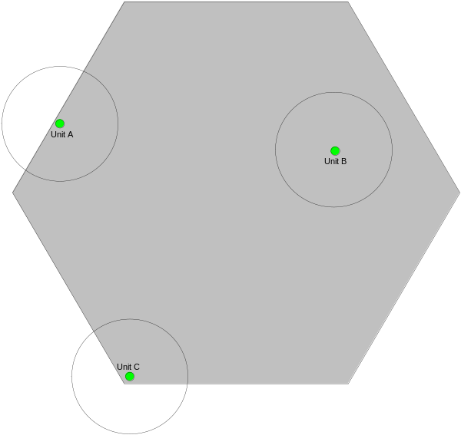 |  | 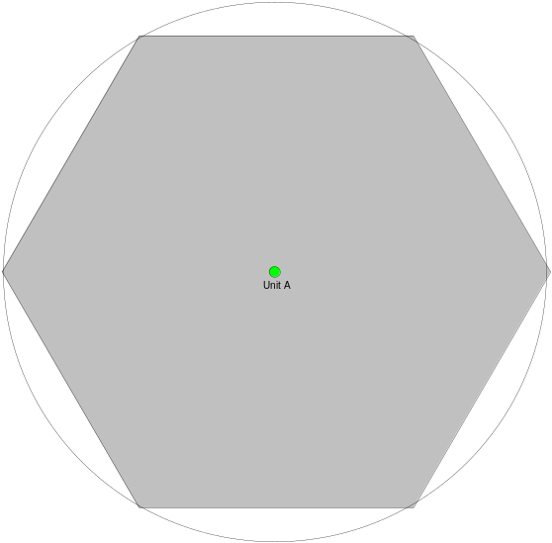
(a) | (b)
Figure 4-2. Calculating the probability that movements will occur to the area outside the region of interest.

(a) Short distance movements. The area containing eligible recipient units for contact from Unit B is entirely contained in the region of interest, resulting in a 100% probability that movements will stay within the region. The area containing eligible recipient units for contact from Unit A is about 55% within the region of interest, so there is about a 45% chance that a movement will occur outside the region. The area containing eligible recipient units for contact from Unit C is about 35% within the region of interest, so there is about a 65% chance that a movement will occur outside the region.

(b) Long distance movements. The area containing eligible recipient units is about 95% within the region of interest, so there is about a 5% chance that a movement will occur outside the region.

End of changes

Discussion:
- By this method, there is a direct relationship between the probability that a contact will go outside the region of interest and the area encompassing eligible recipient herds.
- In some cases, the best match for an eligible herd might be outside the area defined by distance. In these cases, an edge effect-like phenomenon might still occur (unless the process was repeated based on the new, greater distance).
- There is a computational cost associated with the calculation of the intersection of the area of the circle and the study area [step 3(b) above]. This calculation would need to be made for every contact.
- The proposed scheme does not allow for the identification of different regions outside the study area: if this capability is required, additional calculations would be needed.

