Request for comments

RFC20070313SD: Replacing the algorithm for airborne spread

1st draft, Seth Dunipace, 13 March, 2007

Applies to: Model document 1.0.6

Summary: This RFC proposes to alter the current formula used for airborne spread.

Justification: The current formula allows the largest farm in a parameterized model run to be twice as infectious as the median sized farm and it allows for the smallest farm in a parameterized model run to take a near zero value. This is true regardless of the size of the largest and smallest farms. Thus, in a population with farms ranging in size from 400-600 animals and a median size of 500 animals, those farms at 600 will be twice as infectious as the median farm size and those at 400 will be hardly infectious at all. By contrast, in a population with farms ranging in size from 1 to 1000 animals, the difference in infectiousness between a farm of 400 and a farm of 600 would be dramatically less.

The proposed algorithm still accounts for farm size and distance between farms, but only the source and destination farm influence the calculation: unlike in the current method, the rest of the population has no effect on the result.

Conceptual change: The proposed change would use the formula

P = 1 – exp^(-k(n_{A} × n_{B})/d_{AB})

to determine the probability of airborne spread.

Where:
k is a constant related to the infectiousness of the disease being modeled
n_{A} is the herd size of infectious farm A
n_{B} is the herd size of susceptible farm B
d_{AB} is the distance between farms A and B

The only required parameter for this algorithm is the constant k. It will likely be easier, however, for the user to enter several values that can be used to compute k, rather than enter it directly.

In order for the model to calculate k, the user would need to enter the following parameters (the user interface might suggest reasonable starting values for these):
The size of an infectious source herd i
The size of a susceptible recipient herd j
The distance between i and j
The probability that, on any given day, unit i will infect unit j by airborne spread
From this point, k would be calculated with
k = -1 × [ln(1-P) × d_{ij}]/(n_{i} × n_{j})

This calculated value k could then be used as a constant in the formula as the sizes and distances between farms vary over the course of the model run

Notes: k would be determined once for each possible production type combination (i.e., beef to dairy transmission, dairy to beef transmission, beef to beef transmission).

This correction would allow for a nicer distribution of infectious values and probabilities across farm sizes.

This correction would also make it impossible to have a value greater than 1 for the probability of airborne spread from one farm to another.

A typical graph for an airborne spread of this type would look like the following. (Note that a direct comparison to values generated existing algorithms is not possible, because of the population dependency of the existing algorithms):
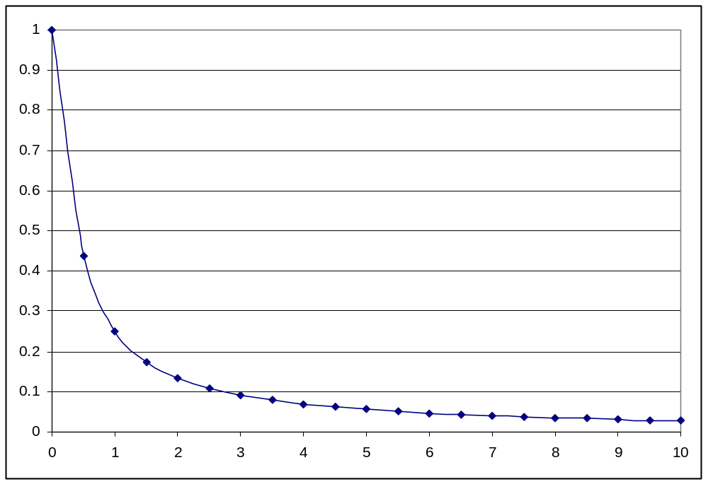

Where
P = 0.25
n_{i} = 20,000 animals
n_{j} = 20,000 animals
d_{ij} = 1 kilometer
and k is computed to be 7.19205E-10
Changes to specification: section 4.3 of the model specification would be altered as shown below. New text is highlighted, old text is struck out. (The changes are applied to existing text for the linearly declining probability of airborne spread. The text related to exponentially declining probability of airborne spread would be rendered obsolete, and removed entirely.)

4.3. Airborne spread

The simulation of airborne spread works as follows:

On each day,
- For each unit A,
  - Check whether A can be the source of an infection. That is, is it Infectious Subclinical or Infectious Clinical?
  - If A cannot be a source, go on to the next unit.
  - For each other unit B,
    - Check whether B can be the recipient target of an infection. That is, is it Suspectible, is the distance from A to B < the maximum distance of spread, and is the direction from A to B inside the wind direction range?
    - If B cannot be a target, go on to the next unit.
    - Compute the probability of infection
P = 1 - exp^(-k(n_{A} × n_{B})/d_{AB})
P = probability of infection at 1 km × DistanceFactor(A,B) × HerdSizeFactor(A) × HerdSizeFactor(B).
    - Generate a random number r in [0,1).
    - If r < P, turn B Latent after a delay.
Where
k is a constant calculated as shown below
n_{A} is the herd size of infectious farm A
n_{B} is the herd size of susceptible farm B
d_{AB} is the distance between farms A and B
DistanceFactor(A,B) = (maximum distance of spread - distance from A to B) / (maximum distance of spread - 1)
HerdSizeFactor(A) = (area under histogram of unit sizes from 0 to size of A) × 2

The distance between 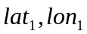 and 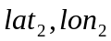 is approximated as before. The direction from to is approximated with the inverse tangent using the same x and y.

For each combination of source and recipient production types, the constant k is calculated from the following input parameters:

d_{ij}, the distance between two arbitrary herds i and j
n_{i}, the size of the infectious source herd i
n_{j}, the size of a susceptible recipient herd j
P_{fixed}, the probability that, on any given day, unit i will infect unit j by airborne spread

k is then calculated as:
k = -1 × [ln(1-P_{fixed}) × d_{ij} ]/(n_{i} × n_{j})

Airborne spread can occur from and to quarantined units.

Airborne exposure is not recorded since it would not be used directly by mitigation processes such as movement-controls, vaccination, and destruction.

Parameters for airborne spread
Parameters for each pair of production types:
- d_{ij}, the distance between two arbitrary herds i and j
- n_{i}, the size of the infectious source herd i
- n_{j}, the size of a susceptible recipient herd j
- P_{fixed}, the probability that, on any given day, unit i will infect unit j by airborne spread
- probability of infection at 1 km from source (Infectious Subclinical or Infectious Clinical unit)
- wind direction, given as a range (start and end) in degrees
- maximum distance of spread (km)
- airborne transport delay (days) 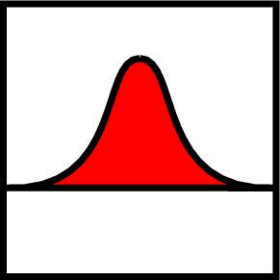

The parameters are given separately for spread in each direction between each pair of production types. That is, the parameters for spread from pig herds to cattle herds can be different from the parameters for spread from cattle herds to pig herds, to account for potential differences in amount of virus produced and/or different minimum-infective-doses for animals in different production-types.

End of changes

