Request for comments
RFC-20090428AR: Within-unit prevalence and disease spread by direct contact or local area spread
1st draft, Aaron Reeves, 28 April 2009
2nd draft, Aaron Reeves, 8 May 2009
Applies to: Model document 1.1.1. Proposed for model description 2.0.0.
Summary: This RFC introduces new parameters to more appropriately model the spread of disease by direct contact and airborne/local area spread when the existing approach for modeling within-unit prevalence with simple relational functions is used. These changes are proposed for NAADSM 4.0.
Justification:
When within-unit prevalence is used in NAADSM 3, it has two effects:
- For disease spread by direct contact, the probability of disease transmission from an infectious unit is taken directly from the curve used to represent within-unit prevalence of disease
- For airborne spread, the prevalence of disease is used to determine the number of infectious animals in the source unit, which is in turn used to calculate the probability of airborne spread from the unit.
Within-unit prevalence should affect these two components in different ways. In the case of direct contact, the probability of disease spread is related not only to the prevalence of infected (latent, subclinical, and clinical) animals in the unit but also to the number of animals included in a shipment. In the case of local-area or airborne spread, the prevalence of shedding (subclinical and clinical) animals is the critical factor. Existing features of NAADSM 3 are flexible enough to allow users to capture one or the other of these phenomena, but is not possible to adequately represent both with just a single prevalence curve.
The features proposed here would extend the existing NAADSM framework to represent within-unit prevalence for both local-area spread and disease spread by direct contact more adequately.
Although it would be possible to implement these new features in a backward-compatible way, it is perhaps more practical to consider them as part of a new version of NAADSM, tentatively called “NAADSM 4”, which might incorporate improvements to the local-area spread mechanism currently used in NAADSM (see RFC-20070313SD, draft 2 or higher).
Conceptual changes:
Rather than using a single curve to represent within-unit prevalence of disease, I propose to use two. One curve, to be used for direct contact, will represent the prevalence of infected (latent, subclinical, and clinical) animals. The second, to be used for local-area spread, will represent the prevalence of shedding (subclinical and clinical) animals. Figure 1 shows these two curves, generated with a prototype model of within unit disease spread (WH 0.9.1) for a 1000-animal dairy herd using data from Carpenter et al. 2004. The differences are most pronounced early in the disease cycle when there are more latent individuals relative to subclinical and clinical individuals.
In addition to the two curves (relational functions) for within-unit prevalence, an additional, bounded probability density function would be used to represent the proportion of a unit that is included in a shipment. The probability that a shipment will contain at least one infected animal (i.e., the probability that direct contact will result in disease transmission) can be calculated using a value drawn from this distribution, the total number of animals in the unit, and the prevalence of infected animals in the unit. Figure 2 shows sample calculations for this probability.
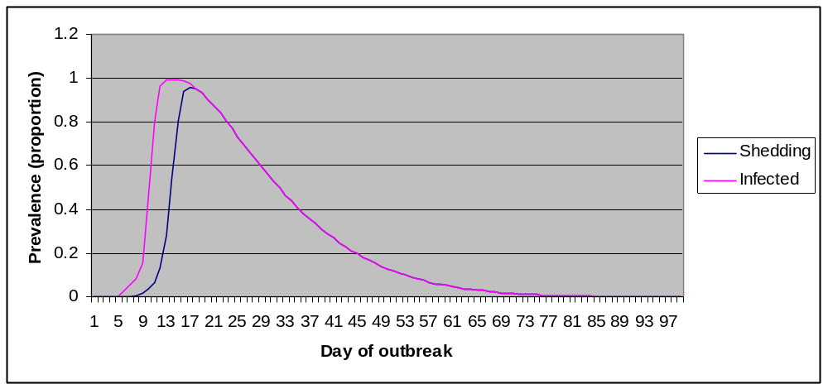
Figure 1. Prevalence of infected and shedding animals in a 1000-animal dairy herd.

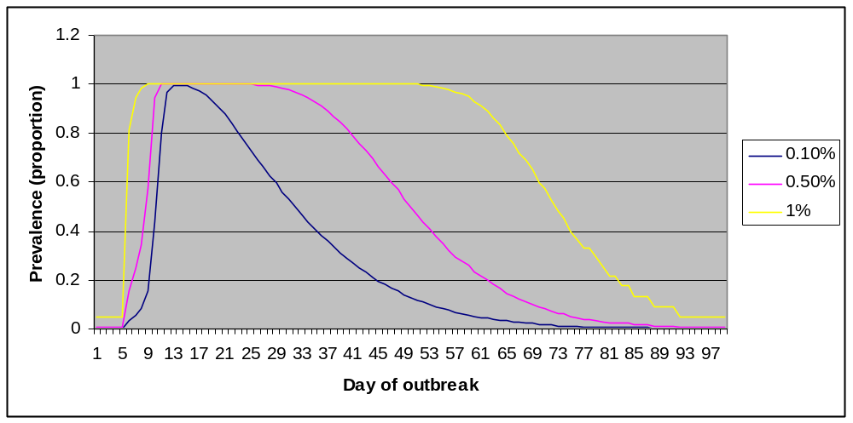
Figure 2. Probabilities that a shipment of 1 animal (0.1% of a 1000-animal herd), 5 animals (0.5%) or 10 animals (1%) will contain at least 1 infected (latent, subclinical or clinical) animal, given the indicated prevalence of infection. This calculation is an application of the hypergeometric distribution as described below.

Changes to specification:
Change 1. The third paragraph in section 3 (Disease) would be replaced with the following text (text to be removed is struck out, text to be added is highlighted):
While in the Latent, Infectious Subclinical, and Infectious Clinical states, a chart may be used to determine the prevalence, or proportion of animals infected, on a given day. The chart is Charts (relational functions) may be used to represent the prevalence of infected (latent, infectious subclinical, and infectious clinical) animals and the prevalence of shedding (infectious subclinical and infectious clinical) animals. These prevalences are given as the proportion of the unit that are infected or shedding on a given day. The charts are stretched to cover the total number of days spent in these states, and the prevalence value for a particular day is obtained by interpolating at the middle of that day (Figure 3-1). The use of prevalence charts is optional. When they are used, they influence the way in which disease spread is spread by direct contact (see section 4.1) and local area spread (see section 4.3).
Change 2. The list of disease parameters in section 3 will be changed as shown below:

Disease parameters
Parameters specified for each production type:
  - latent period (days) 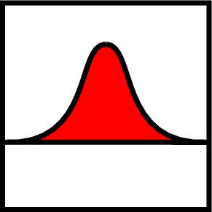
  - infectious subclinical period (days)
  - infectious clinical period (days)
  - natural immune period (days)
  - prevalence (0-1) of infected (latent, subclinical, and clinical) individuals vs. time (optional) 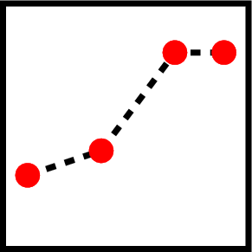
  - prevalence (0-1) of shedding (subclinical and clinical) individuals vs. time (optional)

Change 3. Section 4.1 (Direct contact spread) would be changed as follows:
- For each unit A,
  - Check whether A can be the source of an infection. That is, is it Latent, Infectious Subclinical, or Infectious Clinical, and not quarantined? (Infectious Clinical is always a source. Latent and Infectious Subclinical are optionally a source.)
  - If A cannot be a source, go on to the next unit.
  - If using fixed movement, the number of shipments N = [(day+1)×k] – [day×k]. Otherwise, sample N from a Poisson distribution whose mean is k. (k is calculated in step 1 above.)
  - Create N shipments from A.

3. For each shipment,
- Make a list of units that can be the recipient of a contact, that is, those that are not Destroyed or quarantined or are the source.
- If the list is empty, drop this shipment. No exposure is recorded; go on to the next shipment.
- Sample a number, distance, from the movement distance distribution.
- From the list, choose the unit B whose distance from the source is closest to distance. If several possible recipients are the same distance from the source,
    - Eliminate the ones where contact is forbidden by zone movement rules. If that eliminates all of them, drop this shipment.
    - Choose one randomly, giving preference to larger units (a unit with twice as many animals is twice as likely to be chosen).
- If movement from A to B is forbidden by zone movement rules (see below), drop this shipment.
- If B is not Susceptible, the shipment has no effect on the disease state but is recorded as an exposure; go on to the next shipment.
- If a within-unit prevalence chart has been specified for the source unit production type, set P = prevalence in source unit. Otherwise, set P = probability of infection given exposure. If a within-unit prevalence chart has not been specified for the source unit production type, set P = probability of infection given exposure. Otherwise, calculate P as shown below:
    - Determine the prevalence of infected (latent, subclinical, and clinical) individuals in the source unit on the indicated day from the appropriate relational function. Calculate the number of infected individuals (nInfected) by multiplying this prevalence and the total number of animals in the unit.
    - Calculate the number of animals in the shipment (nShipped) by multiplying the proportion of the unit included in the shipment (drawn from a probability density function) and the total number of animals in the unit. (Note that the number of animals in a shipment is used only for this probability calculation: the sizes of source and recipient units are not altered by the model.)
    - Calculate the probability of infection as P = 1 – Hypergeometric( 0, nShipped, nInfected, unitSize )
- Generate a random number r in [0,1), that is, from 0 up to but not including 1.
- If r < P, turn B Latent after a shipping delay.

Change 4. The parameters for direct contact spread in section 4.1 would be changed as shown below:

Parameters for direct contact spread
Parameters for each combination of source production type and recipient production type:
- Mean rate of movement (recipient-units for shipments per source-unit per day)
- use fixed movement (yes/no)
- movement distance (km)
- shipping delay (days)
- probability of infection given exposure (required if within-unit prevalence is not used)
- proportion of the unit included in a shipment (required if within-unit prevalence is used)
- movement rate multiplier vs. days since the first detection (for units not inside a zone focus)

Parameters for each combination of source production type and zone:
- movement rate multiplier vs. days since the first detection (for units inside a zone focus)

Change 5. The description of local-area spread (see RFC-20070313SD, 3nd draft) would be changed as shown below:
- For each unit A,
  - Check whether A can be the source of an infection. That is, is it Infectious Subclinical or Infectious Clinical?
  - If A cannot be a source, go on to the next unit.
  - For each other unit B,
    - Check whether B can be the recipient of an infection. That is, is it Suspectible, and is the direction from A to B inside the wind direction range?
    - If B cannot be a target, go on to the next unit.
    - Compute the probability of infection
P = 1 - exp (-k((n_{A} × p_{A})× n_{B})/d_{AB})
If a within-unit infectious prevalence chart has not been specified for the source unit production type, the prevalence term is dropped from the calculation.
    - Generate a random number r in [0,1).
    - If r < P, turn B Latent after a delay.
Where
      - k is a constant calculated as shown below
      - n_{A} is the herd size of infectious farm A
      - p_{A} is the prevalence of infectious shedding (subclinical and clinical) animals on farm A on the indicated day from the appropriate relational function
      - n_{B} is the herd size of susceptible farm B
      - d_{AB} is the distance between farms A and B

End of changes.

Discussion:
- This approach does not consider the actual number of infected animals that are introduced into a susceptible herd when a direct contact occurs, nor does it consider the disease stages of infected animals. A newly exposed herd will be treated as though a single animal is infected and becomes latent. This does not a change to current model behavior.

Carpenter, T.E., Thurmond, M.C., Bates, T.W., 2004. A simulation model of intraherd transmission of foot and mouth disease with special reference to disease spread before and after clinical diagnosis. J Vet Diagn Invest 16: 11-16.
See section Error: Reference source not found for a description of quarantine.

