Change to generation of artificial units to be used in disease simulation model

Background: Many times data on the location of production units is not available to model the spread of animal diseases. Therefore the analyst needs to create artificial animal populations locations based on the demographic data available. Traditionally such data has been created assuming complete spatial randomness which means that the production units are uniform (units have no tendency to occupy any particular region on the area) and independent (the location of a unit is independent on the location of any other units), therefore not exhibiting clustering. While this is a reasonable approximation for some cases, it is not the most appropriate assumption when an analyst wants to model regions where certain livestock industries like dairies or feed-lots are spatially clustered. We propose to incorporate a set of new facilities to generate populations that present different random and aggregated spatial patterns.

Implementation:
New features will be added under the “Setup Starting units” form in the software. The user will specify the four bounds of a rectangular region where the population will be created and then will have the option to either create a spatially clustered or spatially random population, based on a set of parameters. Alternatively the user will be able to load more complex bounds for the population, based on actual geographic regions.

Algorithms to create a spatially random population: The single user parameter needed will be n the number of units to create.
The algorithm will use a homogeneous Poisson process. If the area is a polygon use the conditional form, if the area is irregular use the unconditional form
  - Conditional form: For A fixed and given number of units in a region = m, generate m random locations based on a uniform distribution for the latitude and longitude
  - Unconditional form:
    - Generate a P(λ |A|) random variate and call this N(A) and then proceed as in the conditional form.
    - Embed A in a rectangle say [0, a] × [0, b], e.g.
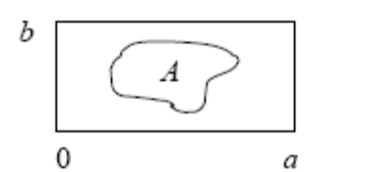
and then generate a Poisson process on the rectangle which is accomplished as follows:

1. Generate a Poisson process on the real line with intensity λ. For example, if E1, E2 ,. . . are independentexponential with mean 1/ λ , then points of the Poisson process are given by E1, E1+ E2, E1+ E2+ E3, ….

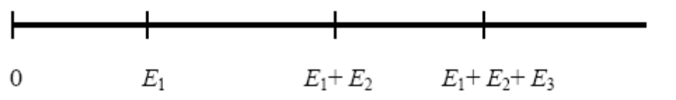
2. Generate U1, U2, . . . iid U((0, b]) random variables. The desired points are of the Poisson process on the rectangle are x1=(E1, U1), x 2=(E1+ E2, U2), . . . , x n=(E1+ . . . + En , Un), where E1+ . . . + En<a and E1+ . . . + En+1<a.

If there is more than one production type (PT), the procedure is repeated for each PT. The user will specify the number of units to be created for each production type, or alternatively the total number of units to be created and the proportion of unit from each PT.

Algorithms to create a clustered spatial population (Poisson clustered): The three parameters needed to create a Poisson clustered population will be the number of units to be created m, the number of clusters c, the average radius of the clusters r, and an alternative parameter p for the unit-level probability of being part of a cluster. The algorithm used to create the population is as follows:
- Generate m “parent” units based on a Poisson(lambda=m) as described for the spatially random population

- Fill in the clusters by:
  - Randomly select (without replacement) a parent unit
  - Allocate secondary units of the cluster based on a uniform distance distribution with min=0 and max=r
  - 1-p is the probability that a secondary units is not inside a cluster, hence use 1-p to allocate unit randomly in the region (outside of clusters)
  - Continue until all the secondary units are allocated

If there is more than one production type, the procedure is repeated for each PT. The user will specify the number of units to be created for each production type, or alternatively the total number of units to be created and the proportion of unit from each PT.

See figures 1 and 2 examples of a population created using the Poisson clustered algorithm with one and two PT’s respectivelly.

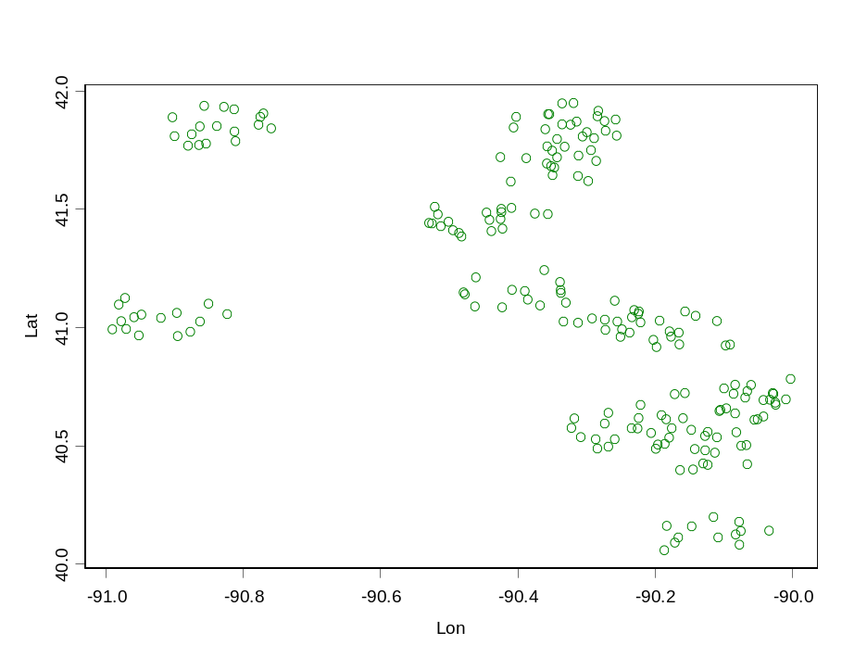
Figure 1: Clustered spatial population with 200 units, c=10, r=0.1 and p =.9

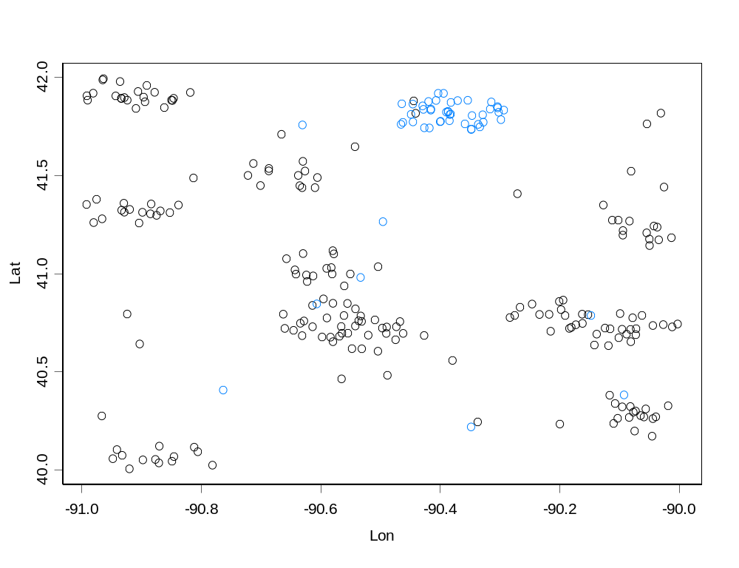
Figure 2: Clustered spatial population with 250 units (200 of “black” PT and 50 of “blue” PT), c=10, r=0.1 and p =.9

For either clustered or random populations, the size of the unit (the number of animals in the unit) will be randomly allocated to each unit based on a user defined probability mass function, using the random number generation methods already implemented in the model software.

