Request for comments

RFC20050928AR: Vaccination parameters for individual production types

1st draft: A. Reeves and B. Corso, September 28, 2005

Applies to: Model description v1.0.2a (June 11, 2005)

Type of change: Addition to the specification

Summary: This RFC describes the approach to vaccination used in legacy versions of SpreadModel, and proposes that it should be implemented in the current version of the model.

Justification: In legacy versions of SpreadModel, the decision to create a vaccination ring upon detection of an infected unit of a particular production type was independent from the decision to vaccinate units of that production type in response to the detection of nearby infected units. For example, detection of an infected swine herd could trigger a vaccination ring around the unit, but surrounding swine units would not have to be vaccinated. This “decoupling” is not yet available in the current model: if units of a production type can trigger vaccination rings, then they must always be vaccinated as part of a control strategy.

This proposed change is intended to re-create the approach to vaccination present in legacy versions of SpreadModel. Other options may be available: alternative proposals are encouraged.

Change: This change applies to Section 6.3 (Vaccination), first paragraph. Current text to be deleted is struck out, proposed new text is highlighted:

6.3. Vaccination

When the disease is detected, authorities may also initiate a vaccination campaign. This consists of vaccinating units within a specified distance of the detected units – in circles or rings around detected units. A production-type-specific parameter determines whether detection of an infected unit of a particular production type will trigger the formation of a vaccination ring or not: for example, detection of an infected swine unit might lead to the vaccination of surrounding units of various production types, while detection of an infected sheep unit might not trigger vaccination of surrounding units.

A production-type-specific parameter also governs whether units of a particular production type are included in a vaccination program. For example, dairy cattle units might be vaccinated in response to the detection of a diseased unit nearby, while sheep units might not be vaccinated.

The decision to vaccinate may be delayed until a certain trigger point is reached in terms of numbers of detected units.

Change: This change applies to Section 6.3 (Vaccination), parameter list. Proposed new text is highlighted:

Vaccination program parameters
Global parameters (applied to all production types):
- number of detected units before vaccination begins
- vaccination capacity vs. days since the first detection (units per day ) 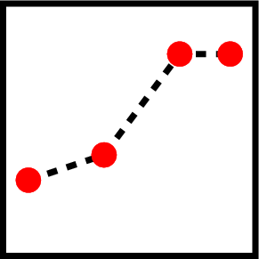 (see section 6.3.1)
- vaccination priorities (see section 6.3.2)

Parameters set individually for each production type:
- indication of whether detection of units of the production type will trigger a vaccination ring (yes/no)
- radius of vaccination ring (km), if units of the production type will trigger a vaccination ring
- indication of whether units of the production type will be vaccinated in response to detection of nearby units (yes/no)
- minimum time between vaccinations (days), if units of the production type will be vaccinated (see section 6.3.3)

End of changes

