Request for comments

RFC20051111NHb: Zones

1st draft: N. Harvey, November 11, 2005
2nd draft: N. Harvey, January 16, 2006
- fixed mistakes pointed out in Dec. 22 conference call
- added a flowchart
- added walkthrough examples
- removed the quarantine/zone leakage rules so that those can be discussed separately
3rd draft: N. Harvey, May 15, 2006
- included decisions made in May 11 conference call

Applies to: Model description v1.0.6

Type of change: New feature, for next major version

Summary: This RFC proposes adding disease-control zones that modify movement and detection.

Justification: Requested in the document Action plan for Sharcspread Team following QUADS modelling workshop, Canberra, March 8-10 2005 (sent to N. Harvey by C. Dubé on 8 Apr 2005). Also extensively discussed within the modeling group.

Change: This change applies to Section 4.1 (Direct contact spread). It adds a step where a contact is dropped if it would violate zone rules.

Note that the best-matching recipient (by distance) is chosen before we consider zone rules. This is the “gingerbread man” rule discussed in Feb. 2005, meant to prevent an “edge effect” from happening at zone boundaries.

Proposed new text is highlighted:

The simulation of direct contact – movement of animals among units – works as follows:

On each day,
- Look up a multiplier to adjust the rate of movement of animals based on the number of days since the first detection of the disease. Use this multiplier to scale the movement rate. This approximates applying movement-controls over the course of an infection spreading through the population of units.
- For each unit A,
  - Check whether A can be the source of an infection. That is, is it Latent, Infectious Subclinical, or Infectious Clinical, and not quarantined? (Infectious Clinical is always a source. Latent and Infectious Subclinical are optionally a source.)
  - If A cannot be a source, go on to the next unit.
  - Sample a number N from a Poisson distribution whose mean is the movement rate (adjusted by 1 above).
  - Create N shipments from A.
- For each shipment,
  - Make a list of units that can be the recipient of a contact, that is, those that are not Destroyed or quarantined or are the source.
  - If the list is empty, drop this shipment. No exposure is recorded; go on to the next shipment.
  - Sample a number, distance, from the movement distance distribution.
  - From the list, choose the unit B whose distance from the source is closest to distance. If several possible recipients are the same distance from the source,
    - Eliminate the ones where contact is forbidden by zone movement rules. If that eliminates all of them, drop this shipment.
    - Choose one randomly, giving preference to larger units (a unit with twice as many animals is twice as likely to be chosen).
  - If movement from A to B is forbidden by zone movement rules (see below), drop this shipment.
  - If B is not Susceptible, the shipment has no effect on the disease state but is recorded as an exposure; go on to the next shipment.
  - Generate a random number r in [0,1), that is, from 0 up to but not including 1.
  - If r < P, the probability of infection given exposure, turn B Latent after a shipping delay.

Change: This new flowchart replaces the old one. The changed section is highlighted. Note that paths that result in dropping a shipment are emphasized in red.

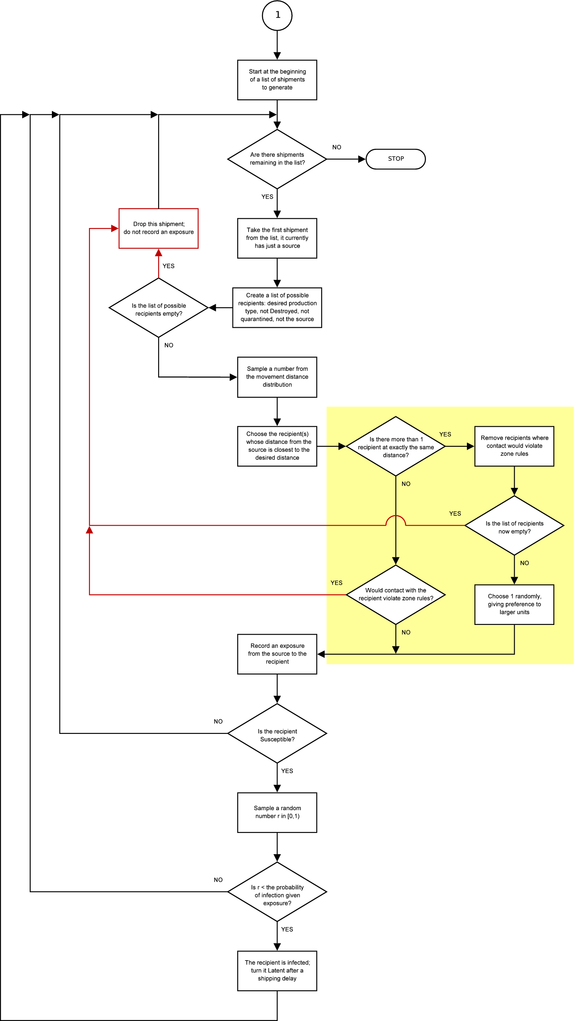

Change: This change also applies to Section 4.1 (Direct contact spread.) This new text is to be added before the paragraph that begin “The progress of the disease in the receiving unit...”:

Direct contact between units is forbidden if either the source unit or receiving unit if quarantined (see section 6.1). Direct and indirect contact between units can also be forbidden if the source unit and receiving unit are in physically separated foci of the same zone, or if the source unit is in a zone of a higher surveillance level than the receiving unit (figures 2-3, see also section 6.4).

Change: Three new figures are to be added to Section 4.1 (Direct contact spread).

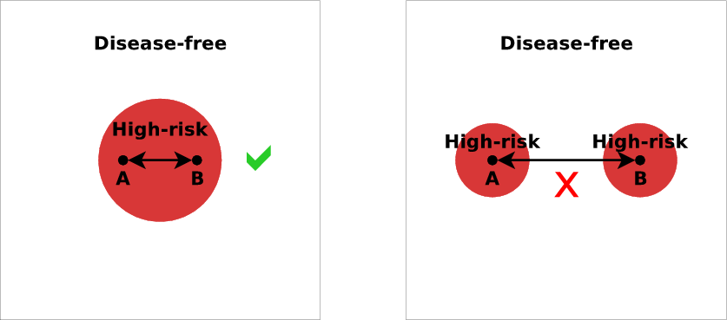
Figure 2. Movement inside a zone may be allowed, but movement
between physically separated foci of the same zone is not.

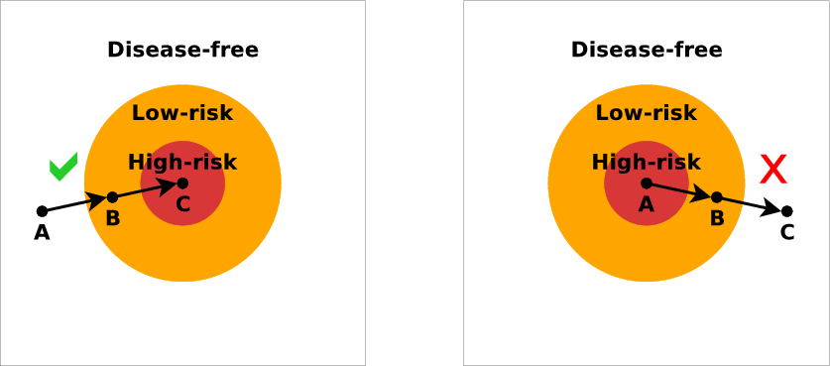
Figure 3. Movement from a zone to an adjacent zone of a
higher surveillance level is allowed, but not vice-versa.

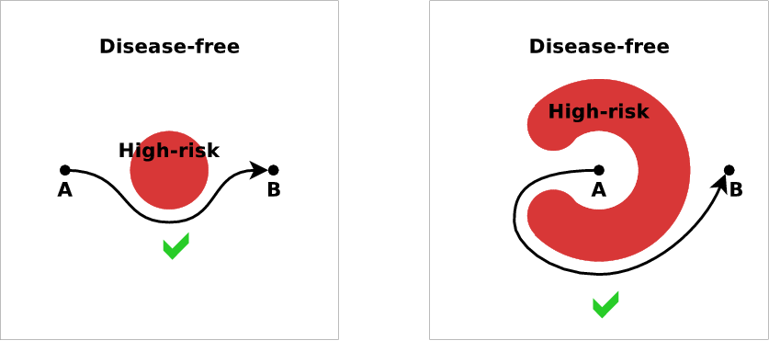
Figure 4. Movement that would cross a zone of a higher surveillance
level “as the crow flies” but where a “detour” exists, is allowed.

Subsequent figures would be renumbered appropriately.

Change: This change also applies to Section 4.1 (Direct contact spread). This change adds some examples of how contact recipients would be chosen with zone rules.

Most of the text here is repeated from RFC20051222NH – Quarantine. It has been slightly modified, to consistently use the term “recipient” instead of “target”.

Current text to be deleted is struck out, proposed new text is highlighted:

As an example, suppose that shipments are being generated from “Beef” to “Dairy” units. In step 3, shipments are being generated from a particular source unit of production type “Beef”. Other units in the population are:

Unit 1. Swine unit, Susceptible, not quarantined, 25 km away
Unit 2. Dairy unit, Susceptible, not quarantined, 40 km away
Unit 3. Dairy unit, Susceptible, not quarantined, 300 km away

In step 3a, the possible target units recipients are units 2 and 3. (Unit 1 is excluded because shipments from Beef units to Swine units are separate from and independent of shipments from Beef units to Dairy units. See notes on multiple production types below.) Suppose that in step 3c, the value “30 km” is sampled from the movement distance distribution. Unit 2 will be chosen because 40 km is closer than 300 km to the desired movement distance of 30 km.

Suppose that the other units were instead:

Unit 1. Swine unit, Susceptible, not quarantined, 25 km away
Unit 2. Dairy unit, Infectious Clinical, not quarantined, 40 km away
Unit 3. Dairy unit, Susceptible, not quarantined, 300 km away

In this case, unit 2 will still be chosen. The fact that unit 2 is already diseased does not affect the decision.

An example with a Destroyed unit:

Unit 1. Swine unit, Susceptible, not quarantined, 25 km away
Unit 2. Dairy unit, Destroyed, 40 km away
Unit 3. Dairy unit, Susceptible, not quarantined, 300 km away

In this case, the only possible target recipient is unit 3, so it will be chosen. It does not matter that 300 km is much farther than the desired movement distance of 30 km, only that of all possible targets recipients (in this case there is only one), 300 km is the best match.

A final example An example where there are no possible recipients:

Unit 1. Swine unit, Susceptible, not quarantined, 25 km away
Unit 2. Dairy unit, Destroyed, 40 km away
Unit 3. Dairy unit, Susceptible, quarantined, 300 km away

In this case, the shipment will be “dropped” because there is no possible target unit in the population.

The following cases illustrate how zone rules can affect contacts. Suppose the source “Beef” unit is inside a zone focus. Other units in the population are:

Unit 1. Dairy, Susceptible, quarantined, inside the same zone focus, 30 km away
Unit 2. Dairy, Susceptible, not quarantined, inside the same zone focus, 31 km away
Unit 3. Dairy, Susceptible, not quarantined, outside the zone focus, 25 km away

Suppose we decide, again, to generate a 30 km shipment. Although unit 1 is exactly 30 km away, it will not be considered because it is quarantined (it is excluded in step 3a). Unit 2 will be chosen because 31 km is closest to 30 km. Unit 2 is inside the same zone focus as the source, so the shipment is not blocked by zone rules.

Suppose instead that the distances of units 2 and 3 were exchanged:

Unit 1. Dairy, Susceptible, quarantined, inside the same zone focus, 30 km away
Unit 2. Dairy, Susceptible, not quarantined, inside the same zone focus, 25 km away
Unit 3. Dairy, Susceptible, not quarantined, outside the zone focus, 31 km away

Again, unit 1 is excluded because it is quarantined. Unit 3 will be chosen because 31 km is closest to 30 km. However, unit 3 is outside the zone focus that the source is in, so the shipment is blocked by zone rules and dropped.

A final example:

Unit 1. Dairy, Susceptible, quarantined, inside the same zone focus, 30 km away
Unit 2. Dairy, Susceptible, not quarantined, inside the same zone focus, 30 km away
Unit 3. Dairy, Susceptible, not quarantined, outside the zone focus, 30 km away

Again, unit 1 is excluded because it is quarantined. Units 2 and 3 both match the chosen shipment distance of 30 km. According to step 3d, we can eliminate the contact that would be blocked by zone rules (unit 3), and so we choose unit 2.

Change: This change also applies to Section 4.1 (Direct contact spread). This change, plus the next two changes, show which parameters are specified by zone: direct & indirect contact rate multipliers, and detection probability. Current text to be deleted is struck out, proposed new text is highlighted:

Parameters for direct contact spread
Parameters for each pair of production types combination of source production type and recipient production type:
- Mean rate of movement (recipient-units for shipments per source-unit per day)
- movement distance (km) 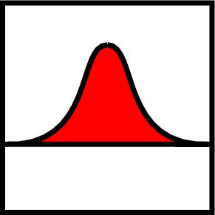
- shipping delay (days)
- probability of infection given exposure
- movement rate multiplier vs. days since the first detection (for units not inside a zone focus) 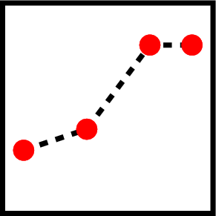

Parameters for each combination of source production type and zone:
- movement rate multiplier vs. days since the first detection (for units inside a zone focus)
Change: This change applies to Section 4.2 (Indirect contact spread). Current text to be deleted is struck out, proposed new text is highlighted:

Parameters for indirect contact spread
Parameters for each pair of production types combination of source production type and recipient production type:
- Mean rate of movement (recipient-units for shipments per source-unit per day)
- movement distance (km)
- shipping delay (days)
- probability of infection given exposure
- movement rate multiplier vs. days since the first detection (for units not inside a zone focus)

Parameters for each combination of source production type and zone:
- movement rate multiplier vs. days since the first detection (for units inside a zone focus)

Change: This change applies to Section 5 (Detection). Current text to be deleted is struck out, proposed new text is highlighted:

The simulation of detection works as follows:

On each day,
- Look up the probability that a farmer or attending veterinarian, for example, will report signs of disease to authorities based on the number of days since the first detection in the population. A nonzero static probability represents the baseline before the first detection.
- For each Infectious Clinical unit,
  - Look up the probability of detecting signs of disease based on the number of days the unit has been Infectious Clinical.
  - If the unit is not inside a zone focus,
    - Compute the probability of detection and reporting as
P = (probability of detecting signs of disease) × (probability of reporting)
Go to step d.
  - If the unit is inside a zone focus,
    - Compute the probability of detection and reporting as
P = (probability of detecting signs of disease) × (zone multiplier)
Note that the probability of reporting is assumed to be 1 inside a zone focus, so that value drops out of the calculation.
  - Compute the probability of detection and reporting (Equation 1 X 2a).
  - Generate a random number r in [0,1).
  - If r < P, the disease is detected and reported.

Change: This change also applies to Section 5 (Detection). Current text to be deleted is struck out, proposed new text is highlighted:

Detection parameters
Parameters for each production type:
- probability of reporting vs. days since the first detection
- probability of detection vs. days the unit has been Infectious Clinical

Parameters for each combination of production type and zone:
- multiplier for probability of detection

The parameters are given separately for each production type, to account for the possibility that signs of disease may be more obvious in animals of certain production-types, e.g., signs may be reported more rapidly in intensive swine production systems versus cow-calf operations on pastures. The multiplier for detection of units inside a zone focus allows for the simulation of greater vigilance in higher-level zones (see section 6.4).

Change: Add a new subsection to Section 6 (Control measures).

6.4. Zones

Zones are areas of differing surveillance and control policies. This section describes how zones are established; see also sections 4 and 5 for a discussion of how zones affect movement and detection, respectively.

There can be an arbitrary number of zones, each with a name. The basic form of a zone is a circle around a unit. Higher levels of surveillance correspond to smaller circles. Areas outside the circle also constitute a zone, with the lowest surveillance level (figure 8).

A “focus” of a zone can be established around any unit that is detected as diseased. A focus can also be established around any “dangerous contact” unit that has been discovered through tracing (see section 6.2). The number and size of zone rings established is always the same and does not depend on the production type of the unit that caused the zone focus (figure 9).

Overlapping foci of the same zone merge (figure 10). Zones with lower surveillance levels are absorbed when enclosed by a zone of a higher surveillance level (the “no donuts” rule, figure 11).

Zone parameters
Parameters set individually for each zone:
- name
- radius (km)

Parameters set individually for each production type:
- indication of whether detection of diseased units of the production type will create a zone focus (yes/no)
- indication of whether traced “dangerous contacts” of this production type will create a zone focus (yes/no)

Change: Four new figures are to be added to the new section 6.4.

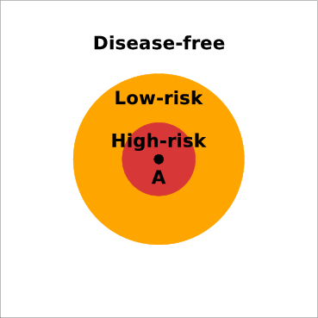
Figure 8. A focus with 2 zones established around it.

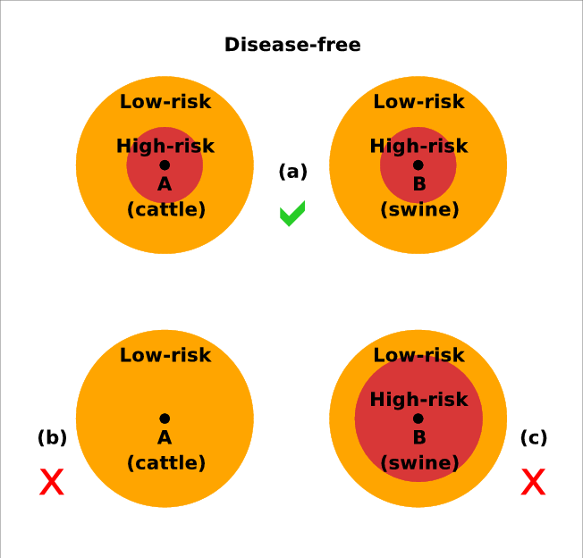
Figure 9. Zones are triggered uniformly, regardless of the production types which triggered the zone focus (a). It is not possible to trigger only selected zones (b) or zones of different sizes (c) around different production types.

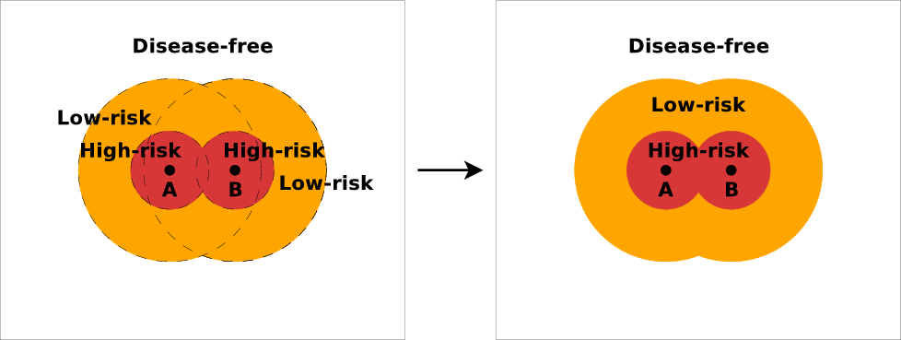
Figure 10. Overlapping foci of the same zone merge.

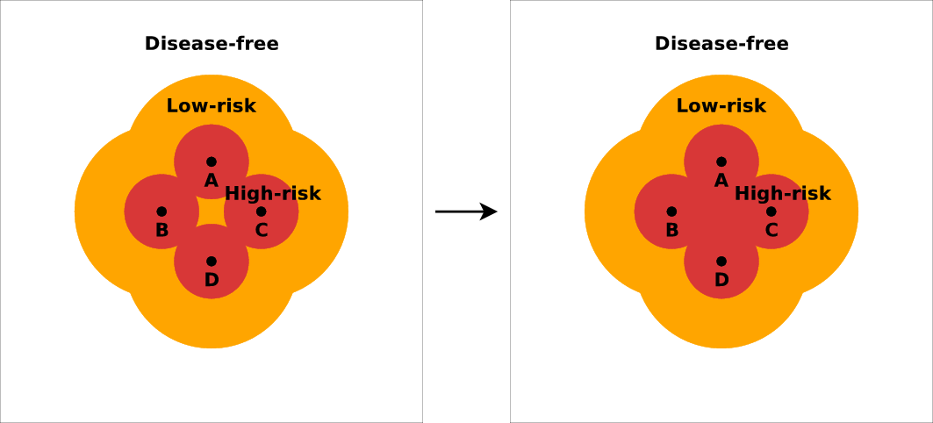

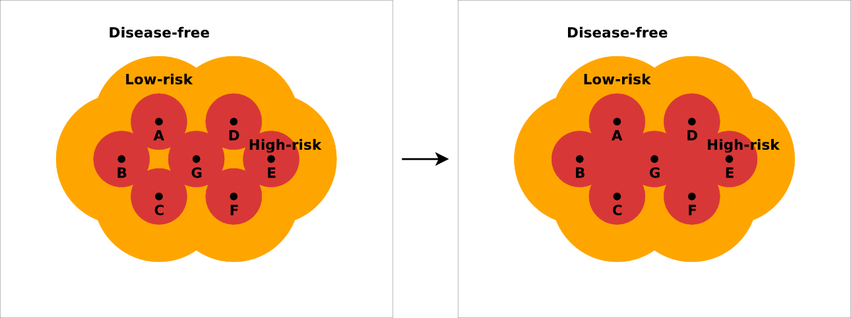
Figure 11. Enclosed areas of a lower surveillance level are absorbed. Note that adding
a new focus (G) can create more than one enclosed area that must be absorbed.

End of changes

Attachment: excerpt from Action plan for Sharcspread Team following QUADS modelling workshop, Canberra, March 8-10 2005.

List of features to be included in Sharcspread:

...

3. Disease control zones.
These are not different than what was already discussed.

Reference: Report on Detection / Surveillance discussions by C. Dubé, circulated 16 Aug 2004.

