Request for comments

RFC20051130NH: Detection diagram

1st draft: N. Harvey, November 30, 2005
2nd draft: N. Harvey, December 2, 2005 (switched the green and purple dots in the graph on the right)
3rd draft: A. Reeves, January 3, 2006 (added captions to the two figure panels, as communicated by C. Dubé)

Applies to: Model description v1.0.3

Type of change: Clarification

Summary: This RFC proposes adding a figure to the detection section.

Justification: There was a bug in NAADSM concerning detection, and from the emails discussing the bug, there still seems to be confusion about how the calculation works, particularly before the first detection.

Change: This change applies to Section 5 (Detection). Proposed new text is highlighted:

On each day,
- Look up the probability that a farmer or attending veterinarian, for example, will report signs of disease to authorities based on the number of days since the first detection in the population. A nonzero static probability represents the baseline before the first detection.

Change: This change also applies to Section 5 (Detection). This new figure would be added:

On-farm awareness  (Probability of detecting disease)  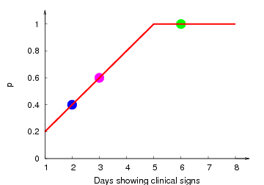 | Overall awareness  (Probability of reporting to authorities)  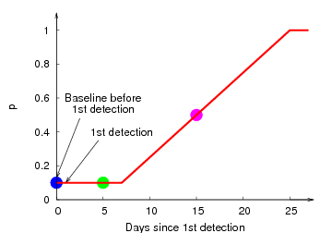
Figure 3. Probability of detection and reporting is found by two charts. In this example,
● before 1st detection, 2nd day of clinical signs, P = 0.1 × 0.4 = 0.04
● 5 days since 1st detection, 6th day of clinical signs, P = 0.1 × 1 = 0.1
● 15 days since 1st detection, 3rd day of clinical signs, P = 0.5 × 0.6 = 0.3

Subsequent figures would be renumbered appropriately.

End of changes

