Request for comments

RFC20051208NH: Destruction parameters for individual production types

1st draft: N. Harvey, December 8, 2005, text mostly re-used from RFC20050928AR (A. Reeves and B. Corso)

Applies to: Model description v1.0.3

Type of change: Addition to the specification

Summary: This RFC proposes to change the way ring destruction is described in the model description document.

Justification: Discussion following Dec. 2 2005 conference call (emails included at the end of this document) indicates that the NAADSM code does not implement ring destruction as the group intended, so a clarification in the document and fixes to the code are needed.

Change: This change applies to Section 6.2 (Destruction). Proposed new text is highlighted:

All detected units are marked for destruction. Units that have had contact with diseased units within a given number of days prior to detection of the diseased unit (found through trace-investigations) and units within a given distance of diseased units may also be marked for destruction. The destruction of these units associated by trace or distance has been called pre-emptive or dangerous-contact slaughter.

A production-type-specific parameter determines whether detection of an infected unit of a particular production type will trigger the formation of a destruction ring or not: for example, detection of an infected swine unit might lead to the destruction of surrounding units of various production types, while detection of an infected sheep unit might not trigger destruction of surrounding units.

A production-type-specific parameter also governs whether units of a particular production type are included in a destruction ring. For example, dairy cattle units might be destroyed in response to the detection of a diseased unit nearby, while sheep units might not be destroyed.

Trace-investigations are immediate. Tracing goes one level forward, that is, it identifies units that were recipients of direct or indirect contact from infected, detected units. Tracing does not identify contacts that led to the infection of infected, detected units. (Figure 3).

Change: This change also applies to Section 6.2 (Destruction). Proposed new text is highlighted:

Destruction parameters
Global parameters (applied to all production types):
- delay to begin a destruction program (days)
- destruction capacity vs. days since the first detection (units per day) 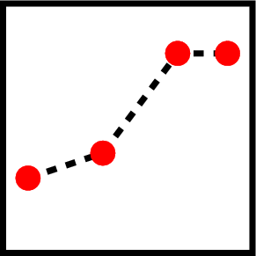 (see section 6.2.1)
- destruction priorities (see section 6.2.2)

Parameters specified separately for every production type:
- probability of a trace-out investigation succeeding
- period of interest for trace-out investigations
- indication of whether detection of units of the production type will trigger a destruction ring (yes/no)
- radius of destruction ring (km), if units of the production type will trigger a destruction ring
- indication of whether units of the production type will be destroyed in response to detection of nearby units (yes/no)

End of changes

Attachment: email communication

From: Barbara.A.Corso@aphis.usda.gov <Barbara.A.Corso@aphis.usda.gov>
To: aehill@lamar.colostate.edu, m.d.salman@colostate.edu, Aaron.P.Reeves@aphis.usda.gov, barbara.a.corso@aphis.usda.gov, FZagmutt@aphis.usda.gov, Kenneth.W.Forsythe@aphis.usda.gov, Steve.Weber@aphis.usda.gov, Mark.E.Teachman@aphis.usda.gov, Ann.H.Seitzinger@aphis.usda.gov, dubecm@inspection.gc.ca, nharvey@uoguelph.ca, Conrad.Estrada@aphis.usda.gov
Date: Dec 2, 2005 2:07 PM
Subject: answer to destruction question

Old Version destruction: for each production type you say whether you want to trigger a ring when that type herd is detected, and whether you want to destroy that type when they are in a ring. The interface of the new version indicates - to me, anyway - that it does the same. Is that true or false?
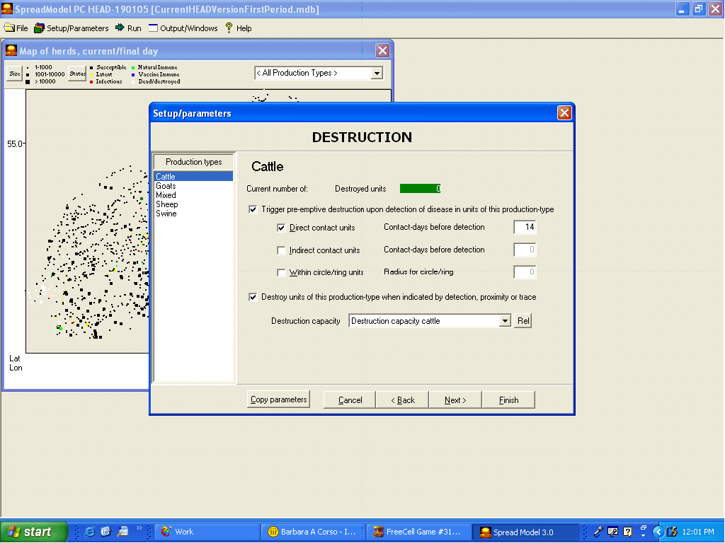

Attachment: email communication

From: Neil Harvey <neilharvey@gmail.com>
To: "Barbara.A.Corso@aphis.usda.gov" <Barbara.A.Corso@aphis.usda.gov>
CC: aehill@lamar.colostate.edu, m.d.salman@colostate.edu, Aaron.P.Reeves@aphis.usda.gov, barbara.a.corso@aphis.usda.gov, FZagmutt@aphis.usda.gov, Kenneth.W.Forsythe@aphis.usda.gov, Steve.Weber@aphis.usda.gov, Mark.E.Teachman@aphis.usda.gov, Ann.H.Seitzinger@aphis.usda.gov, dubecm@inspection.gc.ca, nharvey@uoguelph.ca, Conrad.Estrada@aphis.usda.gov
Date: Dec 2, 2005 2:16 PM
Subject: Re: answer to destruction question

Hi Barbara,
On 12/2/05, Barbara Corso <Barbara.A.Corso@aphis.usda.gov> wrote:
> Old Version destruction: for each production type you say whether
> you want to trigger a ring when that type herd is detected, and
> whether you want to destroy that type when they are in a ring.
> The interface of the new version indicates - to me, anyway - that it
> does the same. Is that true or false?

False. The underlying code triggers a ring on *any* detection, and it lets you specify which production types are included in a ring.
So you can say:
kill all cows within 5 km of a detection
kill all pigs within 2 km of a detection
don't kill sheep
But you *cannot* say:
trigger rings only around detected pig units
trigger 5 km rings around pigs, but only 2 km rings around cattle
kill cattle in the rings, but not goats
etc.
Sounds like that's not at all in sync with the intention. Good thing we looked at this!

Neil

