Request for comments

RFC20051222NH: Quarantine

1st draft: N. Harvey, December 22, 2005
2nd draft: N. Harvey, Janaury 6, 2006 - added flowcharts

Applies to: Model description v1.0.4

Type of change: Clarification

Summary: This RFC proposes adding notes to the direct contact section about potential recipients that are quarantined, about distance limits for shipments, and about the conditions under which a shipment can be dropped.

Justification: Discussion on the Dec. 22 2005 conference call indicated that these points are not clear in the document.

Change: This change applies to Section 4.1 (Direct contact spread), step 3. Proposed new text is highlighted:

On each day,
- Look up a multiplier to adjust the rate of movement of animals based on the number of days since the first detection of the disease. Use this multiplier to scale the movement rate. This approximates applying movement-controls over the course of an infection spreading through the population of units.
- For each unit A,
  - Check whether A can be the source of an infection. That is, is it Latent, Infectious Subclinical, or Infectious Clinical, and not quarantined? (Infectious Clinical is always a source. Latent and Infectious Subclinical are optionally a source.)
  - If A cannot be a source, go on to the next unit.
  - Sample a number N from a Poisson distribution whose mean is the movement rate (adjusted by 1 above).
  - Create N shipments from A.
- For each shipment,
  - Sample a number, distance, from the movement distance distribution.
  - From all units that can be the target of disease exposure (that is, those that are not Destroyed or quarantined or are the source), choose the unit B whose distance from the source is closest to distance. If several possible targets are the same distance from the source, choose one randomly, giving preference to larger units (a unit with twice as many animals is twice as likely to be chosen).
  - If no target B could be found, this shipment is dropped. Do not record an exposure; go on to the next shipment. This can happen if there are no units of the desired target production type or if all units of the desired target production type are Destroyed or quarantined.
  - If B is not Susceptible, the shipment has no effect on the disease state but is recorded as an exposure; go on to the next shipment.
  - Generate a random number r in [0,1), that is, from 0 up to but not including 1.
  - If r < P, the probability of infection given exposure, turn B Latent after a shipping delay.

These steps are also illustrated as a flowchart in figure 2.

Note that this differs from the way Caroline described Graeme's implementation. Instead of saying that if the target you pick is quarantined, you do a certain number of “re-tries” to find one that is not, we exclude quarantined units from the list of potential targets before picking a target (step b).

Change: A new figure spanning 2 pages is to be added to Section 4.1 (Direct contact spread).

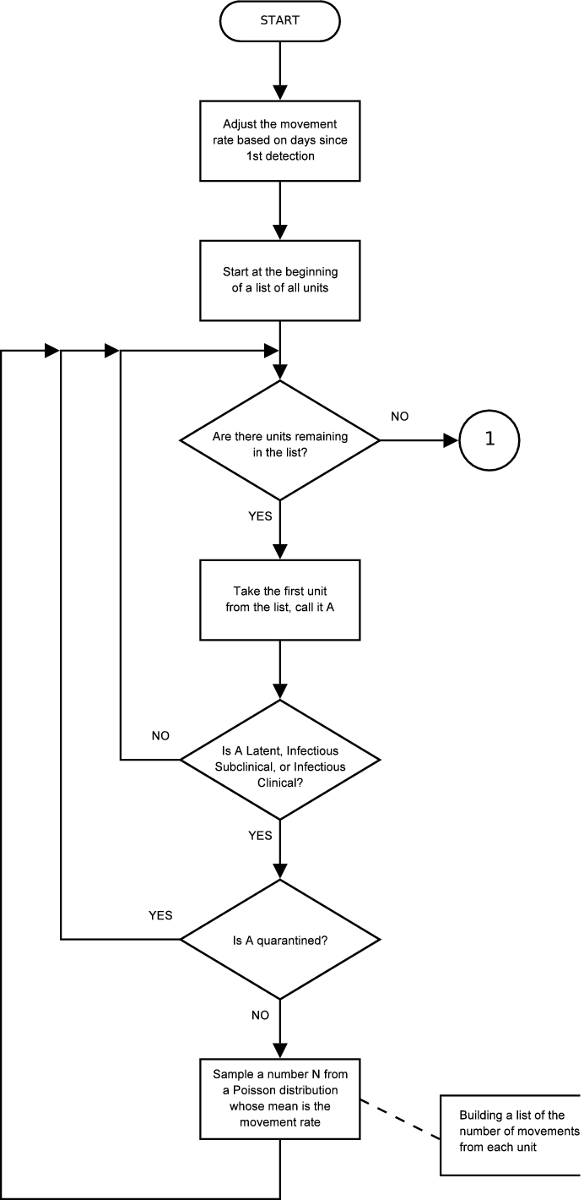

Figure 2: Generating direct contacts. The number in the circle links
to the continued flowchart on the next page.

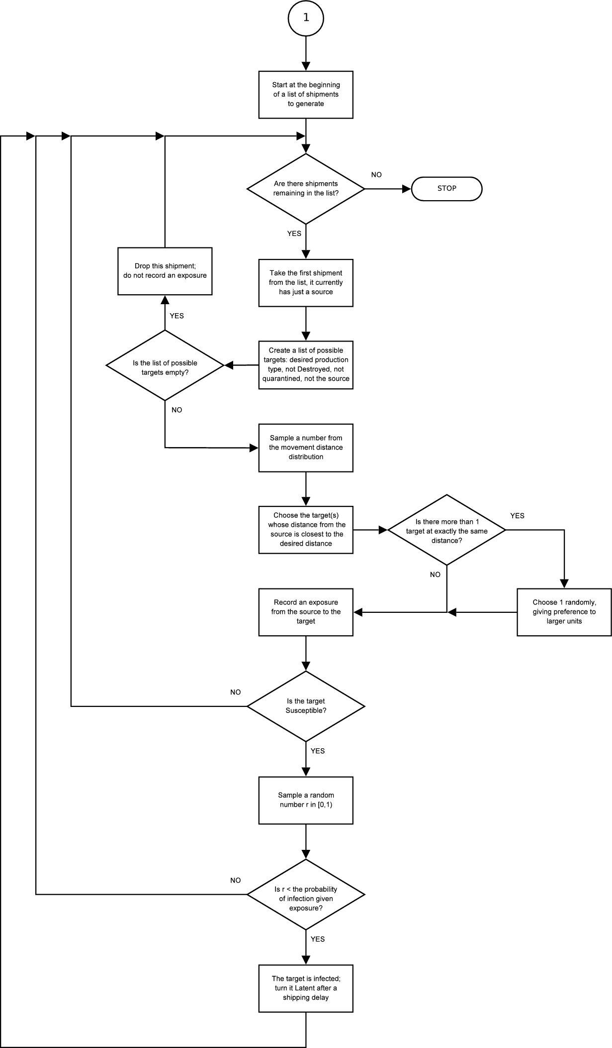

Figure 2 (cont'd): Generating direct contacts. The number in the circle
continues the flowchart on the previous page.

Subsequent figures would be renumbered appropriately.

Change: This change applies to Section 4.1 (Direct contact spread), step 3. These examples would immediately follow the step-by-step description above.

As an example, suppose that shipments are being generated from “Beef” to “Dairy” units. In step 3, shipments are being generated from a particular source unit of production type “Beef”. Other units in the population are:

Unit 1. Swine unit, Susceptible, not quarantined, 25 km away
Unit 2. Dairy unit, Susceptible, not quarantined, 40 km away
Unit 3. Dairy unit, Susceptible, not quarantined, 300 km away

Suppose that in step 3a, the value “30 km” is sampled from the movement distance distribution. In step 3b, the possible target units are units 2 and 3. (Unit 1 is excluded because shipments from Beef units to Swine units are separate from and independent of shipments from Beef units to Dairy units. See notes on multiple production types below.) Unit 2 will be chosen because 40 km is closer than 300 km to the desired movement distance of 30 km.

Suppose that the other units were instead:

Unit 1. Swine unit, Susceptible, not quarantined, 25 km away
Unit 2. Dairy unit, Infectious Clinical, not quarantined, 40 km away
Unit 3. Dairy unit, Susceptible, not quarantined, 300 km away

In this case, unit 2 will still be chosen. The fact that unit 2 is already diseased does not affect the decision.

An example with a Destroyed unit:

Unit 1. Swine unit, Susceptible, not quarantined, 25 km away
Unit 2. Dairy unit, Destroyed, 40 km away
Unit 3. Dairy unit, Susceptible, not quarantined, 300 km away

In this case, the only possible target is unit 3, so it will be chosen. It does not matter that 300 km is much farther than the desired movement distance of 30 km, only that of all possible targets (in this case there is only one), 300 km is the best match.

A final example:

Unit 1. Swine unit, Susceptible, not quarantined, 25 km away
Unit 2. Dairy unit, Destroyed, 40 km away
Unit 3. Dairy unit, Susceptible, quarantined, 300 km away

In this case, the shipment will be “dropped” because there is no possible target unit in the population.

End of changes

