Request for comments

RFC20060202AR: Trace surveillance

1st draft: A. Reeves, February 2, 2006

Applies to: Model description v1.0.5

Type of change: Addition to the specification

Summary: The proposed changes document the behavior of the current version of the core model regarding the process of trace surveillance.

Justification: Legacy versions of SpreadModel featured surveillance as a component separate from disease control measures. Two forms of surveillance were available: trace surveillance (simulating the process of tracing forward to units that were recipients of contact from infected, detected units) and ring surveillance (counting the number of units surrounding detected, infected units).

The most recent version (as of this writing) of the core NAADSM model re-implements trace surveillance. This RFC explicitly documents the behavior of the core model and separates the process of surveillance from destruction.

In the most recent version of the core model, units identified by trace surveillance are quarantined: surveillance, then, may affect disease spread. Surveillance does not, however, affect the process of disease detection. We may wish to address this latter point in the future.

Change: This change would insert a new section to the existing model specification document between the current sections Detection and Control Measures. Most of the language for this new section (Surveillance) is taken directly from the existing subsection Destruction.

6. Surveillance
Surveillance in the model refers to the process of identifying units at high risk for disease based upon exposure or (potentially) proximity to infected, detected units. Units identified by surveillance will be quarantined and thus can no longer spread disease by direct contact (see section 7.1).

Surveillance does not affect disease detection: that is, units subject to surveillance which become infected are no more likely to be detected than other units of the same production type.

6.1 Trace surveillance

Units that have had contact with diseased units within a given number of days prior to detection of the diseased unit may be identified by trace investigations. Units subjected to surveillance will be quarantined. Optionally, units identified by trace surveillance may be preemptively destroyed (see section 7.2).

Trace-investigations are immediate. Tracing goes one level forward, that is, it identifies units that were recipients of direct or indirect contact from infected, detected units. Tracing does not identify contacts that led to the infection of infected, detected units (Figure 6-1).

Trace surveillance parameters
Parameters specified separately for every production type:
- probability of a trace-out investigation succeeding when direct contact has occurred
- period of interest for trace-out investigations of direct contacts
- probability of a trace-out investigation succeeding when indirect contact has occurred
- period of interest for trace-out investigations of indirect contacts

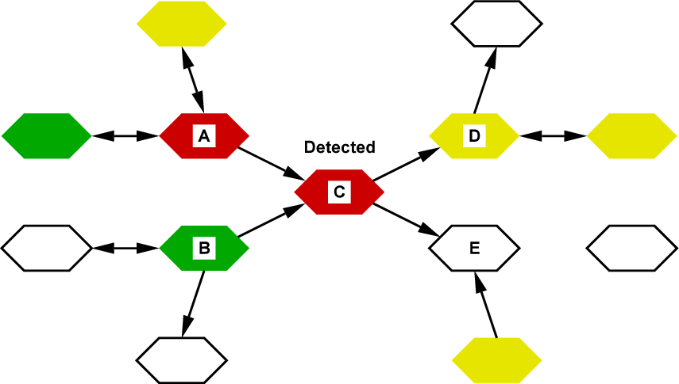

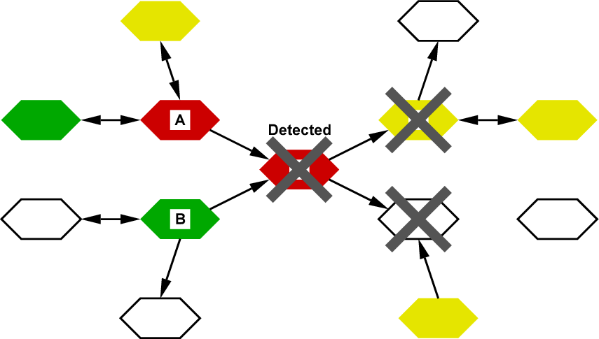
Figure 6-1. Trace out. When unit C is detected, units to which C has shipped animals or sent people or equipment are quarantined and may be marked for destruction. The trace does not extend further, e.g., to units that shipped animals to C (A or B), or units that received animals from D.
Change: All sections, subsections, etc., following the newly inserted section will be renumbered as required.

Change: Section 7.2 (Destruction), formerly section 6.2, will be revised as indicated below. New text is highlighted, removed text is struck through.

7.2. Destruction

When the first detection happens in the study population, the authorities may initiate a destruction program. It can take several days before the authorities are ready to begin destroying.

All detected units are marked for destruction. Units that have had contact with diseased units within a given number of days prior to detection of the diseased unit (found through trace-investigations: see section 6.1) and units within a given distance of diseased units may also be marked for destruction. The destruction of these units associated by trace or distance has been called pre-emptive or dangerous-contact slaughter.

A production-type-specific parameter determines whether detection of an infected unit of a particular production type will trigger the formation of a destruction ring or not: for example, detection of an infected swine unit might lead to the destruction of surrounding units of various production types, while detection of an infected sheep unit might not trigger destruction of surrounding units.

A production-type-specific parameter also governs whether units of a particular production type are included in a destruction ring. For example, dairy cattle units might be destroyed in response to the detection of a diseased unit nearby, while sheep units might not be destroyed.

Trace-investigations are immediate. Tracing goes one level forward, that is, it identifies units that were recipients of direct or indirect contact from infected, detected units. Tracing does not identify contacts that led to the infection of infected, detected units (Figure 6-1).

Destruction parameters
Global parameters (applied to all production types):
- delay to begin a destruction program (days)
- destruction capacity vs. days since the first detection (units per day) 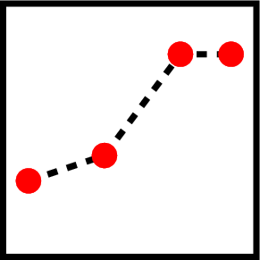 (see section 6.2.1)
- destruction priorities (see section 6.2.2)

Parameters specified separately for every production type:
- probability of a trace-out investigation succeeding
- period of interest for trace-out investigations
- indication of whether detection of units of the production type will trigger a destruction ring (yes/no)
- radius of destruction ring (km) , if units of the production type will trigger a destruction ring
- indication of whether units of the production type will be destroyed in response to detection of nearby units (yes/no)
- indication of whether units of this production type identified by trace surveillance after direct contact will be destroyed (yes/no)
- indication of whether units of this production type identified by trace surveillance after indirect contact will be destroyed (yes/no)

End of changes

