Request for comments

RFC20070426AR: Direct costs of surveillance in zones

1st draft: A. Reeves,April 26, 2007

Applies to: Model description v1.0.7 (April 24, 2007) and RFC20051111NHb (Zones)

Type of change: New feature, for NAADSM version 3.1

Summary: This RFC describes the parameters and calculations needed to determine the costs associated with surveillance within zones.

Justification: Legacy versions of SpreadModel had a cost accounting mechanism for ring surveillance (see attachment 1 below). In NAADSM 3.1, the concept of zones replaces that of ring surveillance, and it is possible to more finely adjust for the costs associated with multiple zone types and sizes.
Costs of ring surveillance in SpreadModel was based on the cost per unit, and incorporated a fixed number of visits that would be made to each unit. The number of visits was apparently independent of the length of time that a unit was under surveillance.
NAADSM can track the length of time that each unit (or each animal in a unit) spends in a zone. A unit is in a particular zone type from the time that a zone focus is established, until one of three things happens: 1) the zone that the unit is in changes, e.g., as a result of merging of zones or the creation of a new zone focus; 2) the unit is destroyed; or 3) the outbreak ends and all disease control measures are complete.
Several options for cost accounting have been discussed by part of the modeling team (see attachement 2 below). This RFC proposes a cost accounting mechanism based on the number of animals in each zone on each day.

Change: This change applies to Section 10 (Costs). Proposed new text is highlighted:

10. Costs

Direct costs associated with destruction and vaccination during an outbreak may be calculated. If zones are used, direct costs associated with surveillance within zones may also be determined.

Change: This change introduces a new subsection of section 10. All of the following text is new:

10.3. Costs associated with zone surveillance

For each animal within a particular zone (see section 7.4), there is a daily cost associated with enhanced surveillance, diagnostic testing, and any other special activity that might occur within that zone.

The length of time that an individual unit – and animals within that unit – spends in a zone is the number of days from the time that the zone focus is established, until the time that at least one of the following three conditions is met: 1) the zone that the unit is in changes, e.g., as a result of merging of zones or the creation of a new zone focus; 2) the unit is destroyed; or 3) the outbreak ends and all disease control measures are complete.

For each unit of a particular production type in a particular zone, the number of “animals days” spent in the zone is calculated as follows:

(Animal days for a unit in a zone) =
[(Number of days that the unit is in the zone) × (Number of animals in that unit)]

For the production type, the number of animal days spent in the zone is the sum of the number of animal days for each unit of that type in the zone:
(Animal days for a production type for a zone ) = 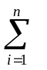(Animal days for unit_{i} in a zone)
Where n is the number of units of the production type in the zone

The total cost of zone surveillance for the production type in the zone is calculated as shown below:

(Cost of surveillance of a production type in a zone) =
[(Animal days for a production type for a zone )
× (Cost of surveillance in the zone, per animal of the production type, per day)]

From the costs of surveillance for each production type for each zone, other totals (e.g., the cost of surveillance of a particular production type across all zones) can be calculated.

Parameters for surveillance costs
Parameters for each combination of production type and zone:
- Cost of surveillance per animal per day

End of changes
Attachment 1: Description of cost accounting for ring surveillance in legacy versions of SpreadModel
In legacy versions of SpreadModel, it was possible to conduct ring surveillance, by counting the number of units surrounding detected, infected units (see figure below). Users could specify a number of surveillance visits, as well as costs associated with surveillance visits and diagnostic testing. Ring surveillance appears to have been only partly implemented in SpreadModel, and documentation is not available.

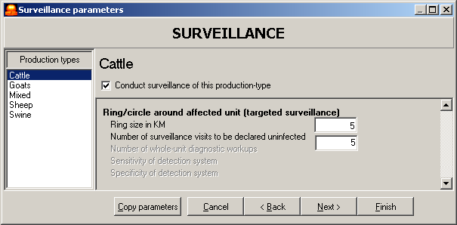

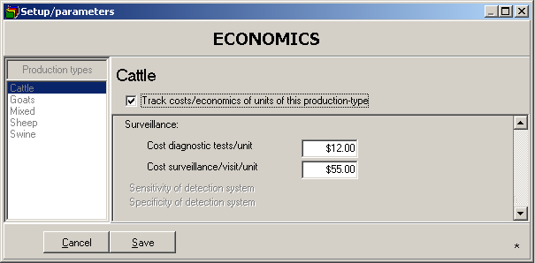

Ring surveillance and associated costs from legacy versions of SpreadModel

Attachment 2: Email correspondence between A. Reeves and A. Seitzinger

Ann.H.Seitzinger@aphis.usda.gov wrote:
> Aaron,
>
> I went through the cost parameters paper which I had proposing a new system
> for estimating costs in NAADSM. As you know, we have not had time to
> consider implementing a new system given other priorities, so what I did
> was ask myself if it made sense to replace the old set of surveillance
> parameters (which actually have not been available for some time now) with
> a new set of surveillance cost parameters without going in and also
> changing the destruction and vaccination cost parameters. It does not seem
> like this makes sense to me at this point in time. I would stick with the
> old system which estimates the following with one exception:
>
> 1. radius of surveillance zone (estimated average number of herds tested
> for each herd detected) CAN THIS BE CHANGED TO HAVE AN ACTUAL COUNT OF THE
> HERDS RATHER THAN USING THE RADIUS TO ESTIMATE?
>
> 2. cost diagnostic tests/unit - average cost of diagnostic testing per herd
> (includes collection, supplies, lab fees)
>
> 3. number of surveillance visits/month/unit - estimated number of
> surveillance visits made per affected herd detected
>
> 4. cost surveillance/visit/unit - average cost of surveillance visit
> (includes transportation and labor)
>
> Ann

Sender: Aaron Reeves <Aaron.Reeves@colostate.edu>
Date: 02/13/2007 03:19 PM
To: Ann.H.Seitzinger@aphis.usda.gov
cc: Dustin.Pendell@colostate.edu, <Barbara.A.Corso@aphis.usda.gov>
Subject: Re: Cost Parameters

Hi, Ann (and Barbara and Dustin).

I think we can adapt these parameters without much trouble. There are,
though, two major differences between the old and new models that we
need to work around: in the new model, A) zones are much more dynamic,
and B) there can be several levels of them.

For each of the four outputs Ann mentioned, what do y'all think about
the following:

1. On every day, we can record how many herds/animals of each
production type are in each zone. Those numbers can change from day to
day as new zone foci are created and as herds are destroyed. At the end
of an iteration, we would have the total amount of time (in days) spent
by all herds (or animals) in each zone.

2. Would there be a difference in the testing strategy applied in
different zones? For example, would testing in a high-risk zone cost
enough more (either because of the test used or because of the intensity
of sampling required) that the cost of testing should be estimated
separately for each zone?

3. Each zone will probably its own frequency of surveillance visits: I'm
guessing that herds in a high-risk zone would be visited more often than
herds in lower-risk zones. The number of visits per month per unit
would probably have to be a zone-specific parameter. The total number
of surveillance visits could be estimated as the total amount of time
(in days/30) spent by all herds in each zone, times the number of visits
per herd per month for that zone.

4. Does a surveillance visit to a high-risk herd have the same cost as
a surveillance visit to a low-risk herd? If so, the per-visit cost
could be fixed across all zones, and the higher cost of high-risk zones
could be reflected just by the greater frequency of visits.
Alternatively, if a visit to a high-risk herd is more intensive or takes
more time, this parameter might need to be specified separately for each
zone.

I've also got another question or three:

- Will any of these costs vary enough from one production type to
another that we need to parameterize separately for them? If so, we
need [(number of production types ) x (number of zones)] new parameters.
If not, we can get by with (number of zones).

- When total cost is displayed, would you want it to be itemized by
zone, or would a single cost of surveillance per production type be
adequate? Itemizing by zone is a bit more complicated, but might be
informative, particularly if an objective is to determine an optimal
zoning strategy.

- I suspect that the old model assumed a 1-to-1 ratio of surveillance
visits to diagnostic tests, so that the bill for each visit would be
[(cost of visit) + (cost of test)]. Does that sound right?

Thanks,
Aaron

-------- Original Message --------
Subject: Re: Cost Parameters
Date: Tue, 20 Feb 2007 10:59:14 -0700
From: Ann.H.Seitzinger@aphis.usda.gov
To: Aaron Reeves <Aaron.Reeves@colostate.edu>
CC: Barbara Corso <Barbara.A.Corso@aphis.usda.gov>,
Dustin.Pendell@colostate.edu

Aaron and I discussed these changes/questions late last week, and I
ended up reversing my opinion of whether to move the zone cost
parameters toward a per animal basis from the per herd basis that
currently tends to dominate the destruction and vaccination cost
calculations. I think we need to go ahead and move to a per animal
calculation that basically ends up with

the number of animals requiring surveillance visits per day of a
given production type in a given zone type

multiplied by

the cost of surveillance testing per animal of a given
production type in a given zone type

to arrive at the costs for each production type of being in a given
zone. This can then be summed across the production types to come up
with a total surveillance cost for the given type of zone. And in turn,
the costs for each given zone can be summed for total surveillance costs
across all zones included in the simulation.

Ann

