Maximum frequency of vaccination

Description
The maximum frequency of vaccination is the number of days which must pass before a unit may be revaccinated. Once the specified number of days has passed, a unit may be revaccinated if vaccination of that unit is triggered again.

Consider the simple situation involving units A, B, and C as shown in the figure below. Disease is detected in unit A ten days before disease is detected in unit C. Both detections trigger vaccination circles as shown.

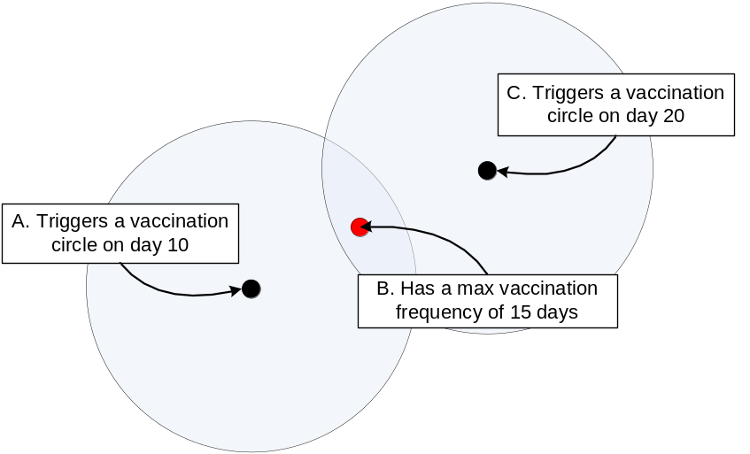

Unit B is within vaccination circles triggered by detection of units A and C, and will be added twice to the queue of units to be vaccinated. If there is no waiting period for vaccination (i.e. vaccination capacity is not reached), unit B will receive only one vaccination: its maximum vaccination frequency will not have been reached before it comes to the head of the queue the second time.

If vaccination capacity has been reached, unit B will receive two vaccinations if the elapsed time between the first and second scheduled vaccinations exceeds the unit’s maximum vaccination frequency. This subsequent vaccination resets the vaccine-immune period for unit B If the elapsed time is less than the unit’s maximum vaccination frequency, unit B will not be revaccinated.

Implementation in SpreadModel
Maximum frequency of vaccination is specified in SpreadModel by a single integer value, set independently for each production type.

Implementation in SHARCSpread
Maximum frequency of vaccination appears to be available in SHARCSpread, where it is referred to as “minimum time between vaccinations”. A single value is applied to all production types.

Specification status
The current model specification document refers to the minimum time between vaccinations as a parameter which is set individually by production type.

Justifications for the “SpreadModel” approach
- (A. Reeves) Maximum vaccination frequency should be assigned by production type: the biology of vaccination (e.g. extent and length of immunity conveyed) will differ between species and production types, and it should be possible to model control strategies which acknowledge these differences.

Justifications for the “SHARCSpread” approach
- (Please fill in the blanks)

Additional comments
- (A. Reeves) For a unit to receive multiple vaccinations, vaccination of that individual unit must be triggered multiple times. It is not currently possible to schedule revaccination of units without an additional trigger. (Compare the control strategy used in Uruguay during 2001, where scheduled revaccination was routinely conducted to achieve improved within-herd immunity. Since complete immunity is assumed and within-herd immunity is not considered by the current model, this may not be a problem.)

