Request for comments

RFC20071127NH: Trace in

1st draft: N. Harvey, November 27, 2007
2nd draft: N. Harvey, December 11, 2007. Incorporates changes discussed on Dec. 6 conference call.
3rd draft: N. Harvey, December 19, 2007. Incorporates changes discussed on Dec. 13 conference call.
4th draft: N. Harvey, December 20, 2007. Incorporates change suggested by B. Corso via email.
5th draft: N. Harvey, January 24, 2008. Adds notes about trace and test delays, and now counts a Naturally Immune unit as one that should test positive.
6th draft: A. Reeves, February 21, 2008. Describes a way to accomplish detection based on clinical signs, as well as laboratory testing, of herds identified by tracing.
7th draft: A. Reeves, February 27, 2008. Makes explicit the testing strategy for herds traced and preemptively destroyed.
8th draft: A. Reeves, March 13, 2008. Incorporates changes discussed on Mar. 6 conference call; incorporates required changes to the destruction priority scheme.
9th draft: A. Reeves, March 27, 2008. Incorporates minor wording changes as suggested by Bruce McNab via email.

Applies to: Model description v1.1.0

Type of change: New feature

Summary: This RFC proposes a trace-in feature and an ability to do traces that go more than one step.

Justification: Trace-in is part of the minimum required response to foot-and-mouth disease in the EU directive on FMD, and possibly in laws elsewhere.

Change: This change applies to section A6.1, Trace surveillance. Current text to be deleted is struck out, new text proposed in drafts 1 through 7 is highlighted in yellow. New text proposed in draft 8 is highlighted in green, 9 is highlighted in cyan:

Units that have had contact with diseased units within a given number of days prior to detection of the diseased unit may be identified by trace investigations. Units subjected to surveillance will be quarantined. Optionally, units identified by trace surveillance may be preemptively destroyed (see Section A7.2 Destruction).

Trace investigations are may be immediate or there may be a delay for results. Tracing goes one level step forward, that is, it identifies units that were recipients of direct or indirect contact from infected, detected units (referred to as “trace out” or “trace forward”) or units that were sources of direct or indirect contact to infected, detected units (“trace in” or “trace back”). Tracing does not identify contacts that led to the infection of infected, detected units (Figure A6-1).

When a unit is identified by a trace investigation, it will be quarantined. Units showing clinical signs of disease can be detected with a specified probability (see below). Optionally, the unit may also be:
- preemptively destroyed (see Section A7.2)
- tested for disease
- tested for disease and preemptively destroyed

When an Infectious Clinical unit is identified by a trace investigation, it can be detected by the following method:
- Compute the probability of detection and reporting as
P = (probability of detecting signs of disease) × (multiplier)
- Note that the probability of reporting is assumed to be 1 when a unit is identified by tracing, so that value drops out of the calculation.
- Generate a random number r in [0,1).
- If r < P, the disease is detected and reported.

If a unit is not detected based on clinical signs, it may still be detected by a diagnostic test. When a unit is tested for disease, the sensitivity and specificity of the test and a random number r in [0,1) are used to determine the test result as follows:

unit is Latent, Infectious Subclinical, Infectious Clinical, or Naturally Immune
r < sensitivity → positive (TP)
r ≥ sensitivity → negative (FN)
unit is Susceptible or Vaccine Immune
r < specificity → negative (TN)
r ≥ specificity → positive (FP)
unit is Destroyed
No testing can occur: the effect is functionally equivalent to a test-negative result.

If the test result is positive, the unit is considered to have been “detected” as diseased (see Section A5). Detection either by clinical signs or diagnostic testing may trigger subsequent control actions, including further traces.

Optionally, units to be preemptively destroyed may be subject to detection based on clinical signs and diagnostic testing. Detection of disease (either based on clinical signs or diagnostic testing) in units to be preemptively destroyed may trigger further control actions as described above.

There are two delays that can potentially affect detection by tracing. The first is a delay in carrying out the tracing activity. This delay can impact the ability to detect a unit based on the appearance of clinical signs. The second is a delay in obtaining results of a diagnostic test. Detection of units on the basis of diagnostic test is subject to both the delay in carrying out a trace, as well as the delay in obtaining test results. When test results are delayed, the results depend on the state of the simulation on the day the trace or test was initiated, not the day the results become available. The following examples illustrate the effects of these delays:

- A unit is Infectious Clinical on the day that a trace to that unit is initiated. The unit is still Infectious Clinical on the day that the trace investigation takes place. This unit may be identified at that time on the basis of clinical signs. If it is not detected on the basis of clinical signs, it still may be detected by a diagnostic test (after a delay), even if the unit has recovered by the time the test results become available.

- A unit is Infectious Clinical on the day that a trace to that unit is initiated. The unit has progressed to Natural Immune by the time that the trace investigation takes place. This unit cannot be detected on the basis of clinical signs, but it may be detected (after a delay) by a diagnostic test.

- A unit is Subclinical on the day that a trace to that unit is initiated. The unit has progressed to Clinical by the time that the trace investigation takes place. This unit may be detected on the basis of clinical signs at that time, or (after a delay) by a diagnostic test.

- A unit is Subclinical on the day that a trace to that unit is initiated. The unit is still Subclinical on the day that a trace investigation is carried out. This unit cannot be detected on the basis of clinical signs, but may be identified (after a delay) by a diagnostic test.

- A unit is Susceptible on the day that a trace investigation is carried out, but is infected and becomes Latent by the time diagnostic test results are available. This unit will not be detected as a result of the trace.

- A unit is Subclinical on the day that a trace investigation is carried out, but is destroyed for a reason other than preemptive destruction due to this trace, before diagnostic test results become available. This unit may be detected by a diagnostic test, and further control measures could be initiated.

- A delay for test results does not apply if a unit is already Destroyed on the day that the trace finds it. A destroyed unit is automatically and immediately negative. A unit identified by a trace investigation is Destroyed (for a reason other than preemptive destruction due to tracing) before the trace investigation could be carried out. Regardless of the unit's disease state prior to its destruction, it is not available at the time of tracing for either clinical or laboratory testing. Consequently, no further control measures can be initiated.

When trace and test results are delayed, the results depend on the state of the simulation on the day the trace or test was initiated, not the day the results become available. For example, if a unit was Infectious on the day of the test, but has recovered by the time the test results become available, the test will be positive. This is justified by a real-world analogy. For tracing, the analogy is that a box of records is opened on the day the trace is initiated, but it may take several days to go through the records. For testing, the analogy is that samples are taken on the day the test is done, but it may take several days to get laboratory results.

Change: This change also applies to section A6.1. The parameters section is changed as follows:

Trace surveillance parameters
Parameters specified separately for every production type:
Conducting tracing:
- conduct trace-out of direct contacts (yes/no)
- conduct trace-in for direct contacts (yes/no)
- probability of a trace-out investigation succeeding when direct contact has occurred
- period of interest for trace-out investigations of direct contacts
- conduct trace-out of indirect contacts (yes/no)
- conduct trace-in for indirect contacts (yes/no)
- probability of a trace-out investigation succeeding when indirect contact has occurred
- period of interest for trace-out investigations of indirect contacts
- delay for carrying out trace investigation result (days) 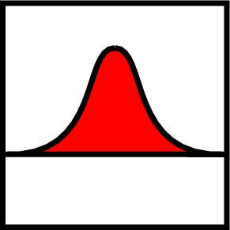

Detection of traced units by clinical signs:
- examine units identified by trace-out of direct contacts (yes/no)
- multiplier for the probability of detection for units identified by trace-out of direct contacts
- examine units identified by trace-in of direct contacts (yes/no)
- multiplier for the probability of detection for units identified by trace-in of direct contacts
- examine units identified by trace-out of indirect contacts (yes/no)
- multiplier for the probability of detection for units identified by trace-out of indirect contacts
- examine units identified by trace-in of indirect contacts (yes/no)
- multiplier for the probability of detection for units identified by trace-in of indirect contacts

Diagnostic testing of traced units:
- test for disease in units identified by trace-out of direct contacts (yes/no)
- test for disease in units identified by trace-in of direct contacts (yes/no)
- test for disease in units identified by trace-out of indirect contacts (yes/no)
- test for disease in units identified by trace-in of indirect contacts (yes/no)
- test sensitivity (0-1)
- test specificity (0-1)
- delay for test result (days)

Preemptive destruction:
- destroy units identified by trace-out of direct contact (yes/no)
- destroy units identified by trace-in of direct contact (yes/no)
- destroy units identified by trace-out of indirect contact (yes/no)
- destroy units identified by trace-in of indirect contact (yes/no)

Note that the probability of a trace investigation succeeding depends on the production type of the unit where the trace originates. Suppose a unit of production type A ships to a unit of production type B. If the A unit is then detected, the probability that trace out will find the B unit depends on the probability set for production type A. If the B unit is detected instead, the probability that trace in will find the A unit depends on the probability set for production type B, which may be different.

Change: This change applies to Figure A6-1. This simpler diagram replaces the old one:

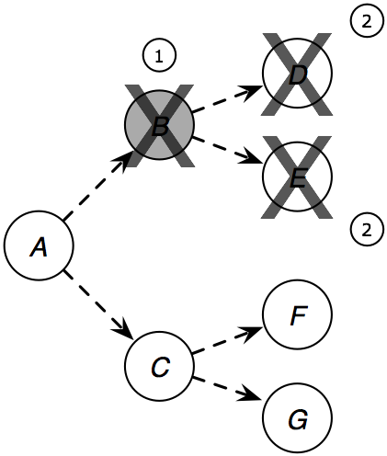

The caption changes as follows. Current text to be deleted is struck out, proposed new text is highlighted:

Figure A6-1. Trace out with preemptive destruction. When unit C B is detected (1), units to which C B has shipped animals or sent people or equipment are destroyed (2).quarantined and may be marked for destruction. The trace does not extend further, e.g., to units that shipped animals to C (A or B), or units that received animals from D. Such units may be assessed clinically and may have samples collected for laboratory testing immediately prior to preemptive destruction.

Change: Two new figures, A6-2 and A6-3, are added.

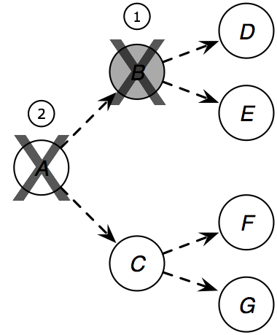

Figure A6-2. Trace in with destruction. When unit B is detected (1), units which have shipped animals or sent people or equipment to B are found by trace in (2).

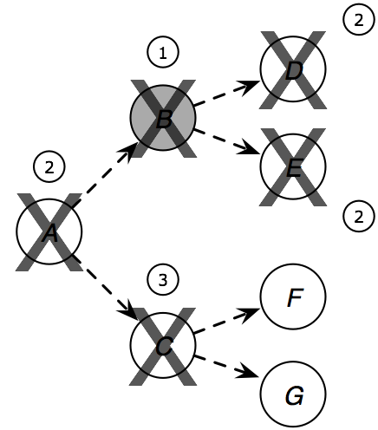

Figure A6-3. Trace out and in with testing and destruction. When unit B is detected (1), unit A is found by trace in and units D and E are found by trace out (2). Assuming that unit A tests positive, further traces are triggered and unit C is found by trace out (3). In this example we assume that C does not test positive, so the trace does not continue to units F and G.

Change: This change applies to section A7.2.2 Destruction Priorities. Current text to be deleted is struck out, new text proposed in draft 8 is highlighted in green:

There are three criteria which may be used to set destruction priorities: the production type of the unit, the reason for destruction of the unit, and the number of days a unit has been waiting in the destruction queue. Within the production type criterion, the production types present in a scenario are further prioritized (e.g. cattle may have a higher destruction priority than swine, or vice versa). Similarly, within the action reason criterion, the reasons for destruction are further prioritized: these reasons are detection of disease, exposure by identification by trace-out of direct contact, identification by trace-in of direct contact, exposure by identification by trace-out of indirect contact, identification by trace-in of indirect contact, and presence within a specified destruction ring. For example, cattle herds that are marked for destruction because they were detected as diseased may have a higher priority than cattle herds that are marked for destruction because they are near a diseased unit.

Change: the examples in section A7.2.2 would be changed as follow:

Examples of destruction priorities

Consider the following examples, using these four units which have been designated for destruction:

Unit A. Cattle herd, detected infection, holding for 3 days
Unit B. Cattle herd, identified by trace-out of indirect contact, holding for 5 days
Unit C. Swine herd, identified by trace-in of direct contact, holding for 1 day
Unit D. Swine herd, within circle/ring, holding for 5 days

Example 1:
With the following destruction priorities:
Days holding > production type (swine > cattle) > destruction reason (detected > direct> indirect > circle/ring) (detected > trace-out of direct contacts > trace-out of indirect contacts > circle/ring > trace-in of direct contacts > trace-in of indirect contacts)

The four herds are destroyed in the following order:
D, B, A, C

Example 2:
Priorities: production type (cattle > swine) > destruction reason (detected > direct> indirect > circle/ring) (detected > trace-out of direct contacts > trace-out of indirect contacts > circle/ring > trace-in of direct contacts > trace-in of indirect contacts) > days holding:

Destruction order: A, B, C, D A, B, D, C

Example 3:
Priorities: production type (cattle > swine) > days holding > destruction reason (detected > direct > indirect > circle/ring) (detected > trace-out of direct contacts > trace-out of indirect contacts > circle/ring > trace-in of direct contacts > trace-in of indirect contacts):

Destruction order: B, A, D, C

Example 4:
Priorities: destruction reason (detected > circle/ring > direct > indirect) (detected > circle/ring > trace-out of direct contacts > trace-out of indirect contacts > trace-in of direct contacts > trace-in of indirect contacts) > production type (cattle > swine) > days holding:

Destruction order: A, D, C, B A, D, B, C

End of changes

To discuss: The number of units found by trace-in will be underestimated, because the model does not simulate contacts from uninfected units. (It will be less underestimated than it is with no trace-in, but still...)

One possible solution is to allow the user to turn on simulation of all contacts. The simulation would be slow, and recording all contacts might take a lot of memory, but the ability to simulate “peace time” movement could be useful in other situations too.
User interface mock-up
Input parameters required for tracing for EACH PRODUCTION TYPE:
(Corresponds to draft 9 of RFC-20071127NH)

1. Tracing

- Conduct TRACE-OUT for DIRECT contacts?
- Conduct TRACE-OUT for INDIRECT contacts?
- Conduct TRACE-IN for DIRECT contacts?
- Conduct TRACE-IN for INDIRECT contacts?

- If tracing of DIRECT contacts is selected from the above:
  - Probability of successful trace (applies to trace in and out)
  - Period of interest for tracing (applies to trace in and out)

- If tracing of INDIRECT contacts is selected from the above:
  - Probability of successful trace (applies to trace in and out)
  - Period of interest for tracing (applies to trace in and out)

- If ANY tracing is selected above:
  - Delay for carrying out tracing (applies to any/all)

2. Examination of units identified by tracing

- Examine units identified by TRACE-OUT of DIRECT contacts for clinical signs of disease? If yes:
  - Multiplier for probability of detection

- Examine units identified by TRACE-OUT of INDIRECT contacts for clinical signs of disease? If yes:
  - Multiplier for probability of detection

- Examine units identified by TRACE-IN of DIRECT contacts for clinical signs of disease? If yes:
  - Multiplier for probability of detection

- Examine units identified by TRACE-IN of INDIRECT contacts for clinical signs of disease? If yes:
  - Multiplier for probability of detection

3. Testing of units identified by tracing

- Test units of this production type that have had DIRECT contact with a detected unit as identified by TRACE-OUT?
- Test units of this production type that have had INDIRECT contact with a detected unit as identified by TRACE-OUT?
- Test units of this production type that have had DIRECT contact with a detected unit as identified by TRACE-IN?
- Test units of this production type that have had INDIRECT contact with a detected unit as identified by TRACE-OUT?

- If yes to any of the above:
  - Delay in obtaining test results
  - Test sensitivity
  - Test specificity

4. Preemptive destruction

- Destroy units of this production type that have had DIRECT contact with a detected unit as identified by TRACE-OUT?
- Destroy units of this production type that have had INDIRECT contact with a detected unit as identified by TRACE-OUT?
- Destroy units of this production type that have had DIRECT contact with a detected unit as identified by TRACE-IN?
- Destroy units of this production type that have had INDIRECT contact with a detected unit as identified by TRACE-IN?

