Appendix D. Probability density functions supported by NAADSM
As described in Section 3 and Section 6.1.5, many parameters in a NAADSM scenario are probability density functions (pdfs). Probability density functions are distributions of values representative of the natural range of possible values for some parameter. Values are drawn stochastically from these distributions as a simulation runs.
NAADSM supports 15 general pdf types, described in the following sections. References are provided for users who wish to obtain more detailed information about these distributions: in particular, Vose (2000) provides a very helpful discussion regarding suitable applications of the different types of pdfs.
All but one of the distributions described here are continuous distributions. Recall, though, that NAADSM operates in discrete time steps of one day. Consequently, for parameters that have x axis units of days (e.g., the disease transition state periods described in Section 8.5.1), values obtained from these distributions will be rounded to the nearest whole day.

D1. The Beta distribution
A Beta distribution (Figure D-1) is defined by four parameters: α₁, α₂, a minimum value, and a maximum value. Parameters α₁ and α₂ must be greater than 0, and the minimum value must be less than the maximum value. The probability density f(x) is calculated as:
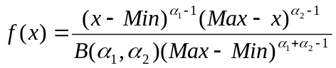
where B denotes the Beta function.

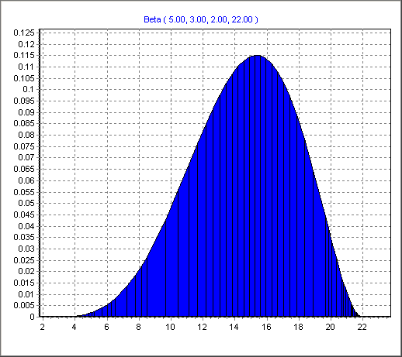

Figure D-1. A sample Beta distribution.

D2. The BetaPERT distribution
The BetaPERT distribution (Figure D-2) is defined by its minimum, its most likely value (mode), and its maximum. In this way, the BetaPERT distribution is similar to the Triangular distribution.
The BetaPERT distribution is related to the Beta distribution: the α₁ and α₂ parameters used to define a Beta distribution are obtained from the minimum, mode, and maximum values of a BetaPERT. There are several slight variations regarding how α₁ and α₂ are calculated from the minimum, mode, and maximum: NAADSM uses the same approach as the risk analysis package @RISK (Palisade Corporation, 2002). In this approach, α₁ and α₂ are calculated with the following formulas:
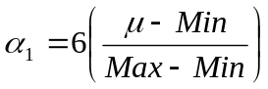
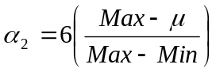
where μ is the distribution mean, defined as:
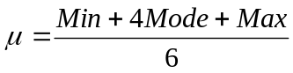

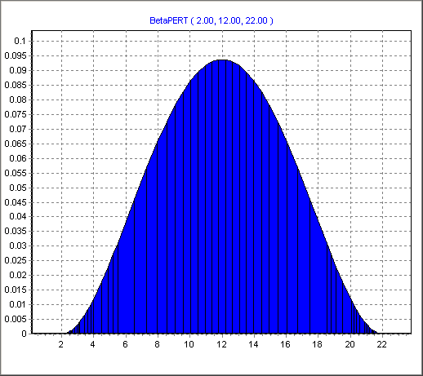 | 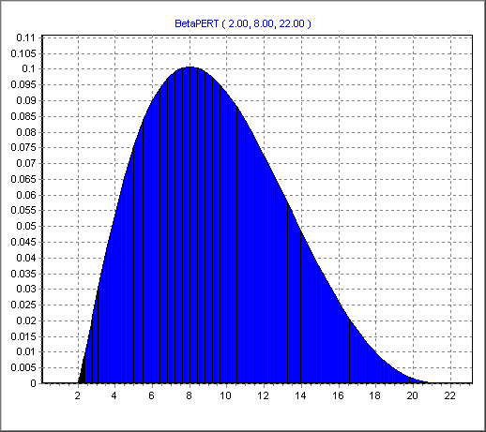
Figure D-2. Two sample BetaPERT distributions.

D3. The Exponential distribution
An Exponential distribution (Figure D-3) is a highly skewed distribution defined by its mean μ, which must be greater than 0. The probability density function f(x) is calculated as:
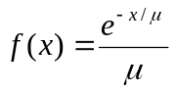

  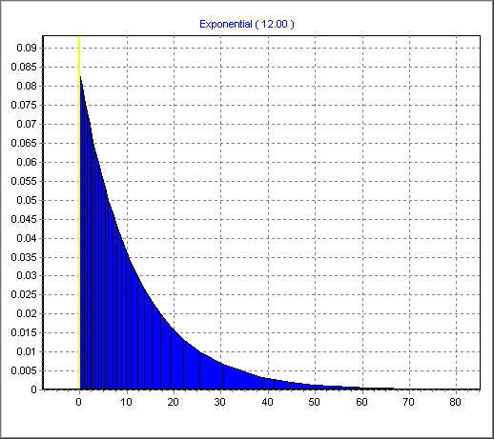
  Figure D-3. A sample Exponential distribution.
  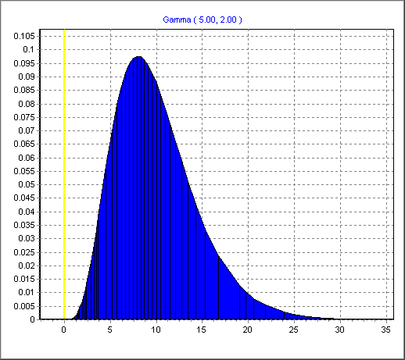
  Figure D-4. A sample Gamma distribution.

D4. The Gamma distribution
A Gamma distribution (Figure D-4) is defined by two parameters: its shape (α), and its scale (β), where α and β must be greater than 0. This distribution has a mean of α×β. The probability density function f(x) is calculated as:
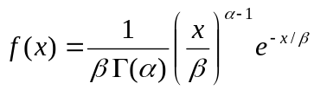
where Γ is the Gamma function.

D5. The Gaussian (Normal) distribution
A Gaussian or Normal distribution (Figure D-5) is a bell-shaped curve described by two parameters: its mean μ, and its standard deviation σ. The standard deviation must be greater than 0. The Gaussian distribution is inherently symmetric. The probability density function f(x) is calculated as:
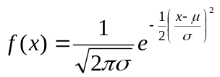

  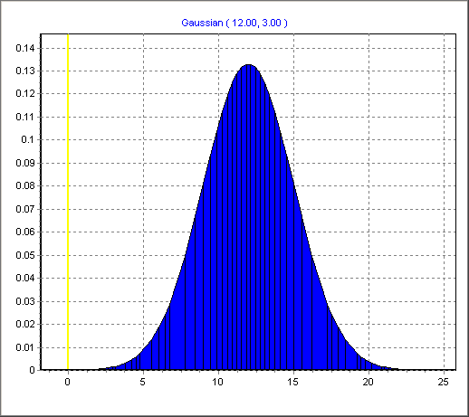
  Figure D-5. A sample Gaussian distribution.
  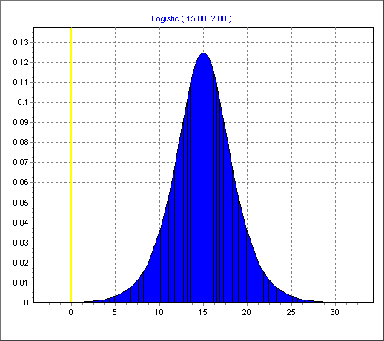
  Figure D-6. A sample Logistic distribution.

D6. The Logistic distribution
A Logistic function (Figure D-6) is defined by two parameters: its location α and scale β. The scale parameter must be greater than 0. The probability density function f(x) is calculated as:
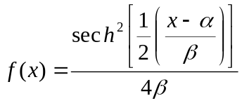
where sech is the hyperbolic secant function

D7. The Loglogistic distribution
The Loglogistic function (Figure D-7) is defined by three parameters: its shape α, scale β, and location γ. Scale and shape must be greater than 0. The probability density function f(x) is calculated as:
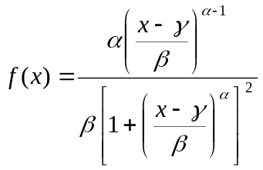

  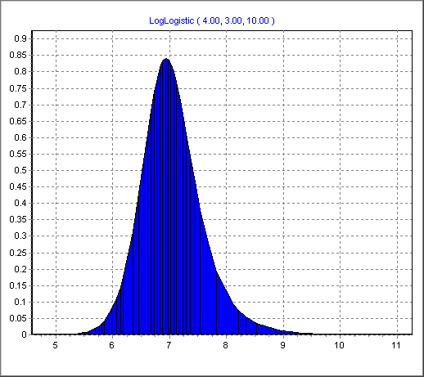
  Figure D-7. A sample Loglogistic distribution.
  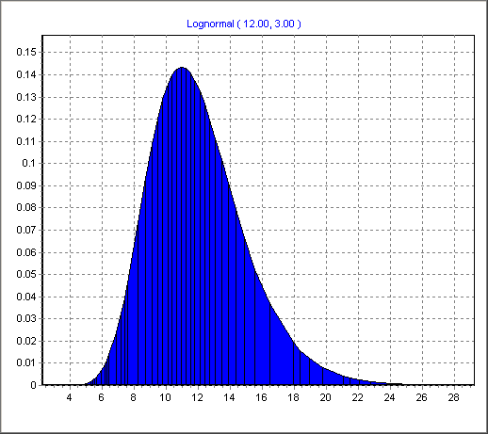
  Figure D-8. A sample Lognormal distribution.

D8. The Lognormal distribution
The Lognormal distribution (Figure D-8) is a logarithmic transformation of the normal distribution; it is described using the same parameters as the normal distribution: its mean μ and its standard deviation σ, where both μ and σ are greater than 0.. The Lognormal distribution is extremely asymmetric (skewed to the right) when the mean is close to 0; the further the mean is from 0, the more the Lognormal distribution approaches the symmetry and shape of a Normal distribution.
The probability density function f(x) for a Lognormal distribution is calculated as:
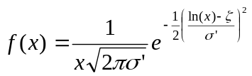 where 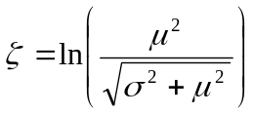 and 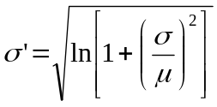
A Lognormal distribution may also be defined by zeta(ζ) and σ’, as shown above: NAADSM supports both sets of parameters for Lognormal distributions, and automatically handles the conversion of μ and σ to ζ and σ’.

D9. The Pearson 5 distribution
The Pearson 5 distribution (Figure D-9) is defined by its shape α and scale β, both of which must be greater than 0. A Pearson 5 distribution has a mean of β/(α-1). The probability density function f(x) is calculated as:
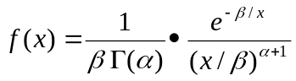 where Γ is the Gamma function.

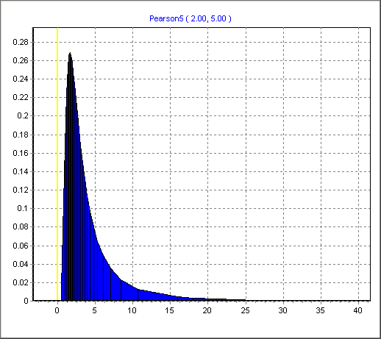 | 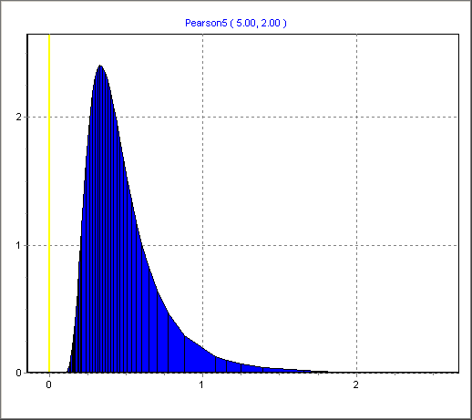
Figure D-9. Two sample Pearson 5 distributions.

D10. The Piecewise (General) distribution
A Piecewise or General distribution (Figure D-10) is defined by an array of points, each of which has an x and a y value. Each x value must be larger than the previous x value. Each y value must be at least 0. Finally, the y values of the first and last points must be 0. The probability density function f(x) is calculated as.
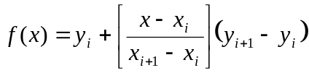 where x_{i} ≤ x ≤ x_{i+1}

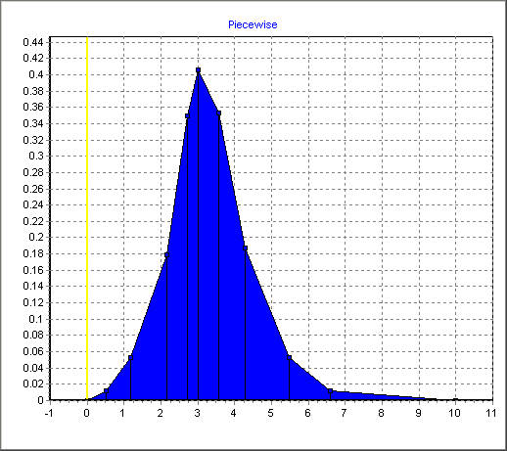 | 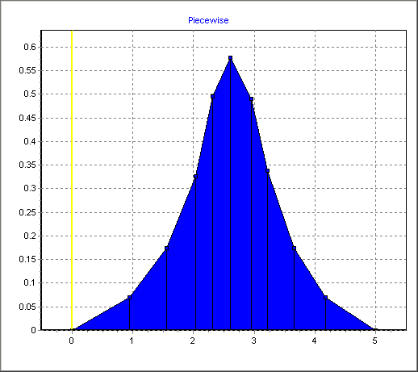
Figure D-10. Two sample Piecewise distributions.

D11. The Point “distribution”
Point values are not distributions, but are used in much the same way by NAADSM. A Point “distribution” is defined by a fixed value y. The probability density function f(x) for a Point “distribution” always returns this fixed value:
f(x) = y

D12. The Poisson distribution
Unlike any of the other distributions described in this appendix, the Poisson distribution (Figure D-11) is discrete rather than continuous. Poisson distributions have one specific role in an NAADSM scenario: Poisson distributions are used to determine the number of contacts that will be initiated by each herd that is a source of disease: see Section 8.6.3.2.
A Poisson distribution is defined by its mean, designated λ. The probability mass function f(x) is calculated as:
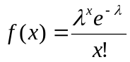

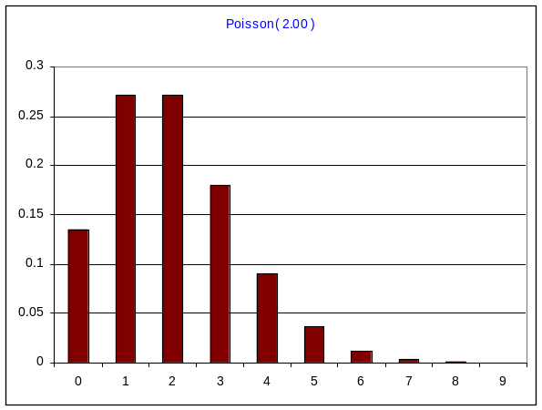 | 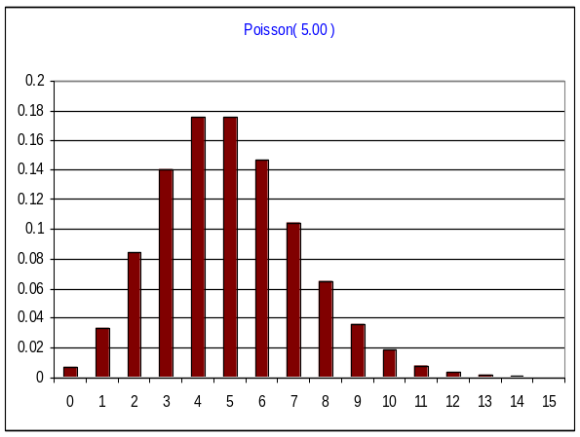
Figure D-11. Two sample Poisson distributions.

D13. The Triangular distribution
A Triangular distribution (Figure D-12) is, as its name implies, a triangle. It is described by three parameters: the minimum, peak (mode or “most likely”), and maximum values. The Triangular distribution can be symmetric or asymmetric depending on the relation of the peak to the minimum and maximum values. The probability density function f(x) is calculated as:
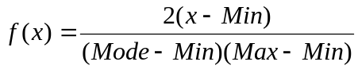 if Min ≤ x ≤ Mode
or
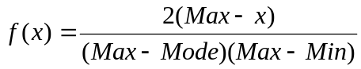 if Mode ≤ x ≤ Max

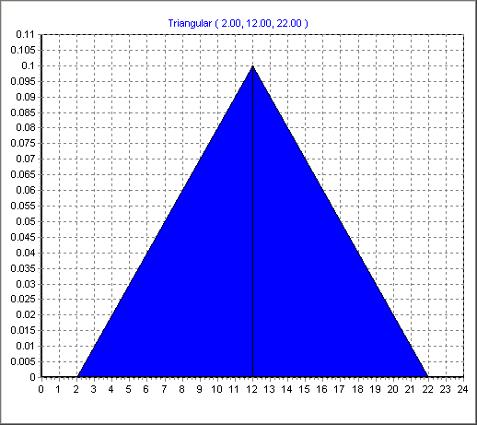 | 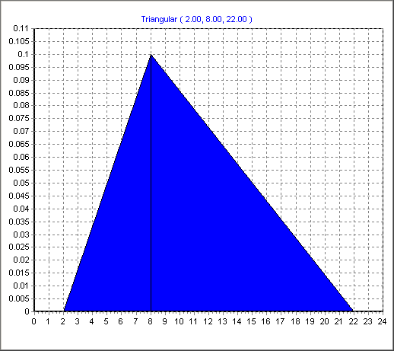
Figure D-12. Two sample Triangular distributions.

D14. The Uniform distribution
The Uniform distribution (Figure D-13) is a rectangular block, indicating that all values within a range occur with equal frequency; it is described by two parameters: the minimum and maximum of the range. The Uniform distribution is inherently symmetric. The probability density function f(x) is calculated as:
f(x) = 1/(Max-Min)

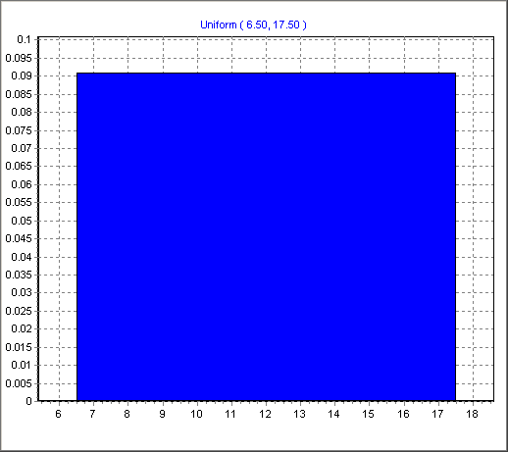

Figure D-13. A sample Uniform distribution.

D15. The Weibull distribution
A Weibull distribution (Figure D-14) is defined by its shape α and scale β, both of which must be greater than 0. The probability density function f(x) is calculated as:
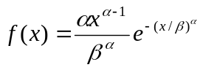

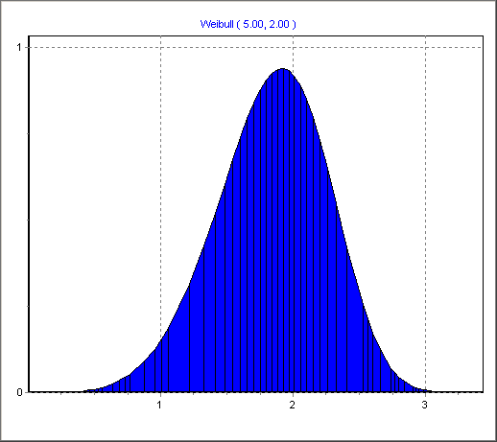 | 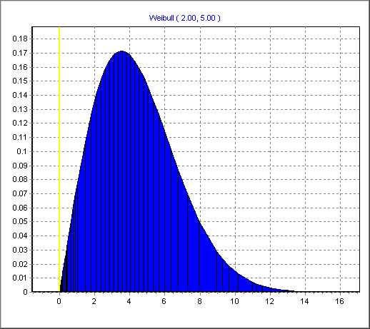
Figure D-14. Two sample Weibull distributions.

D16. References

- Galassi, Mark, Jim Davies, James Theiler, Brian Gough, Gerard Jungman, Micheal Booth, and Fabrice Rossi. 2004. GNU Scientific Library Reference Manual. The GNU Scientific Library (GSL) is a collection of routines for numerical computing. NAADSM uses the GSL for many of its probability density functions. GSL source code is distributed under the GNU General Public License. The Reference Manual is available online at <http://www.gnu.org/software/gsl>. An Adobe PDF file is available for download from <http://gnuwin32.sourceforge.net/packages/gsl.htm> (follow the documentation download link).
- McLaughlin, Michael P. 2000. A Compendium of Common Probability Density Functions. A reference document assembled by the creators of the mathematical modeling program Regress+. The Compendium is available for download as an Adobe PDF file from <http://www.causascientia.org/math_stat/Dists/Compendium.html>.
- Palisade Corporation. 2002. A Concise Summary of @RISK Probability Distribution Functions. A guide published by the creators of @RISK, a risk analysis package for Microsoft Excel. The Summary is available for download as an Adobe PDF file from <http://project.zf.jcu.cz/risk/data/distfunc.pdf >.
- Vose, David. 2000. Risk Analysis: A Quantitative Guide, 2nd edition. New York: John Wiley & Sons. Vose’s book includes a very useful chapter on probability density functions and their applications.

