**ATTENDANCE SYSTEM USING FACE RECOGNITION**

**V. Jayaraj**

Cybersecurity student

Amrita School of Computing

Amrita Vishwa Vidyapeetham Chennai

**E. Kuralamudhan**

Cybersecurity student

Amrita School of Computing

Amrita Vishwa Vidyapeetham Chennai

**S. Navaneethan**

Cybersecurity student

Amrita School of Computing

Amrita Vishwa Vidyapeetham Chennai

1. **INTRODUCTION**
   1. **ABSTRACT**

Face recognition is an important application of computer vision and machine learning, with many practical applications in security, surveillance, and social media. Python and OpenCV are popular tools for implementing face recognition algorithms.

"Attendance using Face Recognition" is a system that uses facial recognition technology to record and manage attendance. The system then stores attendance records in a database and provides real-time reports to the administrators.

In this paper, we present an implementation of a face recognition system using the pre-built “Face Recognition” module and OpenCV library in Python. Our results show that our system achieves high accuracy and robustness, while being efficient and scalable.

**Keywords:**

Computer Vision, machine learning, face recognition, Open CV, facial feature extraction, efficient and accurate

**1.2 BACKGROUND:**

Face recognition has become a widely researched topic due to its practical applications in various fields. It involves recognizing and identifying individuals from facial images or videos.

Face recognition has become a popular area of research in computer vision and machine learning, with many techniques being developed over the years.

The aim of face recognition is to automatically identify or verify an individual based on their facial features. Python and OpenCV are popular tools for implementing face recognition algorithms, with many libraries and modules available for use.

"Attendance using Face Recognition" is a system designed to automate the process of recording attendance using facial recognition technology. The system utilizes a camera to capture images of individuals entering a specific location, which are then processed using deep learning algorithms to identify and verify their identities.

The system stores attendance records in a database and provides real-time reports to the administrators, allowing for easy monitoring and management of attendance. The implementation of this system offers a more efficient and accurate way to manage attendance records compared to traditional methods such as paper-based systems or manual data entry.

* 1. **DISADVANTAGES OF MANUAL ATTENDANCE SYSTEM**
* Time-consuming: It takes time for employees to sign in and out manually, and for the person in charge to verify and record the attendance. This can result in delays and can be time-consuming for both employees and administrators.
* Error-prone: Manual attendance systems are prone to errors such as misreading handwriting, recording the wrong time, or losing attendance sheets. This can result in inaccurate attendance records, which can be a problem for payroll and tracking purposes.
* Security concerns: Manual attendance systems can be vulnerable to fraud, such as employees signing in and out for each other. It can also be easy for employees to manipulate attendance records, leading to inaccuracies in payroll.
  1. **BENEFITS OF SMART ATTENDANCE SYSTEM**
* Time-saving: Face recognition technology can save time as it can accurately identify employees and record their attendance automatically. This eliminates the need for manual attendance sheets and reduces the time needed for attendance tracking.
* Accurate: Face recognition technology can accurately identify employees, reducing the chances of errors in attendance recording.
* Real-time data: Face recognition technology can provide real-time data on employee attendance, allowing administrators to make quick decisions related to staffing, scheduling, or absenteeism.
* Security: Face recognition technology can improve security as it is difficult to fake someone else's face. It can also help prevent fraud by ensuring that employees cannot sign in or out for each other.

In summary, moving to attendance using face recognition can offer several benefits over manual attendance systems, including improved accuracy, time-saving, real-time data, and increased security.

1. **LITERATURE REVIEW & PROBLEM DESCRIPTION:**
   1. **RELATED JOURNALS AND SURVEY STUDIES**

**2.1.1** **Face Recognition System Technology by Sagar Deshmukh, Sanjay Rawat**

<https://web.archive.org/web/20200319020837/http://www.ijtsrd.com/papers/ijtsrd14331.pdf>

This Journal paper starts with an abstract explaining about the biometric as the study of human behavior and features and face recognition is as a domain begins with face detection and extraction of features from a large background using some patterns.

It then briefs about the scope of this project as how beneficial it would be. Then it goes on to talk about various related works to face recognition and describes about the show stoppers for this technique.

Then it explains about the various challenges in face recognition as at that time the availability of data sets for face recognition was very low and then it concludes by telling that face recognition is an emerging technology and it will only become more accurate and efficient in the coming years.

**2.1.2 Age Invariant Face Recognition by Prathama V, Thippeswamy G**

<https://web.archive.org/web/20200318185316/https://www.ijtsrd.com/papers/ijtsrd23572.pdf>

This is a research paper by a professor and his student from bangalore. It talks about how aging affects ones facial features and how it impacts face recognition of a person.

This paper proposes a deep learning and set-based approach to the face recognition subject to aging. The images for each subject taken at various times are treated as a single set, which is then compared to the sets of images belonging to other subjects. Facial features are extracted using a convolutional neural network characteristic of the deep learning

They find that set-based recognition performs better than the singleton-based approach for the both face identification and face verification and also find that by using set-based recognition, it is easier to recognize older subjects from younger ones rather than younger subjects from older ones.

**2.1.3 Mobile Face Recognition Application Using Eigen Face Approaches for Android**

<https://web.archive.org/web/20200213021038/http://mjs.uomustansiriyah.edu.iq/ojs1/index.php/MJS/article/download/540/pdf>

This paper explains the building of mobile face recognition system using Eigen face approach. They start with an introduction about face recognition and says recognition is utilized for determining the identity of an unknown individual and is performed by matching of the facial data of a person to the face data of several people and Verification decides if an individual is actually who he claims he is. The verification procedure performs a comparison of a person’s face data to existing data on the claimed identity

In this work, detection of faces is done using Open CV cascade classifier. Mathematically speaking, the goal is to find the main elements of the distribution of faces, or the Eigen vectors of the co-variance matrix of the group of facial images. These Eigen vectors might be considered as a group of properties that combined classify the difference between facial images.

Every image index has some impact on every Eigen vector, therefore, the eigenvector is displayed as a type of ghostly face known as Eigen face. Every one of the face images in the training group could be represented precisely according to a linear combination of the Eigen faces. The number of potential Eigen faces is the same as the number of face images in the training set. The Eigen faces are the base vectors of the Eigen face decomposition.

Then they discuss about the results where they get 93% accuracy in good light condition and then they also test the battery consumption, processing power and memory used in an android device and at last concludes by telling about the benefits about face recognition in android and its limitations.

**2.1.4 Facial Recognition for Attendance Management by Jaya Baskar, Venkatesh, M Rohith and Sai Bhaskar**

[https://web.archive.org/web/20220303072507/http://www.warse.org/IJETER/sta ic/pdf/file/ijeter04842020.pdf](https://web.archive.org/web/20220303072507/http://www.warse.org/IJETER/sta%20ic/pdf/file/ijeter04842020.pdf)

This research paper starts by discussing about the difficulties in taking manual attendance and maintaining those attendance records. They suggest the creation for the use of a facial identification and recognition device to instantly identify children attending a class lecture by identifying their faces and labeling their attendance.

Although other authentication approaches (such as iris scans or fingerprints) might be more reliable, at the time they reach the classroom students typically have to queue for long. This (facial) biometric system consists of an enrollment process in which the specific features of a person's face are registered in a database, and then the recognition and authentication procedures.

They then discuss about various other related research works on similar topics and study them. It then explains its methodology which is getting the input and extracting the features, giving names for the extracted features and save them as face label pairs, Training & Testing them using a machine learning model and give the result of the comparison. If the result is true then a record is taken for attendance else nothing is done.

They use classifiers(Haar , Cascaded classifiers) which classifies whether an image is a good image or bad image. They conclude the paper by showing the results of the implementation and discussing the areas to improve upon.

**2.1.5 A blog on “Face Recognition module in python” from Medium**

[**https://medium.com/geekculture/face-recognition-library-in-python-5591d0edc877#:~:text=The%20face%20recognition%20library%20has,the%20previous%20line%20of%20code**](https://medium.com/geekculture/face-recognition-library-in-python-5591d0edc877#:~:text=The%20face%20recognition%20library%20has,the%20previous%20line%20of%20code)**.**

This blog explains face recognition as a process or the method of recognizing faces based on predefined photos and videos. It first states how to install the face recognition module and how to import the library in our code.

It then talks about the working of face recognition module and goes on to explain about the various functions and methods in the module such as “load_image_file”, “face_locations”, “face_encodings”, “compare_faces” etc…

“load_image_file” is used to load the face dataset, “face_locations” This method will find those faces and return an array of coordinates of each face and we can print them out, “face_encodings” is used to find the an array that contains the values of various facial features, “compare_faces” method is used to compare the known face_encodings with the unknown_face_encodings. The blog ends by giving a simple implementation of the face_recognition module in python.

Face recognition is a well-researched area, and there have been many approaches proposed over the years. Some of the popular methods include Eigenfaces, Fisherfaces, Local Binary Patterns (LBP), and Deep Learning-based methods. In recent years, deep learning-based methods have shown promising results, with approaches like VGG-Face, FaceNet, and DeepID being developed.

Here we are using a pre-defined face recognition algorithm which automatically detects faces and given a command it also proves us with the face encodings for the facial features which makes the whole process simpler as comparison is much easier than the traditional methods.

**2.1.6 Image Processing using OpenCV - Udit Malik**

<https://www.ijraset.com/research-paper/image-processing-in-open-cv>

This research paper explores the use of OpenCV, an open-source computer vision library, for image processing tasks. The paper provides an overview of OpenCV and its features, including its ability to handle real-time image processing, detect and track objects, and recognize faces.

The author then discusses several image processing techniques, such as thresholding, smoothing, and edge detection, and provides code examples using OpenCV for each technique.

The paper also covers some advanced image processing topics, such as image segmentation and morphological operations, and provides practical examples of their use.

The research paper concludes by highlighting the versatility and power of OpenCV for image processing tasks and the potential for future research in this area. Overall, this paper provides a useful introduction to the capabilities of OpenCV for image processing tasks and demonstrates its practical use through code examples.

**2.1.7 Smart Attendance System using OpenCV based on Face Recognition by Sudhir Bussa, Ananya Mani, Shruti Bharuka**

<https://web.archive.org/web/20200709102713/https://www.ijert.org/research/smart-attendance-system-using-opencv-based-on-facial-recognition-IJERTV9IS030122.pdf>

The research paper "Smart Attendance System using OpenCV based on Face Recognition" presents a system that uses OpenCV and face recognition techniques to automate the attendance process in classrooms. The paper outlines the need for an automated attendance system that can save time and reduce the errors associated with traditional manual attendance systems.

The proposed system uses a camera to capture the images of students present in the classroom and uses OpenCV libraries for image processing, facial detection, and recognition. The face recognition algorithm used in this system is based on the Eigenface method.

The system consists of two main parts: face detection and face recognition. In the face detection stage, the captured image is preprocessed using techniques such as image resizing and conversion to grayscale, followed by the application of the Haar classifier to detect faces in the image. In the face recognition stage, the detected faces are compared with the pre-existing face database to identify the student.

The system records the attendance of the students by updating a database with their names and the date and time they were present in the classroom. The paper also discusses the use of a web-based interface to view the attendance records and generate reports.

The proposed system was tested on a dataset of 100 images and achieved an accuracy of 93% in face recognition. The results indicate that the system is reliable and can be used to automate the attendance process in classrooms.

In conclusion, the research paper "Smart Attendance System using OpenCV based on Face Recognition" demonstrates the effectiveness of using OpenCV and face recognition techniques to develop a reliable and accurate attendance system. The system has the potential to reduce errors and save time in the attendance process, thereby improving the efficiency of classroom management.

1. **METHODOLOGY**
   1. **EXISTING PRACTICE**

The existing practice for taking attendance can vary depending on the specific setting and purpose. Here are some common practices:

* Roll Call: This is the traditional method where the instructor or teacher calls out each student's name and the student respond with "present" or "here".
* Sign-in sheet: In this method, the instructor or teacher provides a sheet of paper with the names of the students and asks them to sign in when they arrive.
* Barcode/RFID scanning: Some institutions use technology such as barcode or radio-frequency identification (RFID) scanners to track attendance. Students are given a barcode or RFID-enabled ID card that is scanned when they arrive.
* Online attendance systems: With the growing use of technology in education, some institutions use online systems to take attendance. Students can log in to a system and mark themselves as present.
* Participation-based: In some courses, attendance may be taken based on participation. This means that students need to actively participate in the class discussion, group work, or other activities to be counted as present.
* Peer Check-in: In this method, students may be asked to check in with a classmate or group to confirm their attendance.

Most of these approaches are subject to errors, Time consuming and are not 100% reliable thus a need for a better solution to taking attendance is necessary in the near future.

* 1. **OUR APPROACH:**

Our implementation involves the following steps:

1. Face Detection:

We use “Face Recognition” module to detect faces in the input image or video stream. The module uses a pre-trained model to detect faces. The image of the person is loaded using “load_image_file” method the detected faces are then passed to the next step for alignment.

1. Face Alignment and Feature Extraction:

The facial features are extracted using face_encodings method which uses an algorithm to locate the facial landmarks such as eyes, nose, and mouth. The detected landmarks are then used to align the face to a standard pose and the coordinates are stored as an array.

1. Real Time Face Detection:

For real time detection we use CV2 where cap.read()command is used to capture a frame from the video. Real time “BGR” image is converted to “RGB” image first and then the face_recognition module is used to extract the features and save them in pairs.

1. Face Recognition:

Then the facial features are compared and if it matches the facial features in our dataset then attendance is marked in the excel sheet with date and time as well.

1. **RESULTS:**

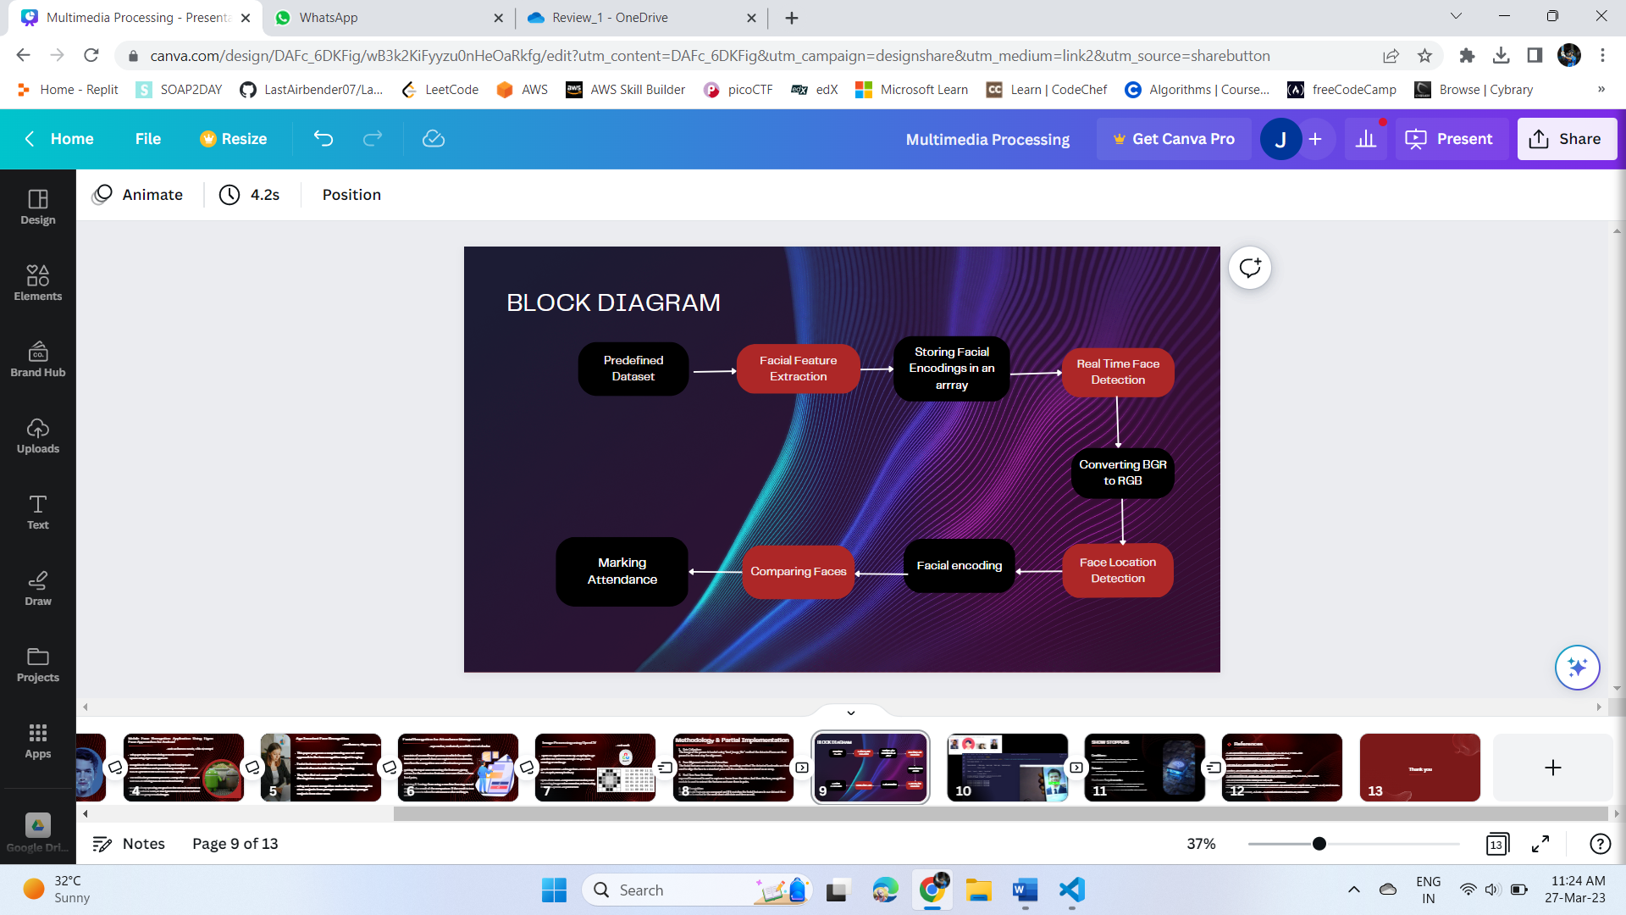

1. **Predefined Dataset**

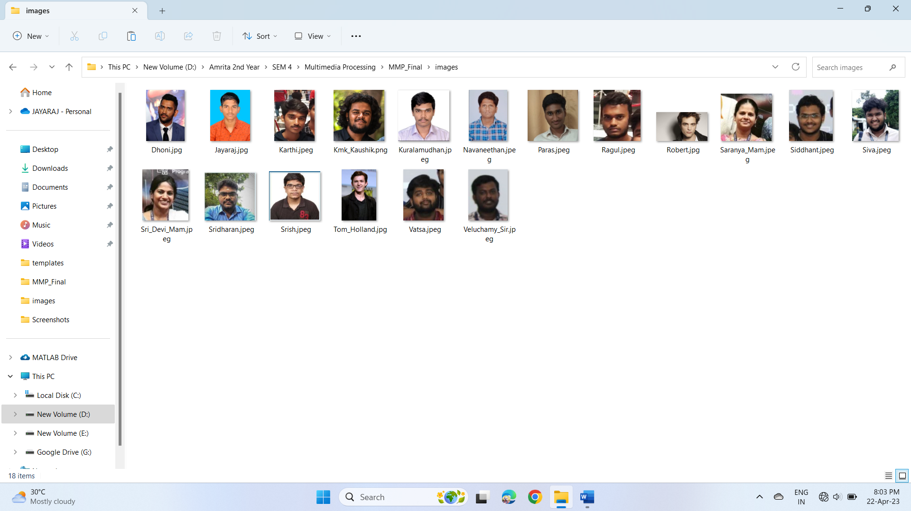

1. **Real-Time Face Recognition**

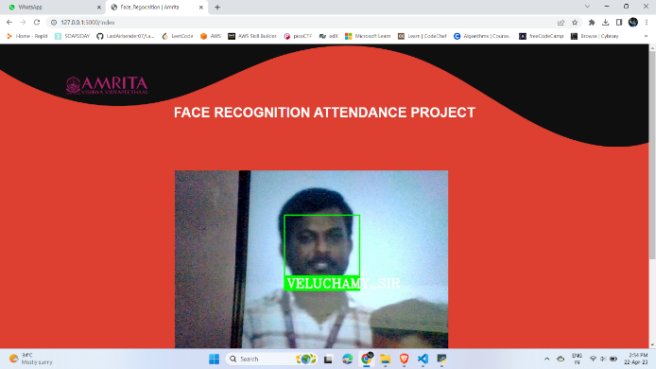

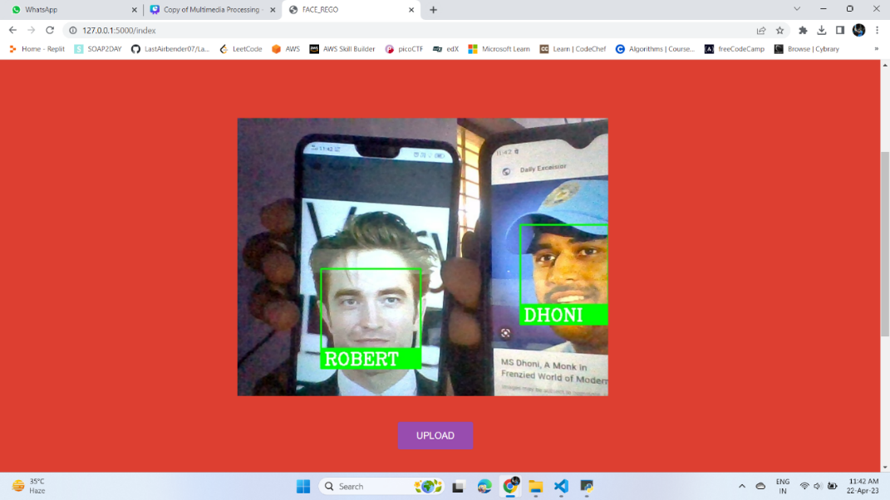

1. **Marking Attendance**



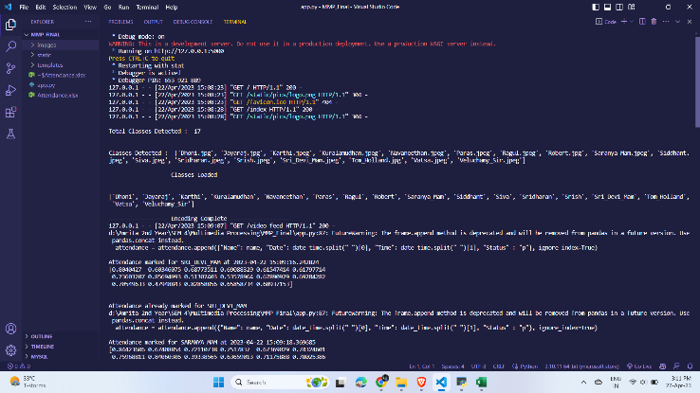

**3.4 CONCLUSION:**

In this paper, we presented an implementation of Attendance using face recognition system which uses Face Recognition module and OpenCV library in Python.

In conclusion, our attendance system using face recognition technology is a reliable and efficient solution for tracking attendance in various settings. The system offers a number of benefits, including increased accuracy, reduced administrative workload, and improved security.

Through the use of deep learning algorithms and machine vision, our system can accurately detect and recognize individuals' faces, even in slightly low-light or crowded environments. This ensures that attendance records are precise and up-to-date, which can be critical for payroll and other administrative tasks.

Moreover, the system can be easily, integrated into existing infrastructure, such as access control systems and time and attendance software. This makes it easy for organizations to adopt and benefit from the technology without major disruptions to their existing processes.

**3.5 FUTURE WORK:**

Our implementation can be further improved and extended in various ways. Some of the possible future work includes:

1. Face recognition in challenging conditions: Our implementation can be extended to handle face recognition in challenging conditions such as occlusions, disguises, and low-resolution images by using advanced techniques such as deep learning and ensemble methods.
2. Large-scale face recognition: Our implementation can be extended to handle large-scale face recognition applications by using distributed computing techniques and optimizing the storage and retrieval of the face feature vectors.
3. Privacy and ethical considerations: Face recognition technology raises privacy and ethical concerns, such as the use of facial recognition for surveillance and the potential for bias and discrimination. Future work should consider these issues and develop methods to address them.

In summary, face recognition using Python and OpenCV is a promising field with many practical applications and the effectiveness of using the Face Recognition module and OpenCV library for face recognition, and provides a starting point for further research and development in this field.

1. **REFERENCES**

[1] Face Recognition for Attendance Management by Jaya Bhaskar, V Venkatesh

<https://web.archive.org/web/20220303072507/http://www.warse.org/IJETER/static/pdf/file/ijeter04842020.pdf>

[2] Face Recognition Technology by Sagar Deshmukh, Sanjay Rawat

<https://web.archive.org/web/20200319020837/http://www.ijtsrd.com/papers/ijtsrd14331.pdf>

[3] J. Hui, S. Tang, and S. Hu, "Face Recognition Based on Convolutional Neural Networks and Softmax Regression," in Proceedings of the 2017 International Conference on Image, Vision and Computing (ICIVC), Chengdu, China, pp. 112-116, 2017.

[4] Age Invariant Face Recognition by Prathama V, Thippeswamy

<https://web.archive.org/web/20200318185316/https://www.ijtsrd.com/papers/ijtsrd23572.pdf>

[5] S. Minaee, S. Abdolshah, and N. Khademi Kalantari, "Deep learning-based face recognition: A survey," Pattern Recognition, vol. 107, 2020.

[6] Mobile Face Recognition Application using Egien Face Approach for Android

<https://web.archive.org/web/20200213021038/http://mjs.uomustansiriyah.edu.iq/ojs1/index.php/MJS/article/download/540/pdf>

[7] Face Recognition for automated attendance management by N. Ramya, D. Manasa, S.K.Naveed

<https://web.archive.org/web/20201119203218/https://eprajournals.com/jpanel/upload/918pm_22.EPRA%20JOURNALS--5583.pdf>

[8] Image Processing using OpenCV by Udit Malik

<https://web.archive.org/web/20220704200918/https://www.ijraset.com/best-journal/image-processing-in-open-cv>

[9] Smart Attendance System using OpenCV based on Face Recognition by Sudhir Bussa, Ananya Mani, Shruti Bharuka

<https://web.archive.org/web/20200709102713/https://www.ijert.org/research/smart-attendance-system-using-opencv-based-on-facial-recognition-IJERTV9IS030122.pdf>

[10] Y. Sun, X. Wang, and X. Tang, "Deep Learning Face Representation from Predicting 10,000 Classes," in Proceedings of the 2014 IEEE Conference on Computer Vision and Pattern Recognition (CVPR), Columbus, OH, USA, pp. 1891-1898, 2014.

[9] J. Lu, V. E. Liong, and J. Zhou, "Face Recognition using Local Quantized Patterns," in Proceedings of the 2012 IEEE Conference on Computer Vision and Pattern Recognition (CVPR), Providence, RI, USA, pp. 3562-3569, 2012.

Face Recognition module, available at <https://github.com/ageitgey/face_recognition>