

A project report on

**IoT-Enabled Floating Robot for Enhanced Water Quality Monitoring and Waste Management in Aquaculture Ponds**

Submitted in partial fulfillment of the requirements for the degree of

B. Tech

In

Electronics and Telecommunication Engineering

By

**ARCHISMAN BANERJEE(2104066)**

**SANKARSHAN PRADHAN (2104094)**

**NAVANITA DAS(2104111)**

**RASHMITA BISWAL(2104118)**

under the guidance of

**Prof. Susanta Kumar Badi**

School of Electronics Engineering

**KALINGA INSTITUTE OF INDUSTRIAL TECHNOLOGY**

(Deemed to be University)

BHUBANESWAR

APRIL 2024

**CERTIFICATE**

This is to certify that the project report entitled **“Project Title”** submitted by

|  |  |
| --- | --- |
| **ARCHISMAN BANERJEE**  **SANKARSHAN PRADHAN**  **NAVANITA DAS**  **RASHMITA BISWAL** | **Roll No.-2104066**  **Roll No.-2104094**  **Roll No.-2104111**  **Roll N0.-2104118** |

in partial fulfilment of the requirements for the award of the **Degree of Bachelor of Technology** in **Electronics and Telecommunication Engineering**  is a bonafide record of the work carried out under my (our) guidance and supervision at School of Electronics Engineering, KIIT (Deemed to be University).

|  |  |
| --- | --- |
|  | Signature of Supervisor  Prof. Supervisor’s Name  School of Electronics Engineering  KIIT (Deemed to be University) |
|  | Signature of Co-Supervisor  Prof./Mr. Co-Supervisor’s Name  Department/School  Organization/Institute |

Date: 01/04/2024

ACKNOWLEDGEMENTS

We feel immense pleasure and feel privileged in expressing our deepest and most sincere gratitude to our supervisor(s) **Prof. Susanta Kumar Badi**, for his excellent guidance throughout our project work. His kindness, dedication, hard work and attention to detail have been a great inspiration to us. Our heartfelt thanks to you sir for the unlimited support and patience shown to us. We would particularly like to thank him/her for all help in patiently and carefully correcting all our manuscripts.

We are also very thankful to **Dr. (Mrs.) Sarita Nanda,** Associate Dean and Associate Professor, **Dr. (Mrs.) Suprava Patnaik** , Dean and Professor, School of Electronics Engineering, and Project Coordinators, for their support and suggestions during entire course of the project work in the 6th semester of our undergraduate course.

|  |  |  |
| --- | --- | --- |
| Roll Number | Name | Signature |
| **2104066** | **ARCHISMAN BANERJEE** |  |
| **2104094** | **SANKARSHAN PRADHAN** |  |
| **2104111** | **NAVANITA DAS** |  |
| **2104118** | **RASHMITA BISWAL** |  |

ABSTRACT

Research has shown a ground-breaking way to improve the monitoring of water quality and transform aquaculture waste management techniques: an Internet of Things (IoT)-enabled floating robot. An essential component of sustainable food production, aquaculture faces constant challenges from waste accumulation and declining water quality. The IoT-powered floating robot is a shining example of innovation that has the potential to completely change the way aquaculture is managed.   
  
By utilizing cutting-edge IoT technology and a broad range of sensors, this innovative invention ushers in a new era of thorough, real-time water condition insights and precise waste management. This autonomous robot promises to provide unmatched efficacy in monitoring and controlling critical parameters impacting aquaculture pond health by seamlessly combining modern sensor capabilities.

This miracle of IoT has enormous potential applications. It is not just a small step forward in the field of aquaculture sustainability; rather, it is a revolutionary one. The robotic solution embodies sustainability and efficiency through its utilization of IoT prowess, effectively tackling the dual problems of waste management and water quality with unparalleled effectiveness.   
  
This invention fundamentally supports the need for careful management of aquatic environments. It establishes the groundwork for a day when aquaculture enterprises can prosper in balance with the environment by maximizing resource usage and minimizing environmental footprint. In the end, the Internet of Things-enabled floating robot is a monument to human inventiveness and a ray of hope for the environmentally friendly and sustainably aquaculture coexistence.

TABLE OF CONTENTS

Aknowledment

Abstract

Table of Contents

**CHAPTER 1: INTRODUCTION 1**

1.1 Background Studies /Literature Survey 1

1.2 Motivation 2

1.3 Objectives 2

**CHAPTER 2: METHODOLOGY 4**

2.1 Applied Techniques and Tools 4

2.2 Project Specifications 9

2.3 working 10

2.4 Algorithm 11

**CHAPTER 3: EXPERIMENTATION AND TESTS 12**

3.1 Circuits and Experimental setup. 12

:

**CHAPTER 4: CHALLENGES, CONSTRAINTS AND STANDARDS 17**

4.1 Challenges and Remedy 17

4.2 Alternatives and Trade-offs 17

**CHAPTER 5: RESULT ANALYSIS AND DISCUSSION 18**

5.1 Results Obtained 18

5.2 Analysis and Discussion 19

**CHAPTER 6: CONCLUSIVE REMARKS**  6.1 Conclusion 20

6.2 Further Plan of Action / Future Scope 20

**REFERENCES:** 21

**APPENDIX A: Gantt Chart** 23

**APPENDIX B: Project Summary** 24

**CHAPTER 1**

**INTRODUCTION**

**1.1 Motivation**

Rapid growth in aquaculture has occurred to fulfill the growing demand for aquatic products, as it is an essential part of the world food production system. The upkeep of ideal water quality in aquaculture ponds, however, is crucial to the industry's production and survival. Nowadays, water is considered as one of the most scarce natural resources on our planet [1]. It is important to humankind, animals, and plants [2]. In addition to protecting aquatic life's health and welfare, maintaining a balanced ecosystem affects aquaculture operations' capacity to make a profit. Conventional approaches to water parameter monitoring have mostly depended on hand sampling and recurring laboratory testing, providing a snapshot of the situation that might not include the dynamic variations that are characteristic of aquatic settings. An unparalleled chance to completely transform the aquaculture monitoring paradigm has arisen with the introduction of the Internet of Things (IoT).

Therefore, technology is used in making agriculture more efficient without endangering the environment. Aquaponics is one approach which integrates plant and fish farming in a single system that relies on each other [3]. Aquaponics is an efficient way in food production involving plants and fishes simultaneously without endangering the environment [4]. Through the integration of IoT technology and robotics, this study aims to present a new approach: an IoT-enabled floating robot that is carefully designed to monitor water quality in real-time and efficiently manage trash in aquaculture ponds.

With the goal of giving aquaculturists continuous, accurate, and useful data, this robotic innovation seeks to go beyond the constraints of traditional monitoring approaches. Consequently, it has the potential to transform the field of aquaculture management by promoting increased sustainability, effectiveness, and adaptability to changing environmental issues. Works by [5], [6], and [7] uses WeMos board for various IoT applications such as smart garbage monitoring and collection system, IoT based agriculture monitoring system, and IoT based weather information prototype. The design is simple since the WeMos board comes with a microcontroller integrated with a Wi-Fi module built-in together.

The floating robot is equipped with a suite of sensors, including pH sensors, dissolved oxygen meters, temperature sensors, turbidity sensors, and nutrient level detectors. These sensors collectively ensure continuous monitoring of key water quality parameters critical for the well-being of aquatic organisms in aquaculture ponds. The real-time data generated by the robot enables prompt identification of fluctuations in water quality, empowering aquaculturists to take proactive measures to maintain optimal conditions.Wireless communication capabilities enable seamless data transmission to a centralized platform, facilitating remote monitoring and analysis.

**1.2 Background Studies /Literature Survey**

Water quality management has always been a great challenge to the aquaculturist for cultivation of aquatic organisms under proper aquatic conditions.In today’s time , the aquatic organisms are facing several threats, owing to deterioration of water quality due to excessive pollutants disposal. Extensive researches has been done on designing IoT enabled floating robot for water quality monitoring and management. In some previous work[8] , a system has been designed that is subdivided into different subsystems - intelligent robotic arm which has Arduino Mega 2560 as core component, sensor chamber consisting of various sensors like Temperature sensor , pH sensor , Dissolved Oxygen sensor and four different chambers for collecting water samples from four different ponds , within the same subsystem. The research study used a programmable logic controller embedded with a PC-based server and NB-IoT technology has been used to transmit data to the server.

In another research work , a low cost , real time water quality monitoring system [9] has been developed. The measured information is analyzed graphically and transmitted through a web based portal on mobile phones to end users. So, Cloud Computing has been used to transmit the data from cloud servers to users at distant locations.

A further extended research has been done by making the robot floating, due to buoyancy , and its hull design incorporates DC geared motors with propellers , controlled by the motor driver L293D.This enables the robot to perform various movements such as moving backward , forward , left , right by the manipulation of DC motors and adjusting their polarity[10]. [11] A floating airboat was developed which contains a Raspberry Pi as the controller , a Wifi Router for connecting to smart devices and sensors . The airboat was used in two lagoons in Fortzela and in a reservoir in Pacatuba.The main purpose is to develop an autonomous system for collection and analysis of water quality parameters.

Another good research paper [12] proposed a low cost advanced water garbage cleaning robot called ‘Aquatic Iguana’. This robot basically moves on the water surface and collects waste materials and also monitors water parameters like temperature , pH , turbidity and a live streaming feature.

Besides , these significant works , further researches are still going on regarding development of IoT based smart robot for water quality management as well as it’s implementation in large scale.With the evolution of Industrial revolution 4.0 , works are going one to design 3D printed water quality monitoring system and thus , more advancement in developing such prototype is expected in the future also.

**1.3 Objectives**

An internet of things enabled floating robot for waste management and water quality monitoring aquaculture ponds may have multiple purposes,each geared toward addressing a different set of issues and objectives related to agriculture management.Here are a few possible goals:

**Early Problem Identification:** By using sensors and algorithms to identify any abnormalities or departures from ideal conditions in the aquatic environment,possible issues like pollution,or disease outbreaks can be identified before they become serious.

Feeding scheduling and quantities, as well as the application of chemical or biological agents for water treatment ,can be optimized with the help of data gathered by the floating robot. This will minimize waste and increase overall efficiency.

**Automated garbage management**: Provide systems that will enable the floating to identify and eliminate dead organisms,excess feed and garbage from the pond, avoiding water contamination and preserving a wholesome environment for aquatic animals.

**Integration with Environmental Conditions**: To better understand how external factors may affect water quality and aquaculture operations,incorporate weather forecasts and other environmental data into a monitoring system.

Enable remote access and control of the monitoring system so that managers of aquaculture can examine data,get alerts,and change operational settings from any location with an internet connection.

Analyze the trend over time,spot patterns ,and offer practical insights to enhance aquaculture operations and decision making by utilizing data analytics and visualization technologies.[13]

**Compliance and Reporting**: Help aquaculture operators prove that they are following the environmental standards and regulations by automatically recording and reporting water quality data.This will facilitate compliance with regulatory requirements.

**Sustainability and Environmental Stewardship**: Encourage environmentally responsible aquaculture practices by maximizing the use of available resources,reducing waste and pollution and improving the environmental sustainability of aquaculture operations as a whole. As a platform for continuous research and development in agriculture,it offers chances to test out new tools,methods and approaches aimed at enhancing resilience,productivity and environmental stewardship.

An internet of things enabled floating robot for waste management and water quality monitoring in an aquaculture environment can help ensure the health and welfare of aquatic organisms,minimize environmental impact and support the sustainable growth and success of aquaculture operations by accomplishing these goals.[14]

**CHAPTER 2**

**METHODOLOGY**

**2.1 Applied Techniques and Tools**

### Sensors

* **Industrial Grade Analog pH Sensor Kit for Arduino:**
  + **Function**: Provides an analog voltage output that corresponds to the pH level by measuring the acidity or alkalinity (pH) of water.
  + **Significance**: pH values are essential markers of the quality of water. Low pH implies acidic water, which could be dangerous for aquatic life since heavy metals and other pollutants are present. On the other hand, high pH denotes basic water, which can interfere with biological activities and alter oxygen levels.
  + **Benefits**: Industrial grade sensors are essential for long-term deployments because they provide exceptional durability and dependability in challenging outside conditions.
  + **Ideal Value Range**: A healthy pH range for the majority of freshwater habitats is between 6.5 and 8.5 [15]. Potential contamination incidents may be indicated by deviations from this range.
  + **Deployment**: The sensor is immersed in water for deployment. To find the pH level, the Arduino reads the analog voltage output.

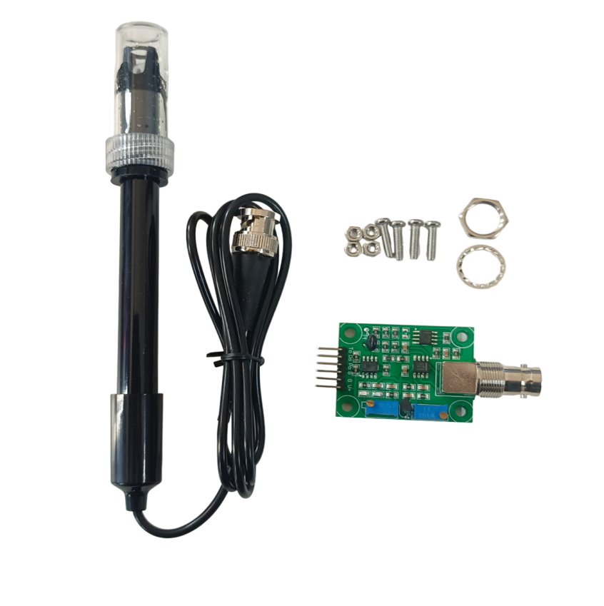

* **DS18B20 Temperature Sensor:**
  + **Features:** Digital temperature sensor for water.
  + **Significance:** Variations in water temperature can have a big impact on aquatic life and water quality. Injurious organisms can develop more quickly in warmer climates and dissolved oxygen levels can drop. On the other hand, lower temperatures have the potential to limit living things.
  + **Benefits:** Suitable for applications involving environmental monitoring, the DS18B20 is an affordable and extremely precise digital sensor.
  + **Range of Ideal Values:** Different ecosystems have different ideal water temperatures. Freshwater fish, on the other hand, often thrive in a temperature range of 15 to 25 degrees Celsius. A departure from this range may be a sign of possible environmental stresses.
  + **Deployment:** Water submerges the sensor during deployment. The temperature is read via digital communication between it and the Arduino.

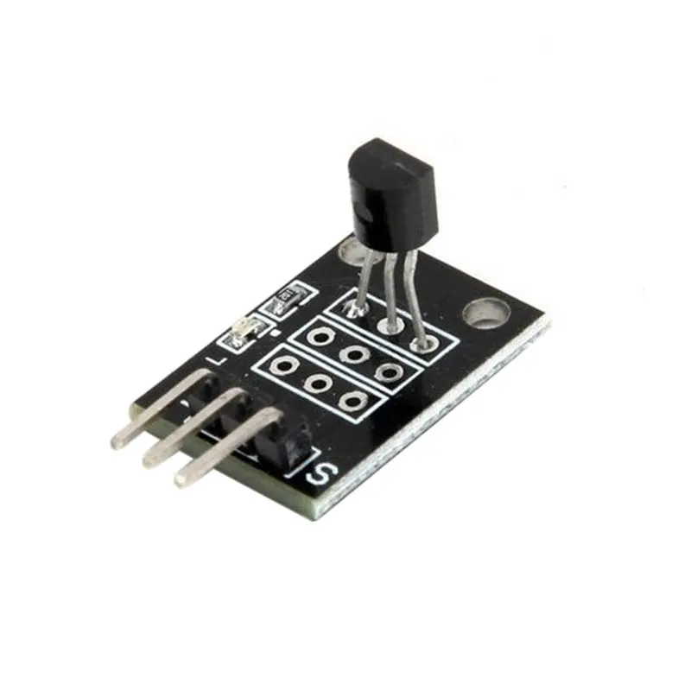

* **DHT11 Sensor:**
  + **Function:** Determines the relative humidity of the air around us.
  + **Significance:** Although high humidity can not directly measure water quality, it can be used as an indirect indicator to identify possible sources of pollution or standing water. Furthermore, analyzing local weather trends can benefit from the use of humidity data.
  + **Consideration:** Because high humidity and frequent exposure to water spray can compromise the accuracy and lifetime of the DHT11 sensor, these conditions might not be the best for it. For situations like this, other humidity sensors that are more water resistant must to be taken into account.
  + **Benefits:** The DHT11 provides a cheap and easy way to measure humidity.
  + **Optimal Value Range:** Depending on the surroundings, different humidity levels are ideal. A range of 40% to 60% is deemed moderate for the majority of outdoor uses, albeit [17]. Deviations from this range may be a sign of possible microclimates or modifications to the weather.
  + **Deployment:** The sensor is attached to the robot at a protected spot (not submerged) in order to monitor the humidity of the surrounding air.

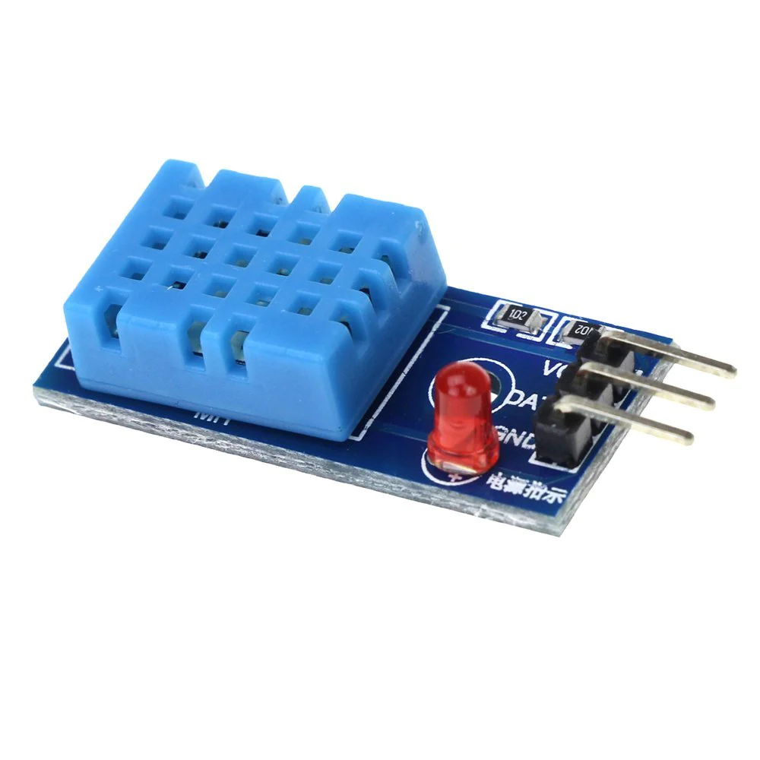

### Actuators and Communication

* **RF Module Kit (e.g., Bluetooth, Wi-Fi):**
  + **Function**: Allows sensor data (temperature, humidity, and pH) to be wirelessly transmitted to a base station or other device for analysis and monitoring.
  + **Significance**: Since wireless connectivity enables remote data access, physically retrieving the robot for data gathering is no longer necessary. This is especially helpful in places with limited access or big bodies of water.
  + **Benefits**: By eliminating the constraints of conventional connections, wireless communication offers freedom in data collection.
  + **Implementation**: To send sensor data wirelessly, the Arduino and RF module communicate.

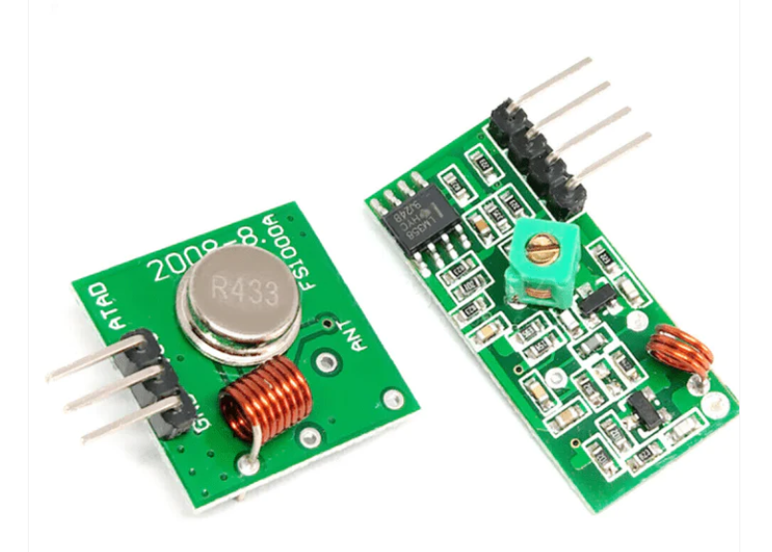

* **Gear Motor** 
  + **Function:** Electric motors with a gear mechanism that provide torque for robot movement across the water surface for data collection and potential waste navigation.
  + **Considerations:**
    - **Motor Power:** Choose a motor with sufficient power to overcome drag and currents while considering the robot's weight and desired speed.
    - **Gear Ratio:** Select a gear ratio that balances speed and torque requirements. Lower gear ratios provide higher torque for slower, more controlled movement in rough waters. Conversely, higher gear ratios offer faster speeds for calm waters but with less pulling power.
  + **Implementation:** The Arduino controls the gear motors to navigate the robot.

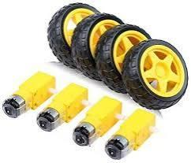

**SUN-BOARD**

Foam board, also known as sun-board, is an extremely durable, lightweight, and readily cut sheet material that can be painted, used as a base for frames, and utilized to mount vinyl prints. Typically, it consists of three layers: white clay-coated paper on the outside, and an inner layer made of polystyrene foam.In addition to being utilized for printing, sun board is frequently used for casting patterns, architectural models, and product prototyping. Hobbyists frequently create backgrounds using sun board for computer games, dioramas, and scale model displays. Aero-modellers can also be used to construct tiny, radio-controlled aircraft.

1. Sun-board is incredibly versatile and is simple to cut, shape, and route to fit your unique project needs.

2. This material can be easily handled to obtain desired results, whether you require it for straight cuts, complicated shapes, or customized designs. Additionally, sticky materials work with it, making installation and mounting on various surfaces simple.



2.2 **Proposed Model**

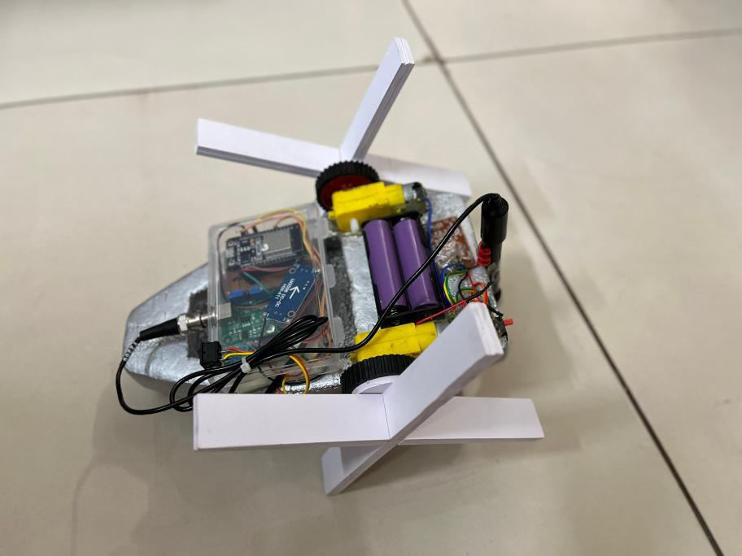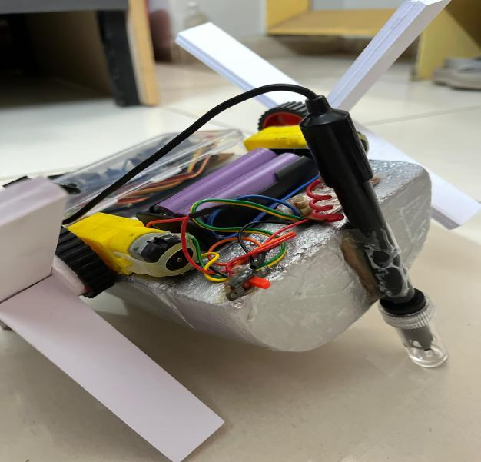

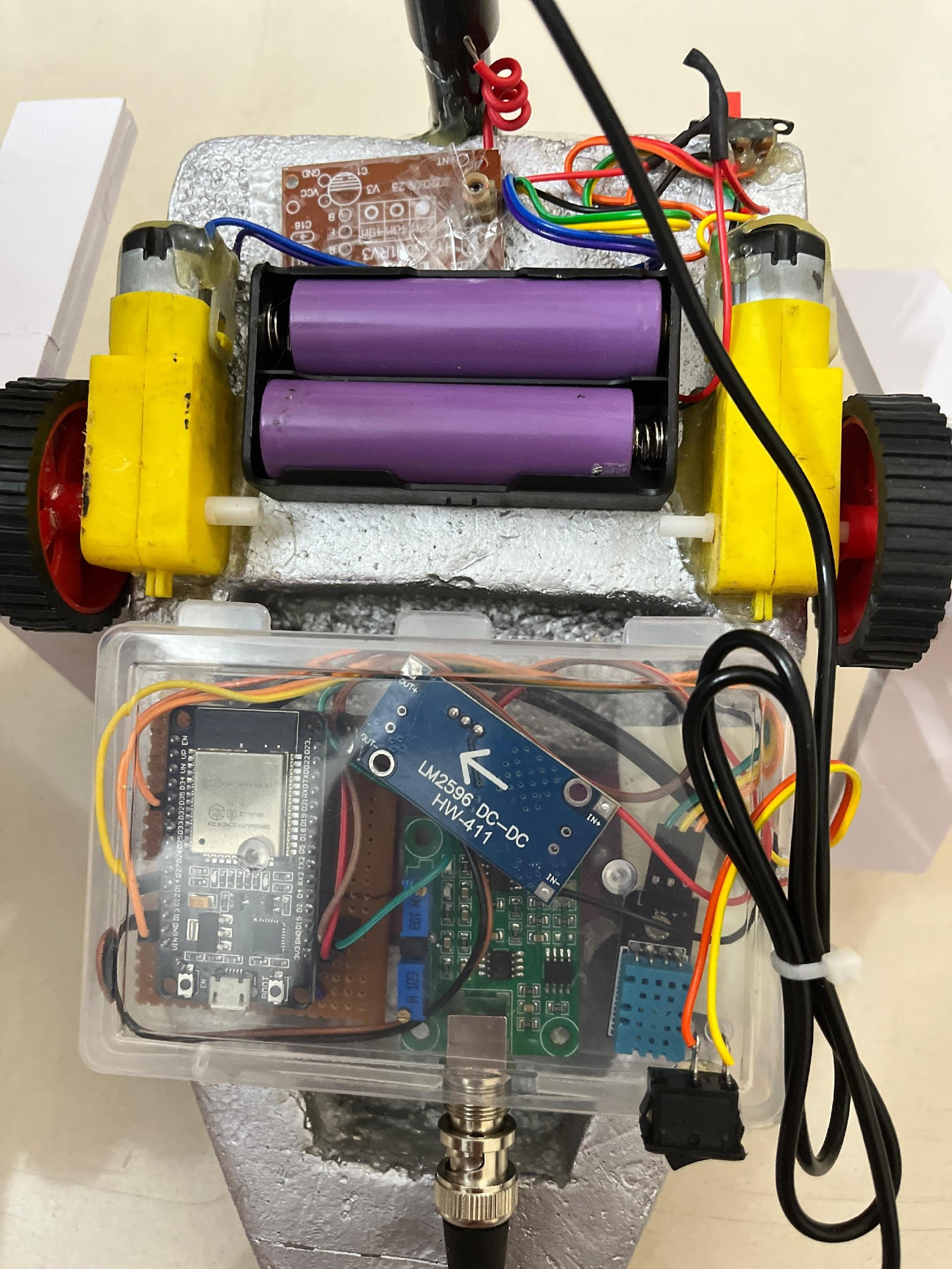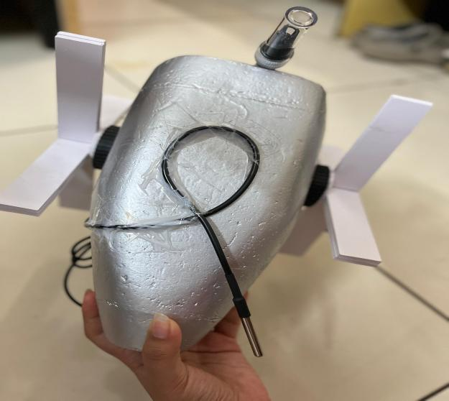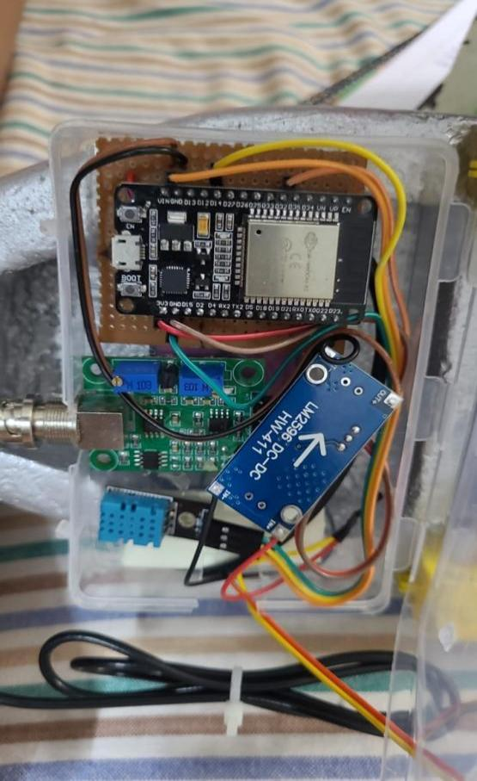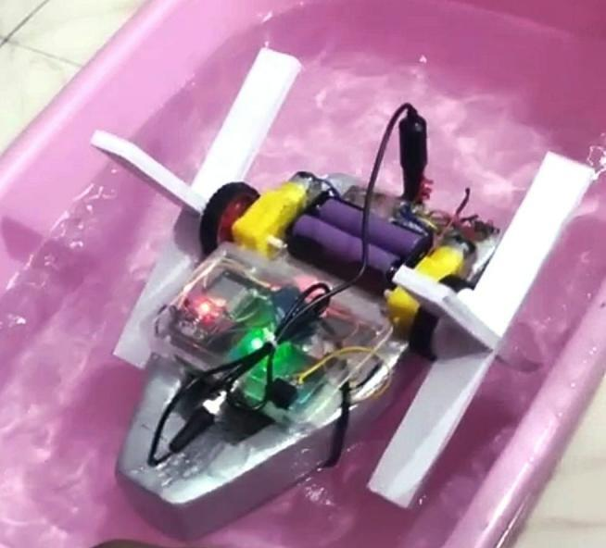

**2.3 Working:**

1. The whole circuit is connected to the floating base which is made of foam board or thermocol.
2. Sun-board is used to make the rotating blades of the wheels.
3. The wheels (BO wheels) are attached with the gear motor (BO motor) so that the whole attached can rotate to enable the boat to move.
4. RF module is used instead of relay because relay has more cost complexity. Rf module is used along with the motors.
5. In the No33 box - ESP32, Buck converter, vero board, ph sensor module, DHT sensor are contained inside it.
6. Rocker Switch is used for on and off the system to retain battery consumption.
7. The battery used in this water monitoring robot is 2200 mah Lithium ion Battery.
8. The whole structure is attached in such a way which makes the boat floatable and easy to move.
9. A remote is used for controlling the movement of the water monitoring robot.
10. Since pH sensor, DHT sensor and Waterproof temp sensor are used, the data we get is presented in terms of numeric level meter (pH of the water body, Humidity & Temperature [environment surrounding the robot] and Temperature of the water body).
11. The platform used for wireless transmission of data is Blynk IoT.
12. When the boat system is made on it starts sensing the environment it is in, then the sensed data is wirelessly transmitted to mobile applications using the wifi module.
13. The wifi module is made working by connecting it to the internet or network access with detailed credentials.
14. Moreover the sensed data is observed in the mobile application (Blynk IoT), according to the algorithm if observed values do not meet the desired values , then an alert signal is sent wirelessly to the connected platform and the user can take action.
15. Further details are explained using the algorithm given below.

**2.4 Design Approach and Algorithm**

The algorithm of the working model is proposed below in the form of a flow chart.

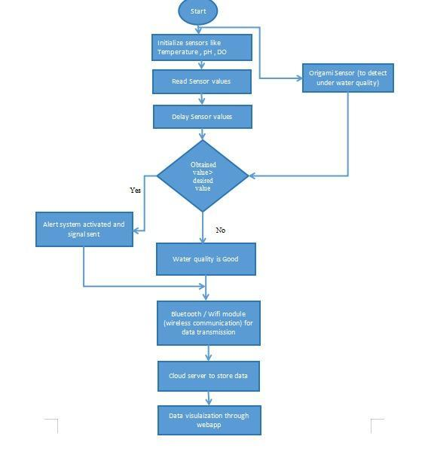

**CHAPTER 3**

**EXPERIMENTATION AND STUDIES**

**3.1 Circuit Design and Simulation**

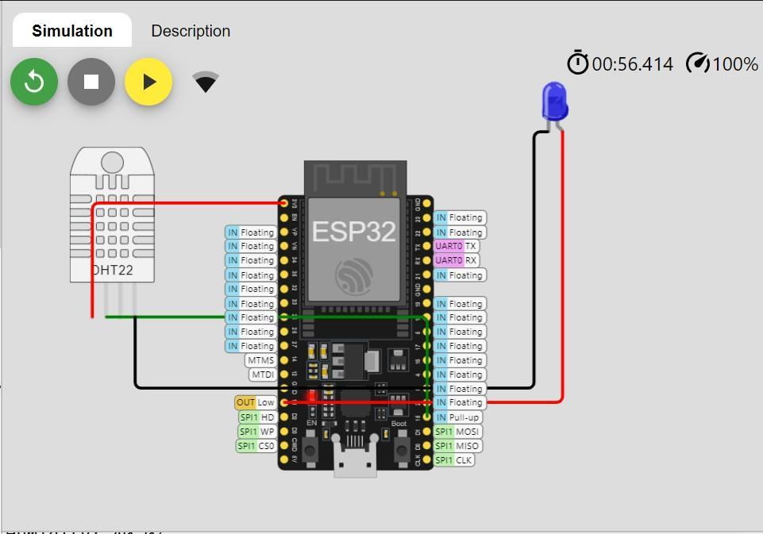

**DHT 22 Interfacing:**

The interfacing of ESP32 module with temperature and humidity sensor DHT 22 has been designed and simulated in an open source online software called Wowki Simulator. The GND and Vcc pin of DHT 22 sensor are connected to the GND and Vcc pin of the ESP 32 module. The data out pin of DHT 22 is connected to analog input pin 16 and the No connection pin is left unconnected as it is not used for wiring purpose.

The code is written in embedded C language in the free compiler associated with Wowki Simulator and then the code is compiled and uploaded. This project uses ThingSpeak application for data processing and analytics. A channel is created in ThingSpeak app and after that following some basic settings , the temperature and humidity can be visualized in the form of a graph. Now this data can be sent wirelessly to remote locations and can be observed in smart phones using an web application called ThingViewFree.

**pH Sensor:**

A pH sensor is a tool used to determine how acidic or alkaline a solution is.It is sometimes referred to as pH probe or pH electrode.It functions by measuring the amount of hydrogen ion() in the solution ,which establishes the pH level.

A typical pH sensor functions as follows:

Fundamental Idea: A solution’s pH level tells us how basic or acidic it is.The concentration of hydrogen ions( in the solutions determines the pH,pH sensors measure this concentration.

Structure of the Electrode: A reference electrode and a glass membrane electrode make up the two primary components of a pH sensor’s core.At the tip of the sensor,the glass membrane electrode resembles a tiny glass bulb. It is constructed from a unique kind of glass that responds to variations in the solution’s hydrogen ion concentration.A reliable reference point for the measurement is provided by the reference electrode.It is often composed of a substance with a steady electrical potential and doesn’t react with the solution

Operation: The hydrogen ions in the solution interact with the glass membrane when the pH sensor is dipped into it.Because the glass membrane is selectively permeable,some ions can travel through while others cannot.Only hydrogen ions are intended to be able to pass through.Hydrogen ions produce a little electrical signal as they pass through the glass membrane.the signal’s relationship to the solution’s hydrogen ion concentration is direct.The glass membrane signal is monitored in relation to a stable electrical potential provided by the reference electrode.

Circuit for Measurement: The pH sensor’s measurement circuit detects the electrical signal produced by the interaction of hydrogen ions with the glass membrane. The signal is processed and amplified by this circuitry to make it readable.After processing, the signal is transformed into a pH value,which is typically shown on a computer screen.

Adjustment: pH sensors must be calibrated on a regular basis to provide accurate readings. In order to calibrate a sensor, it must be exposed to buffer solutions, which have known pH values and its measurements must be adjusted accordingly.

This procedure aids in taking into consideration drift or variations in the sensor’s performance over time

Uses: pH sensors have extensive applications in many domains such as water treatment,food and beverage manufacturing,scientific research,pharmaceutical,and environmental monitoring .They support scientific research,keep an eye on environmental conditions, and aid in ensuring the quality and safety of products.

In conclusion, a pH sensor uses a unique a unique glass membrane electrode and a reference electrode to determine the concentration of hydrogen ions in a solution.Through the use of electrical circuitry, it transforms this data into a pH value; however, periodic calibration is necessary to ensure accuracy. In a variety of industries ,these sensors are indispensable instruments and applications that require exact control over acidity or alkalinity.[c]

**Interfacing with ESP32 Wi-fi Module**: A pH sensor and an ESP32 microcontroller are interfaced by attaching the sensor to the microcontroller’s GPIO pins and reading the sensor data using the relevant libraries.

The steps are followings:

Hardware Configuration:

* Jumper wires, the ESP32 boards and the pH sensor are assembled.The location of the pH sensor’s pins, which are labeled VCC(power),GND(ground),and OUT (signal).
* Using a jumper wire,the pH sensor’s VCC pin is linked to the ESP32’s power supply.
* The pH sensor’s GND pin is then linked to an ESP32 ground pin.
* Lastly,one of the GPIO pins on the ESP32 connected to pH sensor’s OUT pin.

Configuring Software:

* After opening Arduino IDE(making sure that ESP32 board is chosen),

The pH sensor library can be installed using the Library Manager if necessary.

* The Arduino sketch imports any required libraries.
* The writing of the code to read data from the pH sensor has begun.

Composing the Program:

* Initialization is done for variables that are required by the Arduino program,like pin numbers and calibration values.
* Serial connectivity for debugging and any other necessary sensor in the setup function.
* The code to read data from the pH sensor using methods like analogRead() is then written in the loop function
* The serial monitor or alternative means are used to output the sensor data once it has been processed as needed.

Testing and Troubleshooting:

* The Serial Monitor in the Arduino IDE is launched once the code has been uploaded to the ESP32 device.
* By dipping the pH sensor into solutions with established pH values ,accuracy is confirmed.
* If problems arise, errors are double checked in the code and connections.[d]

Combination:

* pH sensor is incorporated into the bigger project after confirmation.
* The project’s usage of pH data is taken into account,including data logging and device control depending on pH levels.
* The code is adjusted to meet the requirements of the project.

By following these procedures, the pH sensor and ESP32 microcontroller should be able to be successfully interfaced,enabling the projects to incorporate pH sensing capabilities.



**Role of pH sensor in this project:**

An Internet of Things(IoT) enabled floating robot intended for waste management and water quality monitoring in aquaculture ponds depends heavily on the pH sensor.The pH sensor plays the following role in making such system work:

Monitoring of Water Quality:

* The aquaculture pond’s water’s acidity or alkalinity is determined by the pH sensor.Because pH levels can have an impact on aquatic organisms health,this data offers important information regarding the general quality of the water
* The floating robot keeps an eye on pH levels and may identify any variations or anomalies in the water’s pH ,informing aquaculture management of any problems including pollution,nutrient imbalances,or toxic algal blooms.

Management of Aquaculture:

* Maintaining the ideal pH level is crucial for the growth and health of aquatic creatures,including shrimp and fish,in aquaculture operations.
* Aquaculture managers can better ensure that the water conditions in their unique species’ habitats stay within the appropriate range with the aid of the pH sensor.It makes it possible to promptly modify the chemistry of the water,for example,by adding buffers or pH regulators,to keep aquatic life at its best.

Environmental Surveillance:

* In order to keep the environment healthy and avoid water contamination,waste management in aquaculture ponds is essential.
* The pH sensor aids in the monitoring of the effects on water quality of waste discharged from aquaculture operations.It can identify pH shifts brought on by the buildup of contaminants,nutrients,or organic waste,enabling prompt action to slow down the deterioration of the environment.

Connecting to an IOT platform:

* Along with sensor data from temperature,dissolved oxygen,the pH sensor data is linked into the IOT platform onboard the floating robot.
* Aquaculture managers can remotely access a cloud-based system or central monitoring station that receives real time pH data via the Internet of things platform.
* Analyzing historical pH data gathered over time can reveal trends,patterns and connections with other water quality metrics,enabling data-driven strategy development for waste management and aquaculture management.[e]

Independent Function and Management:

* The floating robot patrols the aquaculture pond on its own ,gathering data on the quality of the water either in reaction to environmental cues or at predetermined intervals.
* The robot may modify its operation based on sensor data,including pH sensor readings

The pH sensor is an essential component of an Internet of things enabled floating robot designed for waste management and water quality monitoring in aquatic environments.It helps to maintain the ideal water conditions for aquatic life,promotes environmental responsibility, and allows for data-driven decision-making regarding aquacultural management practice.

**CHAPTER 4**

**CHALLENGES AND ALTERNATIVE TRADE-OFF**

**4.1 Challenges**

Challenges: Reliability of the power supply,data transmission problems,sensor maintenance in water,interference from the environment,data security concerns and efficient cost management are some of the obstacles to the successful implementation of an IoT based floating water quality monitoring system for aquaculture ponds. Innovative technology,meticulations preparation,and stakeholder cooperation are needed to these issues.

**4.2 Alternatives and Trade-off**

This project makes use of the lowest resources thereby reducing cost and gives a good result.However , for real life applications , this project can be further improvised by using Raspberry pi in place of ESP 32 , as it offers much more features and faster processing speed. The licensed version of AWS can also be used instead of ThingSpeak as data visualization and analysis will be much better. The TDS sensor and other high quality sensors can also be used for detailed measurement of water quality parameters, but for a rough data estimation , this model performs well.

The above alternatives can be adopted however , the cost will be comparatively high but with better efficiency. So , a trade-off needs to be maintained between cost and efficiency so that optimized results are obtained.

**CHAPTER 5**

**RESULT ANALYSIS AND DISCUSSION**

**5.1 Results Obtained**

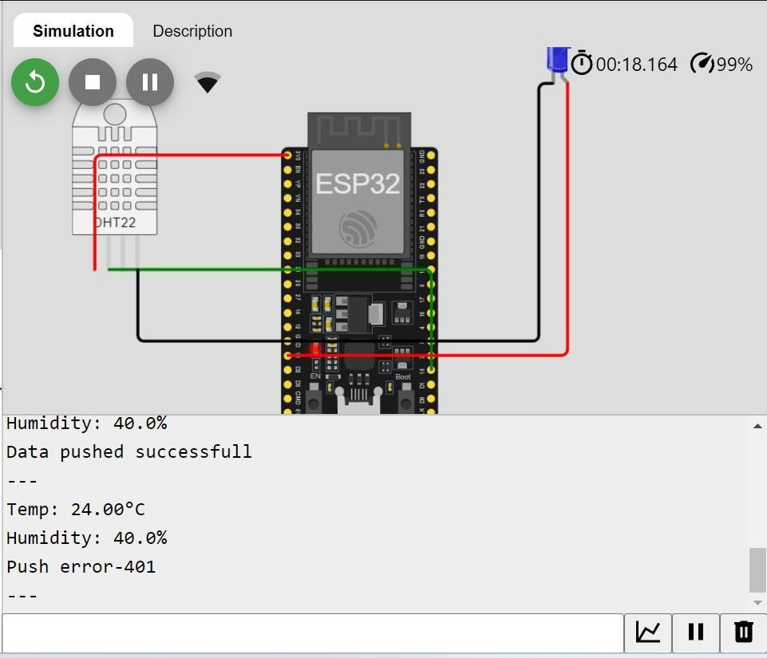

Temperature and humidity reading of online simulation

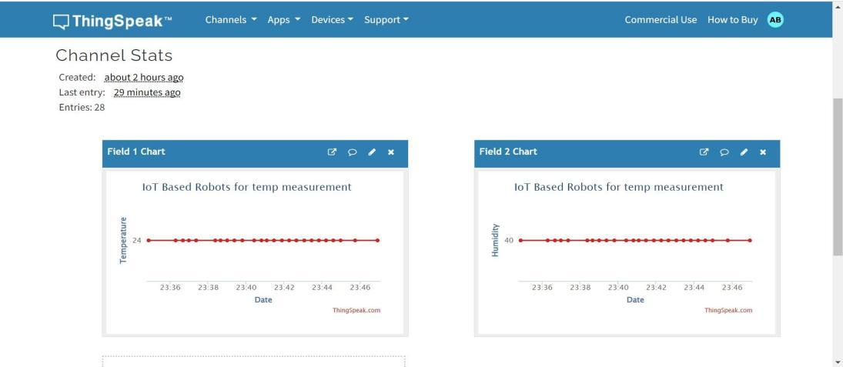

Graphical representation of temperature and humidity values

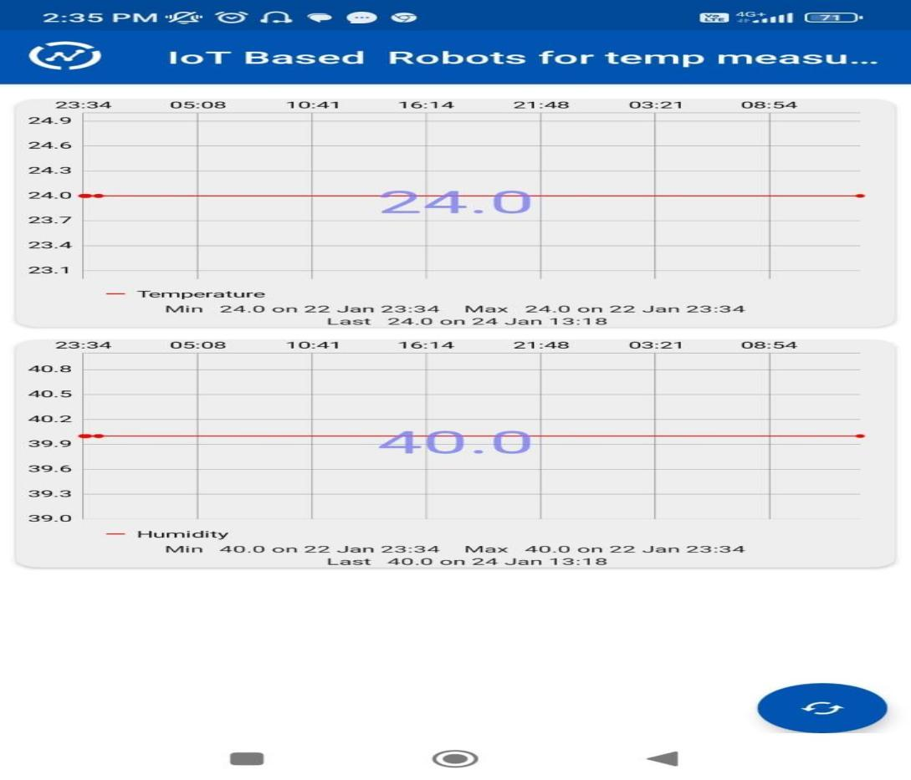

Temperature and humidity values visualized in smart phone through web app ThingViewFree

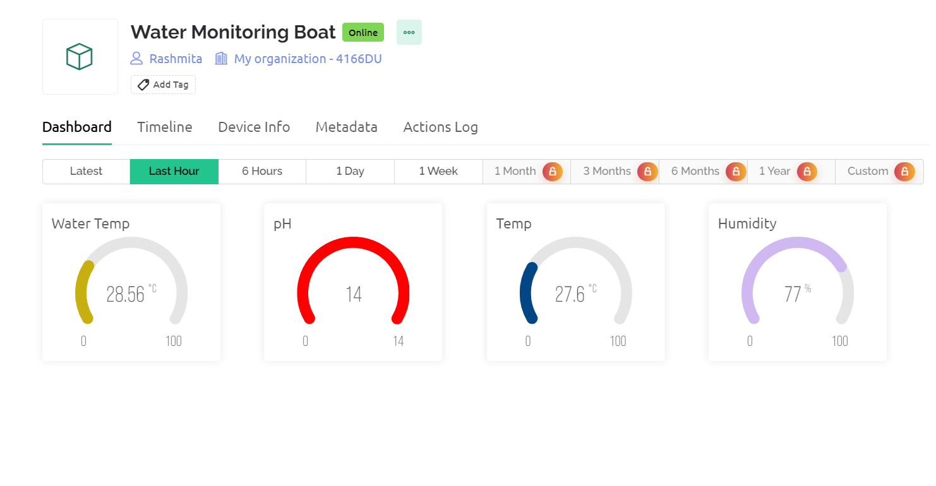

Measured Parameters In Blynk IoT

**5.2 Discussion**

The datas obtained in the form of graphs can be processed and analyzed using some machine learning algorithms. Based on the statistical data analysis , the trend of aquatic water bodies can be observed and also the water bodies suitable for aqua-cultural activities can be identified.This will help in identification as well as labelling of different aquatic bodies on the basis of water quality parameters and thus , the aquatic life will be free from life threats.

**CHAPTER 6**

**CONCLUSIVE REMARKS**

**6.1 Conclusion**

To sum up aquaculturists can reap a number of advantages by installing an internet of Things -based floating water quality monitoring system system in their ponds.This system delivers real-time data that is essential for preserving the ideal conditions for aquatic life by continuously monitoring critical factors like pH,dissolved oxygen,temperature and turbidity.Aquaculturists can reduce the risks,optimize operations and make well-informed decisions through remote access and data visualization,which eventually improves productivity and sustainability in aquaculture methods.By creating healthier habitats for aquatic life and promoting the expansion of the aquaculture sector,this creative approach represents a breakthrough in precision aquaculture management.

**6.2 Further Plan of Action / Future Work**

**Future Work:**

* The future work for IoT-enabled floating robots in aquaculture could

involve enhancing sensor capabilities for more precise water quality

Measurements.

* ORIGAMI / FOLDABLE sensors and actuators
* Implementing machine learning algorithms to enhance the robots'
* decision-making abilities in dynamic aquaculture environments.

**REFERENCES**

[1] Bakker K. Water security: research challenges and opportunities. Science. 2012;337:914–5.

[2] Storey MV, van der Gaag B, Burns BP. Advances in on-line drinking water quality monitoring and early warning systems. Water Res. 2011;45:741–7

[3]. Rakocy, J. E. (2012). Aquaponics: integrating fish and plant culture. Aquaculture production systems, 1, 343-386.

[4] Junge, R., König, B., Villarroel, M., Komives, T., & Jijakli, M. H. (2017). Strategic points in aquaponics.

[5] Memon, S. K., Shaikh, F. K., Mahoto, N. A., & Memon, A. A. (2019, January). IoT based smart garbage monitoring & collection system using WeMos & Ultrasonic sensors. In 2019 2nd International Conference on Computing, Mathematics and Engineering Technologies (iCoMET) (pp. 1-6). IEEE.

[6] Rukhmode, S., Vyavhare, G., Banot, S., Narad, A., & Tugnayat, R. M. (2017). IOT based agriculture monitoring system using wemos. no. March, 14-19.

[7] Kodali, R. K., & Sahu, A. (2016, December). An IoT based weather information prototype using WeMos. In 2016 2nd International Conference on Contemporary Computing and Informatics (IC3I) (pp. 612-616). IEEE.

[8] Kodali, R. K., & Sahu, A. (2016, December). An IoT based weather information prototype using WeMos. In 2016 2nd International Conference on Contemporary Computing and Informatics (IC3I) (pp. 612-616). IEEE.

[9] Chen, Chiung-Hsing, et al. "IoT-based fish farm water quality monitoring system." Sensors 22.17 (2022): 6700.

[10] Demetillo, Alexander T., Michelle V. Japitana, and Evelyn B. Taboada. "A system for monitoring water quality in a large aquatic area using wireless sensor network technology." Sustainable Environment Research 29 (2019): 1-9.

[11]Melo, M., Mota, F., Albuquerque, V., & Alexandria, A. (2019). Development of a robotic airboat for online water quality monitoring in lakes. Robotics, 8(1), 19.

[12]M. Turesinin, A. M. H. Kabir, T. Mollah, S. Sarwar and M. S. Hosain, "Aquatic Iguana: A Floating Waste Collecting Robot with IoT Based Water Monitoring System," 2020 7th International Conference on Electrical Engineering, Computer Sciences and Informatics (EECSI), Yogyakarta, Indonesia, 2020, pp. 21-25, doi: 10.23919/EECSI50503.2020.9251890

[13]Cheng, L., Tan, X., Yao, D., Xu, W., Wu, H., & Chen, Y. (2021). A fishery water quality monitoring and prediction evaluation system for floating UAV based on time series. Sensors, 21(13), 4451.

[14]Pratama, R. P., Rusdinar, A., & Wibawa, I. P. D. (2019, November). Floating robot control system for monitoring water quality levels in citarum river. In 2019 IEEE International Conference on Internet of Things and Intelligence System (IoTaIS) (pp. 206-211). IEEE.

[15]. Design and Deployment of an IoT-Based Water Quality Monitoring System for Aquaculture in Mekong Delta. Luong Vinh Quoc Danh, Dang Vu Minh Dung, Tran Huu Danh, and Nguyen Chi Ngon. 2020

[16]. A Fishery Water Quality Monitoring and Prediction Evaluation System for Floating UAV Based on Time Series by Lei Cheng, Xiyue Tan , ORCID,Dong Yao, Wenxia Xu, Huaiyu Wu andYang Chen. 2021

[17]. An Autonomous Surface Vehicle for Water Quality Monitoring. Matthew Dunbabin , Alistair Grinham and James Udy. 2009

**Appendix A: Gantt Chart**

|  |  |  |  |  |
| --- | --- | --- | --- | --- |
|  |  | | | |
|  | Jan. | Feb. | March | April |
| Background Studies/Literature Survey |  |  |  |  |
| Research Gap/Problem Identification |  |  |  |  |
| Research on the Project Objective |  |  | |  |
| Hardware/Software/Tool Selection |  |  |  |  |
| Formation of Codes/Experiment Design |  |  |  |  |
| Trial and Testing |  |  |  |  |
| Challenges and Remedy |  |  |  |  |
| Assembling of the Prototype/Model |  |  |  |  |
| Project Demonstrations |  |  |  |  |
| Formation of the Project Report |  |  |  |  |
| Finalizing of Project Presentation |  |  |  |  |

**Appendix B: Project Summary**

|  |  |
| --- | --- |
| **Project Title** | **IoT-Enabled Floating Robot for EnhancedWater Quality Monitoring andWasteManagement in Aquaculture Ponds** |
| **Team Members** | **ARCHISMAN BANERJEE**  **SANKARSHAN PRADHAN**  **NAVANITA DAS**  **RASHMITA BISWAL** |
| **Supervisor** | Prof.Susanta Kumar Badi |
| **Semester / Year** | **3rd Year** |
| **Project Abstract** | Research has shown a ground-breaking way to improve the monitoring of water quality and transform aquaculture waste management techniques: an Internet of Things (IoT)-enabled floating robot. An essential component of sustainable food production, aquaculture faces constant challenges from waste accumulation and declining water quality. The IoT-powered floating robot is a shining example of innovation that has the potential to completely change the way aquaculture is managed.   By utilizing cutting-edge IoT technology and a broad range of sensors, this innovative invention ushers in a new era of thorough, real-time water condition insights and precise waste management. This autonomous robot promises to provide unmatched efficacy in monitoring and controlling critical parameters impacting aquaculture pond health by seamlessly combining modern sensor capabilities.  This miracle of IoT has enormous potential applications. It is not just a small step forward in the field of aquaculture sustainability; rather, it is a revolutionary one. The robotic solution embodies sustainability and efficiency through its utilization of IoT prowess, effectively tackling the dual problems of waste management and water quality with unparalleled effectiveness.   This invention fundamentally supports the need for careful management of aquatic environments. It establishes the groundwork for a day when aquaculture enterprises can prosper in balance with the environment by maximizing resource usage and minimizing environmental footprint. In the end, the Internet of Things-enabled floating robot is a monument to human inventiveness and a ray of hope for the environmentally friendly and sustainable aquaculture coexistence. |
| Codes and Standards | pH sensor,DHT11 sensor and Dissolved Oxygen sensor interfaced with ESP 32 Wi-Fi Module.  Necessary Codes are written in the Arduino IDE.  Data collected at Blynk IoT |
| **significant trade-offs** considered | Ensuring accurate monitoring without depleting limited power resources requires balancing power usage with data collecting frequency  Maintaining sensor accuracy over time while guaranteeing robustness against aquatic conditions by addressing environmental interference and algae growth |
| Culminating Knowledge and lifelong learning experience | For this project knowledge from,  EC 3003 Microprocessors and Microcontrollers  EC 3007 Digital Signal Processing  EC 3093 Microprocessor and Microcontroller Lab  EC 4003 Wireless and Mobile Communication,  subjects has been used. |