# IoT-Enabled Floating Robot for Enhanced

# Water Quality Monitoring and Waste

# Management in Aquaculture Ponds

# Rashmita Biswal, Archisman Banerjee, Navanita Das and Sankarshan Pradhan

Guided by- Professor Susanta Kumar Badi

**Electronics and Telecommunications Engineering**

**School of Electronics Engineering**

**Kalinga Institute of Industrial Teechnology (Deemed to be University)**

**[2104066@kiit.ac.in](mailto:2104118@kiit.ac.in) , [2104094@kiit.ac.in](mailto:2104066@kiit.ac.in) , [2104111@kiit.ac.in](mailto:2104111@kiit.ac.in) and [2104118@kiit.ac.in](mailto:2104094@kiit.ac.in)**

**[skbadifet@kiit.ac.in](mailto:skbadifet@kiit.ac.in)**

***Abstract --* Research introduces an innovative solution for advancing water quality monitoring and waste management practices in aquaculture through the design and implementation of an Internet of Things (IoT)-enabled floating robot. Aquaculture ponds, crucial for sustainable food production, face challenges related to water quality degradation and waste accumulation. The proposed floating robot leverages cutting-edge IoT technologies and a diverse array of sensors to provide comprehensive and real-time insights into water conditions and facilitate targeted waste management. The proposed IoT-enabled floating robot offers a transformative approach to addressing water quality and waste management challenges in aquaculture ponds. By harnessing the power of IoT and advanced sensor technologies, this robotic solution contributes to the efficient and sustainable management of aquaculture ecosystems, ensuring the production of high-quality aquatic products while minimizing environmental impact.**

***Keywords - Aquaculture, Arduino, Dissolved Oxygen, Sensors, SolarPanels, Origami, Propellor, Wireless Networking***

1. INTRODUCTION

Rapid growth in aquaculture has occurred to fulfill the growing demand for aquatic products, as it is an essential part of the world food production system. The upkeep of ideal water quality in aquaculture ponds, however, is crucial to the industry's production and survival. Nowadays, water is considered as one of the most scarce natural resources on our planet [1]. It is important to humankind, animals, and plants [2]. In addition to protecting aquatic life's health and welfare, maintaining a balanced ecosystem affects aquaculture operations' capacity to make a profit. Conventional approaches to water parameter monitoring have mostly depended on hand sampling and recurring laboratory testing, providing a snapshot of the situation that might not include the dynamic variations that are characteristic of aquatic settings. An unparalleled chance to completely transform the aquaculture monitoring paradigm has arisen with the introduction of the Internet of Things (IoT).

Therefore, technology is used in making agriculture more efficient without endangering the environment. Aquaponics is one approach which integrates plant and fish farming in a single system that relies on each other [3]. Aquaponics is an efficient way in food production involving plants and fishes simultaneously without endangering the environment [4]. Through the integration of IoT technology and robotics, this study aims to present a new approach: an IoT-enabled floating robot that is carefully designed to monitor water quality in real-time and efficiently manage trash in aquaculture ponds.

With the goal of giving aquaculturists continuous, accurate, and useful data, this robotic innovation seeks to go beyond the constraints of traditional monitoring approaches. Consequently, it has the potential to transform the field of aquaculture management by promoting increased sustainability, effectiveness, and adaptability to changing environmental issues. Works by [5], [6], and [7] uses WeMos board for various IoT application such as smart garbage monitoring and collection system, IoT based agriculture monitoring system, and IoT based weather information prototype. The design is simple since the WeMos board comes with a microcontroller integrated with a Wi-Fi module built-in together.

The floating robot is equipped with a suite of sensors, including pH sensors, dissolved oxygen meters, temperature sensors, turbidity sensors, and nutrient level detectors. These sensors collectively ensure continuous monitoring of key water quality parameters critical for the well-being of aquatic organisms in aquaculture ponds. The real-time data generated by the robot enables prompt identification of fluctuations in water quality, empowering aquaculturists to take proactive measures to maintain optimal conditions.Wireless communication capabilities enable seamless data transmission to a centralized platform, facilitating remote monitoring and analysis.

1. LITERATURE REVIEW

Water quality management has always been a challenge to the aquaculturist for proper cultivation of aquatic organisms under proper aquatic conditions.Extensive researches have been done on designing IoT based floating robot for monitoring water quality management.In a previous study, [8] a system has been designed that is divided into to sub-systems - intelligent robotic arm having Arduino Mega 2560 as core component and sensor sub systems consisting of various sensors like pH sensor , DO sensor , Temperature sensor and four different chambers for collecting water sample from four different ponds , within the same sub-system.

The research study makes use of Programmable logic Controller embedded with a PC-based server and NB-IOT technology has been used for data transmission to the server.In an another research work, a low cost,real time water quality monitoring system [9] has been developed.The measured information is transmitted in the form of graph through a web based portal on mobile phone to end users.

The robot stays afloat due to buoyancy, and its hull design incorporates DC geared motors with propellers, controlled by the Motor Driver L293D. This enables the robot to execute various movements such as moving forward, backward, left, right, left backward, and right forward by manipulating the DC motors and adjusting their polarity[10].

[11] Used an ultrasonic wave to predict the slope failures when there is a heavy rainfall, and they have used a method of monitoring of soil moisture. Optimal sensor placement strategy for environmental monitoring using Wireless Sensor Networks, [12]has used wireless sensor networks to determine the optimal sensor placement method for the monitoring of environmental changes. They have also been used age statistical analysis and Monte Carlo theory to develop the strategy.The system architecture is composed of sensors (temperature,moisture, rainfall and the light), which are installed in theagriculture field. These sensors will be collecting theenvironmental parameters. The sensed data is mitigated intothe cloud through an IOT gateway (thingspeak); thingspeakgives a real time data visualization.

1. TECHNOLOGY AND COMPONENTS USED

**The hardware components:**

* Arduino Board :

This model needs a micro-controller (Arduino is preferable) to measure and effectively optimize water quality parameters.The Arduino board with advanced functionalities can be used and preferred model can be selected while designing the model.

* Sensor Systems :

The sensor systems have to be connected to the chosen Arduino board. The sensors to be used are :

1. pH Sensor :Analog pH sensor has to be connected to the Arduino board to measure the pH of water sample .
2. TDS Sensor : TDS sensor has to be connected to the Arduino board to indicate the total dissolved solids in water sample.
3. DO Sensor : DO sensor has to be connected to the Arduino board to measure the dissolved oxygen level in water sample.

* Foldable Origami Sensor :

A foldable or origami sensor refers to a type of sensor technology that is designed to be flexible and can be folded or manipulated into different shapes, much like origami paper folding. These sensors are typically made from flexible materials or incorporate flexible electronics, allowing them to conform to different surfaces or be folded for specific applications.

* Propellor Section :

The propellor section consists of a remote controlled propellor which makes the system dynamic and movable in ponds and water bodies.

* Camera :

The camera can be used to collect picture of water sample in order to know whether the water sample is clear or turbid.

* Solar Panels :

Solar panels can be used to charge the floating robot continuously in sunny weather conditions.

* Floating Base :

The entire structure is placed above a floating base on it’s two side so that the structure can float in water bodies owing to dominant force of buoyancy.

**Circuit set up and analysis process for wireless communication:**

1. *Wireless Module*

Based on our preferences we have to select a wireless communication module.Bluetooth (HC-05/HC-06) for short-range communication and Wi-Fi module (ESP8266/ESP32) for long-range and internet-connected applications.

1. *Power Supply*

We may consider using solar power or rechargeable batteries for the floating device keeping in mind that it can provide enough power for continuous operation.

1. *Wiring*

The circuit connection of our device will be as following

* The pH sensor's output will be connected to an analog pin on the Arduino.
* The TDS sensor will be connected to a digital pin on the Arduino.
* The dissolved oxygen sensor will be connected to the appropriate pins on the Arduino.
* Wiring of the chosen wireless modules to the Arduino will be according to its datasheet.

1. *Code*

Arduino code will be written to read data from each sensor. We will use libraries specific to each sensor for accurate readings.For the wireless module we will use communication protocols.

1. *Wireless Communication:-*

If using Bluetooth, we have to maintain a serial communication link between the Arduino and a mobile device.For Wi-Fi, we have to set up a local server or use cloud services to store and monitor data remotely.

1. *Power Management:-*

We may implement sleep modes to save power while the device is not being used. Optimizing the sensor readings frequency based on monitoring needs to balance accuracy and power consumption.

1. *Enclosure:-*

A water resistant enclosure will be made for the sensors and Arduino ensuring accessibility for sensor maintenance and battery replacement. This enclosure will be again mounted on the main floating base.

1. *Data Visualization:-*

The analyzed data will be visualized using a web or mobile app to monitor the water parameters remotely.

1. PROPOSED MODEL

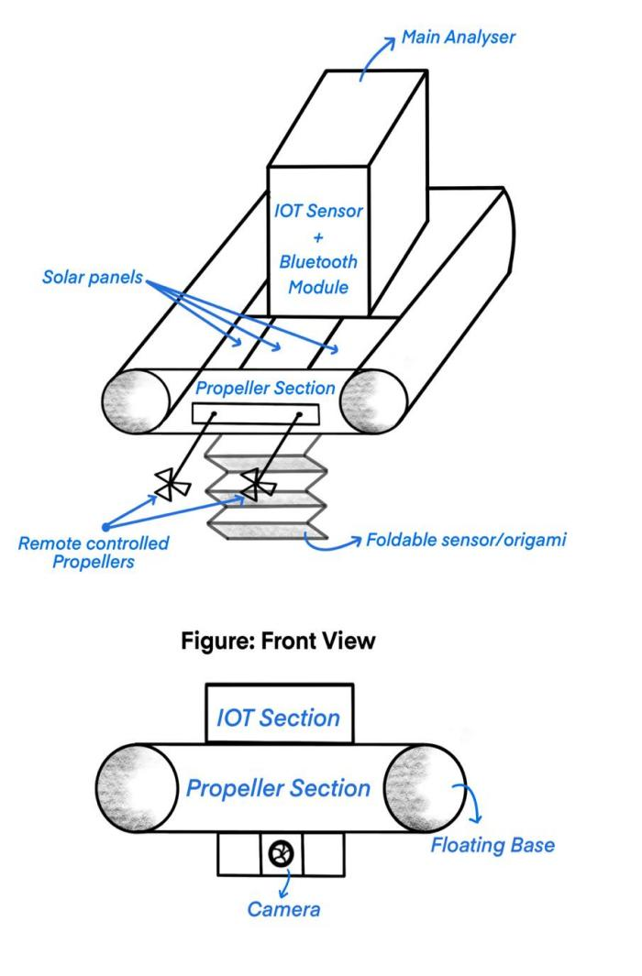

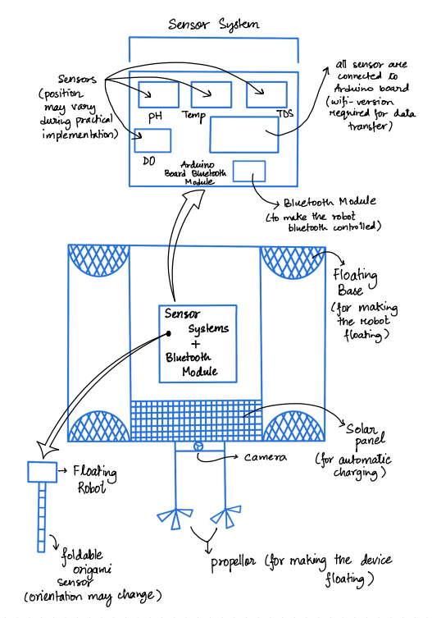BLOCK DIAGRAM OF THE MODEL:

EXPLANATION OF BLOCK DIAGRAM.

MODEL WORKING ALGORITHM:

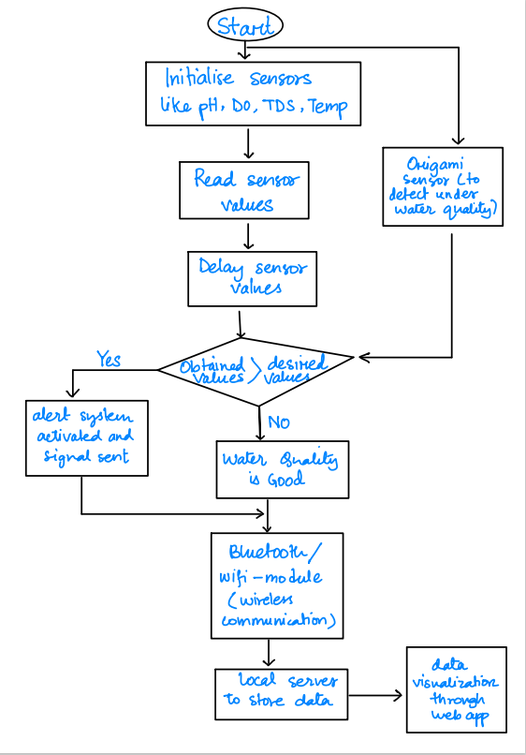

1. IMPLEMENTATION AND RESULT
2. CONCLUSION

REFERENCES

1. Bakker K. Water security: research challenges and opportunities. Science. 2012;337:914–5.
2. Storey MV, van der Gaag B, Burns BP. Advances in on-line drinking water quality monitoring and early warning systems. Water Res. 2011;45:741–7
3. Rakocy, J. E. (2012). Aquaponics: integrating fish and plant culture. Aquaculture production systems, 1, 343-386.
4. Junge, R., König, B., Villarroel, M., Komives, T., & Jijakli, M. H. (2017). Strategic points in aquaponics.
5. Memon, S. K., Shaikh, F. K., Mahoto, N. A., & Memon, A. A. (2019, January). IoT based smart garbage monitoring & collection system using WeMos & Ultrasonic sensors. In 2019 2nd International Conference on Computing, Mathematics and Engineering Technologies (iCoMET) (pp. 1-6). IEEE.
6. Rukhmode, S., Vyavhare, G., Banot, S., Narad, A., & Tugnayat, R. M. (2017). IOT based agriculture monitoring system using wemos. no. March, 14-19.
7. Kodali, R. K., & Sahu, A. (2016, December). An IoT based weather information prototype using WeMos. In 2016 2nd International Conference on Contemporary Computing and Informatics (IC3I) (pp. 612-616). IEEE.
8. Chen, Chiung-Hsing, et al. "IoT-based fish farm water quality monitoring system." Sensors 22.17 (2022): 6700.
9. Demetillo, Alexander T., Michelle V. Japitana, and Evelyn B. Taboada. "A system for monitoring water quality in a large aquatic area using wireless sensor network technology." Sustainable Environment Research 29 (2019): 1-9.
10. .Dr.S.Narendirana , Dr.P.Manjub , Dr.K.Muralibabuc , K.Saravanakumard, R.Nithish Kumare , S.Harshinif , S.Deepak Sriramg , S.Suhana h,-An IOT-based water monitoring system and a floating robot.
11. R.Suresh, S.Gopinath, K.Govindaraju T.Devika,N.SuthanthiraVanitha, ―GSM based Automated Irrigation Controlusing Raingun Irrigation System‖, International Journal of AdvancedResearch in Computer and Communication Engineering Vol. 3, Issue 2, February 2014

12. Pavithra D.S, M. S .Srinath, ―GSM based Automatic IrrigationControl System for Efficient Use of Resources