Open face book application [url:www.\\facebook.com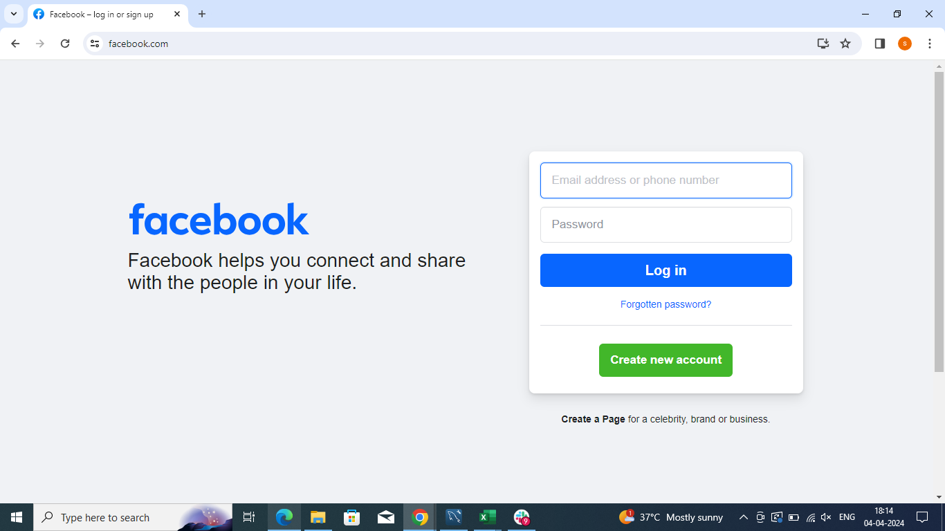Home page](url:www.\\facebook.com#Homepage) is Displayed after enter URL