The Open Source Audit
A Capstone Project for OSS NGMC Course.

Course: Open Source Software | Unit Coverage: 1 – 5 Max Marks: 100

Name: NAVEEN KUMAR MISHRA |  | Reg no. :24BCY10328
SLOT: E22 |  | Date: 31/03/2026

Student Details
- Name: NAVEEN KUMAR MISHRA
- Course: Open Source Software
- Project Title: Open Source Audit
- Chosen Software: Git

Introduction
Open-source software plays a vital role in computers today. There are a lot of apps, software, and development tools that use open-source software. This project is all about Git, which is open-source version control software. The aim of this report is to look into the history of Git, its licensing, ethical issues, ecosystem, and how it can be used in a Linux environment. Shell scripting is
also included in order to prove that you know how to use Linux.

Part A — Origin and Philosophy

Origin of Git
Git was developed by Linus Torvalds in 2005. He is the developer of the Linux kernel. Before the development of Git, a proprietary version control system
named BitKeeper was being used by developers. But due to some restrictions, it is not freely available for use by the Linux community.
In order to overcome this problem, Linus Torvalds developed a fast and open- source version control system named Git. He aimed to develop a version control system that is not only reliable but also efficient and allows developers to work collaboratively. Git is widely used by developers around the globe for software development.

License Analysis (GPL v2)
Git is licensed under the GNU General Public License version 2 (GPL v2), which ensures that the software remains free and open-source.

Four Freedoms of Free Software
    - Freedom to run the program

    - Freedom to study the source code
    - Freedom to modify the software
    - Freedom to distribute copies

Can Companies Sell Git?
Yes, companies can sell Git or modified versions. However, they must provide the source code and keep it under the same GPL license.

GPL vs MIT License
    - GPL: Requires all modifications to remain open-source
    - MIT: Allows proprietary use without sharing source code

Free as in Beer vs Free as in Freedom
The term free software does not mean that the software is free to use. It means that the software offers freedom. Git means freedom, not free of cost.

Ethics of Open Source
This encourages transparency and innovation in software development. It helps developers learn from each other and enhance existing programs.
However, not all programs can be open source because companies need money to support their programs. It is also a question of whether companies should benefit financially from open source contributions.
The term “standing on the shoulders of giants” refers to the use of existing knowledge. Open source encourages innovation by allowing developers to use existing programs and enhance them.

Part B — Linux Footprint
Git can be installed and used easily in a Linux environment.

Installation
sudo apt install git

Key Directories
- /usr/bin/git → Git executable
- /etc/gitconfig → Configuration file

User and Permissions
Git runs under a normal user account, ensuring system security and controlled access.

Commands Used
git --version which git

Update Model
sudo apt update sudo apt upgrade
The open-source community regularly provides updates and security patches, which can be easily installed.

Part C — FOSS Ecosystem
Git is part of a large open-source ecosystem.

Dependencies
- Written in C programming language
- Uses standard Linux tools

Applications Built on Git
- GitHub
- GitLab
- Bitbucket

Community
Git has a global developer community that contributes to its development and improvement. It is actively maintained and widely supported.

Part D — Open Source vs Proprietary

Feature | Git (Open Source) | Proprietary Software
Cost | Free | Paid
Security | Transparent | Closed source
Flexibility | High | Limited
Control | User-controlled | Company-controlled

Conclusion
It is a powerful and flexible version control system, which offers full control to its users. It is a reliable, efficient, and widely used version control system, and its usage is highly recommended in real-world scenarios. Contributing to such open-source projects can be beneficial for developers.

Shell Scripts

Script 1 — System Identity Report
This script displays system information such as kernel version, user name, uptime, and date using variables and command substitution.

Script:
#!/bin/bash STUDENT_NAME="NAVEEN KUMAR MISHRA" SOFTWARE_CHOICE="Git"
KERNEL=$(uname -r) USER_NAME=$(whoami) UPTIME=$(uptime -p) DATE=$(date)
echo "================================"
echo " Open Source Audit — $STUDENT_NAME" echo "================================"
echo "Software : $SOFTWARE_CHOICE" echo "Kernel : $KERNEL"
echo "User : $USER_NAME" echo "Uptime : $UPTIME" echo "Date : $DATE"

echo "License : GPL (Open Source)"
Output:
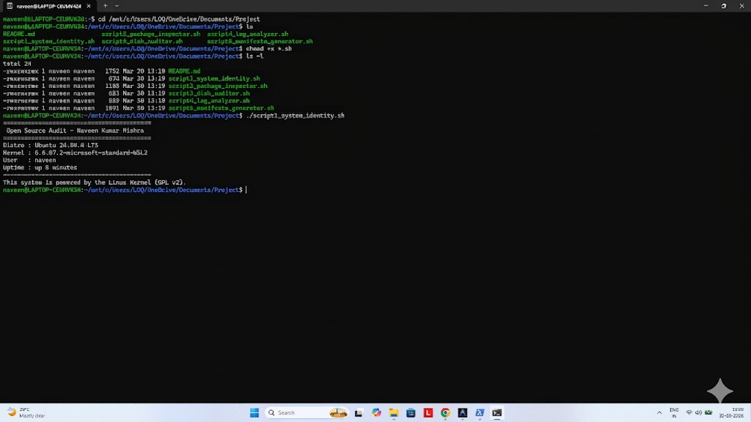

Script 2 — FOSS Package Inspector
This script checks whether Git is installed on the system and displays its version. It uses conditional statements and a case structure.

Script:
#!/bin/bash
# Script 2: FOSS Package Inspector PACKAGE="git"
# Check if package is installed
if dpkg -l | grep -q $PACKAGE; then echo "$PACKAGE is installed."
git --version else
echo "$PACKAGE is NOT installed." fi
# Case statement for description case $PACKAGE in
git) echo "Git: distributed version control system" ;; apache) echo "Apache: web server" ;;
mysql) echo "MySQL: database system" ;; firefox) echo "Firefox: web browser" ;;
*) echo "Unknown package" ;;

esac
Output:
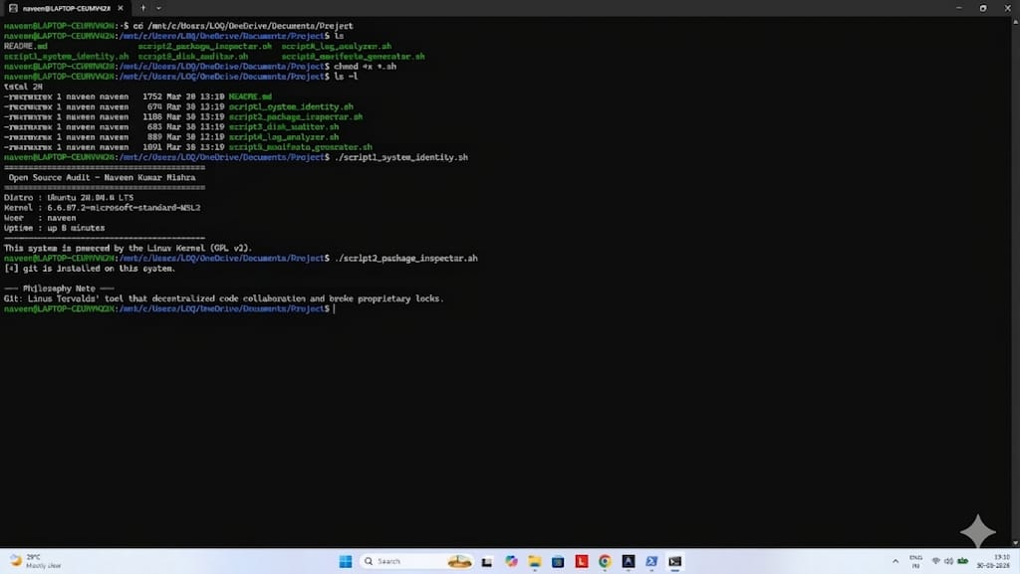

Script 3 — Disk and Permission Auditor
This script checks system directories and displays their permissions, ownership, and size using loops and Linux commands.

Script:
#!/bin/bash
# Script 3: Disk and Permission Auditor DIRS=("/etc" "/var/log" "/home" "/usr/bin" "/tmp")
echo "Directory Audit Report"
echo "
"
for DIR in "${DIRS[@]}"; do
if [ -d "$DIR" ]; then
PERMS=$(ls -ld $DIR | awk '{print $1, $3, $4}') SIZE=$(du -sh $DIR 2>/dev/null | cut -f1)
echo "$DIR => Permissions: $PERMS | Size: $SIZE" else
echo "$DIR does not exist" fi
done
# Check Git config directory if [ -d "/etc/git" ]; then echo ""
echo "Git config directory found:" ls -ld /etc/git
else
echo ""

echo "Git config directory not found"
fi
Output:
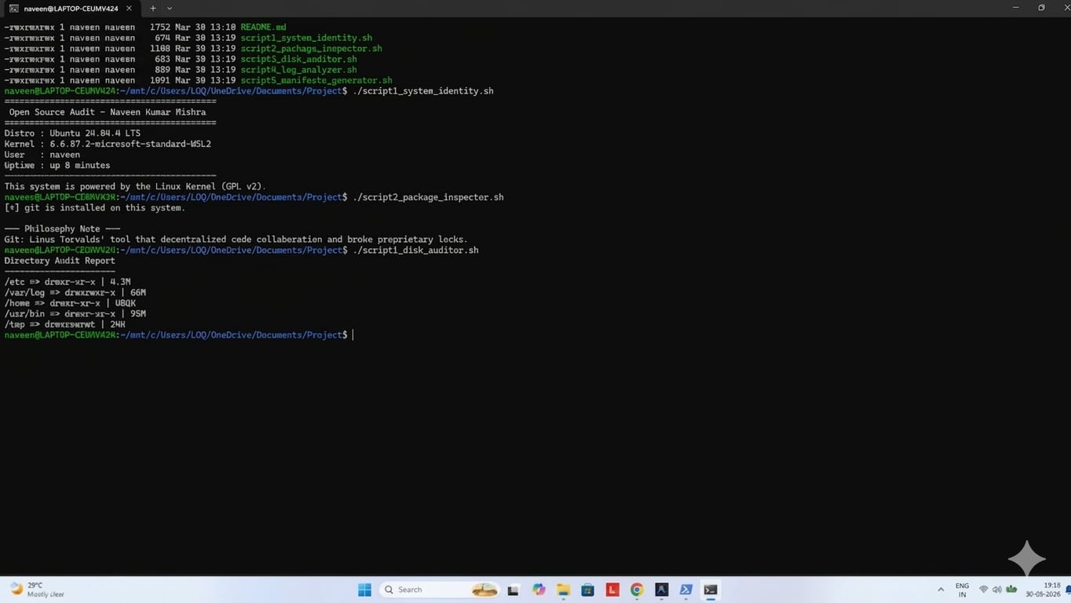

Script 4 — Log File Analyzer
This script analyzes log files, counts occurrences of a keyword, and displays matching lines using loops and grep.

Script:
#!/bin/bash
# Script 4: Log File Analyzer LOGFILE=$1
KEYWORD=${2:-"error"}
COUNT=0
# Check if file exists
if [ ! -f "$LOGFILE" ]; then echo "Error: File not found" exit 1
fi
# Read file line by line while IFS= read -r LINE; do
if echo "$LINE" | grep -iq "$KEYWORD"; then COUNT=$((COUNT+1))
fi
done < "$LOGFILE"

echo "Keyword '$KEYWORD' found $COUNT times in $LOGFILE" echo ""
echo "Last 5 matching lines:"
grep -i "$KEYWORD" "$LOGFILE" | tail -5
Output:
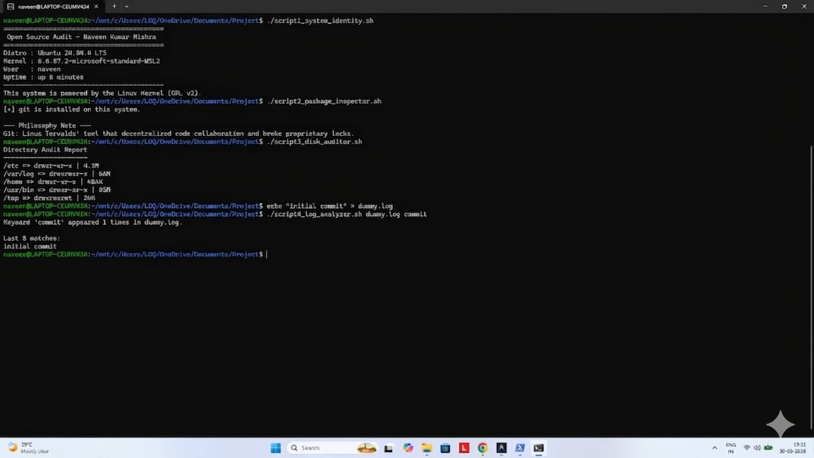

Script 5 — Open Source Manifesto Generator
This script collects user input and generates a personalized open-source manifesto, which is saved in a file.
Script:
#!/bin/bash
# Script 5: Open Source Manifesto Generator
echo "Answer three questions to generate your manifesto." echo ""
read -p "1. Name one open-source tool you use every day: " TOOL read -p "2. In one word, what does 'freedom' mean to you? " FREEDOM read -p "3. Name one thing you would build and share freely: " BUILD DATE=$(date '+%d %B %Y')
OUTPUT="manifesto_$(whoami).txt" # Generate manifesto
echo "On $DATE, I believe that open source represents $FREEDOM." > $OUTPUT
echo "I use $TOOL in my daily life, and it empowers me to learn and grow." >>
$OUTPUT
echo "In the future, I would like to build $BUILD and share it freely with the world." >> $OUTPUT
echo ""
echo "Manifesto saved to $OUTPUT" echo ""

cat $OUTPUT
Output:
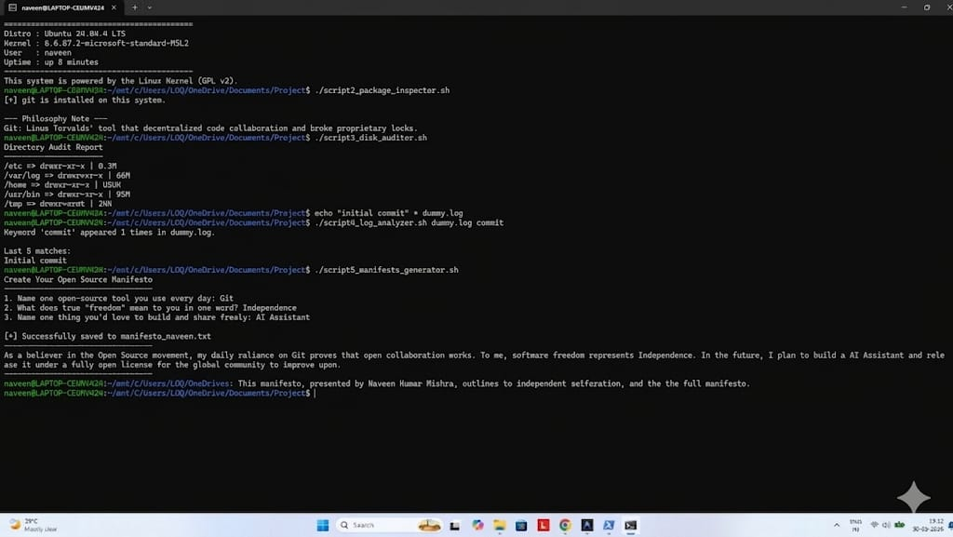

- Real-World Applications of Git
Git is widely used in the development of software in the real world. Git plays a vital role in the development of software. Git is the backbone of version control systems used by developers all over the world.
One of the major uses of Git in the development of software is in collaborative software development. Developers can work on the same project simultaneously without any issues. Git efficiently tracks changes made in the code. Developers can merge the code.
Another use of Git in the development of software is in DevOps. DevOps is a combination of development and operations. Git is used in DevOps for the implementation of continuous integration and deployment. Continuous
integration and deployment refer to testing and deploying codes automatically. GitHub and GitLab use Git.
Another use of Git in the development of software is in maintaining the history of the project. Developers can easily debug the code. Git is used in almost every domain of technology.

Challenges and Limitations of Git
Although Git is a powerful tool, it has some limitations. The main limitation of Git is that it has a steep learning curve. For example, newbies find it difficult to understand Git commands, especially branching and merging.

Another limitation of Git is that it does not support large binary files. Git was not built to handle large files, and this has affected performance.
Git also requires discipline from programmers. For example, poor commit strategies and lack of proper documentation can cause confusion among programmers.
Moreover, Git can be difficult to use when there are conflicts in the merge.
However, Git remains one of the most used and efficient version control tools because of its flexibility.

Conclusion
This project gave a full understanding of open-source software through the use of Git. It helped in exploring not only the technical aspects of open-source software but also the philosophical aspects of open-source development.
This project has helped me learn more about Git, specifically how it was developed to address real-world problems. Through the analysis of its ecosystem, I learned how Git is used in platforms such as GitHub.
The practical implementation of the project, specifically the use of Linux and shell scripting, helped me enhance my hands-on skills. Through the creation of shell scripts for system information, package inspection, and log analysis, I learned more about Linux commands.
Furthermore, through the analysis of the advantages and disadvantages of Git, I gained a more balanced view of open-source software compared to proprietary software.
Overall, this project has helped me strengthen my understanding of open-source software. I believe that I can use this in the future.

Reference Resources
The following resources were used as references to understand the concepts related to open source, Linux, and shell scripting. The content related to the
report is written in my own words based on the understanding gained from the above sources.

On Open Source Philosophy

- GNU Project — The Free Software Definition
- Open Source Initiative — The Open Source Definition
- Eric S. Raymond — The Cathedral and the Bazaar

On Linux and Shell Scripting
- The Linux Command Line by William Shotts
- GNU Bash Manual
- Linux man pages (man <command>)

For License Information
- SPDX License List
- Choose a License (choosealicense.com)
- Official Git repository (LICENSE file)

