
RAJALAKSHMI ENGINEERING COLLEGE
(An Autonomous Institution)
Rajalakshmi Nagar, Thandalam – 602 105
DEPARTMENT OF COMPUTER SCIENCE AND ENGINEERING
(CYBER SECURITY)
CR23532 – CYBER AND DIGITAL FORENSICS
LABORATORY RECORD
III Year / V Semester

Submitted by: NAVEEN RAJ P
Register Number: 241901070
Faculty In-charge: Dr. D. SIVAKUMAR
Academic Year : 2025 – 2026

INDEX
Exp No. | Title of the Experiment | Date
1 | Study of Computer Forensics and Tools Used for Forensic Investigation | 18-07-2026
2 | Introduction to Digital Forensics (TryHackMe) | 18-07-2026
3 | Windows Forensics 1 (TryHackMe) | 23-07-2026
4 | Live Forensics Case Investigation using Autopsy | 30-07-2026
5 | Recover Deleted Files using Forensics Tools (FTK Imager) | 06-08-2026
6 | Find Last Connected USB on the System (USB Forensics) | 13-08-2026
7 | View Last Activity of Your PC | 20-08-2026
8 | Extraction of Browser Artifacts | 03-09-2026
9 | Comparison of Two Files by Compare It Software | 10-09-2026
10 | Collecting Email Evidence in Victim PC | 17-09-2026
11 | Hiding and Extracting Text File behind Image / Audio File via CMD | 24-09-2026
12 | Extraction of EXIF Data from Image Files using ExifReader | 01-10-2026

EXPERIMENT 01
Study of Computer Forensics and Different Tools Used for Forensic Investigation

Aim
To study the fundamentals of computer forensics and explore various commercial, open-source, and field tools used in digital crime investigations.

Overview of Digital Forensics
- Concept: Digital forensics is the field of identifying, collecting, examining, and analyzing digital evidence to determine responsibility for cyber intrusions or computer crimes.

- Core Principle: Perpetrators leave digital traces (log entries, registry modifications, deleted files, malware remnants) that serve as investigative evidence.

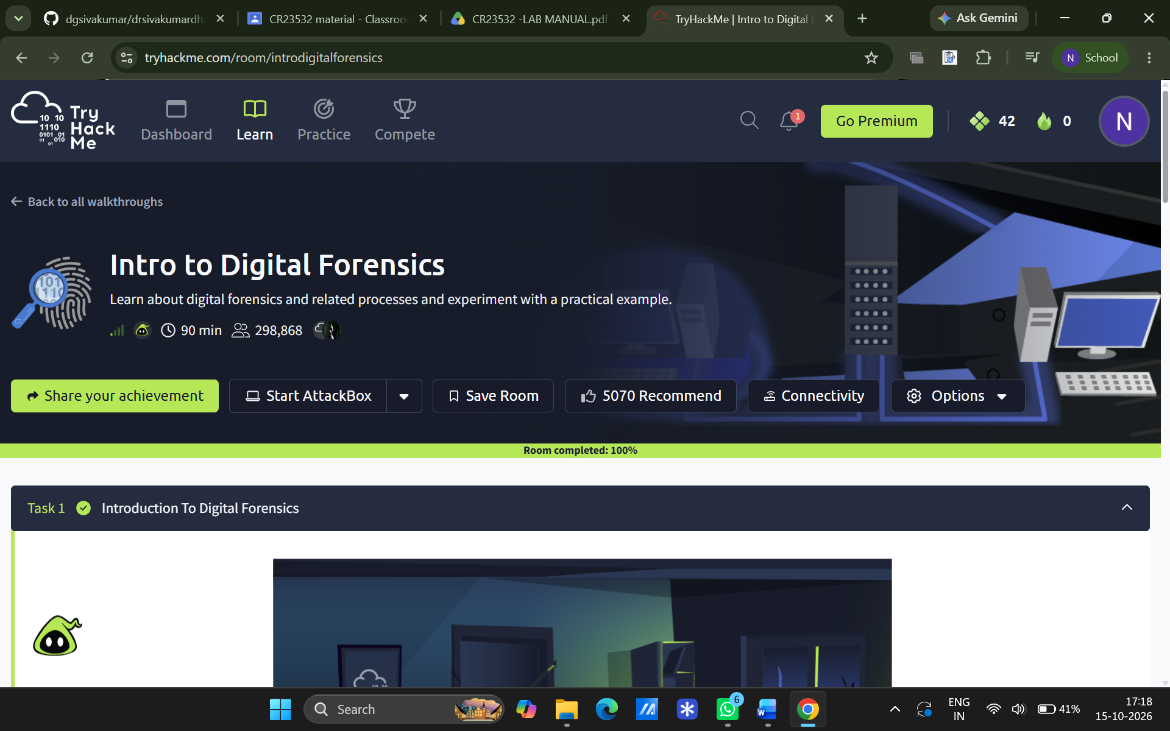
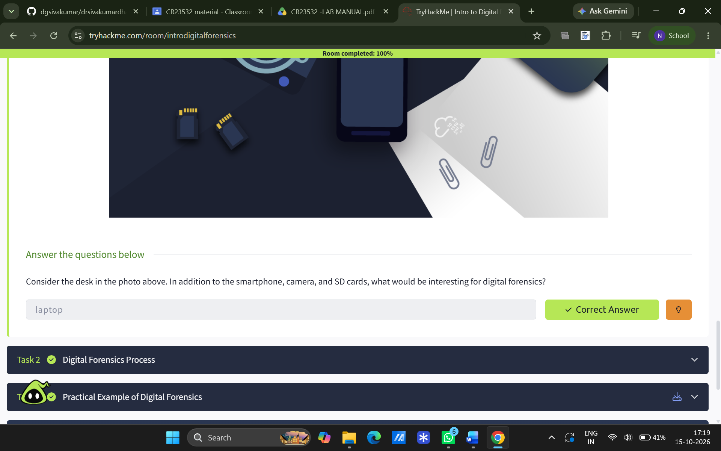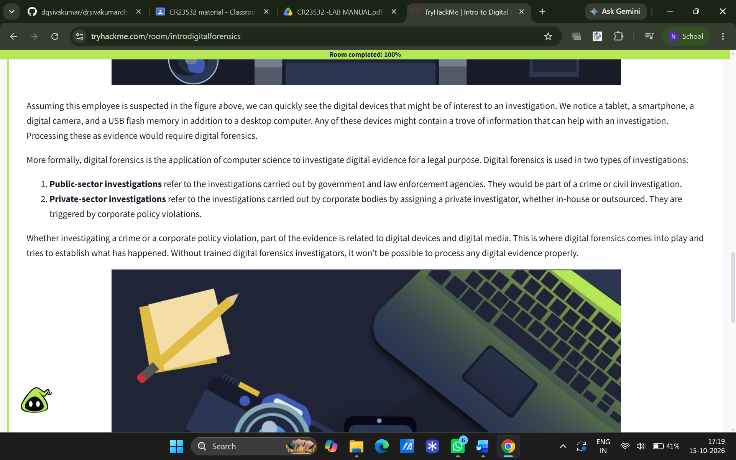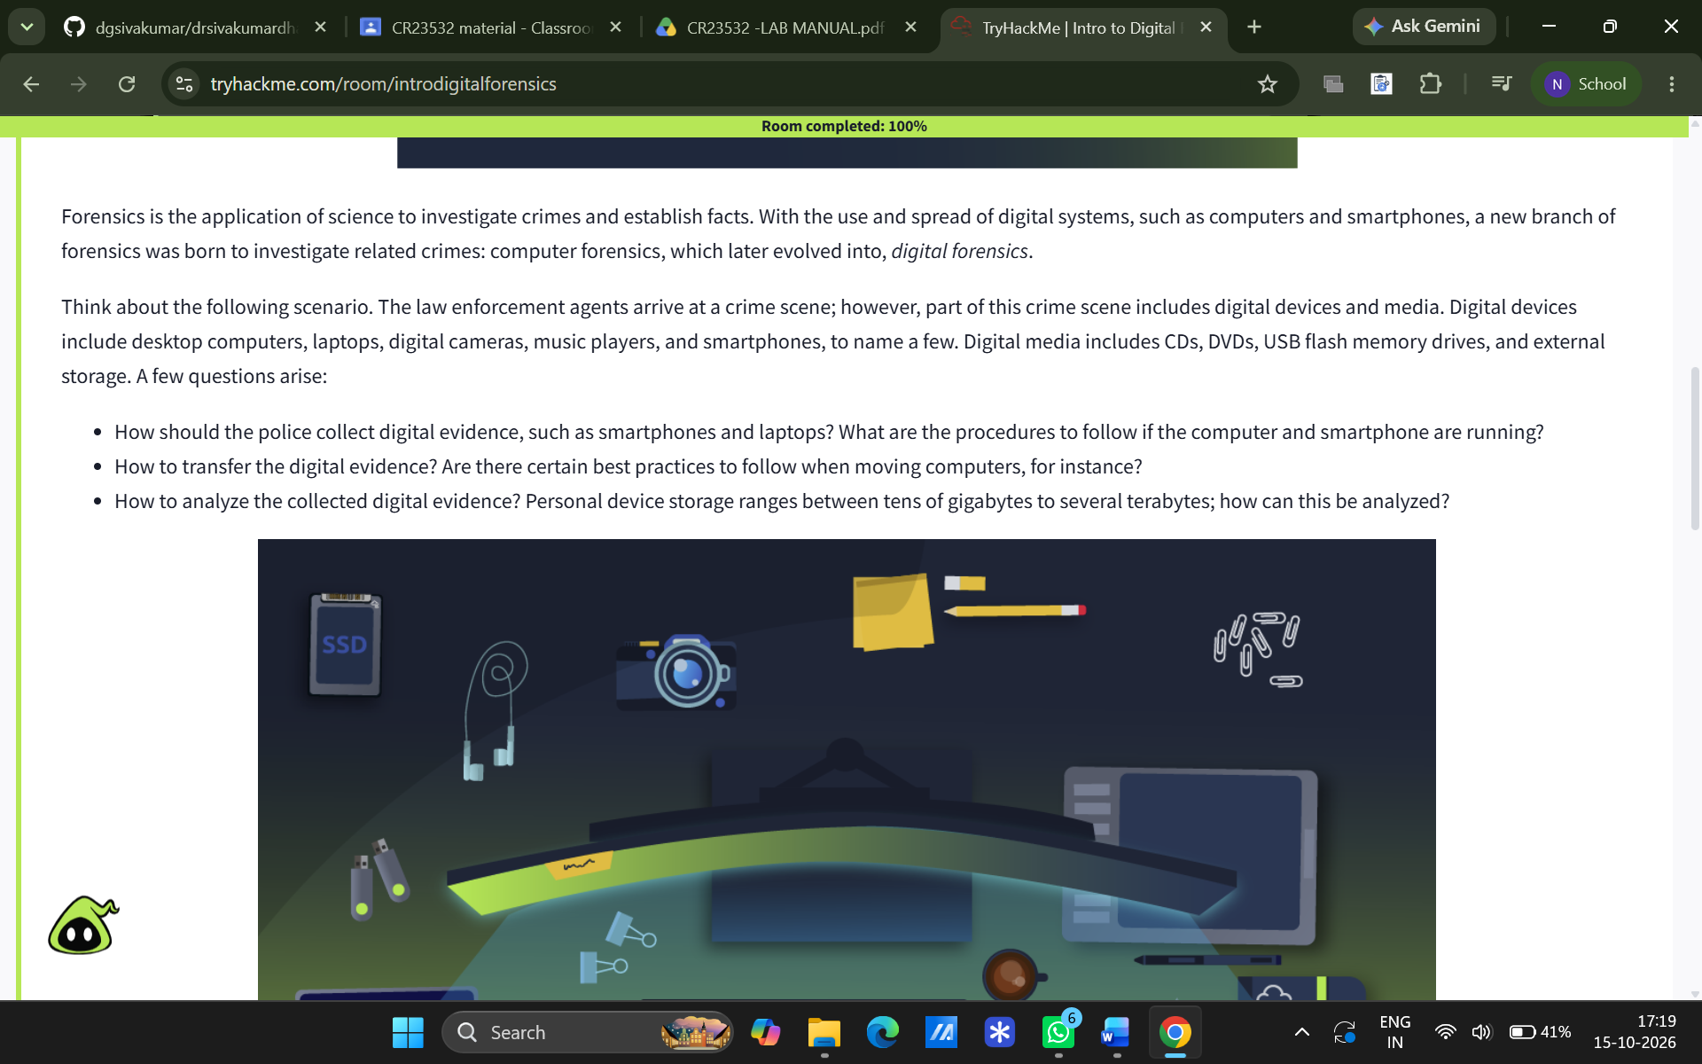

Classifications & Forensic Tools Studied
Category | Tools Studied | Key Purpose / Feature
Commercial Suites | EnCase Forensic, FTK, ProDiscover | Comprehensive forensic suites with advanced reporting used extensively in law enforcement.
Open-Source Suites | The Sleuth Kit (TSK), Helix, Knoppix | Free, accessible forensic suites providing core investigation capabilities without licensing costs.
Disk & Partition Tools | FTK Imager, Active@ Partition Recovery | Bit-by-bit disk imaging, file recovery, and restoring deleted partitions.
Log & Analysis Utilities | Log Parser Lizard GUI, Noxcivis Field Toolkit (NFT) | Log file parsing and evidence collection from host machines.
Forensic Platforms | Autopsy | Open-source digital forensics platform and graphical interface for The Sleuth Kit.

Result
The study of computer forensics concepts and various forensic investigation tools was successfully completed.
EXPERIMENT 02
Live Forensics Case Investigation using Autopsy

Aim
To perform a live digital forensics case investigation and analyze system evidence using the Autopsy forensic tool.

Software / Tools Required
- Autopsy Digital Forensics Platform
- Target System / Evidence Image / Data Source

Procedure
- Case Creation: Launched Autopsy, selected New Case, and configured the Case Name, Base Directory, Case Number, and Examiner Details.
- Data Source Addition: Added the target drive/disk path as the data source to the local database.
- Ingest Modules Configuration: Enabled necessary ingest modules to scan and extract evidence.
- Evidence Analysis: Processed and navigated through the generated investigation results.
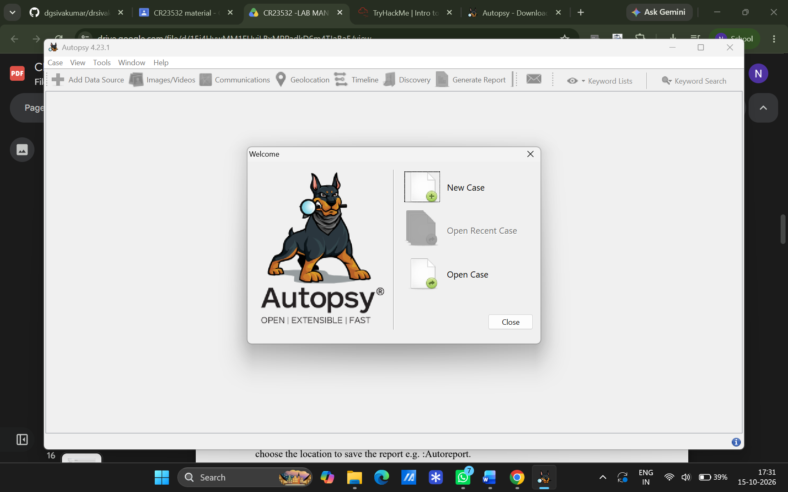

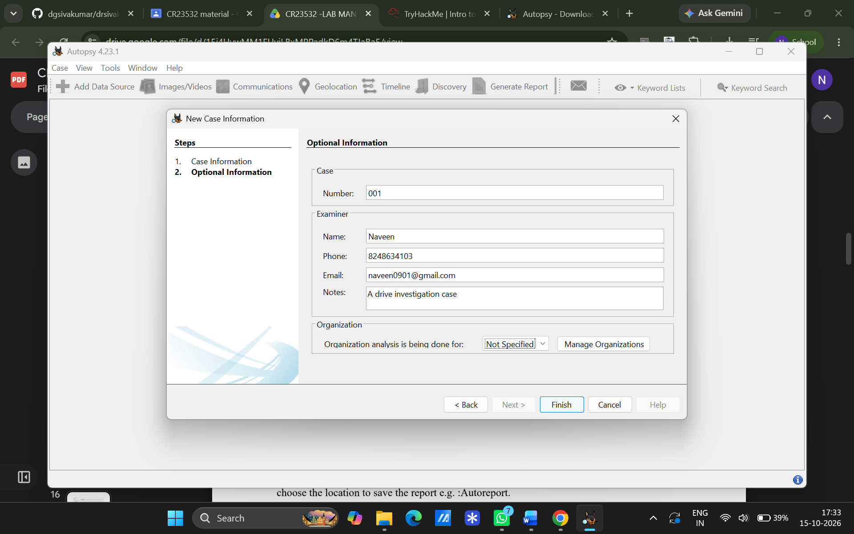
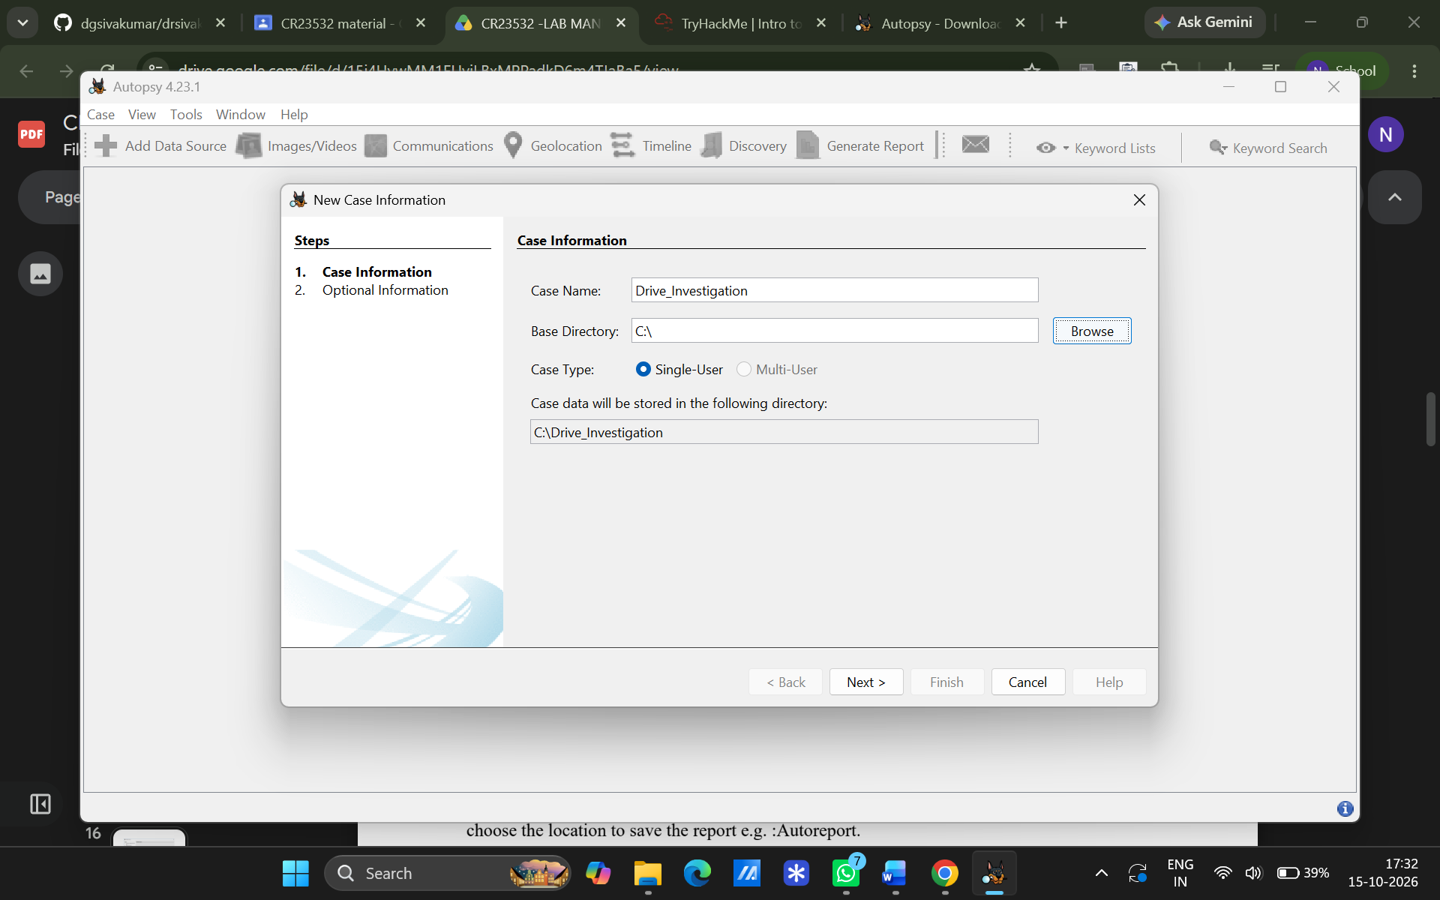
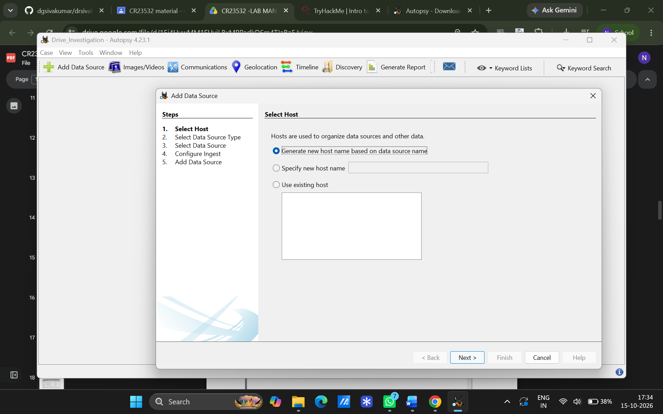
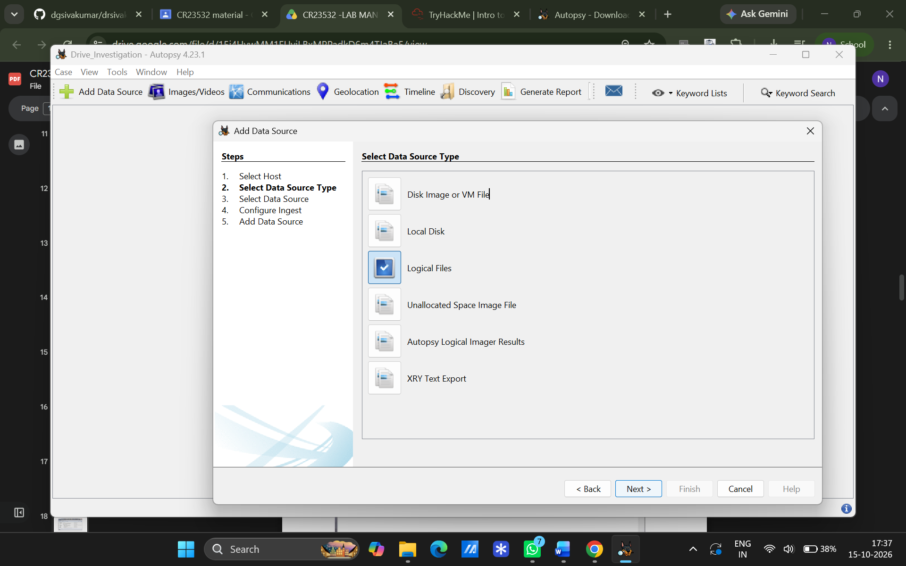
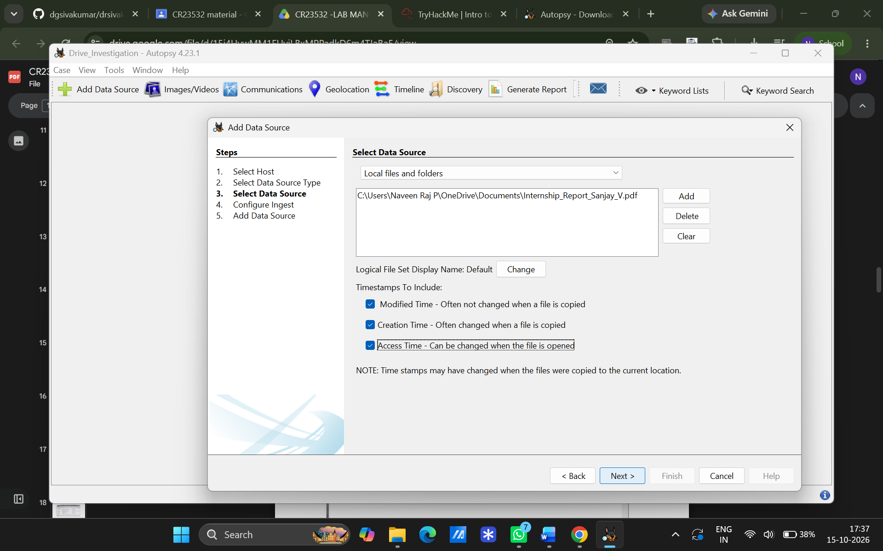
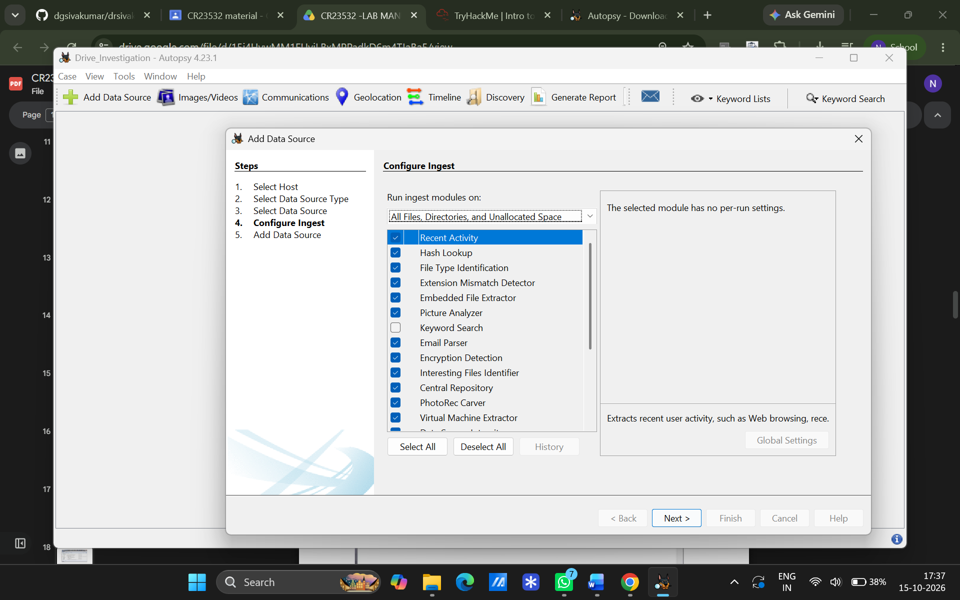
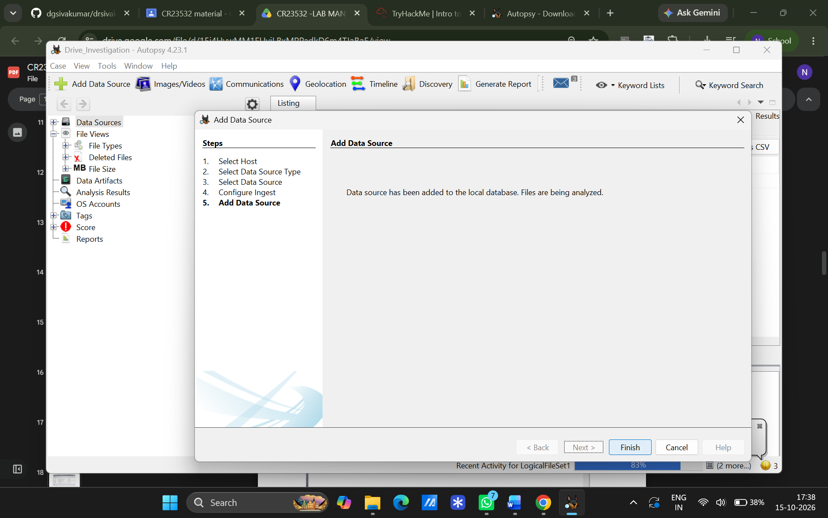
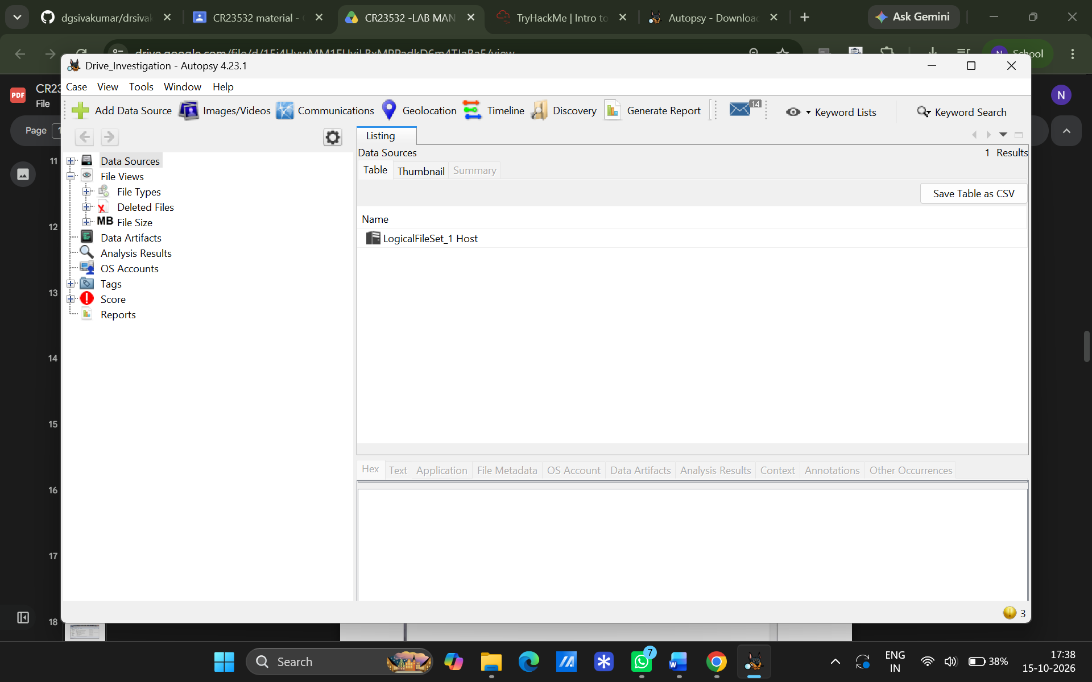
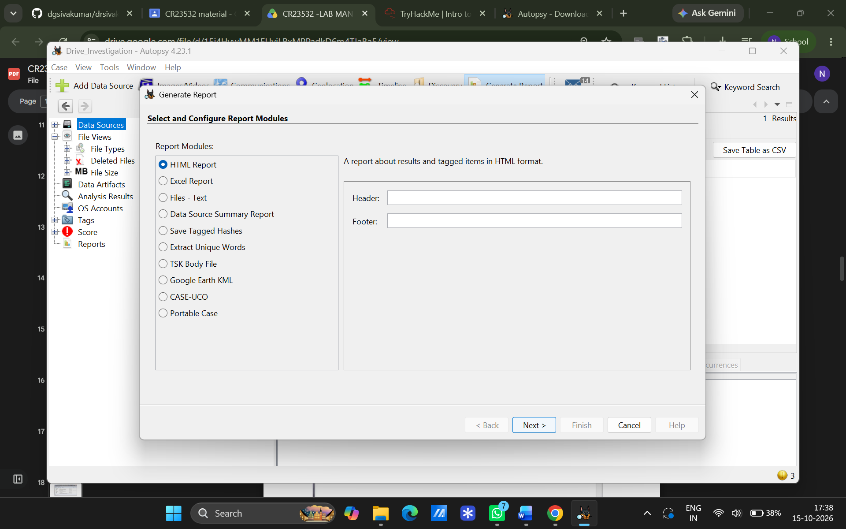
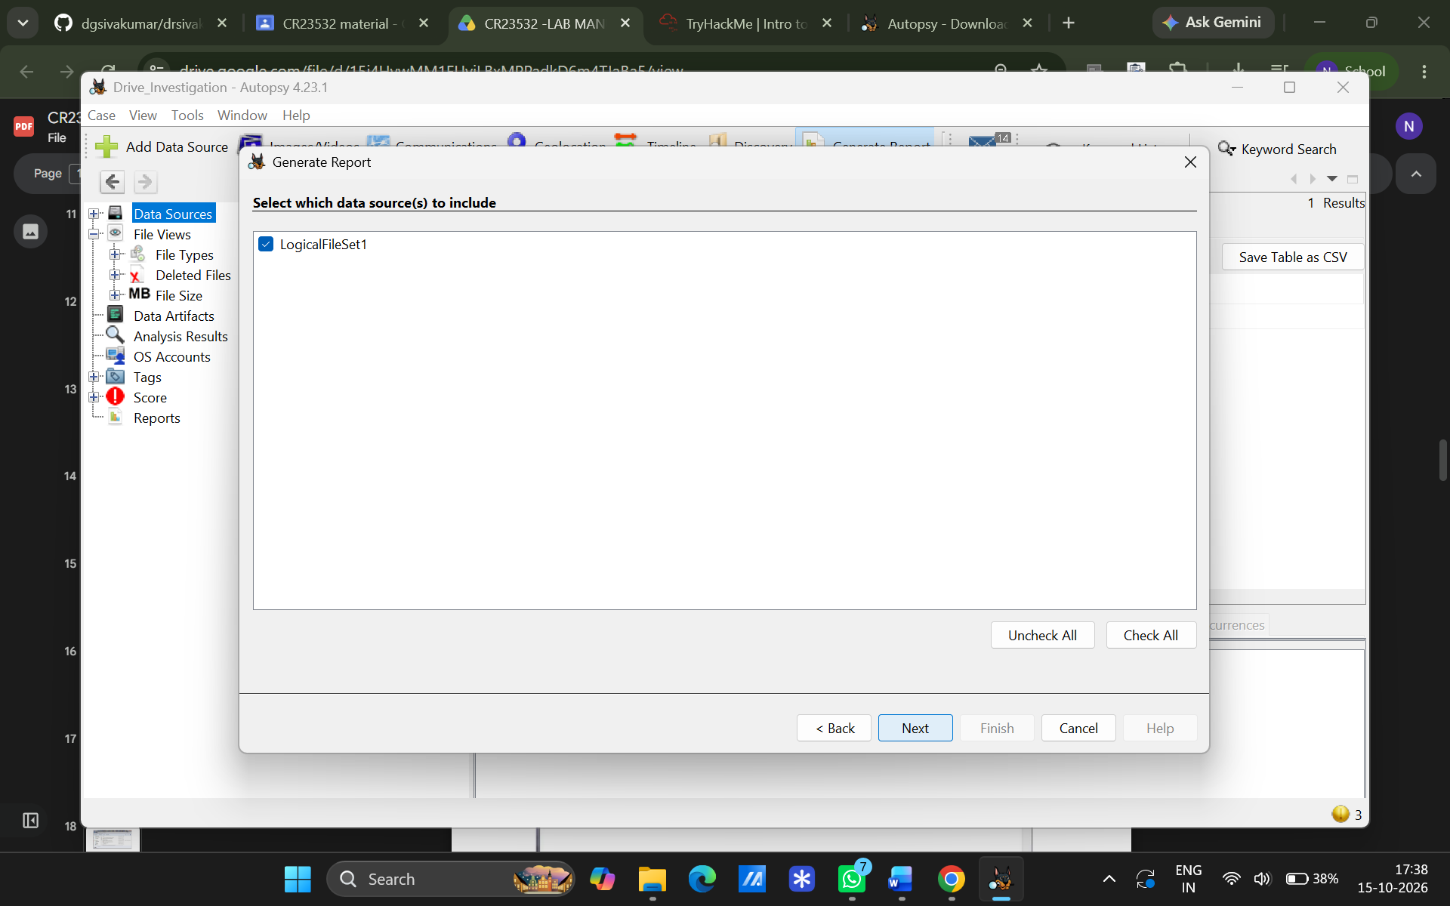
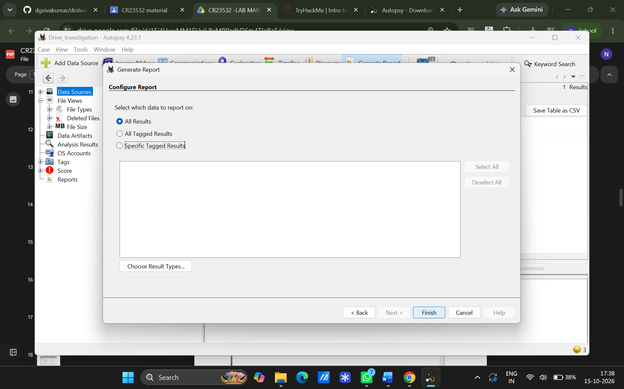
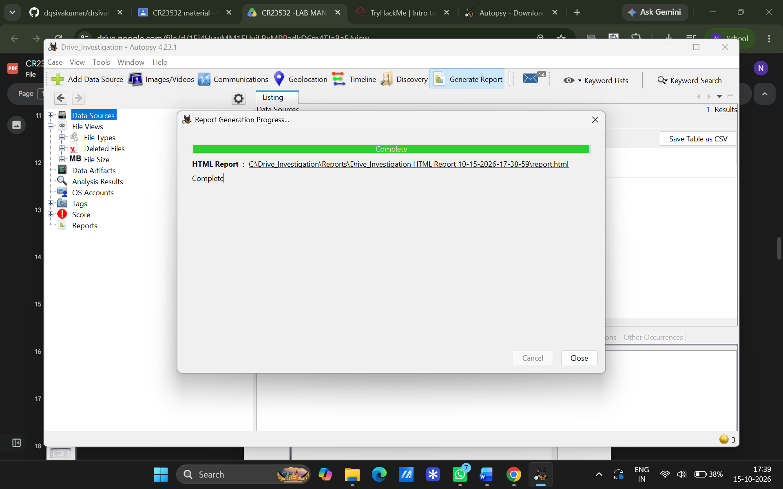
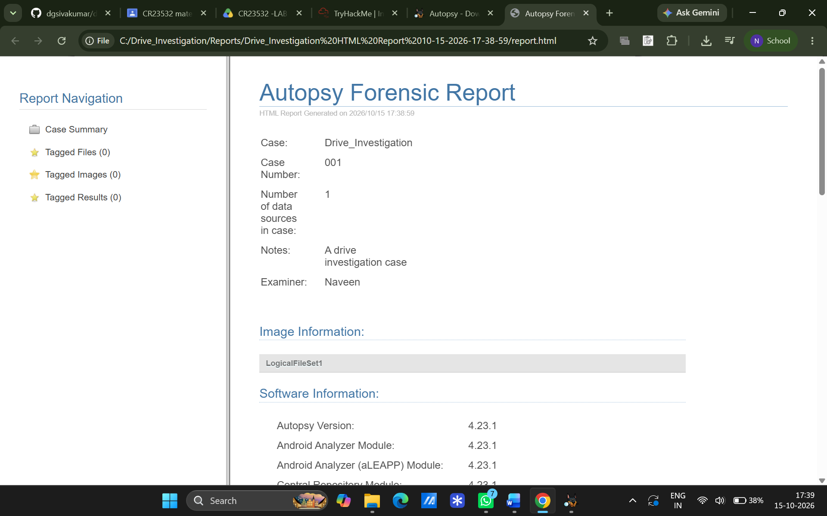
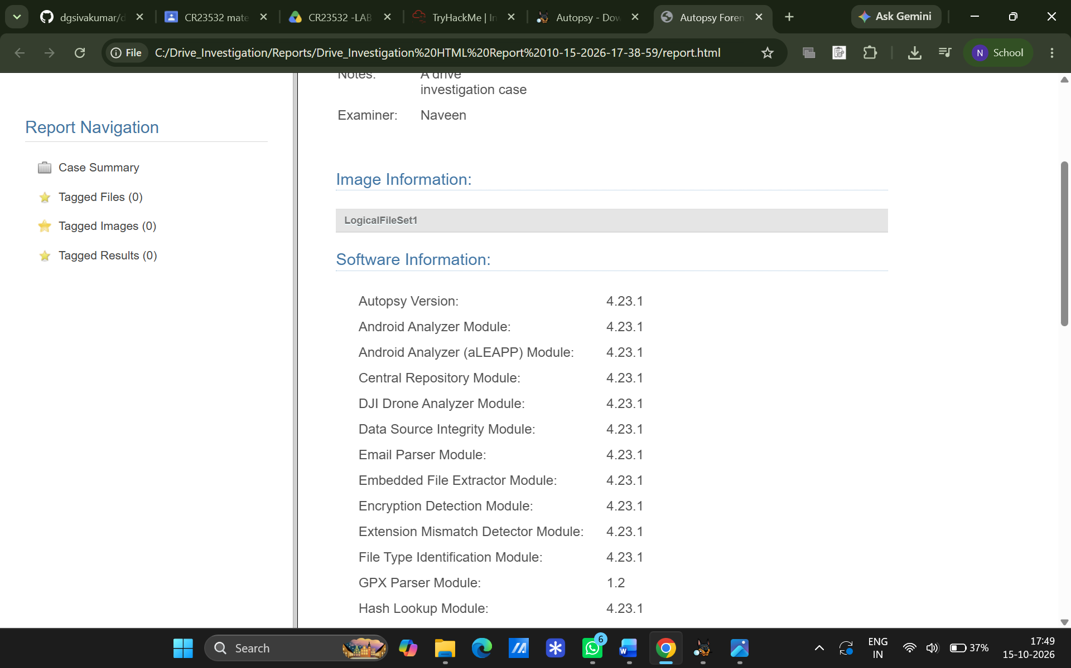
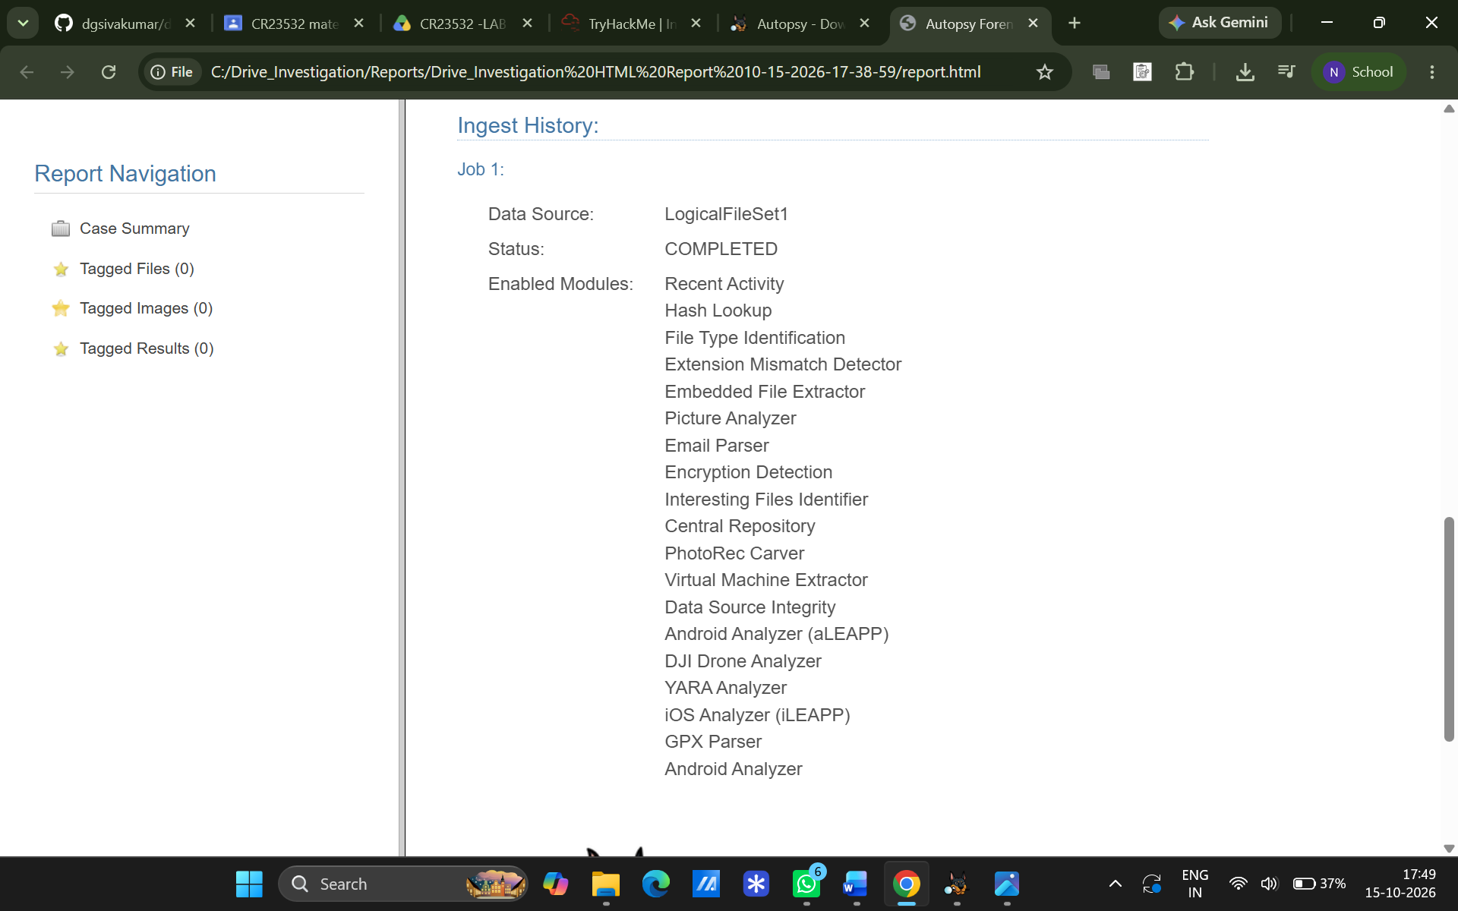

Observations & Artifacts Analyzed
Artifact Category | Information / Data Observed
System & Devices | Hardware and USB devices connected to the target system.
OS & User Accounts | Operating system details and list of active user accounts.
File Activity | Recent documents opened or created on the system.
Web & Browser Artifacts | Web bookmarks, cookies, web search queries, and browsing history.
Media Metadata | EXIF data from images and audio files.
Communication | Installed applications and discovered email addresses.

Result
The Autopsy tool was successfully executed, and digital evidence was captured, categorized, and analyzed.

EXPERIMENT 03
Recover Deleted Files using Forensics Tools
Aim
To practically demonstrate the process of recovering deleted files from a drive using digital forensic imaging and recovery tools.
Software / Tools Required
- FTK Imager (for bit-by-bit imaging)
- RecoverMyFiles (for scanning and recovery)
- Target Storage Device (e.g., USB Flash Drive)
Procedure
- Evidence Simulation: Created a test text file (e.g., malicious.txt) on a flash drive and intentionally deleted it.
- Drive Imaging: Used FTK Imager to select the physical drive and create a bit-by-bit forensic image.
- Data Recovery: Opened RecoverMyFiles, selected "Recover a Drive", and loaded the created forensic image.
- File Extraction: Executed the file recovery scan, filtered results by file type, and located the deleted file.

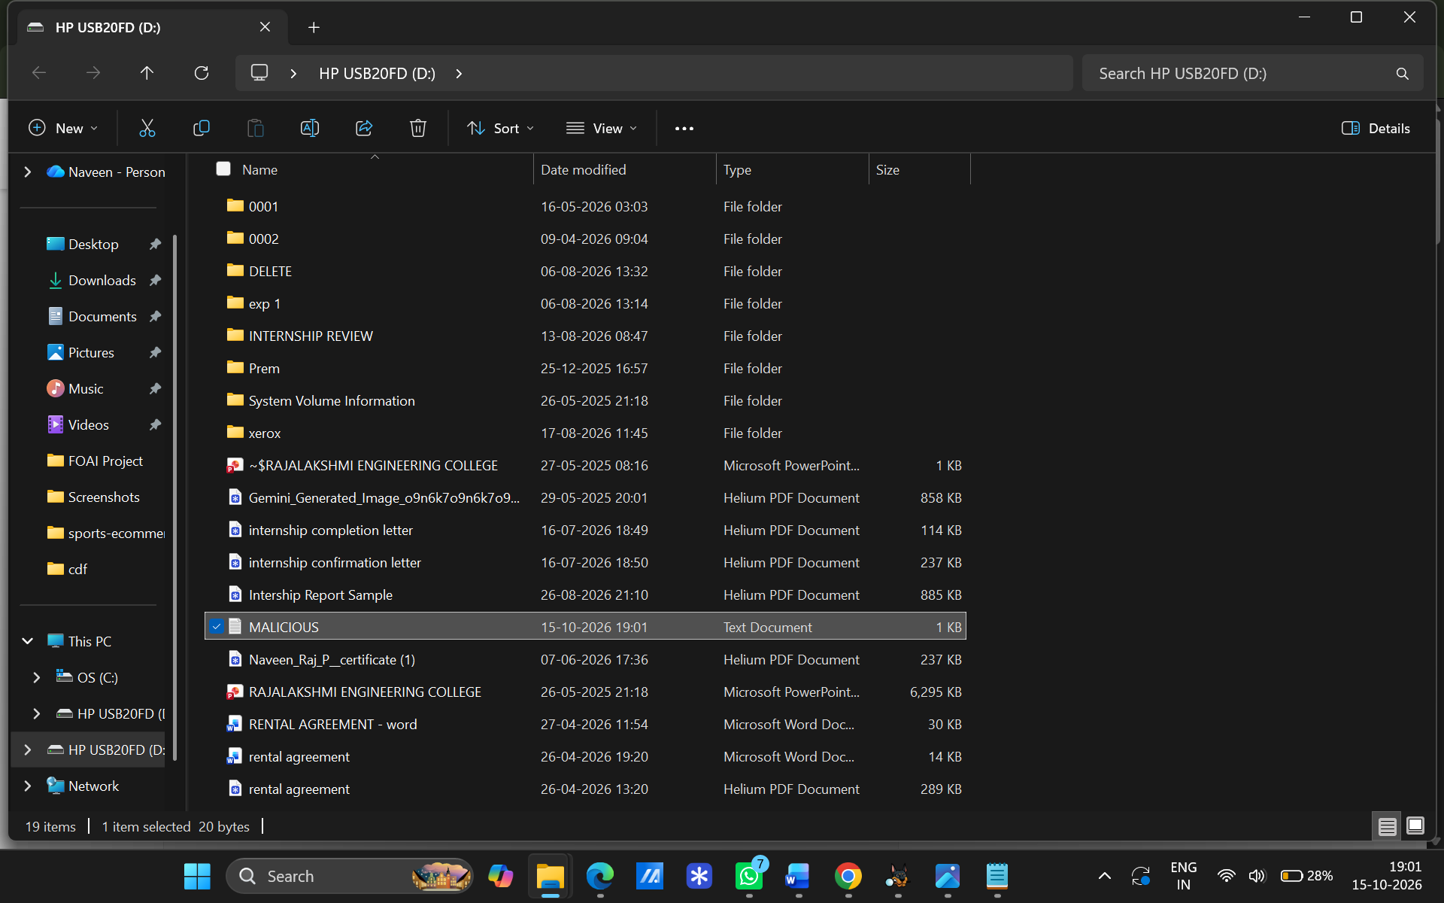
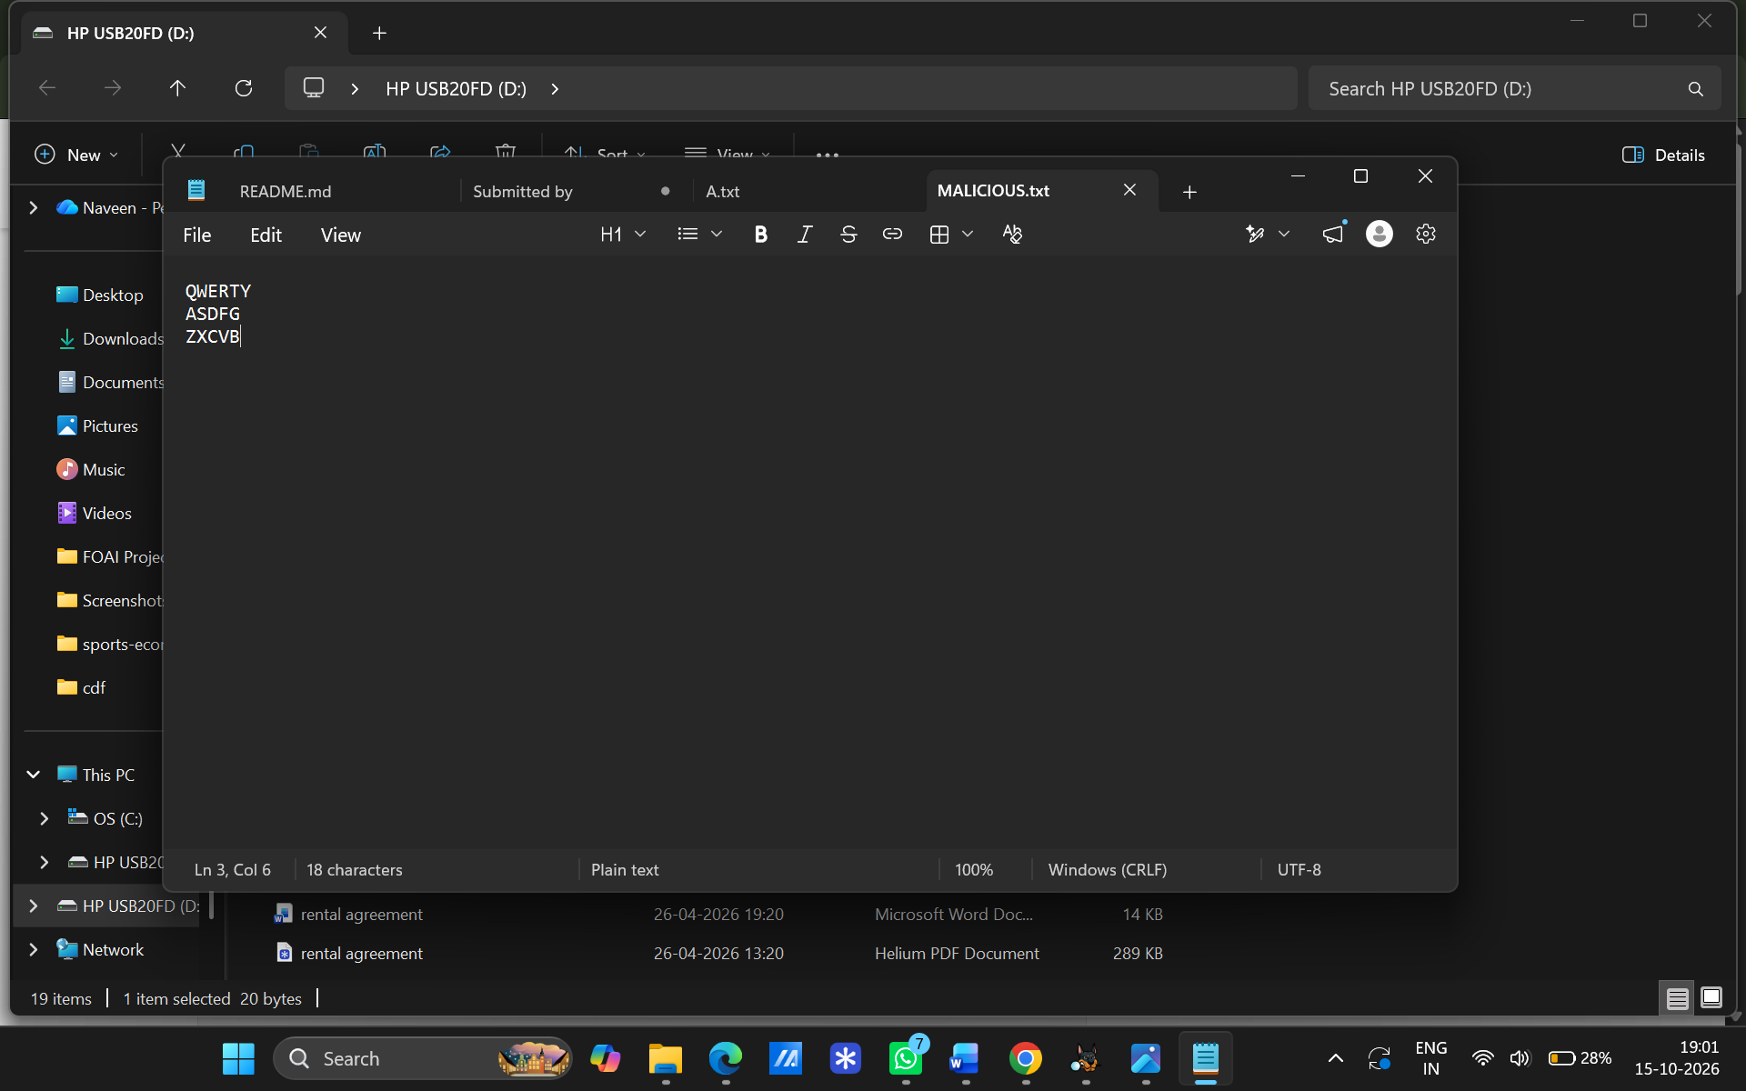
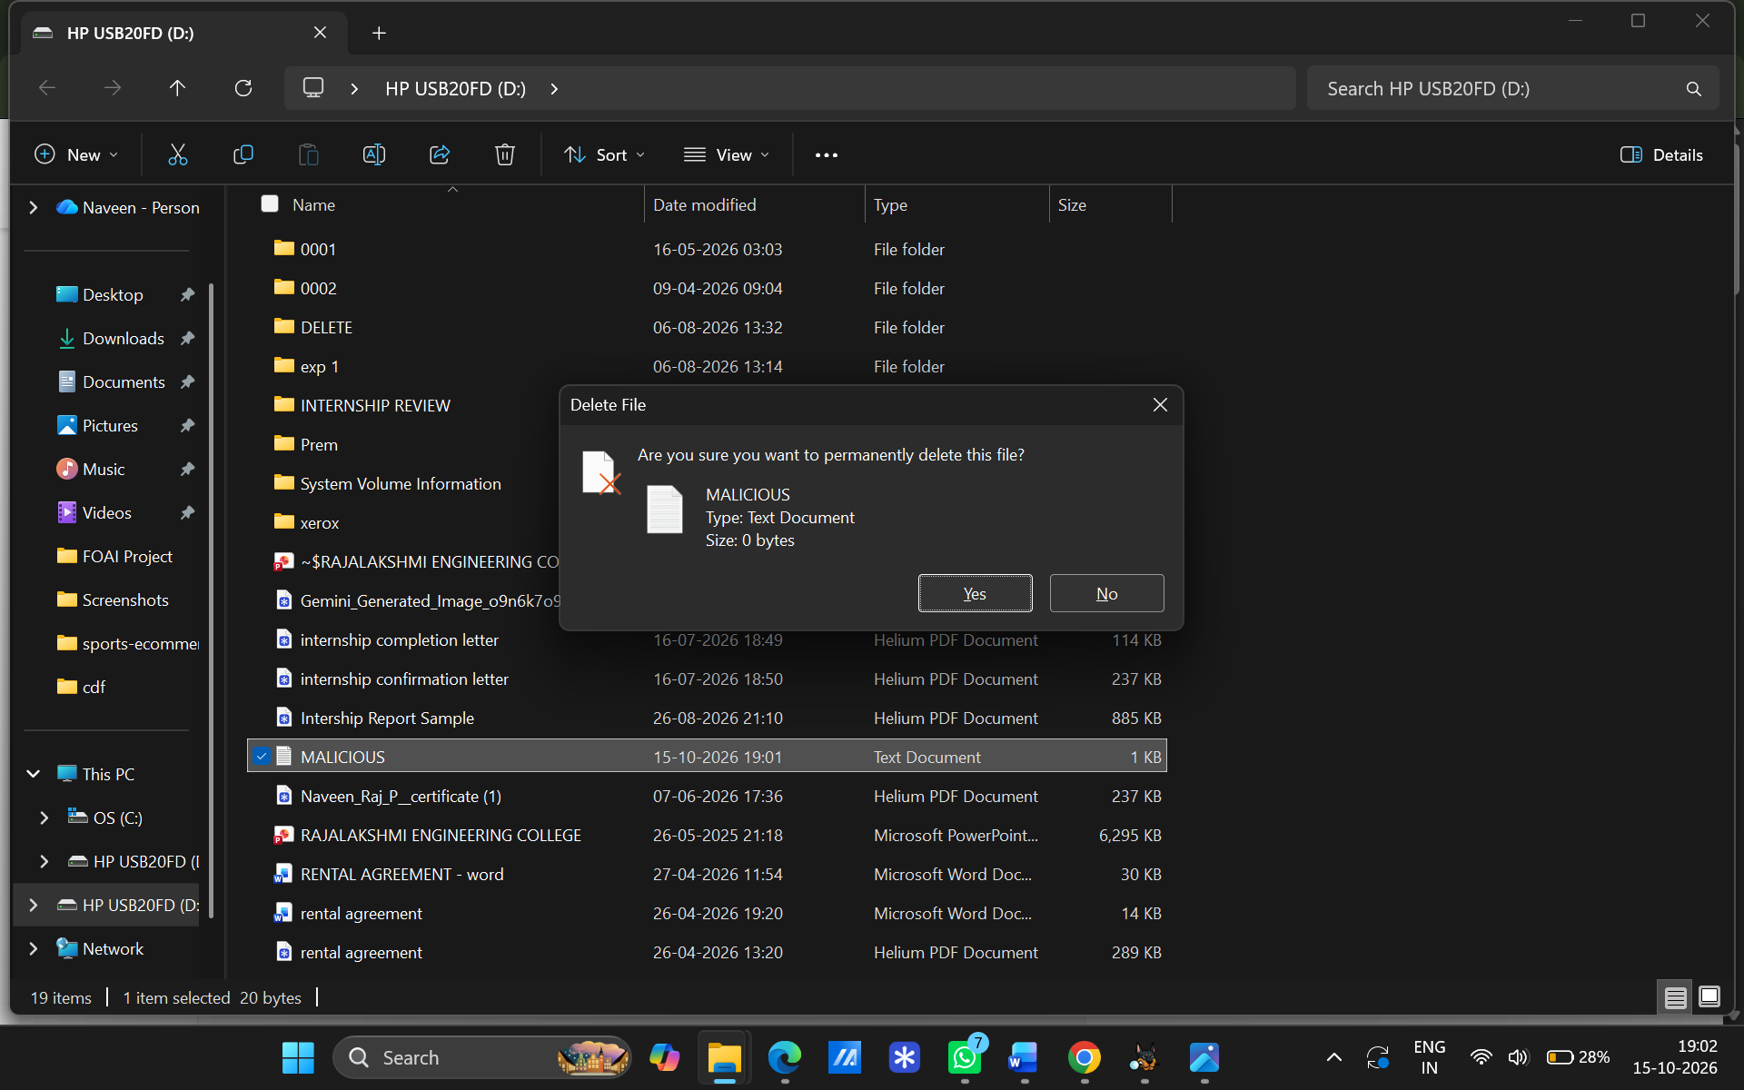
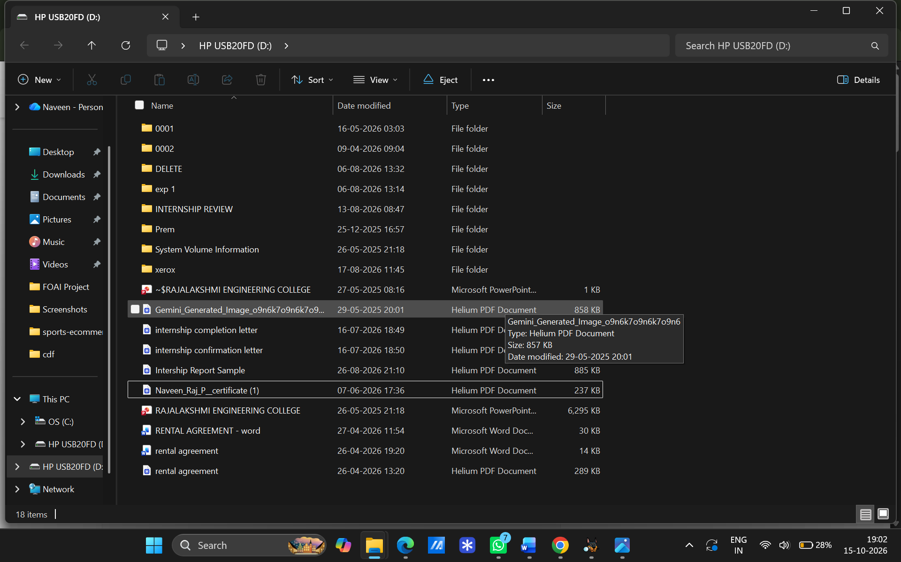
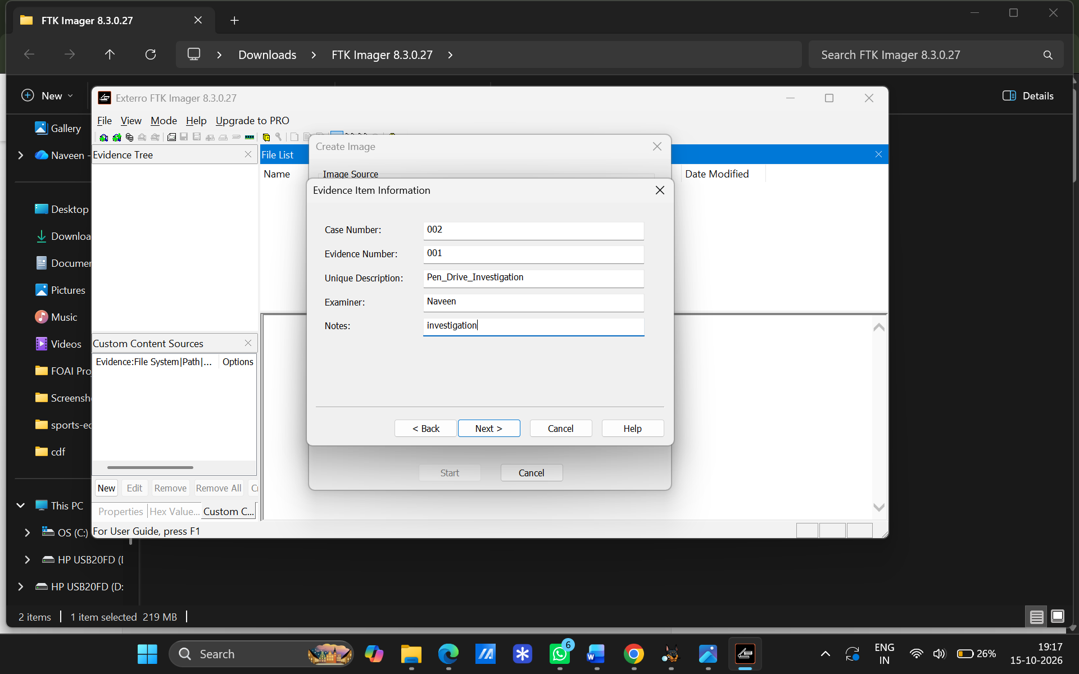
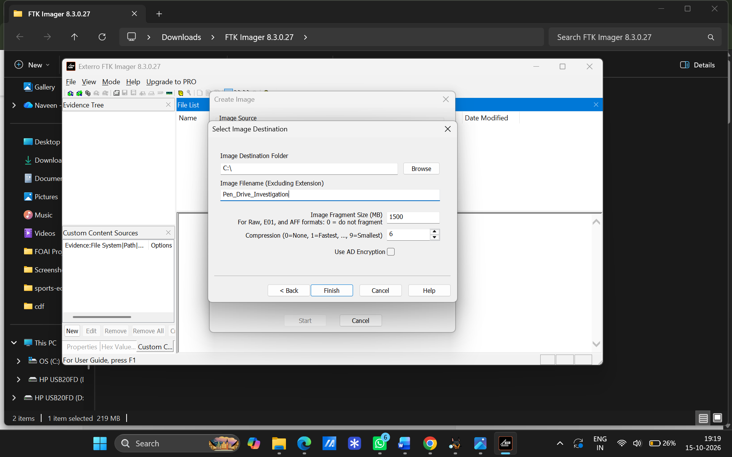
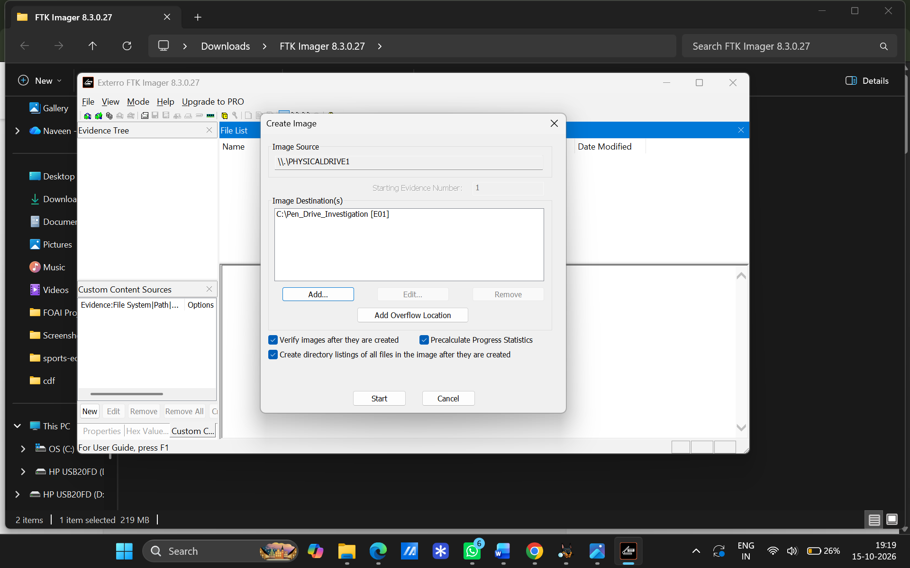
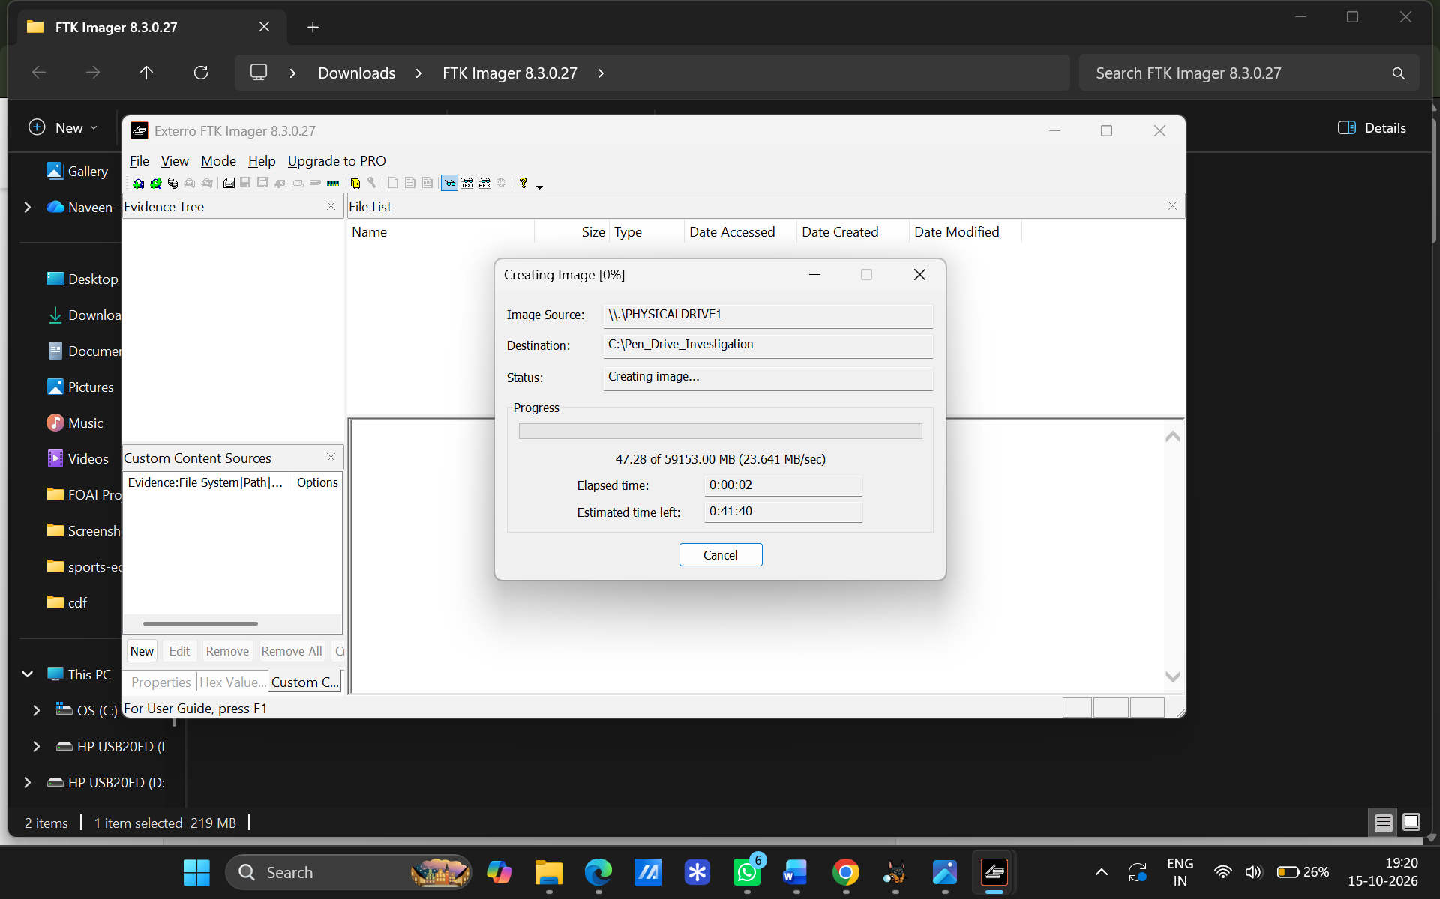
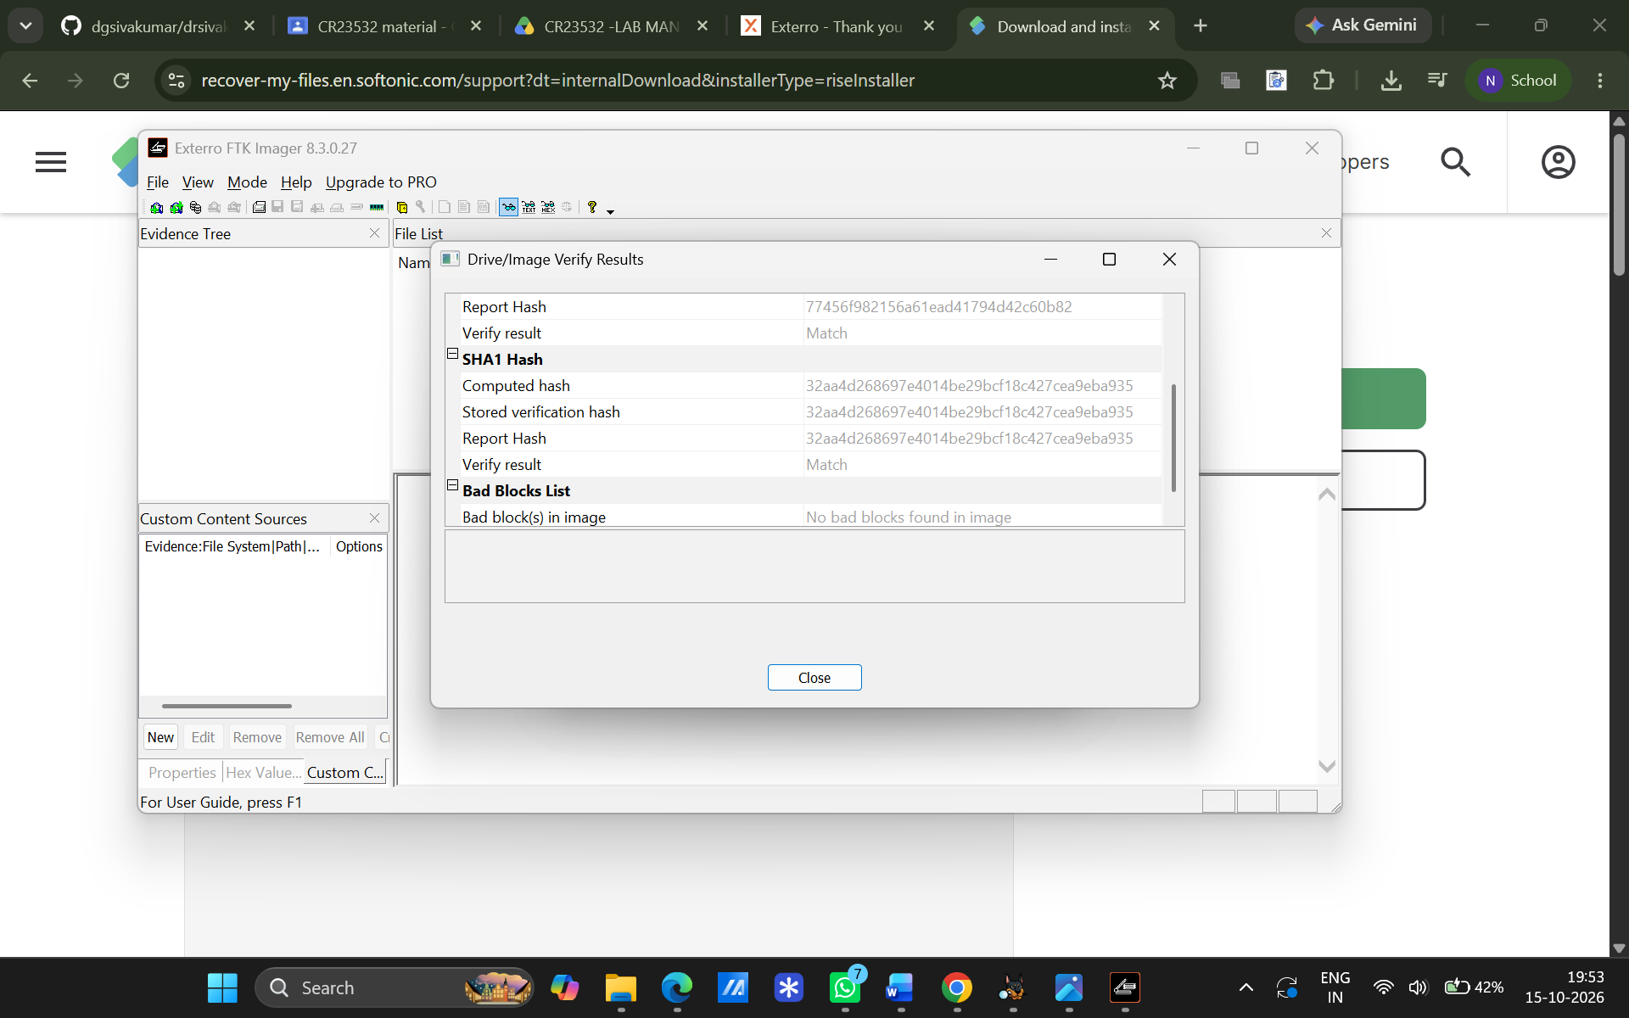
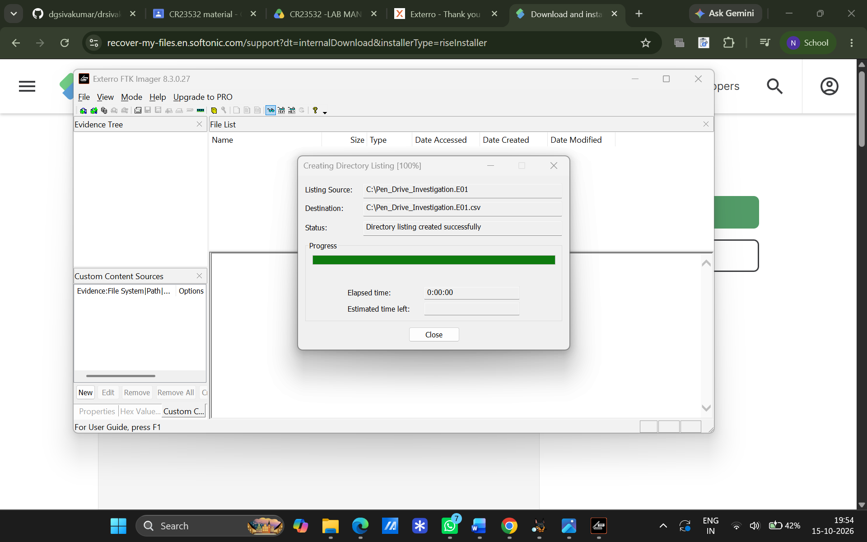
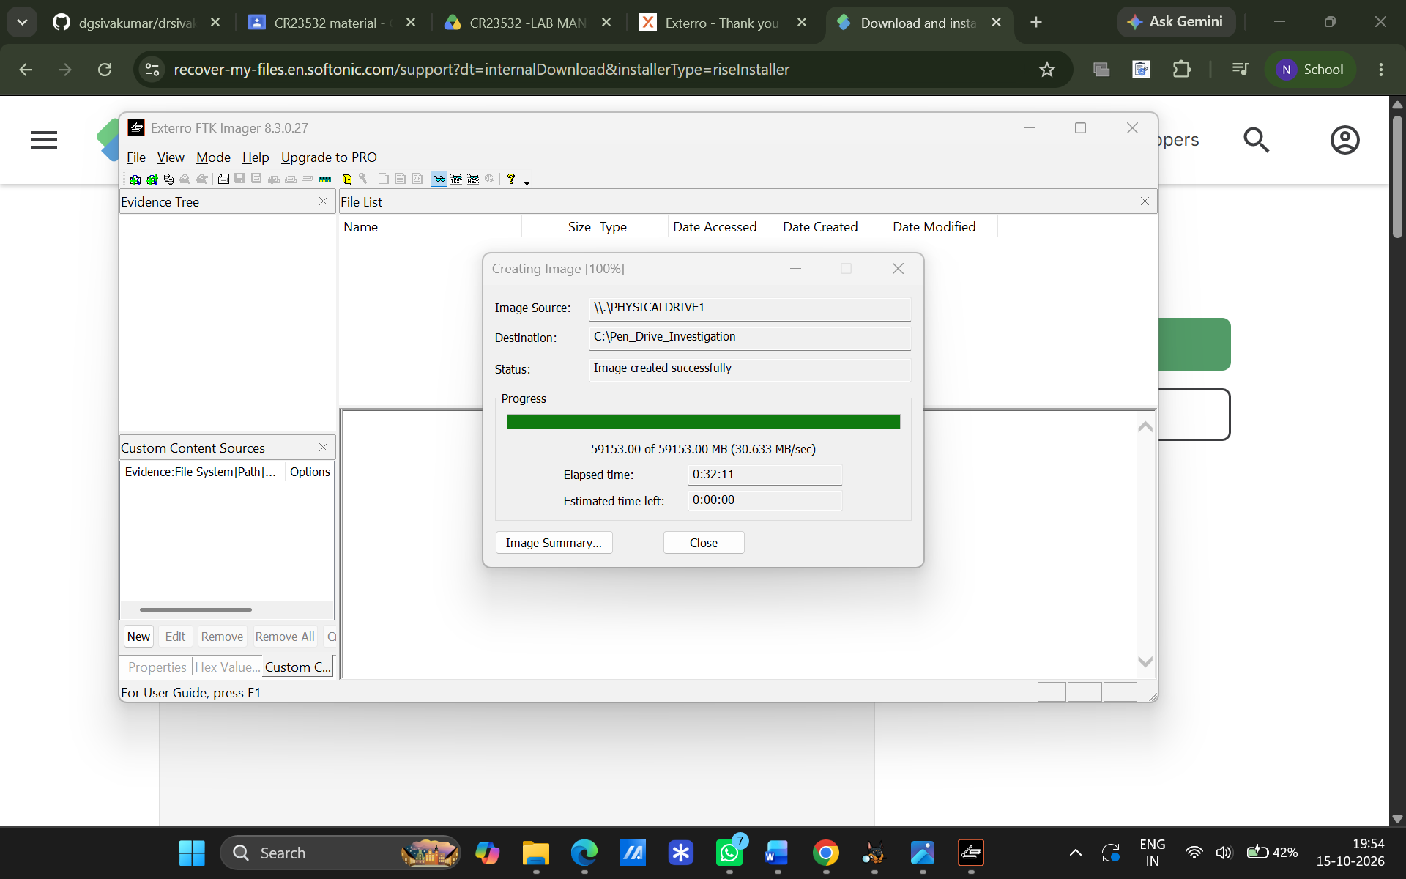

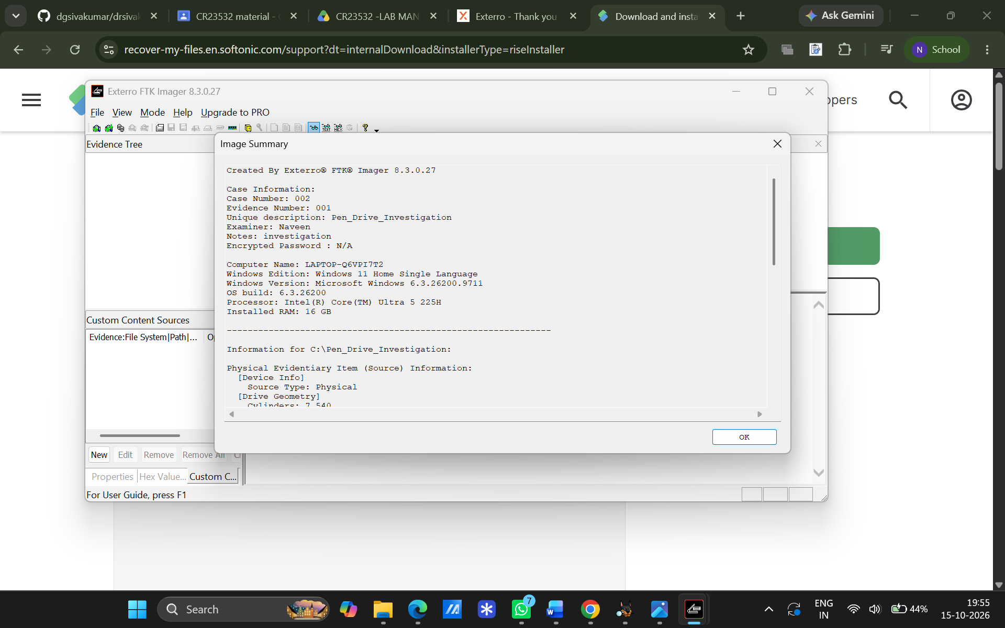
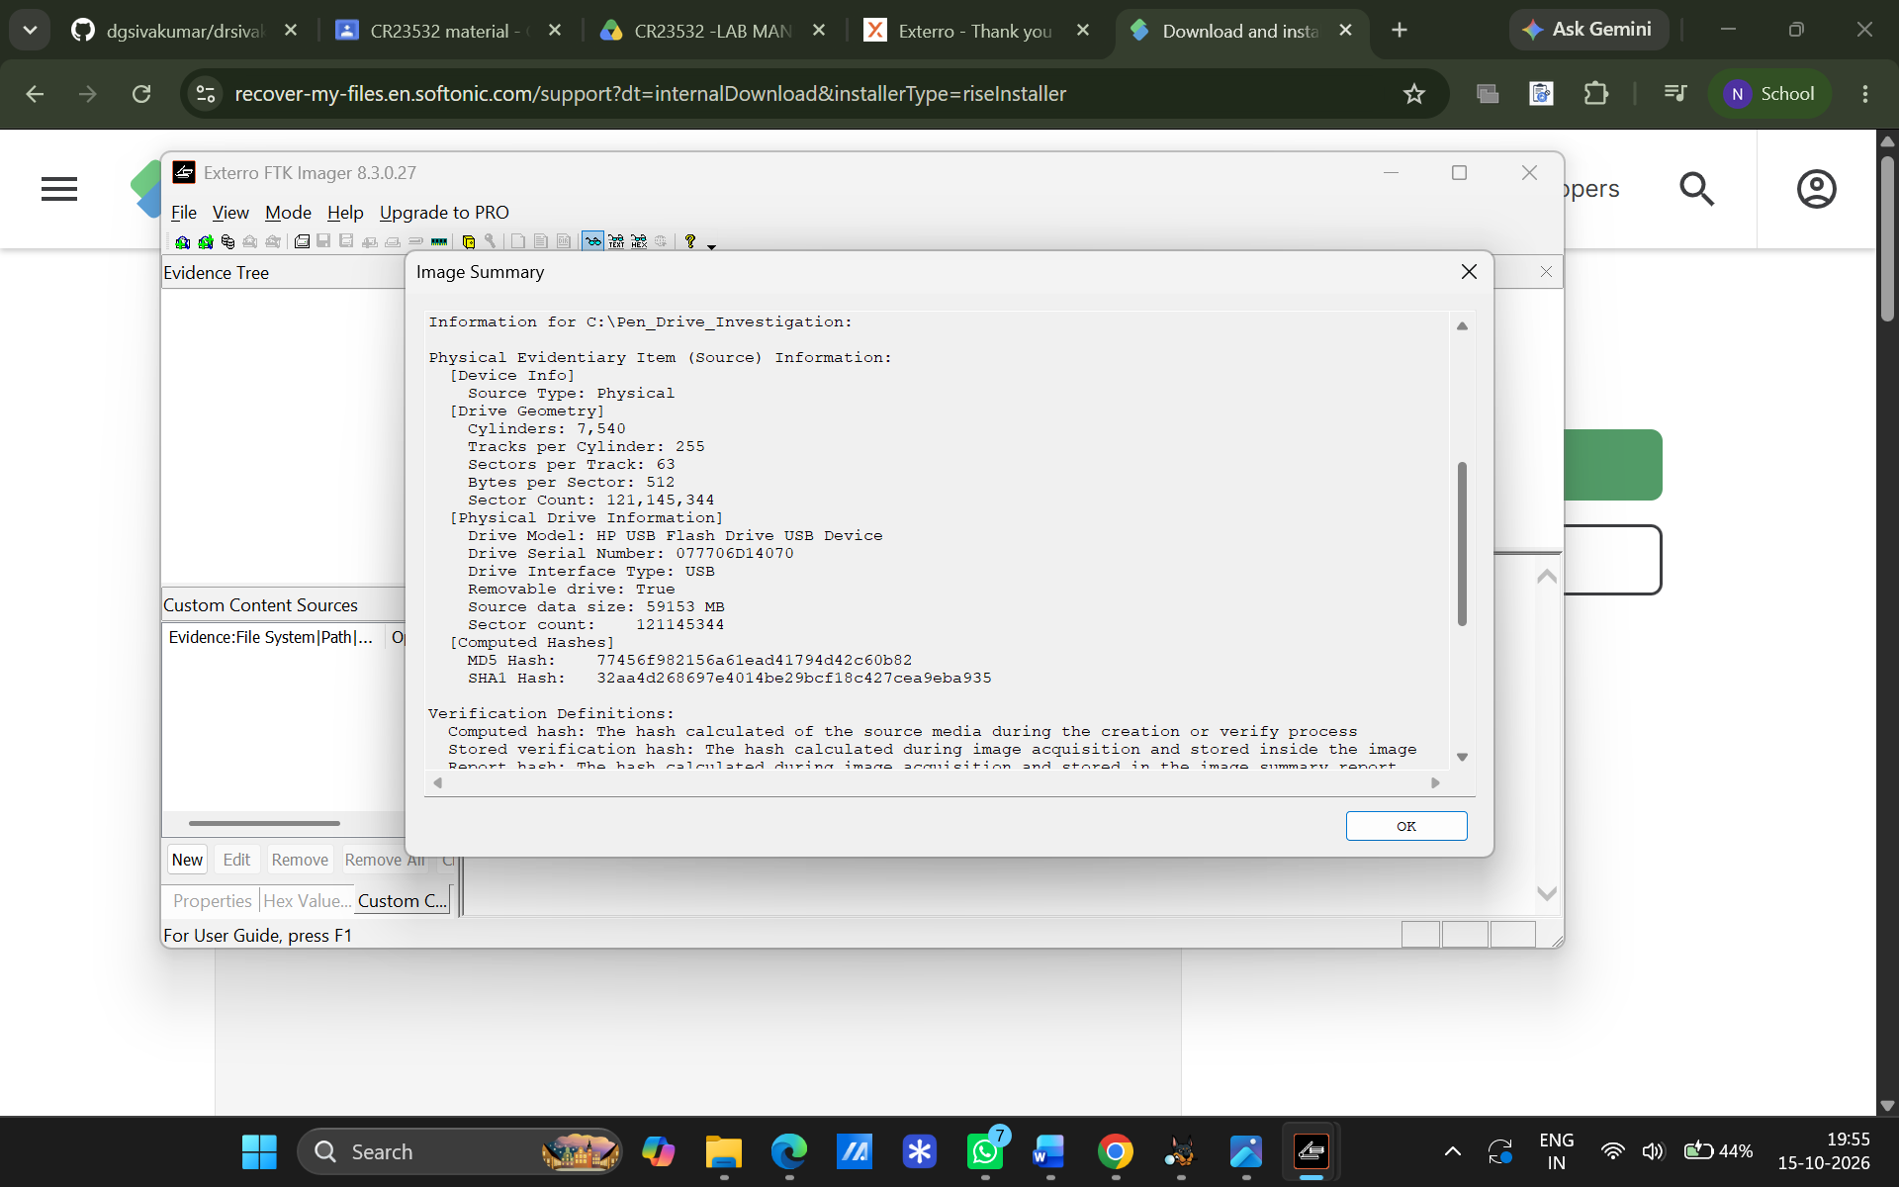
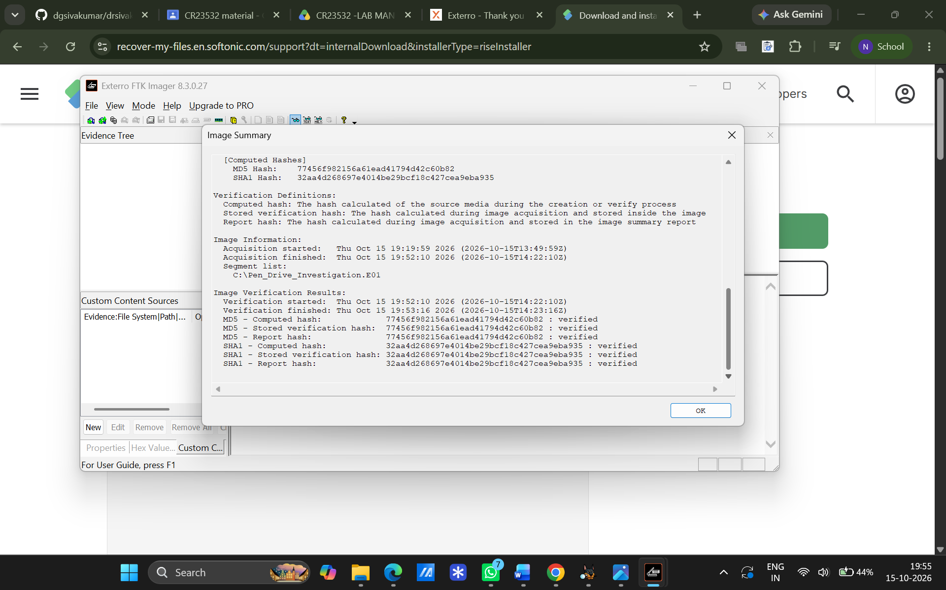
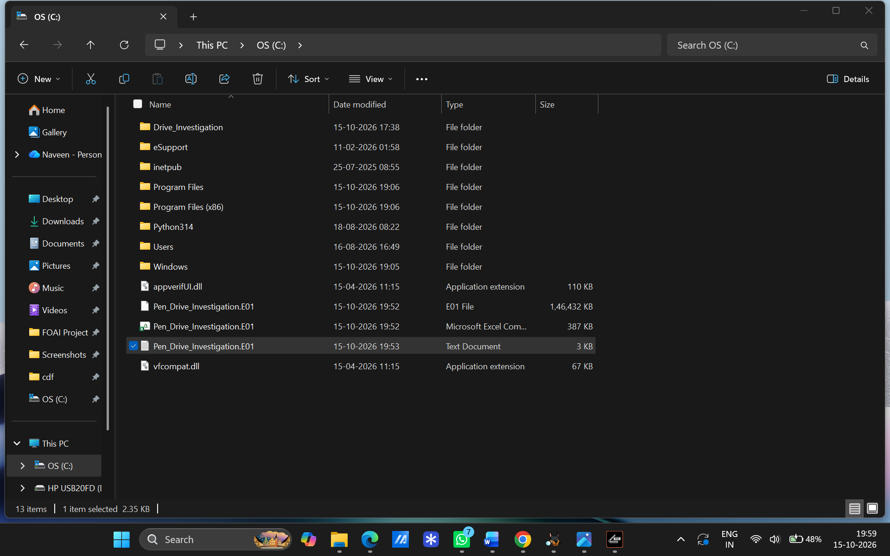
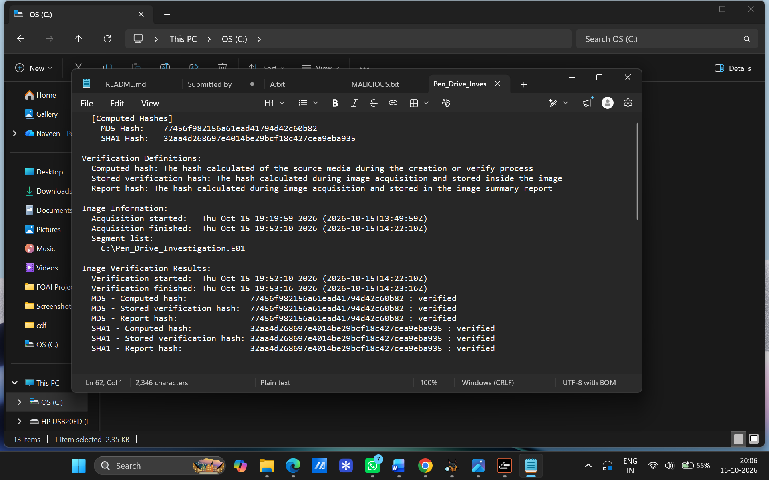
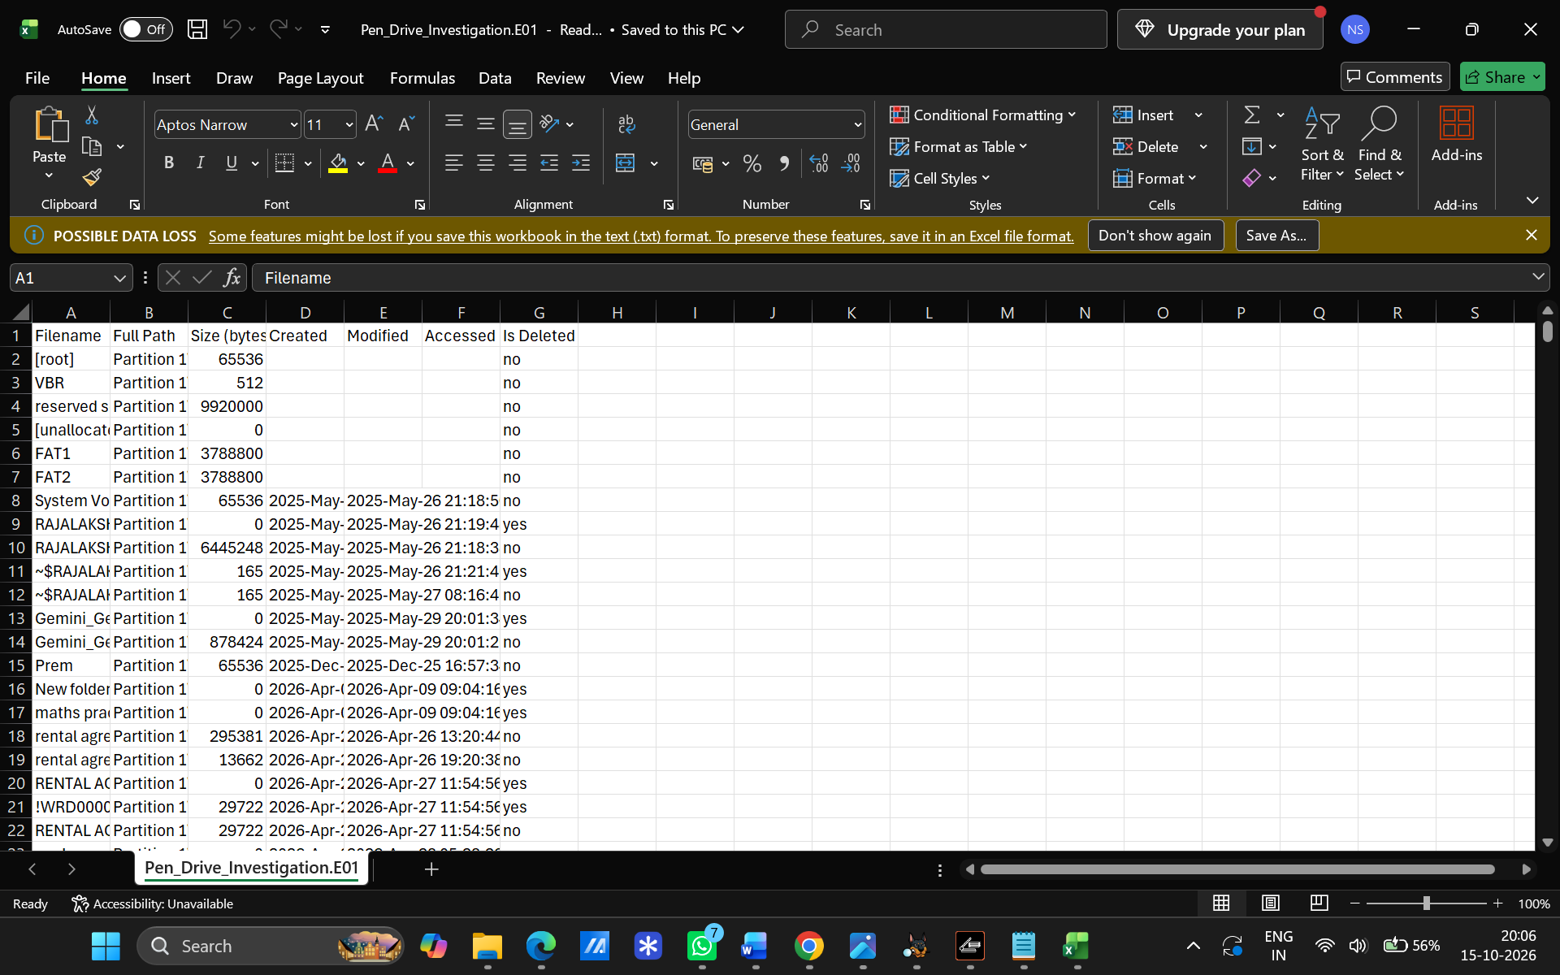
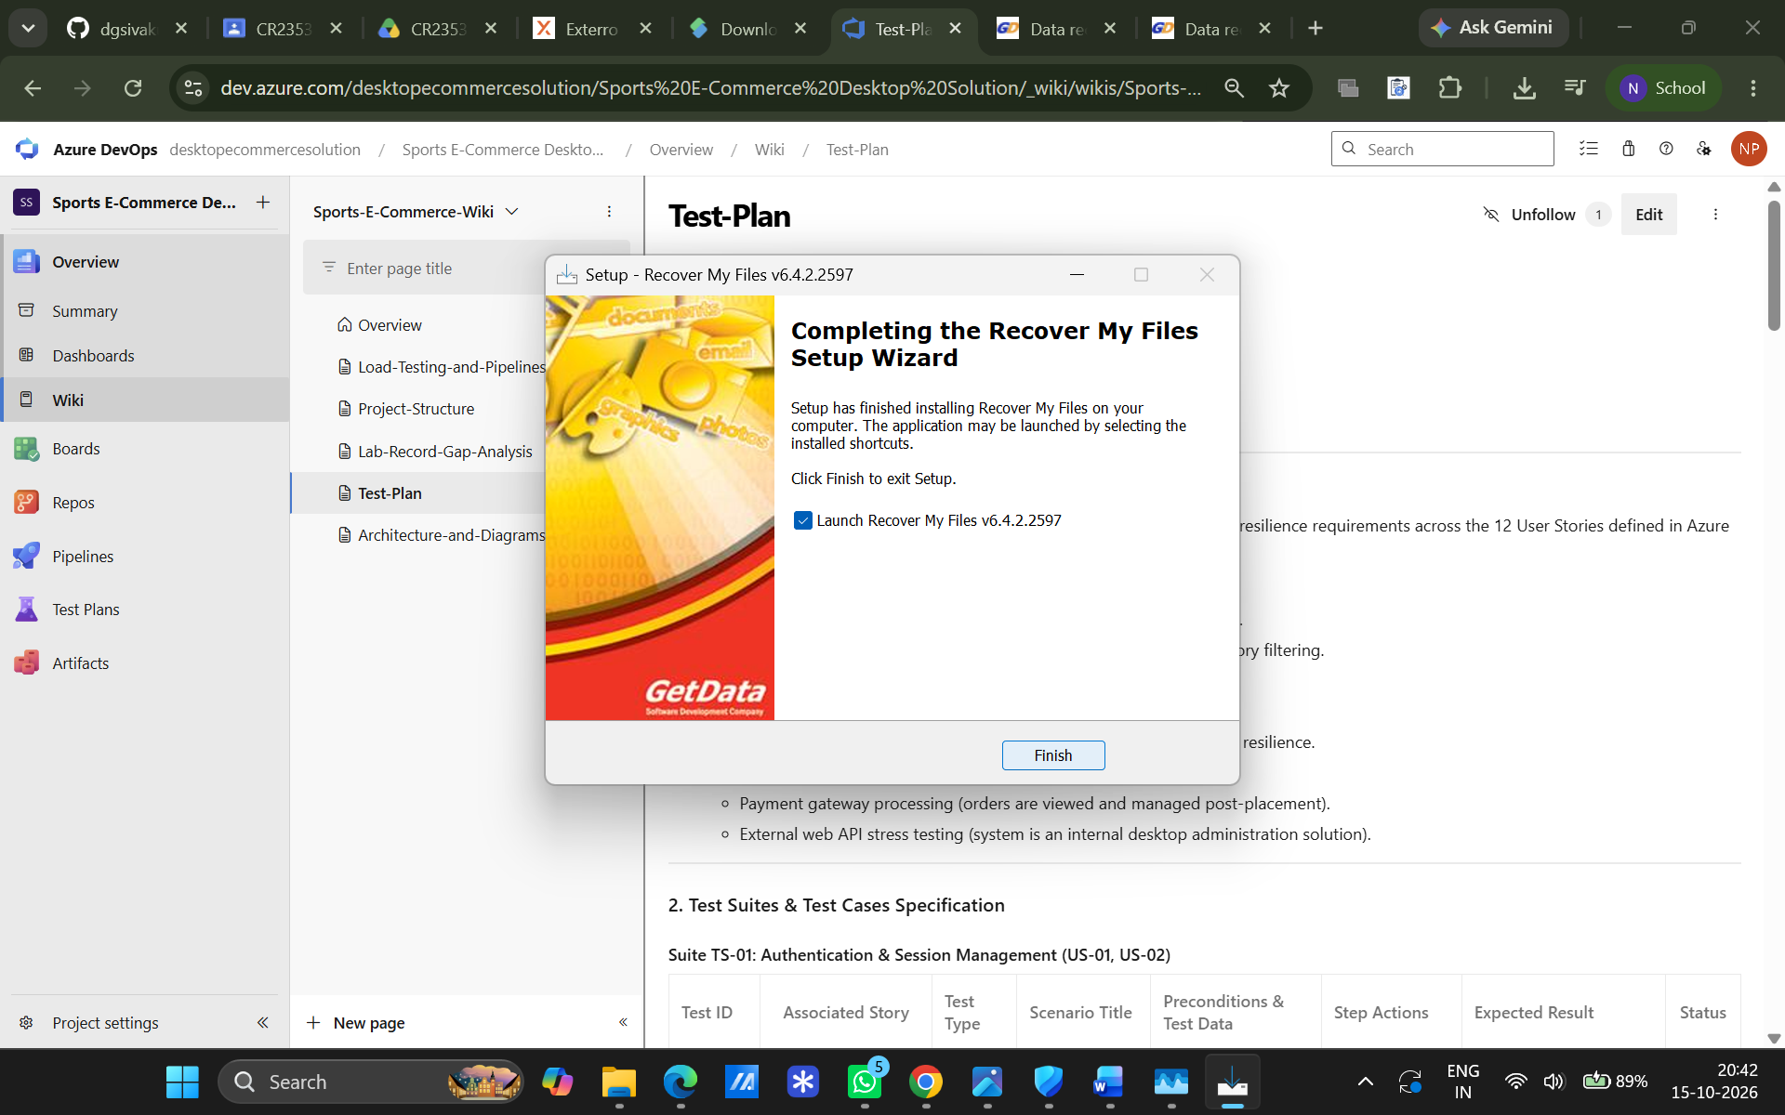
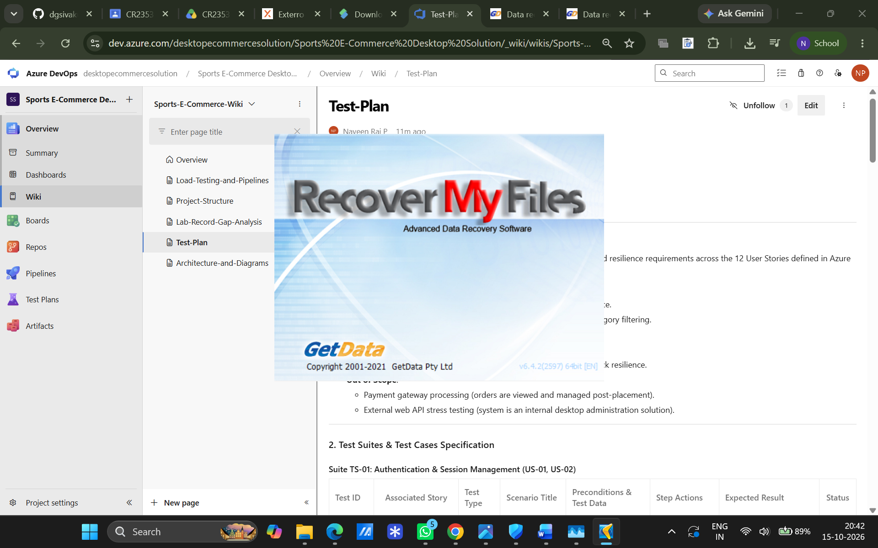
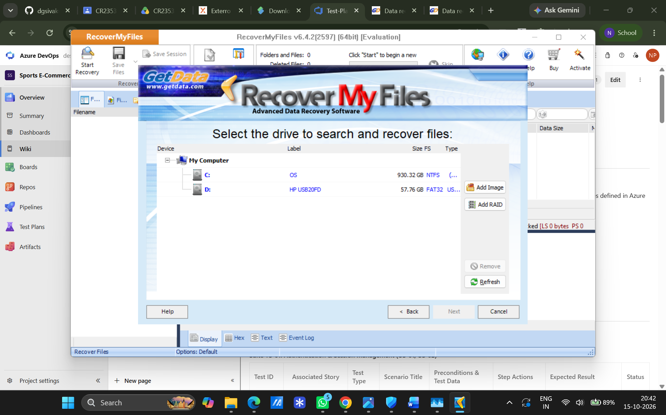
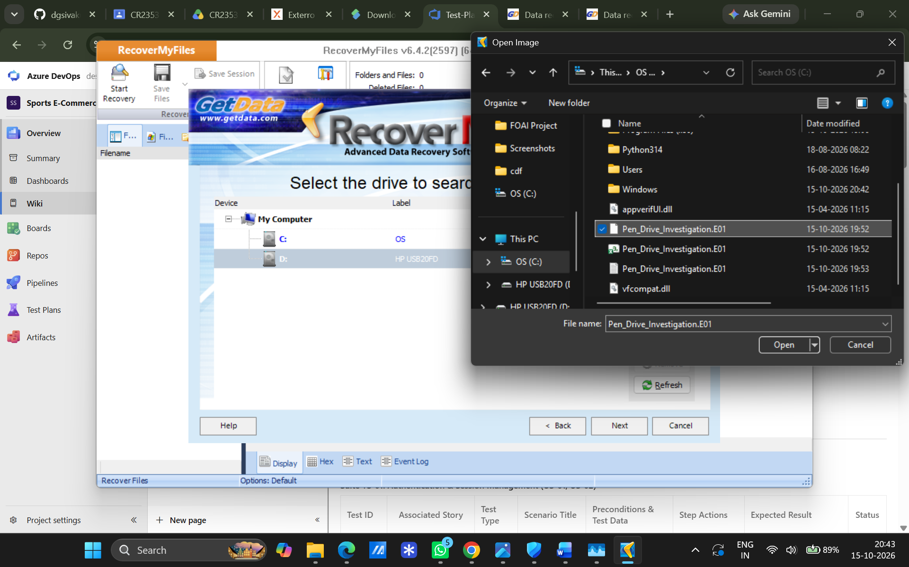
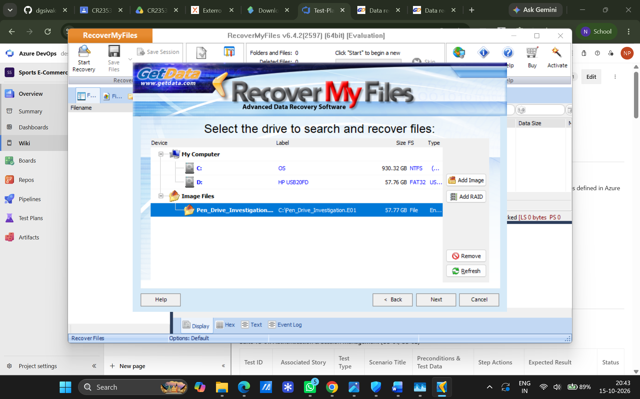
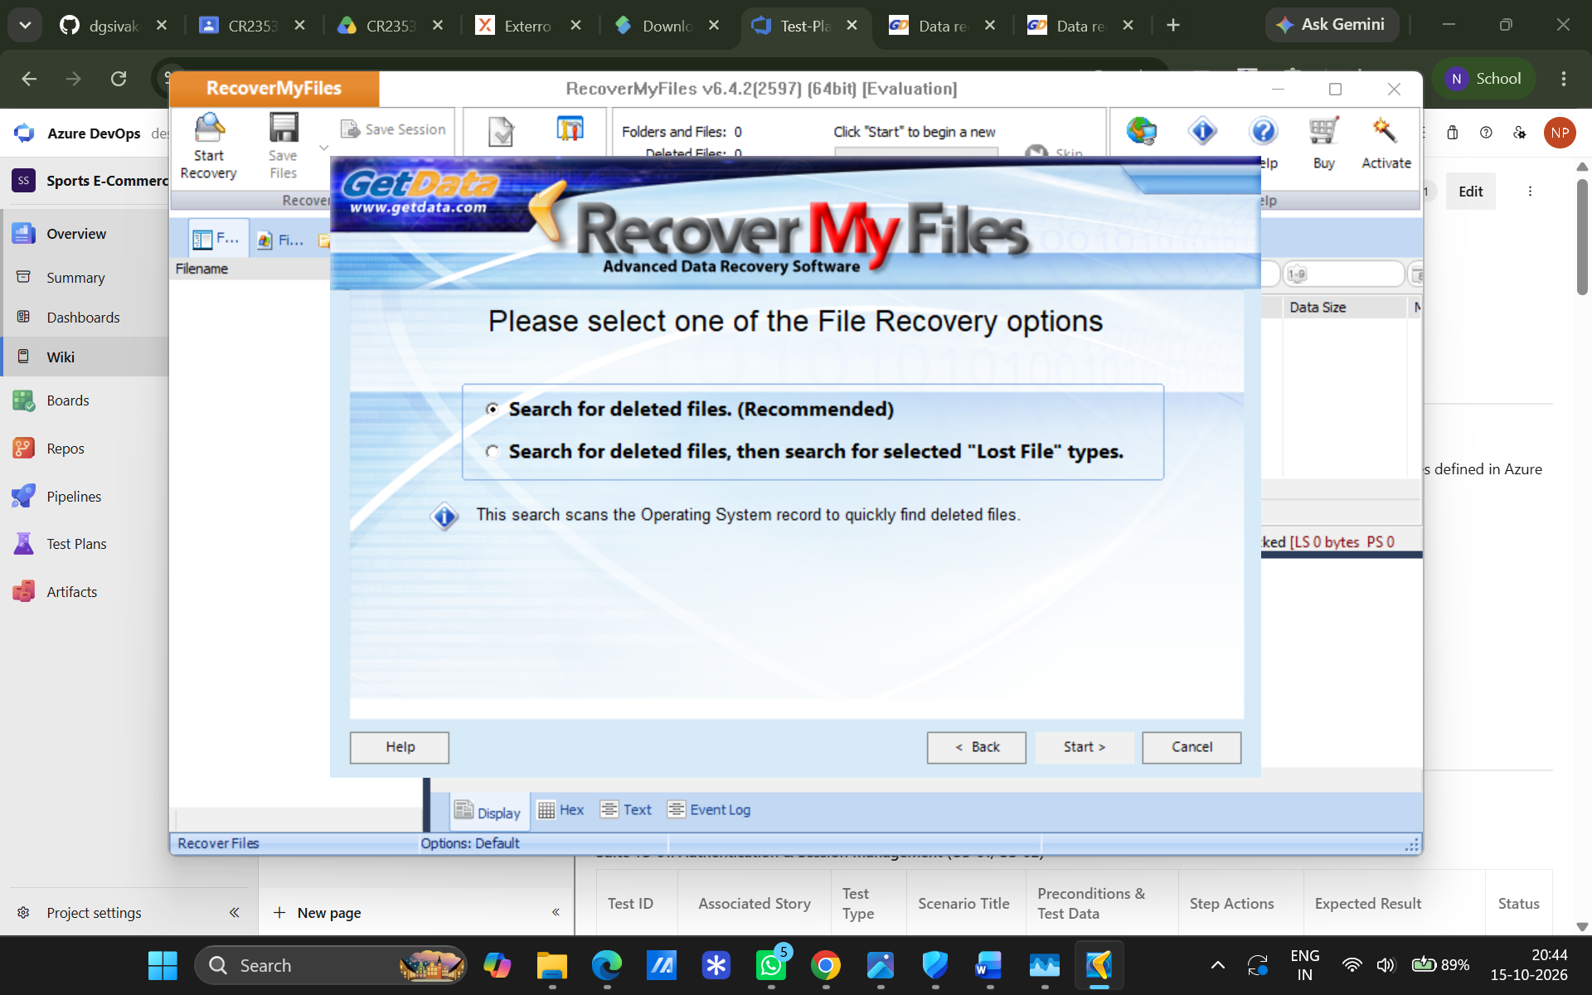
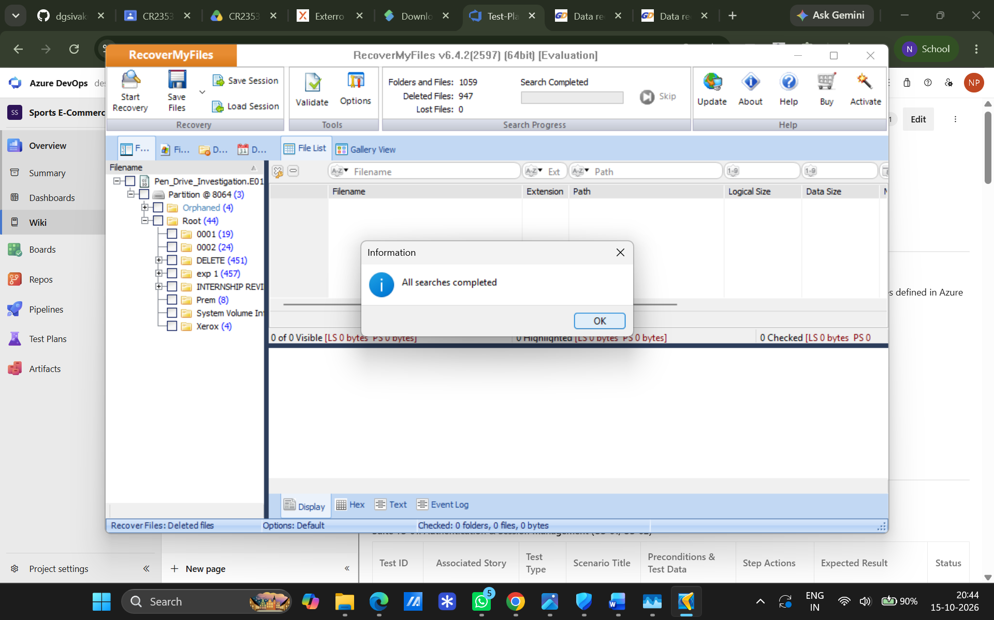
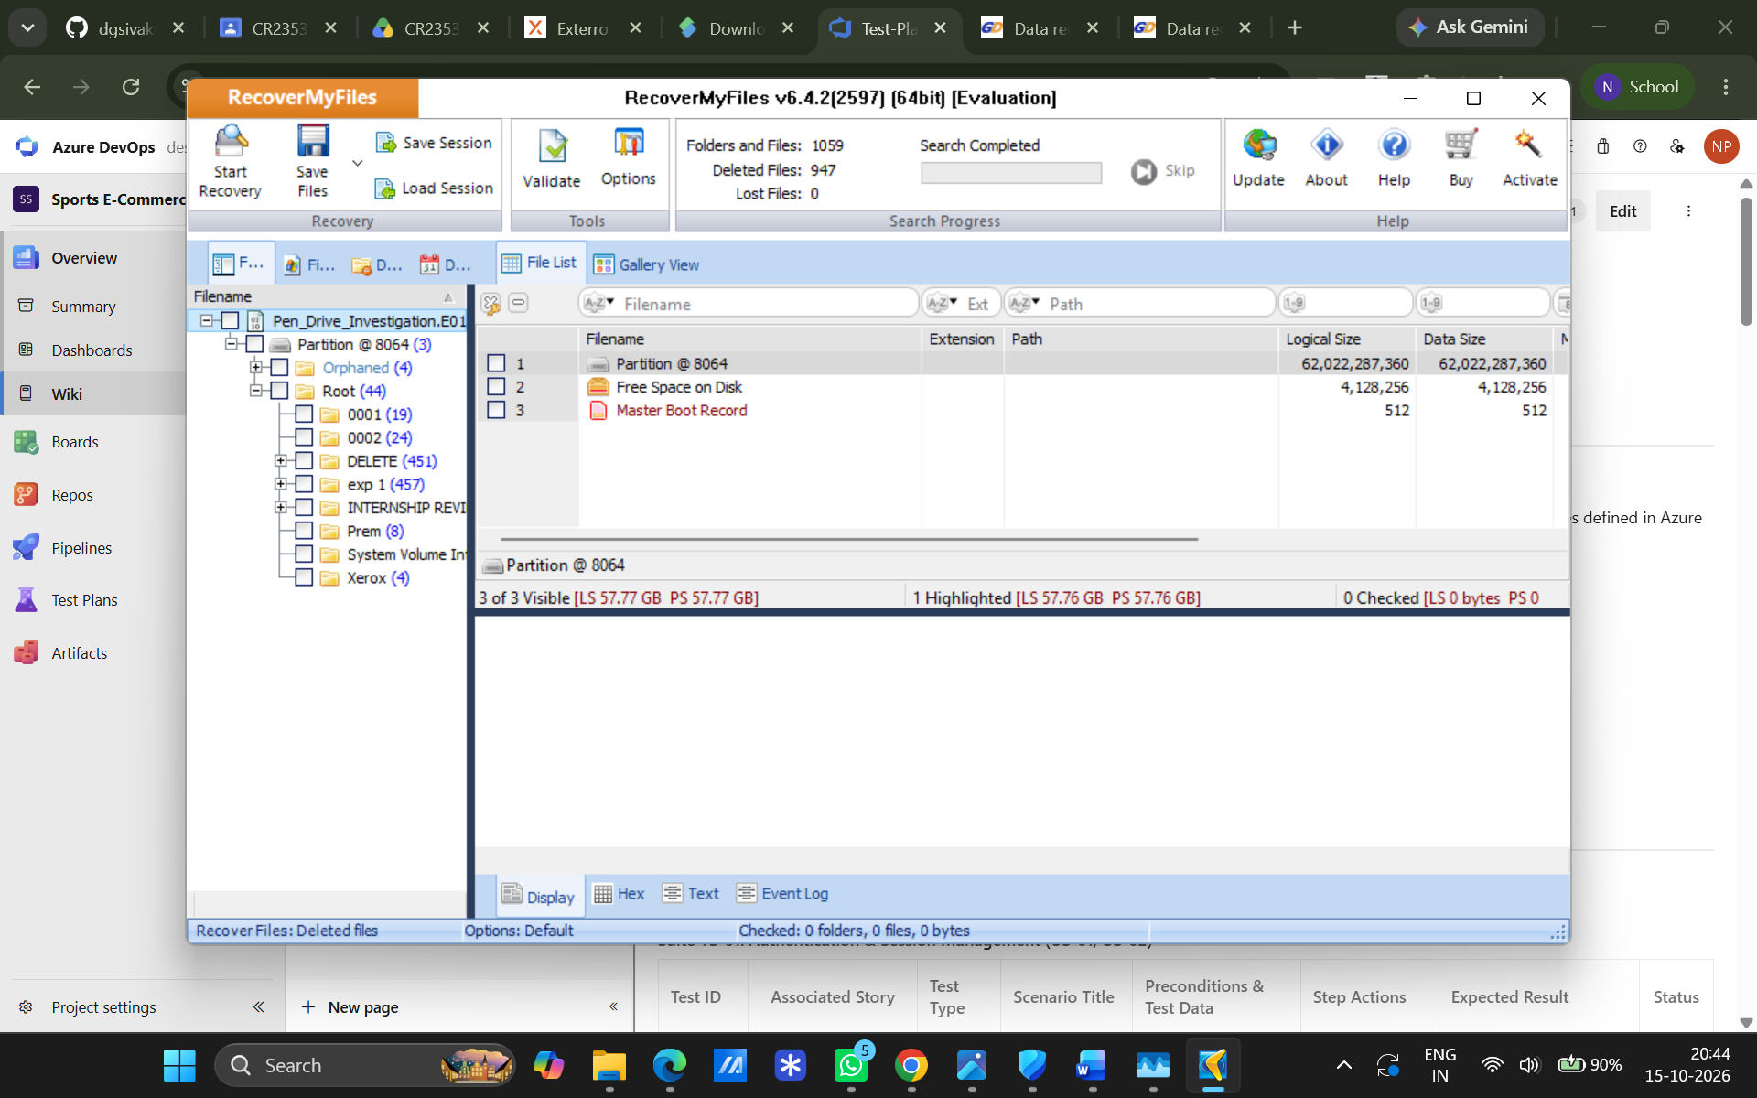
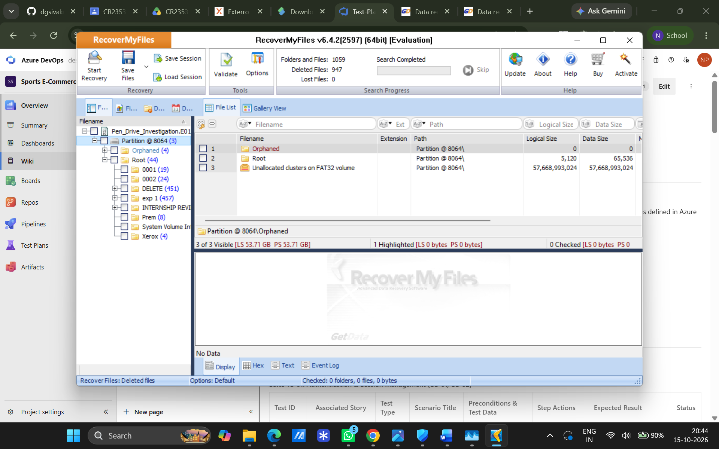
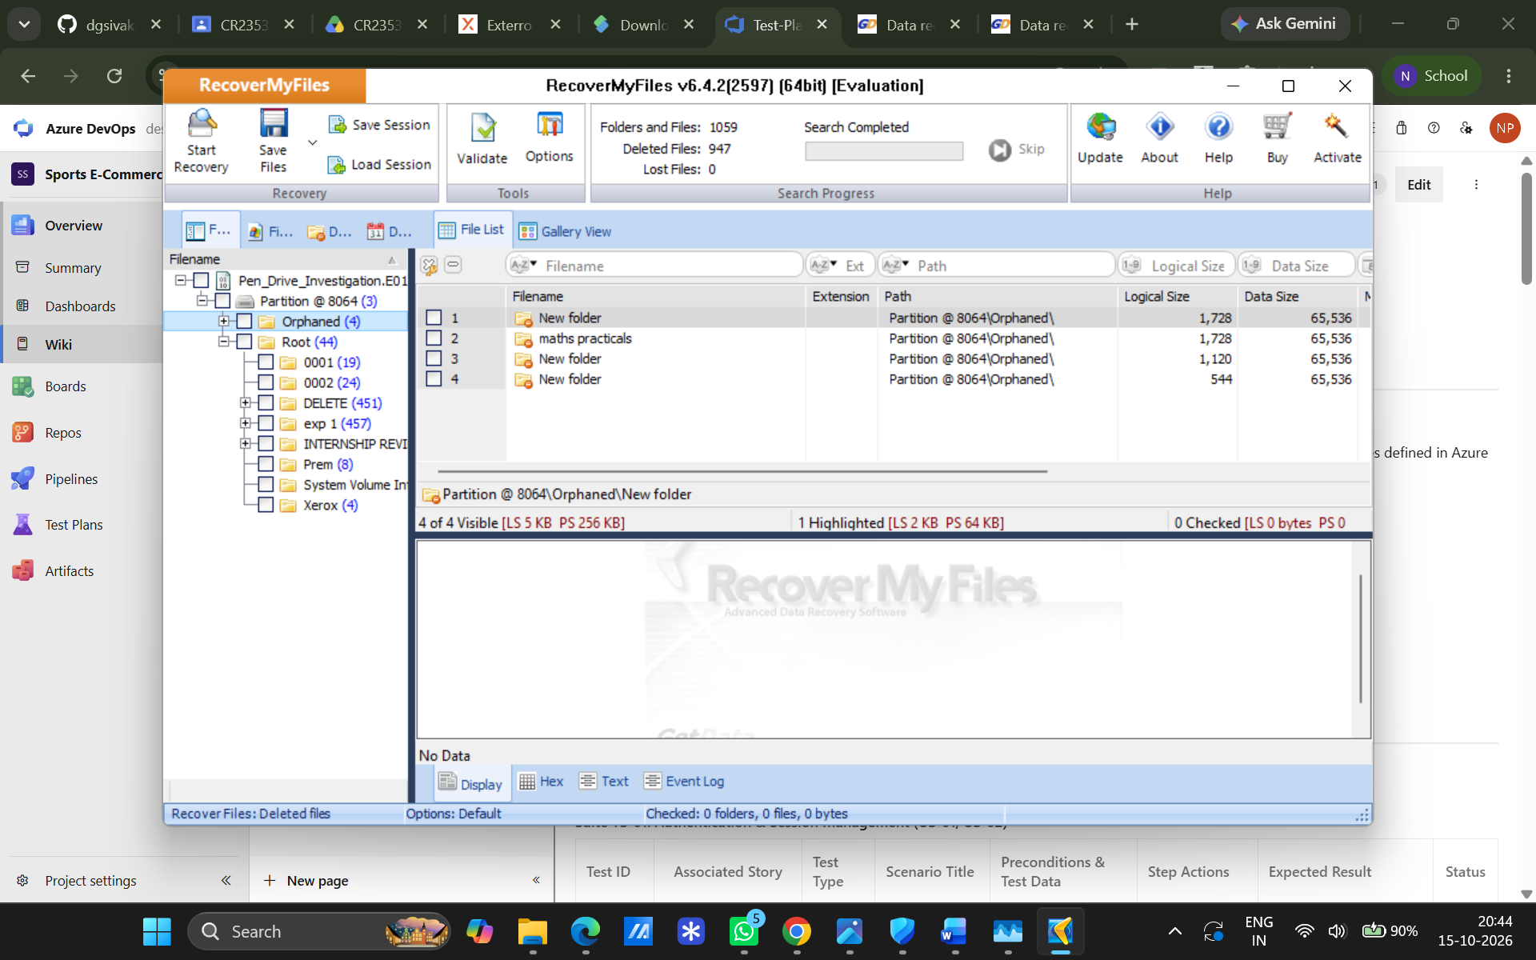
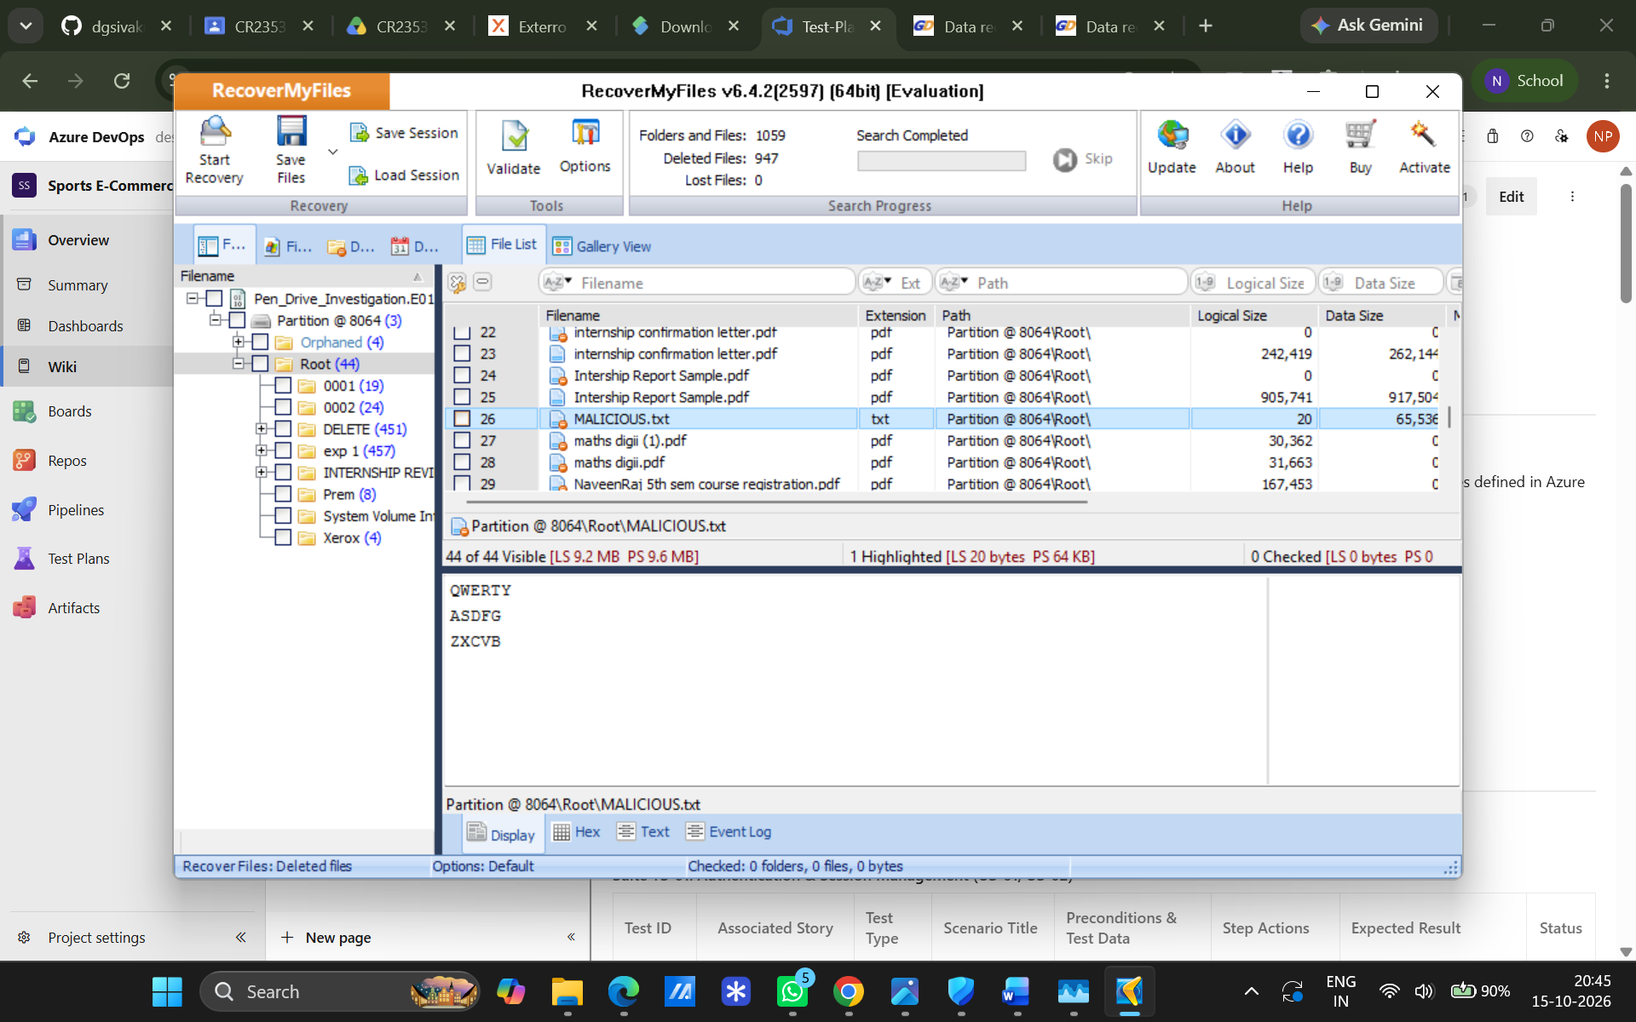
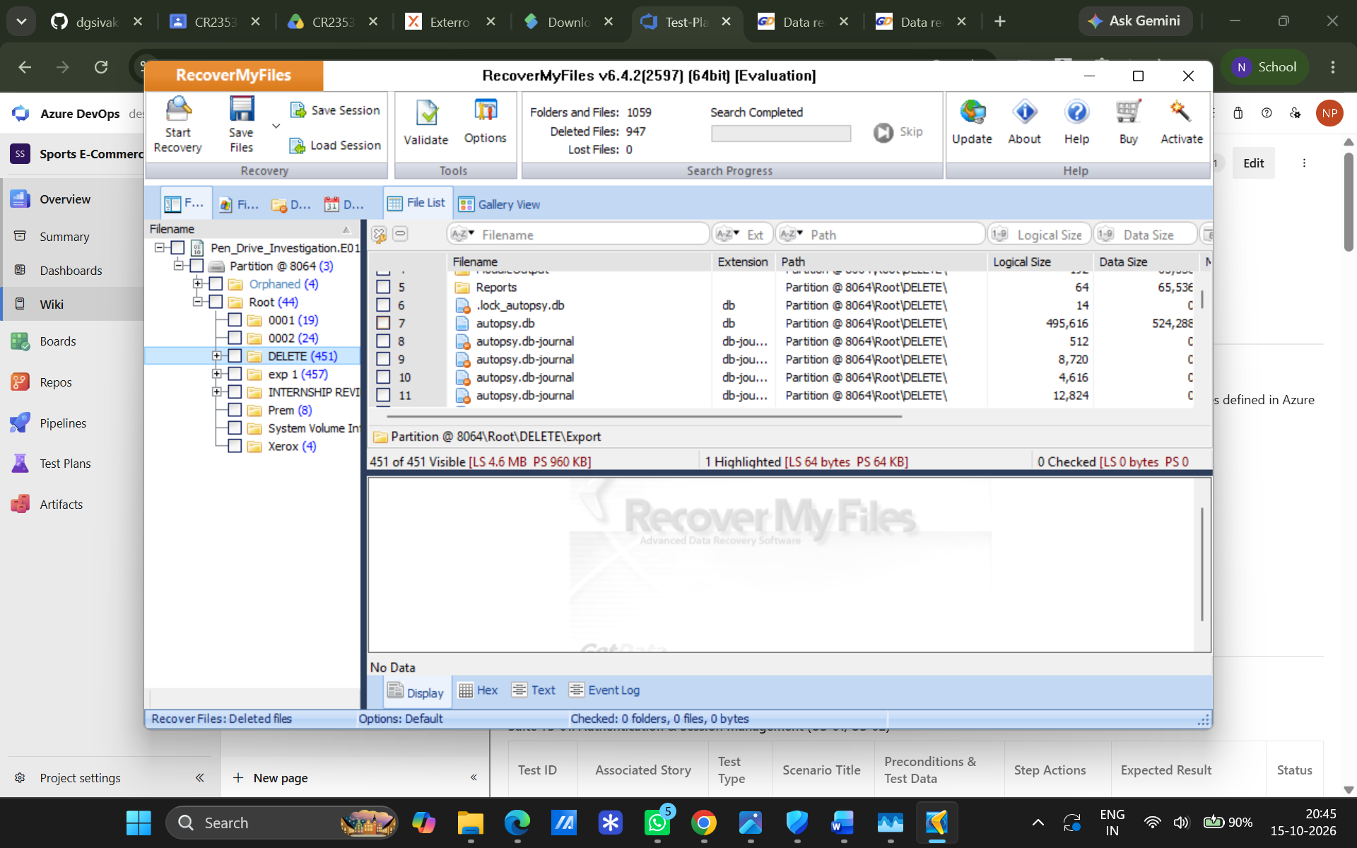

Observations
- Imaging: FTK Imager acquired a complete physical image of the drive without altering original evidence.
- Recovery: RecoverMyFiles successfully parsed unallocated space in the forensic image and fully restored the deleted text file.

Result
The intentionally deleted digital evidence was accurately captured, analyzed, and recovered.

EXPERIMENT 04
Find Last Connected USB on Your System (USB Forensics)
Aim
To identify and analyze history, connection logs, and details of USB devices previously or currently connected to the system.
Software / Tools Required
- USBDeview Utility
- Target Windows Host PC
Procedure
- Executed USBDeview on the target Windows system with administrator privileges.
- Retrived the generated list of all currently connected and previously attached USB devices.
- Extracted device attributes (Device Name, Serial Number, Vendor ID, Product ID, and Last Plug/Unplug Timestamps).
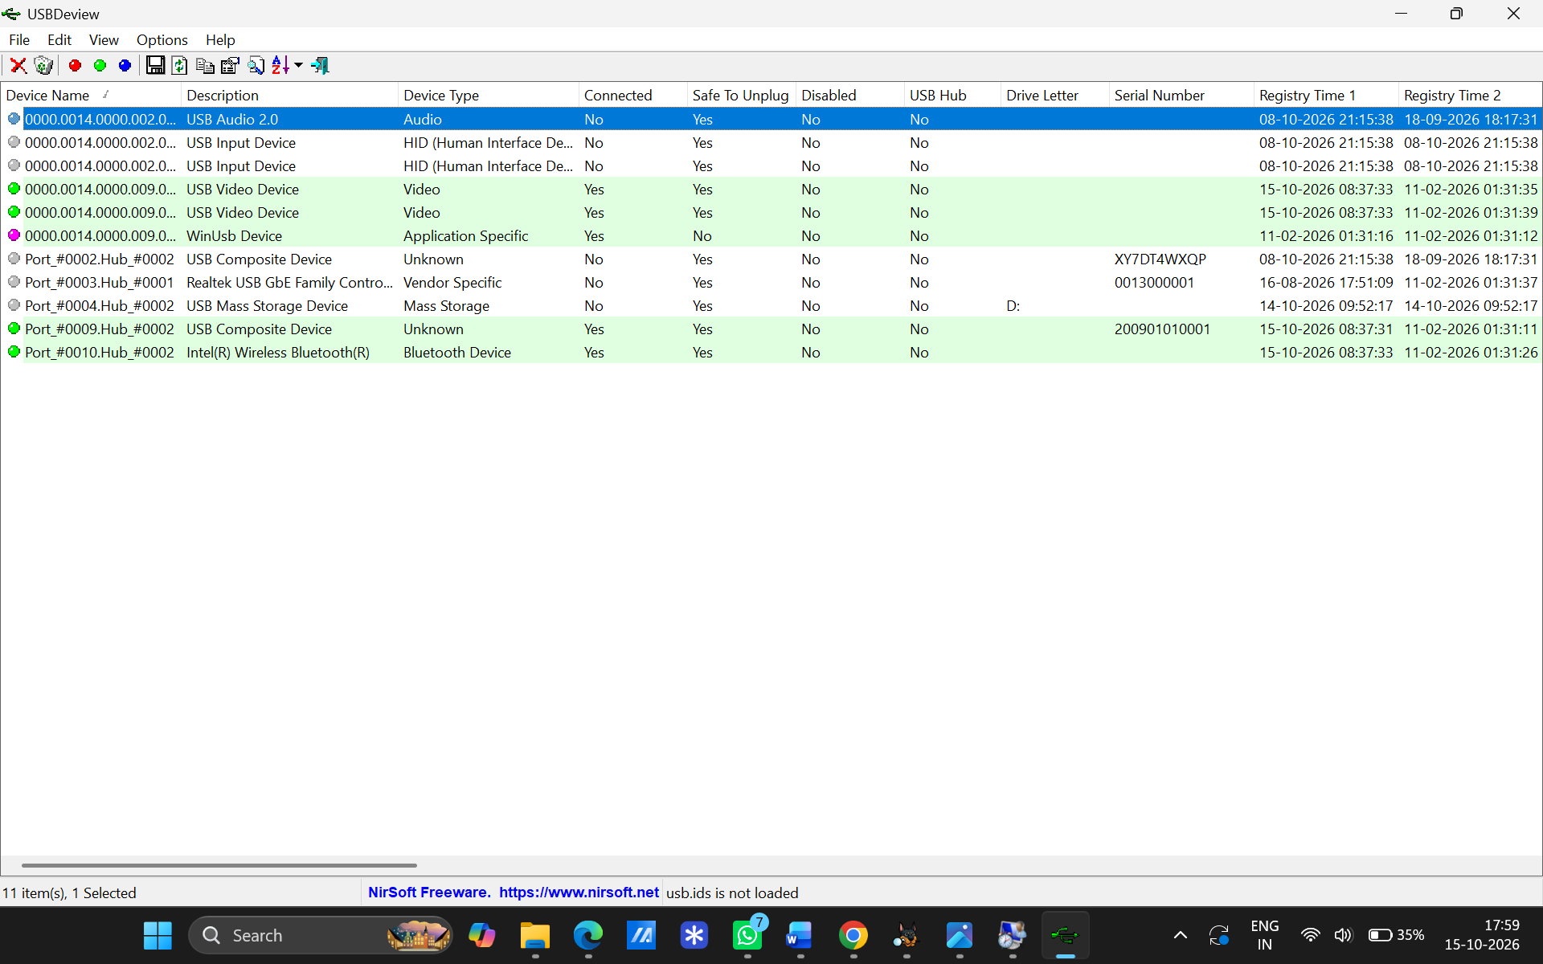

Observations
Attribute Analyzed | Findings / Recorded Data
Device Description & Type | Mass Storage, Communication, and Vendor-Specific devices.
Identifiers | Vendor ID (VID), Product ID (PID), and Serial Numbers.
Connection Timestamps | Exact date and time when each device was last plugged or unplugged.
Connection Status | Indicates whether the device is currently active/connected.

Result
The USB forensic examination using USBDeview was successfully executed, and historical USB connection artifacts were analyzed.
EXPERIMENT 05
View Last Activity of Your PC
Aim
To collect and analyze system logs to view the detailed history of user actions and computer events on a running Windows OS.
Software / Tools Required
- LastActivityView Utility
- Windows Host PC
Procedure
- Launched LastActivityView on the active Windows host.
- Allowed the utility to gather event records from system sources (Registry, log files, system folders).
- Filtered and reviewed the chronological log entries showing user activities, app executions, and system events.
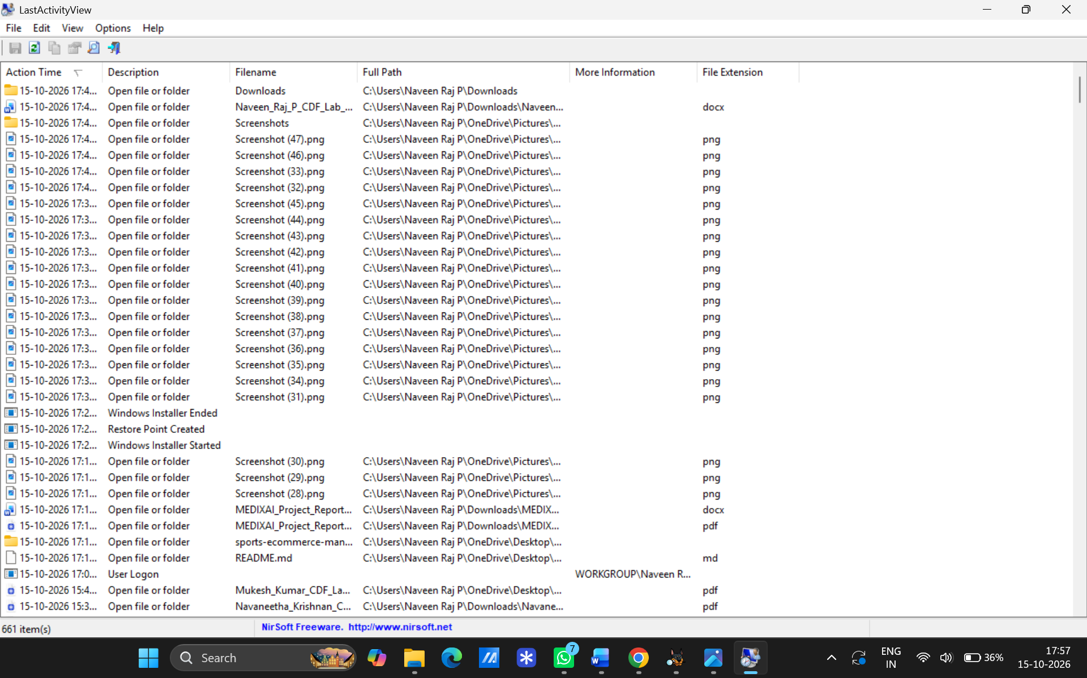

Observations
Log Category | Artifacts & Event Data Observed
User Activity | User logins, folder views, and opened files/folders.
Application History | Installed, executed, or crashed software applications.
System Events | System startup, shutdown, and network connection timestamps.

Result
System activity forensic examination using LastActivityView was successfully performed and historical logs were analyzed.
EXPERIMENT 06
Extraction of Browser Artifacts
Aim
To extract and analyze web browser history, cache, and artifact data using specialized forensic utilities.
Software / Tools Required
- ChromeHistoryView & ChromeCacheView
- IEHistoryView & IECacheView
- Windows Host PC with Google Chrome and Internet Explorer installed
Procedure
- Chrome Extraction: Launched ChromeHistoryView to view browsing history files and ChromeCacheView to inspect cache files.
- IE Extraction: Executed IEHistoryView to read visited URL records and IECacheView to inspect cached file details.
- Data Analysis: Evaluated browsing attributes (URLs, access timestamps, file paths, visit counts) and exported entries to HTML/text reports.
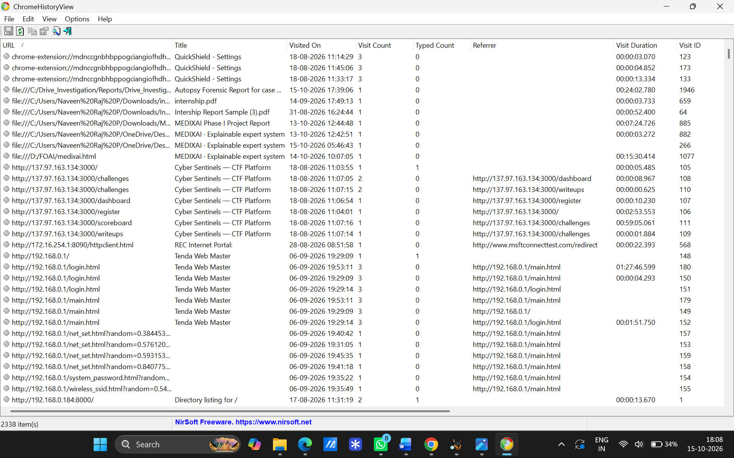
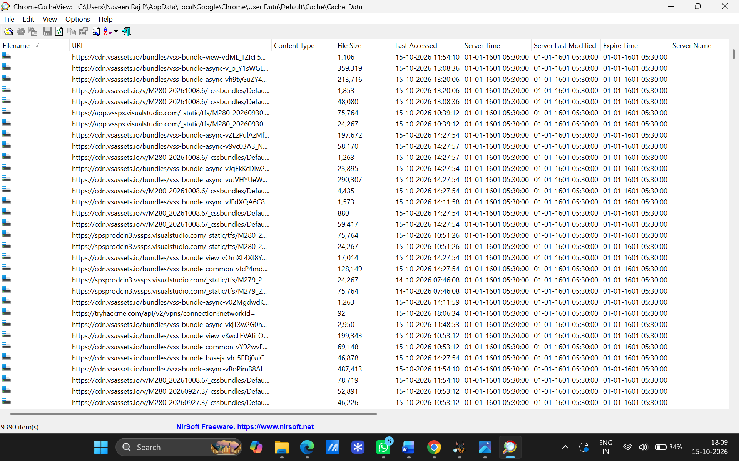

Observations
Tool | Analyzed Artifacts & Displayed Information
ChromeHistoryView | Visited page URLs, page titles, visit dates/times, visit counts, typed counts, and referrers.
ChromeCacheView | Cached file URLs, content types, file sizes, last access times, and server response details.
IEHistoryView | Complete list of visited URLs and historical web page accesses.
IECacheView | Cached file names, full file paths, folder names, content types, file sizes, and hit counts.

Result
Browser forensic tools were executed successfully, and browser artifacts were accurately extracted and analyzed.

EXPERIMENT 07
Comparison of Two Files for Forensics Investigation by Compare IT Software
Aim
To compare two files side-by-side using Compare IT software to detect structural and content differences during a digital forensic investigation.
Software / Tools Required
- Compare IT Software
- Target files for comparison
Procedure
- Installed and opened the Compare IT application.
- Loaded the first file into the left pane and the second file into the right pane.
- Reviewed the side-by-side display with color-coded highlighted differences.
- Saved/printed the color-coded difference report summarizing the findings.

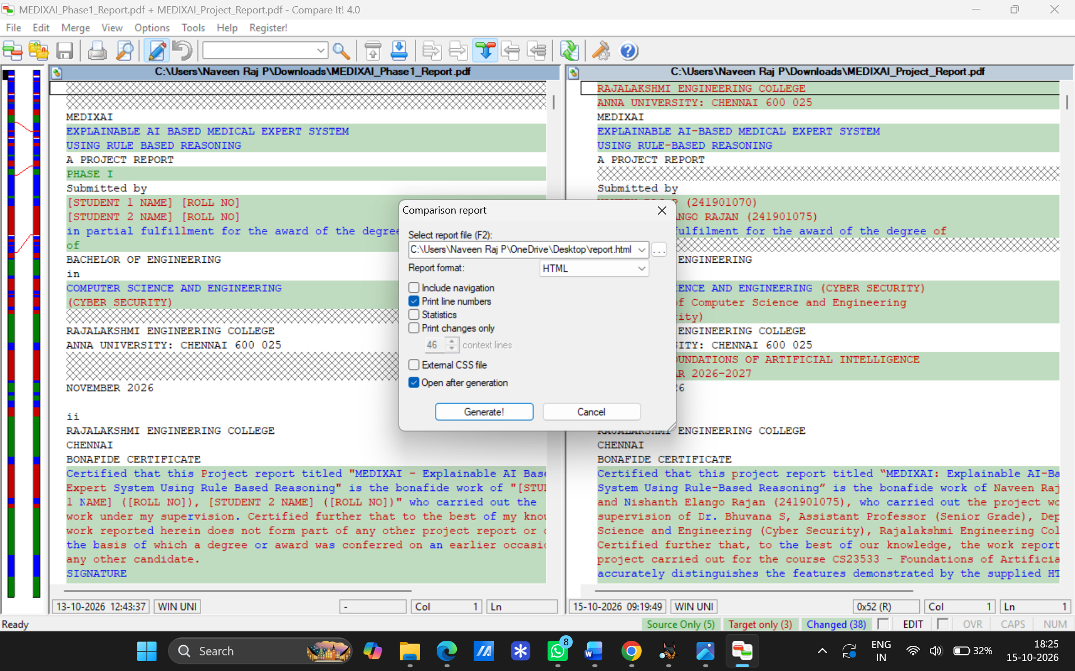
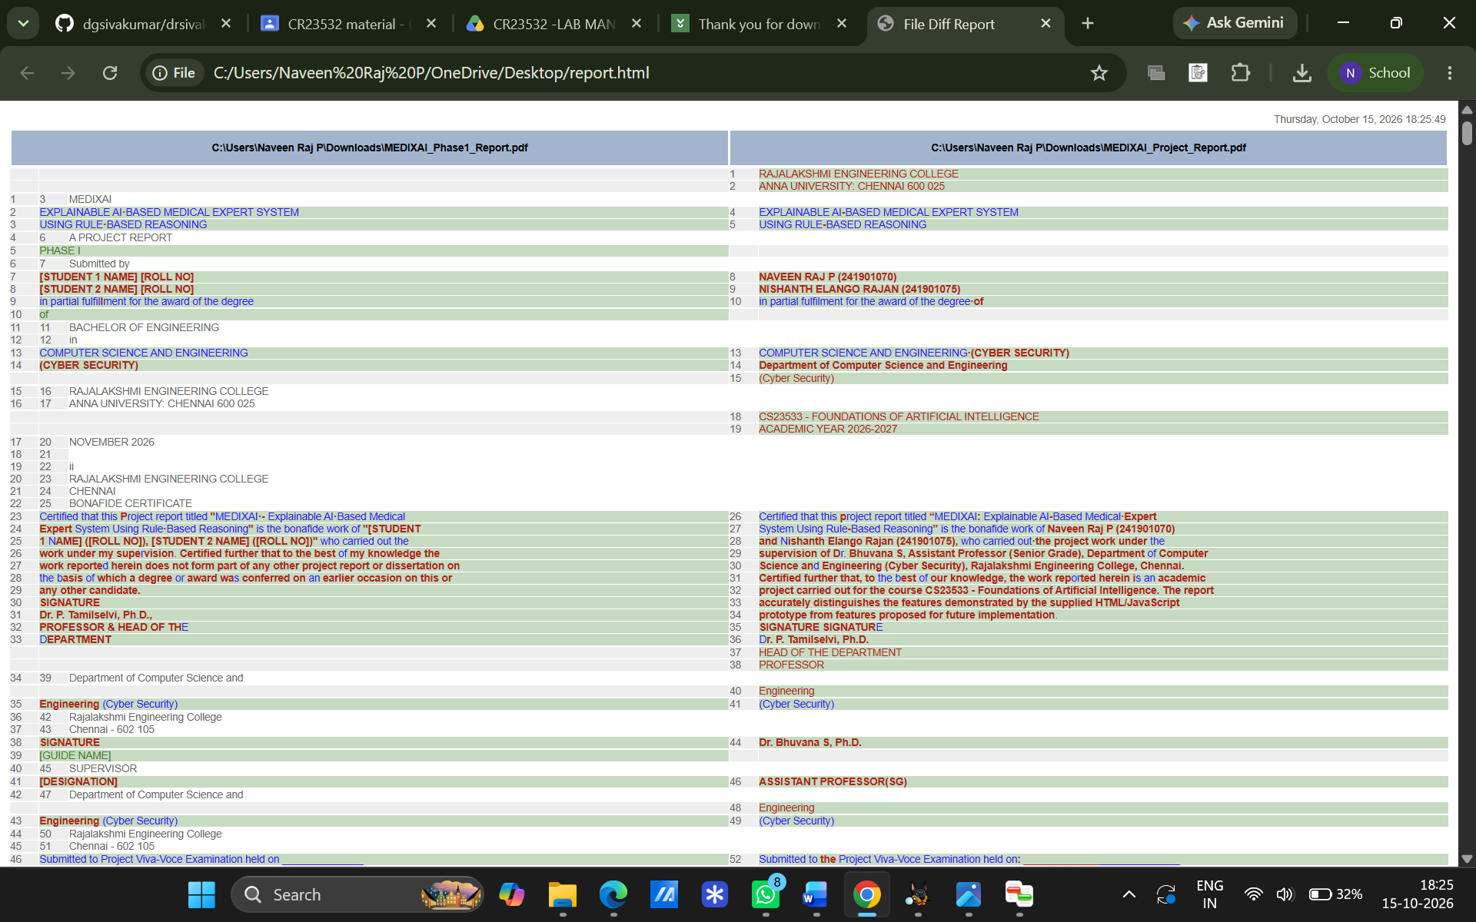
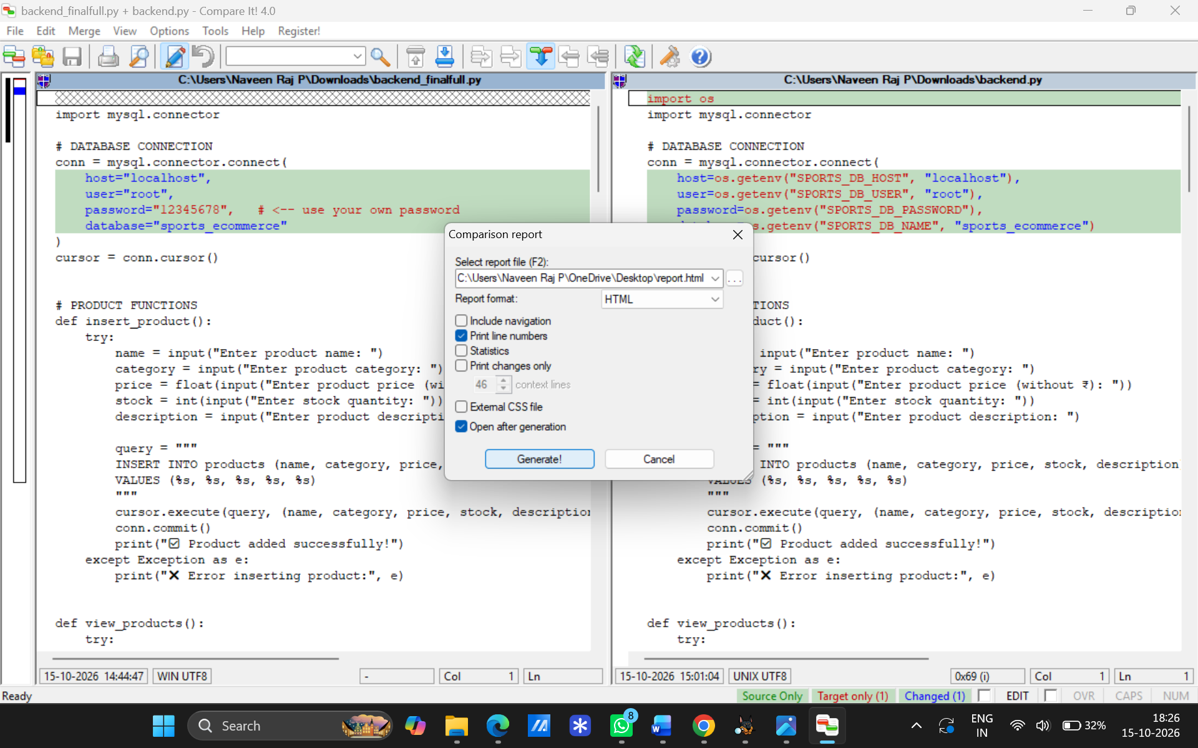
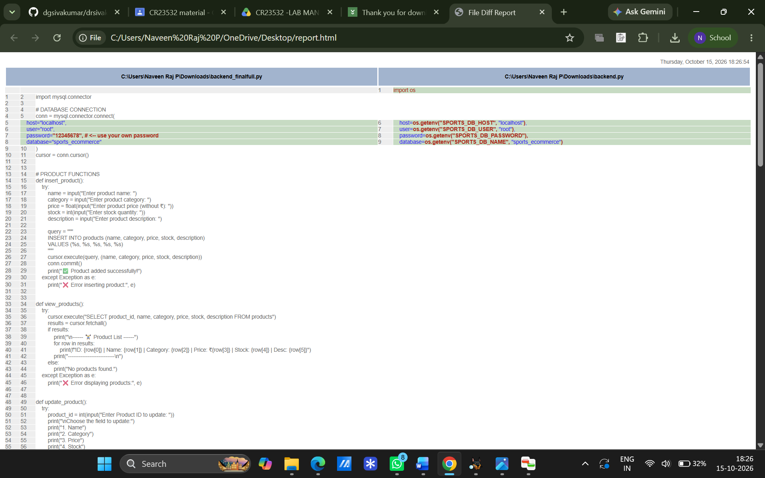
Observations
Feature / Aspect | Findings & Analysis Observed
Visual Comparison | Files are displayed side-by-side with color-highlighted differences for visual tracking.
Modification Capabilities | Direct editing of files and single-click transfer of changes between files.
Output / Reporting | Generates an accurate, color-coded printout or report of the file differences.

Result
File comparison using Compare IT software was successfully conducted, and differences between target files were documented.
EXPERIMENT 08
Collecting Email Evidence in Victim PC
Aim
To collect and extract email evidence and volatile data from a victim PC by capturing and analyzing physical memory (RAM).
Software / Tools Required
- DumpIt Utility
- Bulk Extractor (or RAM analyzer)
- Target Windows Host PC
Procedure
- Executed DumpIt.exe directly from an external USB drive on the victim machine.
- Confirmed the execution prompt to generate a full, raw physical memory dump (.raw file).
- Used Bulk Extractor to scan the generated RAM image for email addresses, headers, and message fragments.
Observations
Feature / Step | Findings & Analysis Observed
Volatile Data Acquisition | DumpIt successfully captured physical RAM across x86/x64 Windows architecture without installation.
Evidence Extraction | Memory dump contained unencrypted email fragments, URLs, and active session artifacts residing in volatile memory.

Result
Physical RAM from the victim PC was successfully dumped using DumpIt, and email evidence was accurately extracted.
EXPERIMENT 09
Hide and Extract Text File Behind an Image/Audio File Using Command Prompt
Aim
To study the steps for hiding and extracting a text file inside an image file using the Windows Command Prompt (Steganography).
Software / Tools Required
- Command Prompt (cmd.exe)
- Source Image file (B.jpg)
- Text file containing secret data (A.txt)
- WinRAR / Archiving tool
Procedure
- Placed cover image (B.jpg) and text file (A.txt) in the same folder directory.
- Opened Command Prompt, navigated to the folder, and executed the binary copy command:
DOS
copy /b B.jpg + A.txt C.jpg
- Opened the output image (C.jpg) using WinRAR or command-line utilities to view and extract A.txt.
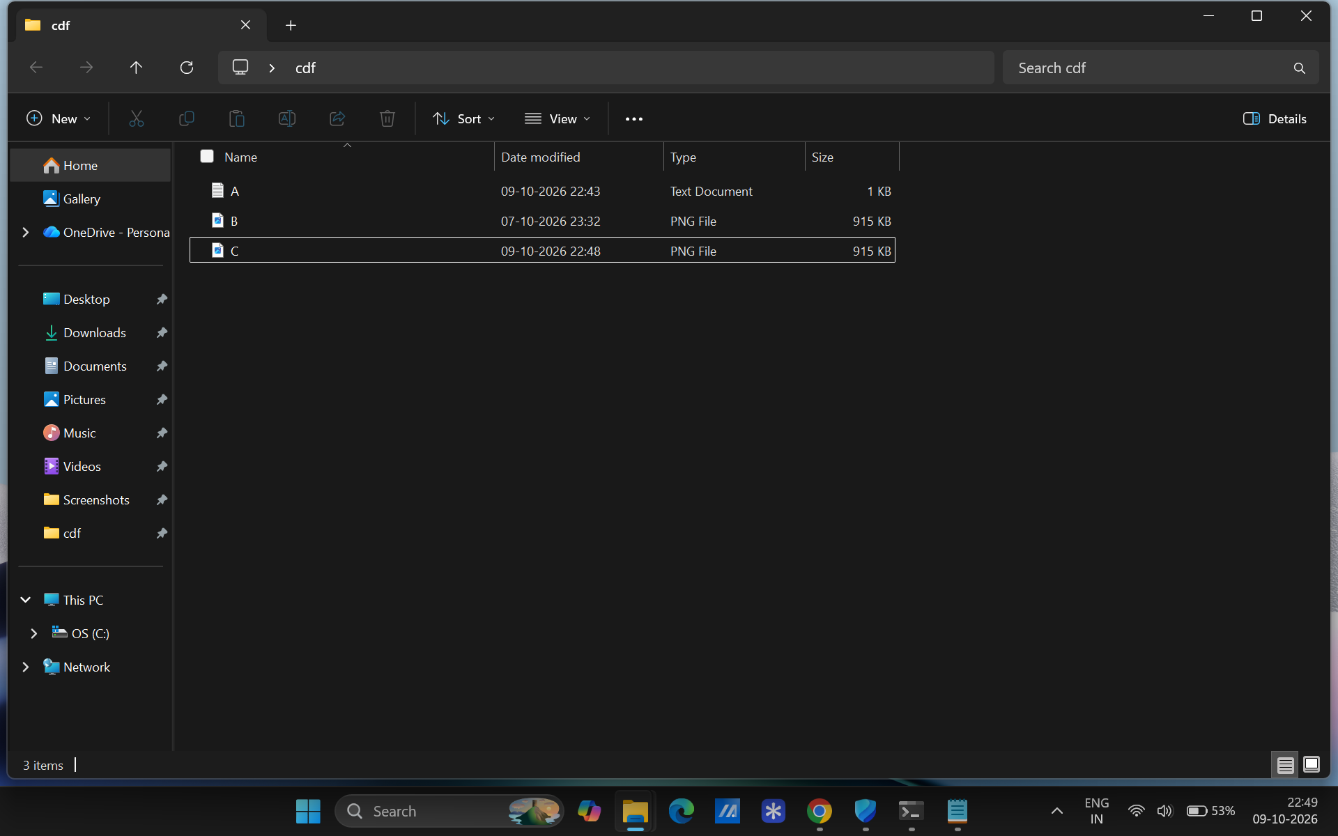
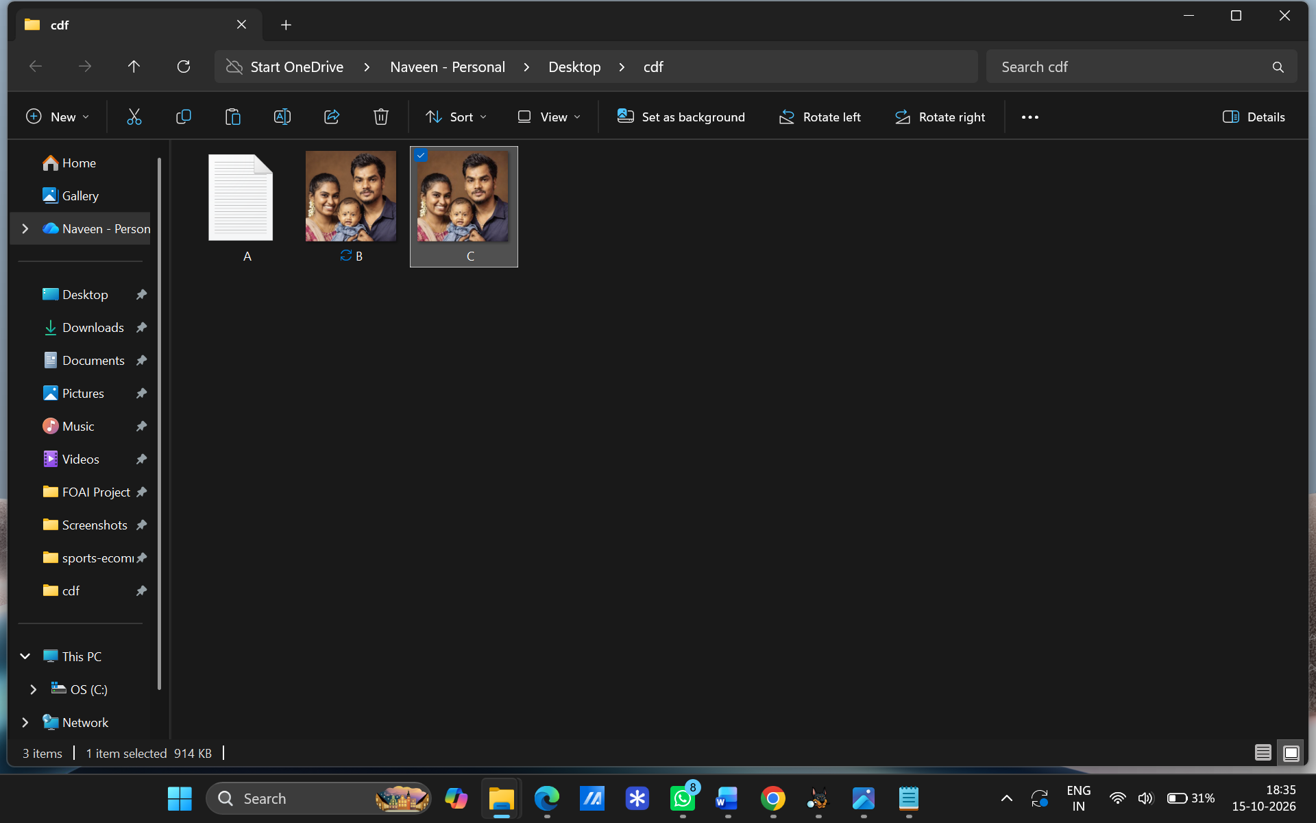
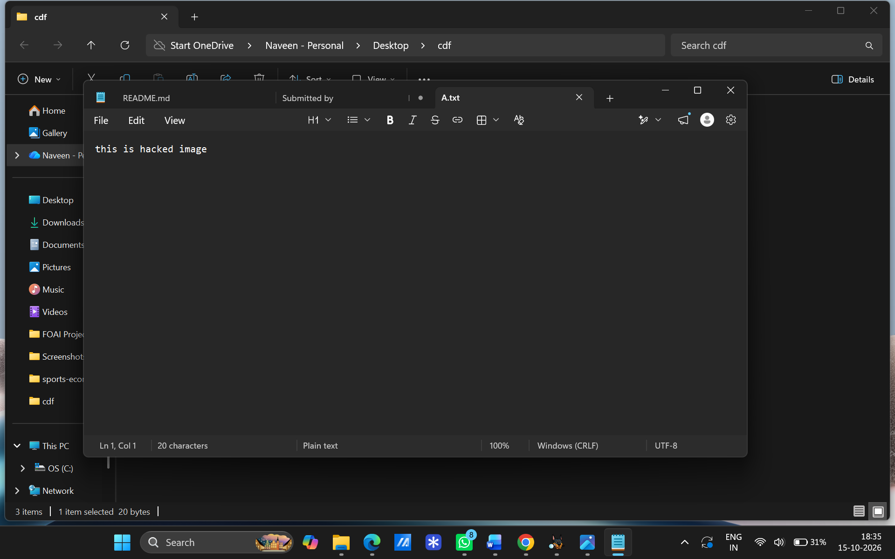

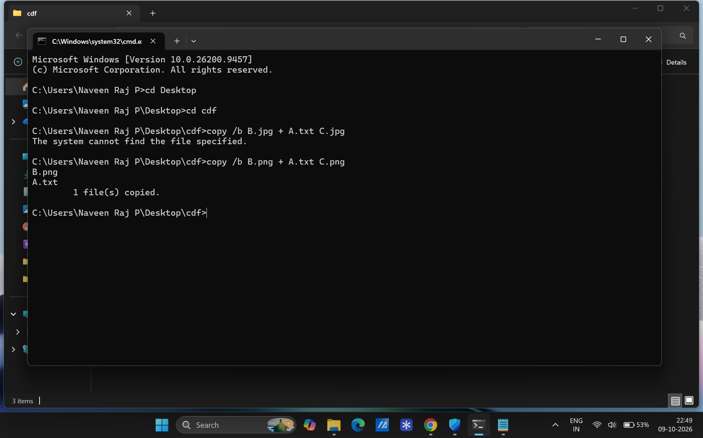
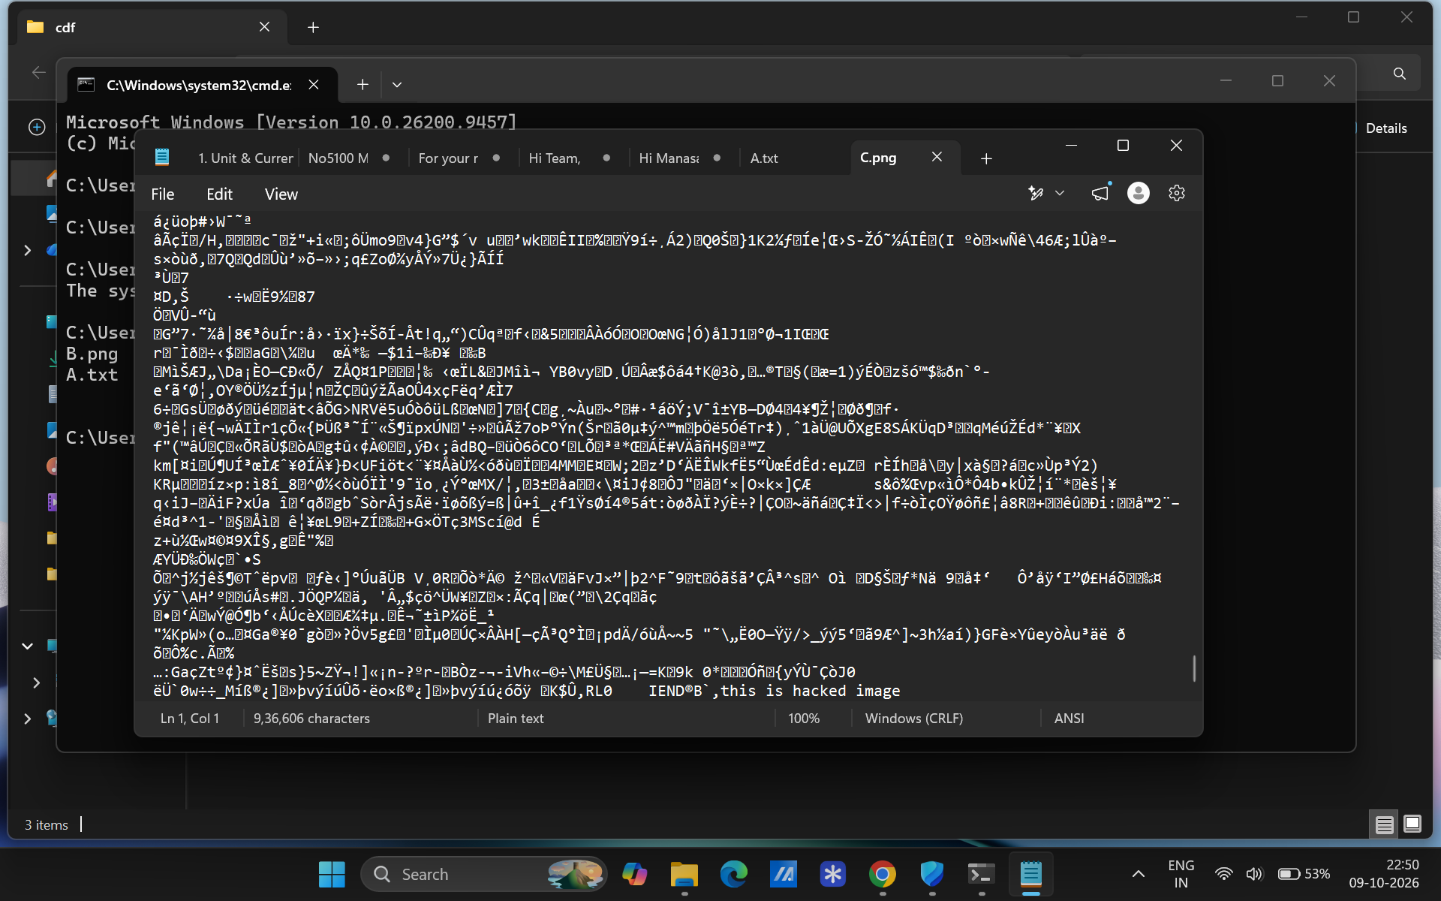

0bservations
Aspect | Findings Observed
Output Image Appearance | Modified image (C.jpg) opens normally in standard image viewers without visual corruption.
File Size Change | The size of C.jpg equals the combined total size of B.jpg and A.txt.
Data Extraction | Opening C.jpg in WinRAR reveals the intact, hidden A.txt file content.

Result
The text file was successfully hidden behind the image file using Command Prompt, and the hidden data was retrieved.
EXPERIMENT 10
Extract Exchangeable Image File Format (EXIF) Data from Image Files using Exifreader Software
Aim
To extract and analyze metadata/EXIF data embedded within digital image files using Exifreader software for forensic investigation.
Software / Tools Required
- Exifreader Software
- Target Digital Image File (JPEG/TIFF image from a camera or smartphone)
Procedure
- Opened the Exifreader application on the investigation host.
- Imported the target digital image file into the software interface.
- Allowed the tool to automatically parse embedded EXIF header tags.
- Reviewed camera settings, device details, timestamps, and geolocation information.

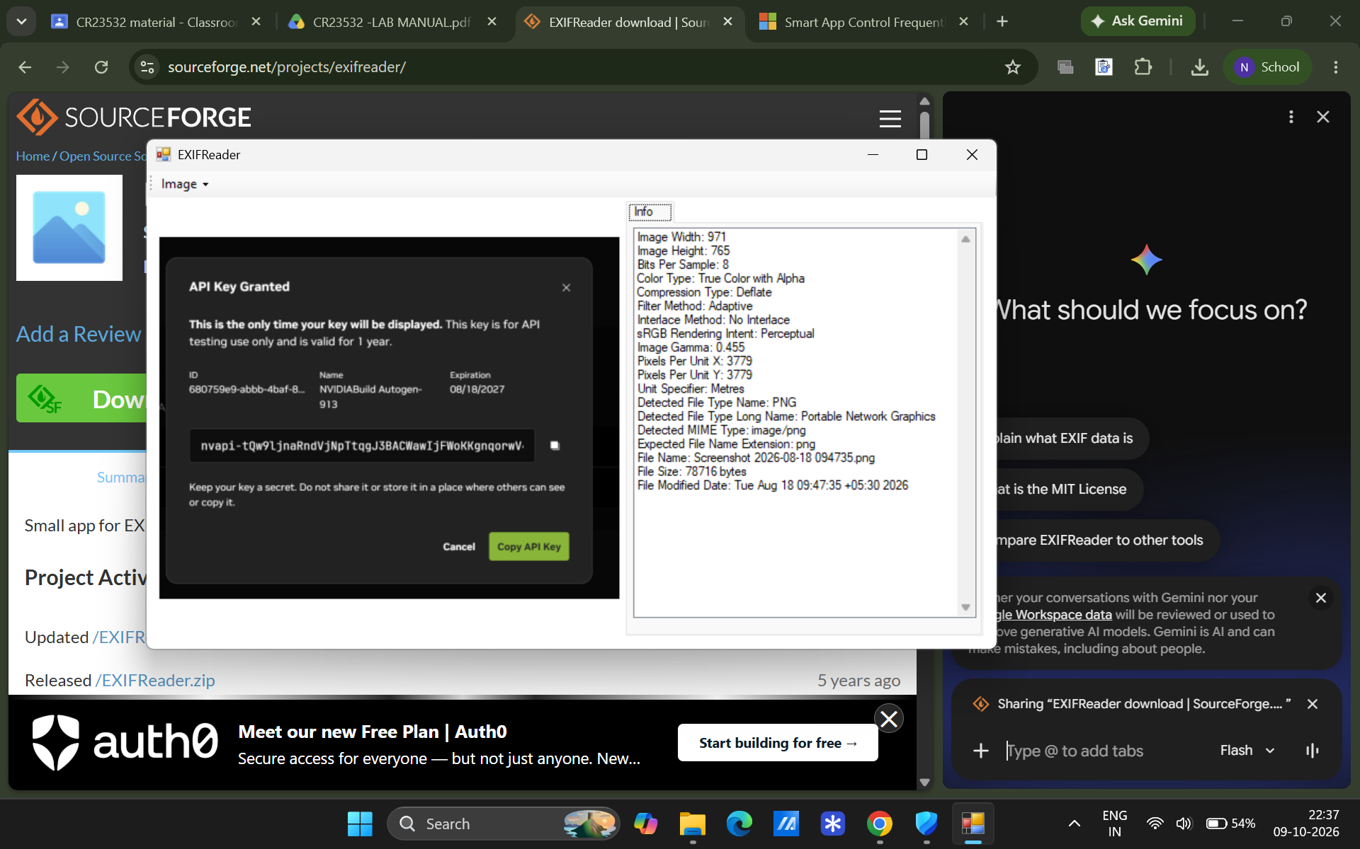
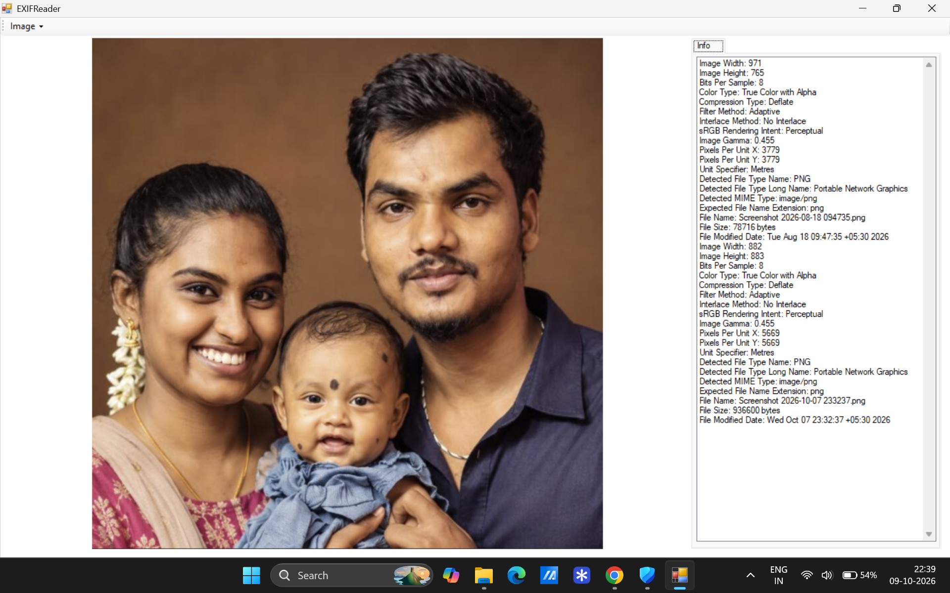
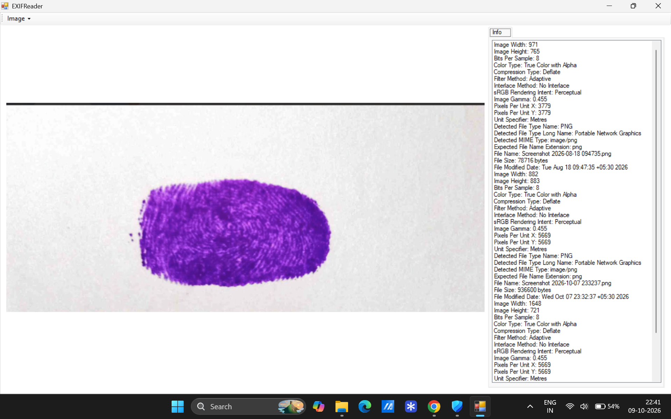

Observations
Metadata Category | Extracted EXIF Artifacts
Device & Hardware Information | Camera make/model, smartphone type, and scanner specifications.
Capture Settings | Shutter speed, aperture, ISO, focal length, flash usage, and resolution details.
Time & Location Data | Exact date/time stamp of image capture and GPS coordinates (if enabled).

Result
EXIF data was successfully extracted from the target image file using Exifreader, providing valuable metadata for linking evidence to a device and timeline.

