Lab 3: Architectural Justification & Diagram
System: Multi-Cloud Asset Cost Optimization Portal

1. Component Diagram
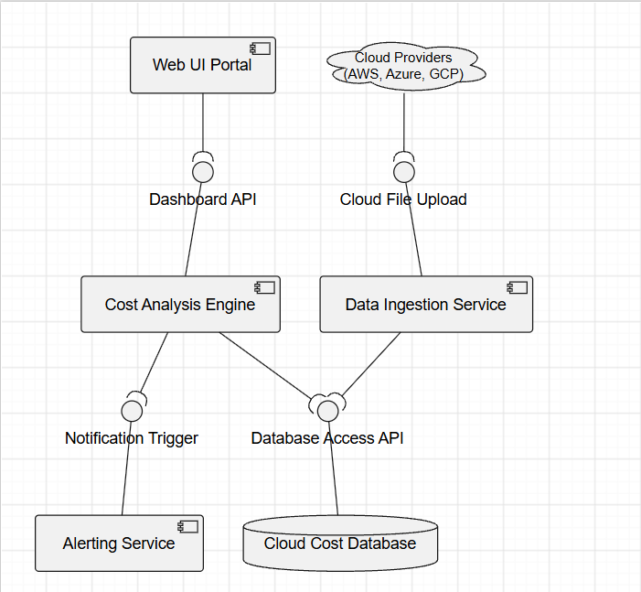

2. Architecture Selection
We chose the Microservices Architecture for the Multi-Cloud Asset Cost Optimization Portal.

3. Justification
Reason 1 (Scalability for Large Data): The portal needs to parse "multi-gigabyte" cloud billing files in under 2 minutes. A microservices architecture allows the Data Ingestion and Analysis components to scale independently to handle massive, concurrent file processing without slowing down the Web UI for end-users.
Reason 2 (Provider Independence): By decoupling services, we can have separate modular services or pipelines for AWS, Azure, and GCP data parsing. If AWS changes its CSV billing format, we only need to update the AWS ingestion microservice without deploying the entire monolithic application.

4. Security Advantage
Microservices allow for strict boundary control and isolation. We can enforce Role-Based Access Control (RBAC) at the API gateway level, ensuring that only Cloud Administrators can access the Budget Configuration service, while isolating sensitive financial data inside a secure, private database component that cannot be accessed directly from the public web interface.

5. Performance Benefit
Because the system is broken into independent services, the heavy computational work (e.g., querying 14-day CPU utilization across thousands of instances) can be offloaded to asynchronous background worker components. This ensures the Web Portal component remains highly responsive (low latency) for FinOps Analysts viewing the dashboard.

