NAVEEN PRASAD M
PES1UG24AM379
AI&ML DEPARTMENT
1 Jira_Backlog_and_Epics
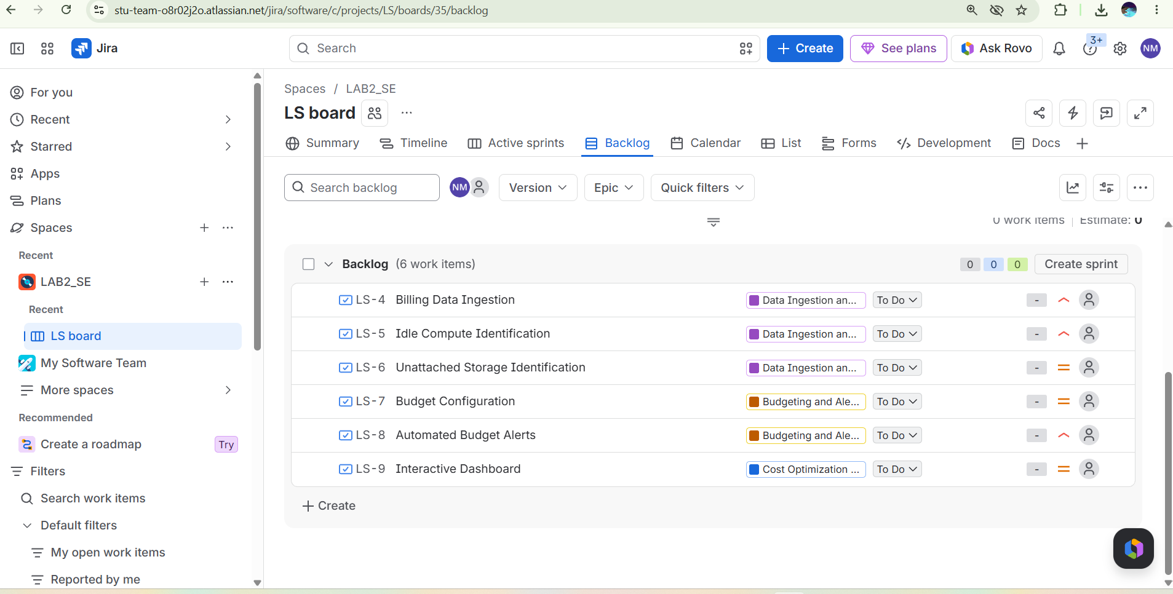

2_Sprint_Burndown_Chart
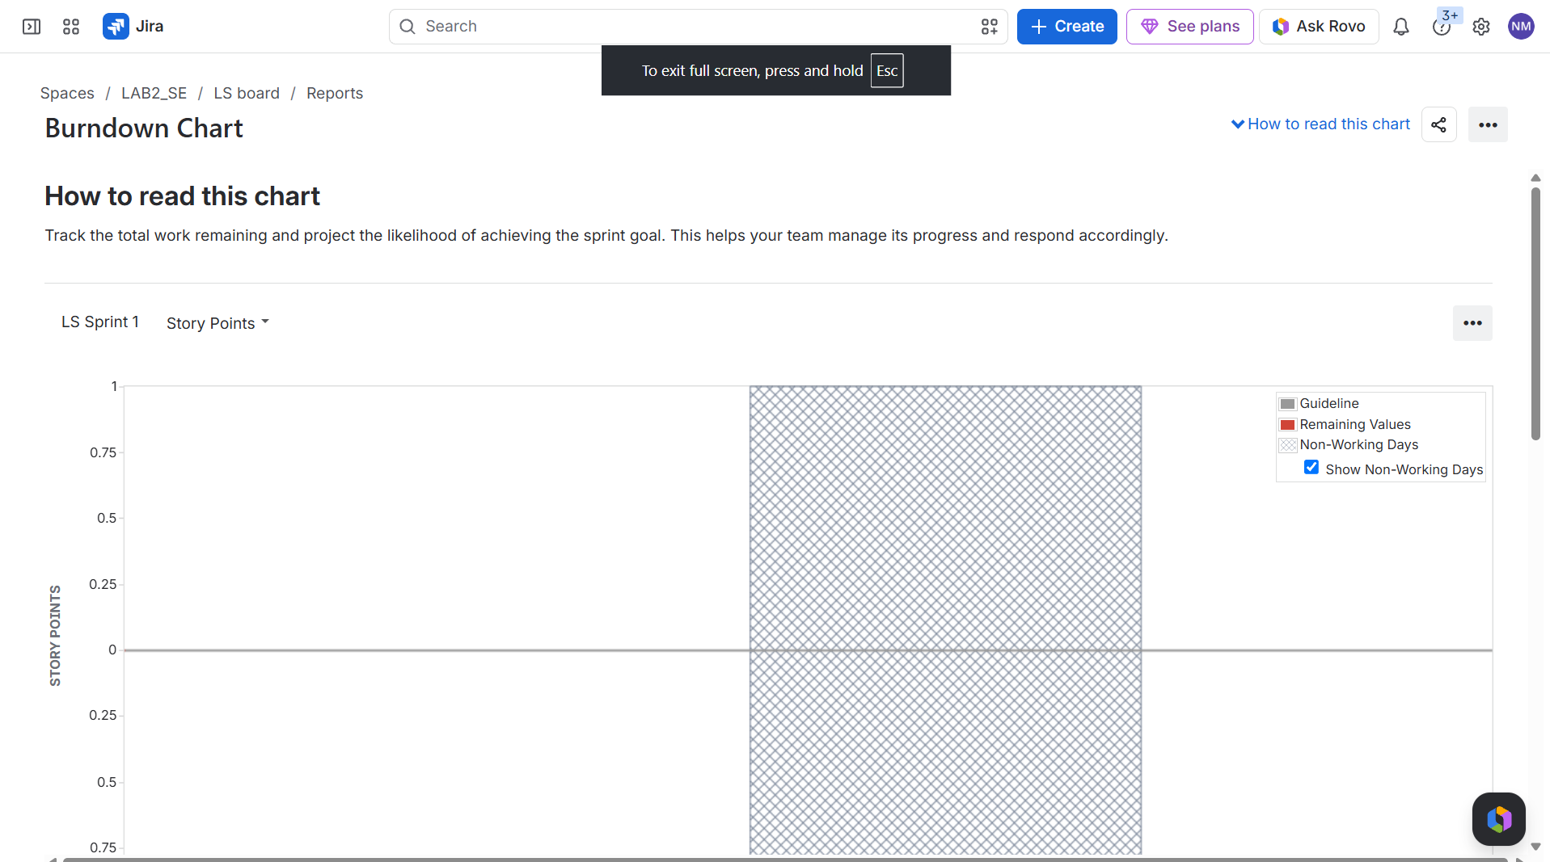

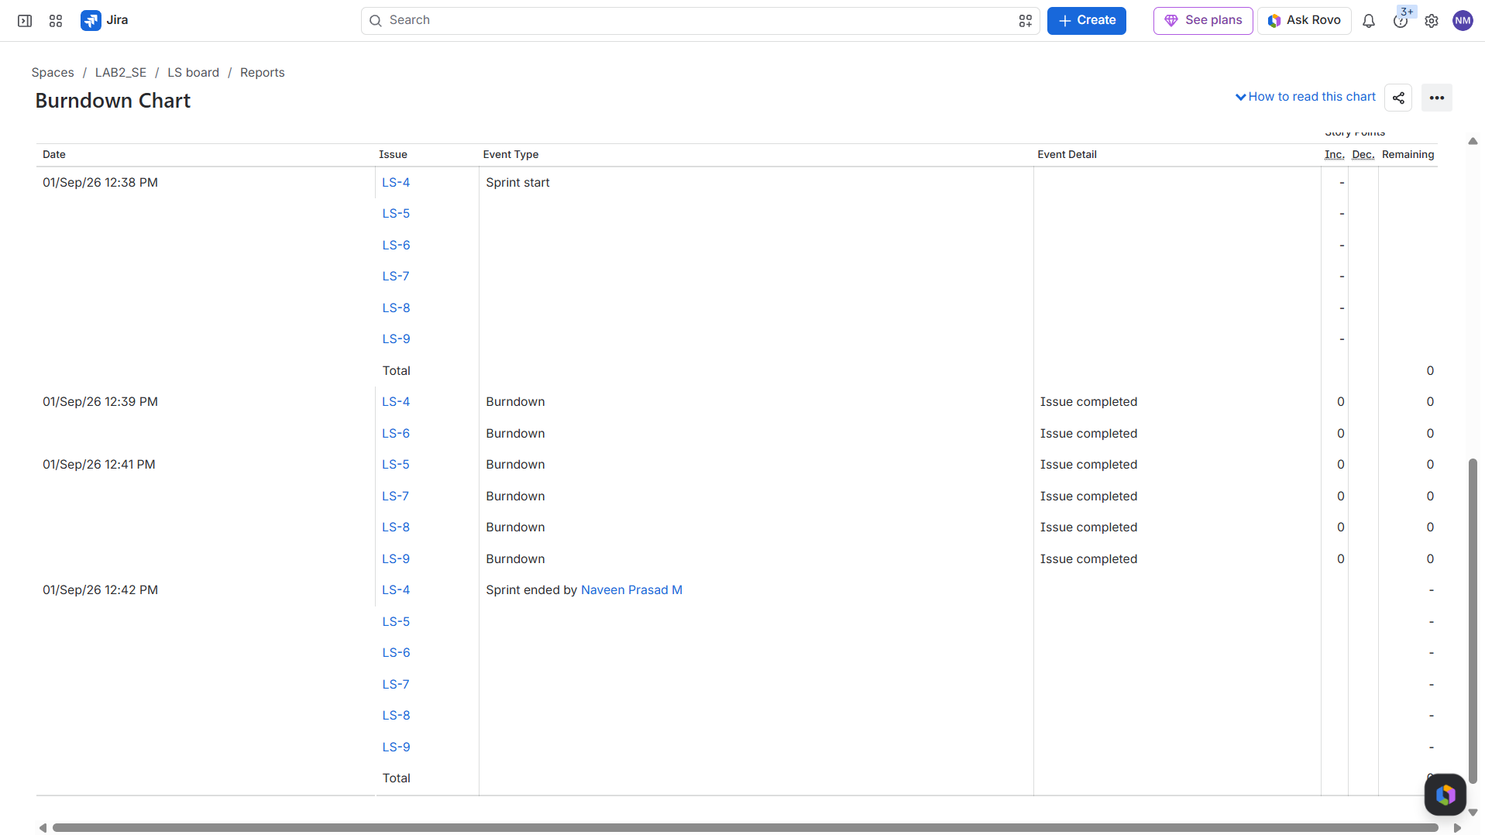

1. Did your estimations reflect the actual effort?
Since this was a simulated sprint, the story points provided a relative measure of complexity rather than exact time tracking. However, assigning an 8 to the interactive dashboard accurately reflected that it was the most complex and time-consuming feature compared to a simple budget configuration .

2. Was your backlog well-prioritized?
Yes, the backlog was prioritized effectively based on business value. The foundational tasks, such as 'Billing Data Ingestion' and 'Automated Budget Alerts' (High priority), were ranked higher than 'Interactive Dashboard' (Medium priority), ensuring that the core data pipelines and critical notifications would be delivered first.

3. How did your simulated sprint align with your plan?
The simulated sprint aligned perfectly with the plan. All 6 user stories committed to the Sprint were successfully moved from 'To Do', through 'In Progress', and into 'Done' without any scope creep or uncompleted issues rolling over.

4. What insights did the burndown chart give about your team’s capacity?
The burndown chart provided a clear visual representation of our velocity. Because all tickets were moved to 'Done' in a short simulation window, the chart showed a steep drop rather than a gradual diagonal line. In a real-world scenario, finishing work this far ahead of the guideline would indicate that the team committed to too little work, suggesting we have the capacity to take on more story points in future sprint planning sessions.

