Software Architecture and Design Specification
Project: Burndown Chart Generator
Version: 1.0
Authors: Team 7: Naveen Prasad M (PES1UG24AM379), Hemanth Reddy (PES1UG24AM390), Bhuvi Sudheendra Katti (PES1UG24AM418)
Date: 13 October 2026
Status: Final

Revision History
Version | Date | Author | Change Summary
1.0 | 13-Oct-2026 | Team 7 | Software Architecture and Design Specification for the Burndown Chart Generator.

Approvals
Role | Name | Signature/Date
Project Lead | Naveen Prasad M
Frontend Lead | Bhuvi Sudheendra Katti
Core Logic Lead | Hemanth Reddy
Course Evaluator

1. Introduction

1.1 Purpose
This document specifies the architecture and design of the Burndown Chart Generator, a web-based Agile/Scrum tool that simulates a Jira-style sprint backlog and shows Ideal vs Actual burndown, schedule variance and sprint KPIs. It translates the requirements of the SRS v1.0 into components, interfaces, data structures and interaction flows.

1.2 Scope
Covers the client-side application: sprint configuration, default dataset load and reset, backlog management (add, update, delete), Ideal and Actual burndown calculation, schedule variance classification, the Chart.js burndown chart with a current-day marker, the KPI dashboard, input validation and security handling. Live Jira / Atlassian Cloud integration, OAuth, cloud persistence, authentication and multi-user collaboration are outside Version 1.

1.3 Audience
Developers, QA engineers, security reviewers, course instructors and evaluators, and future maintainers of the project.

1.4 Definitions
SRS (Software Requirements Specification), SAD (Software Architecture Document), STP (Software Test Plan), RTM (Requirements Traceability Matrix), KPI (Key Performance Indicator), FR / NFR / SR (Functional / Non-Functional / Security Requirement), BDC (Burndown Chart, the requirement ID prefix), DS (Design Specification), XSS (Cross-Site Scripting), CSP (Content Security Policy), STRIDE (Spoofing, Tampering, Repudiation, Information disclosure, Denial of service, Elevation of privilege).

2. Document Overview

2.1 How to use this document
Provides the architectural deliverables for Version 1: UML component and class diagrams, the chosen architecture pattern and rationale, technology stack and data stores, a security architecture (STRIDE), sequence diagrams for the main flows, logical interface definitions, error handling rules and the UX design. Section 3.8 traces every SRS requirement to the component that implements it.

2.2 Related Documents
- Burndown Chart Generator Software Requirements Specification (SRS) v1.0, 28 September 2026
- Burndown Chart Generator Software Test Plan (STP) v1.0
- Requirements Traceability Matrix (SRS section 8 and STP section 13.1)
- SE Mini-Project Deliverables Part 2

3. Architecture

3.1 Goals & Constraints
Goals: calculate burndown values correctly (Appendix A and B of the SRS are the reference); update the chart, KPIs and status within 2 seconds of any valid change (BDC-NF-001); never store or calculate with invalid data (BDC-NF-003, BDC-SR-002); keep UI, data and calculation logic separate and independently testable (BDC-NF-005); run on current Chrome, Firefox and Edge from about 1024 to 1920 px (BDC-NF-004).
Constraints: no live Jira integration (all issue data is simulated locally); no paid third-party services or APIs; local data only (in-memory and optional localStorage), no cloud database; Chart.js is the charting dependency; no authentication in Version 1; the scope must be implementable by a student team within one semester.

3.2 Stakeholders & Concerns
Stakeholder | Concerns
Scrum Master / Project Manager | Accurate schedule status and KPIs; easy sprint configuration and reset
Developer / Team Member | Quick status and completion-day updates; clear chart and backlog
Auditor / Evaluator | Clear dashboard; conformance to the SRS, SAD and STP; traceability
Development team | Modularity and independently testable calculation logic
QA team | Defined interfaces, deterministic calculations, testable validation

3.3 Component (UML) Diagram
The application is a three-layer client-side system (Figure 1). Figure 2 shows the logical classes/modules and their relationships; if the implementation uses plain functions instead of classes, each box is a JavaScript module.
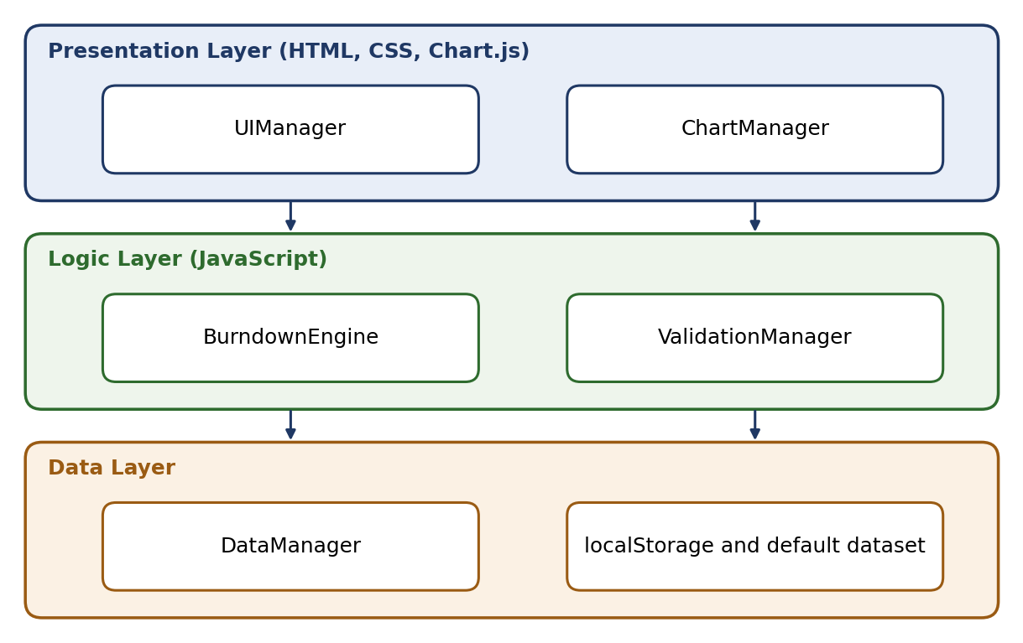
Figure 1: Layered Component Diagram - Burndown Chart Generator
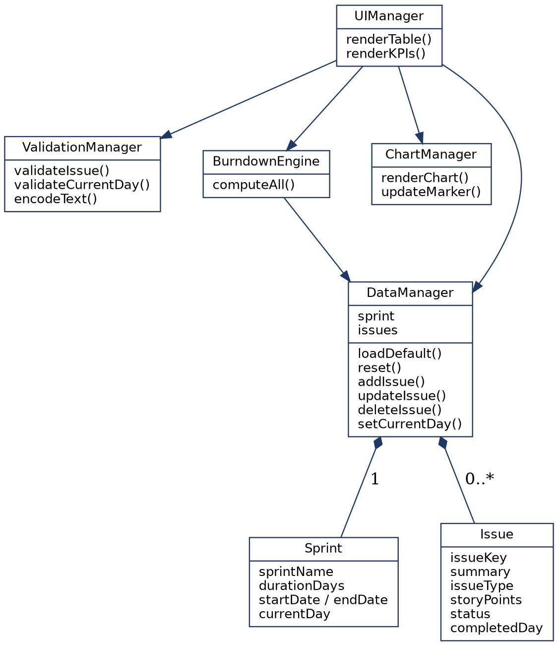
Figure 2: UML Class Diagram - System Modules and Relationships

3.4 Component Descriptions
Component | Responsibility
UIManager | Handles all DOM work: sprint configuration form, KPI cards, backlog table, Add Issue form, edit/status and delete controls, Current Day control, Reset Data control and inline messages. Calls the other modules; contains no calculation logic.
BurndownEngine | Pure calculation functions: total, completed and remaining points; Ideal(d) = TotalPoints x (1 - d / TotalDays); Actual(d) = TotalPoints - sum(points completed on or before d), up to Current Day; variance = IdealRemaining - ActualRemaining; status classification with a +/-1 point tolerance; KPI values. Safe for zero or invalid duration and empty backlog.
ValidationManager | Validates sprint configuration, new issues, status updates, Current Day and stored state; rejects negative, non-numeric, infinite and out-of-range values; encodes user-controlled text before it is inserted into the DOM.
DataManager | Single source of truth for sprint and issue state; loads the default dataset, resets to defaults, adds, updates and deletes issues, sets Current Day, and saves/loads optional localStorage after validating its structure.
ChartManager | Draws the Chart.js line chart (dashed Ideal, solid Actual) and the current-day marker; re-renders when data changes.
Default Dataset | Sprint 1 - Core Features (Duration 10 days, Current Day 4) with issues PROJ-101 to PROJ-110, 50 story points in total (SRS Appendix A).
Browser localStorage | Optional persistence of sprint and backlog data between sessions; never trusted without validation.

3.5 Chosen Architecture Pattern and Rationale
A three-layer client-side architecture (Presentation, Application/Logic, Data) was chosen, as stated in SRS section 2.6. It separates concerns so that calculation and validation logic can be unit tested without a browser DOM, the chart can change without touching the maths, and storage can change without touching the UI (BDC-NF-005). A client-server design, a cloud database and microservices were rejected: the SRS requires local data only, no paid services and a scope a student team can finish in one semester, so a server adds cost and complexity with no benefit.

3.6 Technology Stack & Data Stores
Layer / purpose | Technology
Presentation | HTML5, CSS3, Chart.js (client-side charting library)
Logic | Vanilla JavaScript (ES6+): BurndownEngine, ValidationManager
Data | In-memory state (primary); browser localStorage (optional); default dataset defined in code
Testing | Jest unit tests (tests/ folder); manual browser testing per the STP
Build / CI | GitHub repository, GitHub Projects, GitHub Actions; optional local server (for example npx serve) for development only
Data model (SRS Appendix C):
Entity | Field | Type and description
Sprint | sprintName | String; human-readable sprint name
 | durationDays | Integer > 0; total sprint length in days
 | startDate / endDate | Date; end must follow start
 | currentDay | Integer from 0 to durationDays; selected via the Current Day control
Issue | issueKey | String, unique; Jira-style identifier such as PROJ-101
 | summary | String; short description
 | issueType | Enum: Story, Task, Bug
 | storyPoints | Number >= 0; relative effort estimate
 | status | Enum: To Do, In Progress, Done
 | completedDay | Integer or null; day marked Done, required when status = Done

3.7 Risks & Mitigations
Risk | Mitigation
Chart.js unavailable (CDN offline) | Bundle Chart.js locally with the application
Corrupted or malformed localStorage content | DataManager validates structure before loading and restores the default dataset (BDC-SR-003)
Invalid input corrupts calculations | ValidationManager runs before any value is stored or used; BurndownEngine also guards against zero and invalid values (BDC-SR-002, BDC-SR-004)
Division by zero, NaN or Infinity with empty backlog, zero points or zero duration | Safe calculation functions return defined values (BDC-SR-004)
Script injection through issue summary, key or sprint name | Encode all user text before DOM insertion (BDC-SR-001)
CSP cannot be applied on static-file deployments | Apply CSP when server-hosted; document its absence otherwise (BDC-SR-005)
Browser or screen-size differences | Test on Chrome, Firefox and Edge at 1024 to 1920 px (BDC-NF-004)
Short one-week sprints cause late integration | Fix module interfaces in this document (Sections 3.4 and 4.3) so team members can build in parallel

3.8 Traceability to Requirements
Every SRS requirement is allocated to one or more components:
Req. ID | Requirement | Design Spec | Component(s)
BDC-F-001 | Configure sprint | DS-Sprint-01 | UIManager, ValidationManager
BDC-F-002 | Total Committed Story Points | DS-Burndown-01 | BurndownEngine, DataManager
BDC-F-003 | Current Day control | DS-UI-05 | UIManager, BurndownEngine
BDC-F-004 | Load default dataset | DS-Data-01 | DataManager
BDC-F-005 | Display backlog table | DS-UI-01 | UIManager
BDC-F-006 | Add issue | DS-UI-02 | UIManager, ValidationManager, DataManager
BDC-F-007 | Update issue status / completion day | DS-UI-03 | UIManager, ValidationManager, BurndownEngine
BDC-F-008 | Delete issue | DS-UI-04 | UIManager, DataManager, BurndownEngine
BDC-F-009 | Reset Data | DS-Data-02 | DataManager
BDC-F-010 | Ideal burndown | DS-Burndown-02 | BurndownEngine
BDC-F-011 | Actual burndown | DS-Burndown-03 | BurndownEngine
BDC-F-012 | Schedule variance and status | DS-Burndown-04 | BurndownEngine
BDC-F-013 | Burndown line chart | DS-Chart-01 | ChartManager
BDC-F-014 | Current-day marker | DS-Chart-02 | ChartManager
BDC-F-015 | KPI dashboard | DS-UI-06 | UIManager, BurndownEngine
BDC-NF-001 | Update within 2 seconds | DS-Perf-01 | BurndownEngine, ChartManager
BDC-NF-002 | Usability | DS-UX-01 | UIManager
BDC-NF-003 | Reject invalid data | DS-Val-01 | ValidationManager
BDC-NF-004 | Browser and resolution compatibility | DS-UX-02 | UIManager
BDC-NF-005 | Modular code | DS-Arch-01 | All modules
BDC-SR-001 | Safe encoding of user text (XSS) | DS-Sec-01 | UIManager, ValidationManager
BDC-SR-002 | Numeric validation | DS-Val-02 | ValidationManager
BDC-SR-003 | Safe localStorage handling | DS-Data-03 | DataManager
BDC-SR-004 | Safe edge-case handling | DS-Burndown-05 | BurndownEngine, ValidationManager
BDC-SR-005 | Content Security Policy | DS-Deploy-01 | DataManager, deployment configuration

3.9 Security Architecture
Security objectives (SRS 5.1.1): SO-01 Client Input Sanitization and SO-02 State Integrity and Bounds Enforcement. Threat modelling (STRIDE) for a client-side application with no network communication and no authentication:
Threat | Scenario in this system | Mitigation
Spoofing | No user accounts or authentication in Version 1; single user per session | Not applicable in Version 1; authentication is future work
Tampering | Edited localStorage content or out-of-range values corrupt calculations | Validate stored structure and restore defaults (BDC-SR-003); validate every numeric value (BDC-SR-002, BDC-NF-003)
Repudiation | No accounts or audit trail needed in Version 1 | Not applicable in Version 1
Information disclosure | Technical details shown in error messages; no sensitive data and no network calls exist | Generic user-friendly error messages; no stack traces shown to users
Denial of service | Empty backlog, zero points or zero duration crash or freeze the page | Safe edge-case handling with no NaN, Infinity or crashes (BDC-SR-004)
Elevation of privilege | HTML or script injected through summary, key or sprint name executes in the page | Encode user text before DOM insertion (BDC-SR-001); CSP in server-hosted deployments and no eval (BDC-SR-005)

4. Design

4.1 Design Overview
The design uses one flow for every user action, which keeps results consistent and updates fast (BDC-NF-001): validate the input, store it through DataManager, recalculate with BurndownEngine, then re-render the chart, KPI cards and backlog table. DataManager is the single source of truth; BurndownEngine functions are pure; ChartManager only draws; the UI layer (chart.js, dashboard.js, and related components) only handles the DOM.
Calculation rules (BurndownEngine):
Quantity | Definition
Total Committed Story Points | Sum of the story points of all issues (default dataset: 50)
Completed Story Points | Sum of points of issues with status Done and completedDay <= Current Day (default dataset on Day 4: 29)
Remaining Story Points | Total - Completed (default dataset on Day 4: 21)
Ideal(d) | TotalPoints x (1 - d / TotalDays); Ideal(0) = Total and Ideal(TotalDays) = 0; Ideal(4) = 30 for the default dataset
Actual(d) | TotalPoints - sum(points completed on or before d); plotted only up to Current Day; Actual(4) = 21
Variance | IdealRemaining - ActualRemaining on Current Day (default dataset: 30 - 21 = +9)
Schedule status | Variance > +1: Ahead of Schedule; -1 to +1: On Track; Variance < -1: Behind Schedule
Days Elapsed / Days Left | Current Day / durationDays - Current Day (default dataset: 4 and 6)
Issue status transitions (Figure 3): To Do to In Progress to Done, or To Do directly to Done. A transition into Done requires a valid completion day (BDC-F-007); moving out of Done clears the recorded completion day.
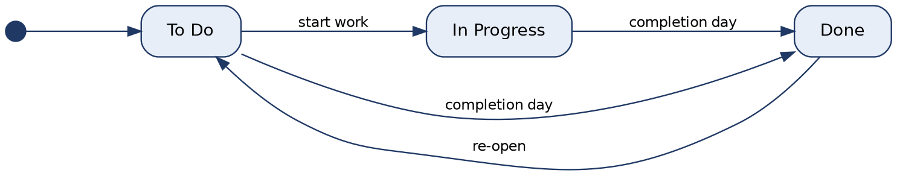
Figure 3: State Diagram - Issue Status Transitions

4.2 UML Sequence Diagrams
Two main flows are shown: adding an issue and changing the Current Day. Read each diagram from top to bottom. Dashed arrows are return values. Updating an issue to Done follows the same pattern as adding an issue, with the status-update validation of BDC-F-007.
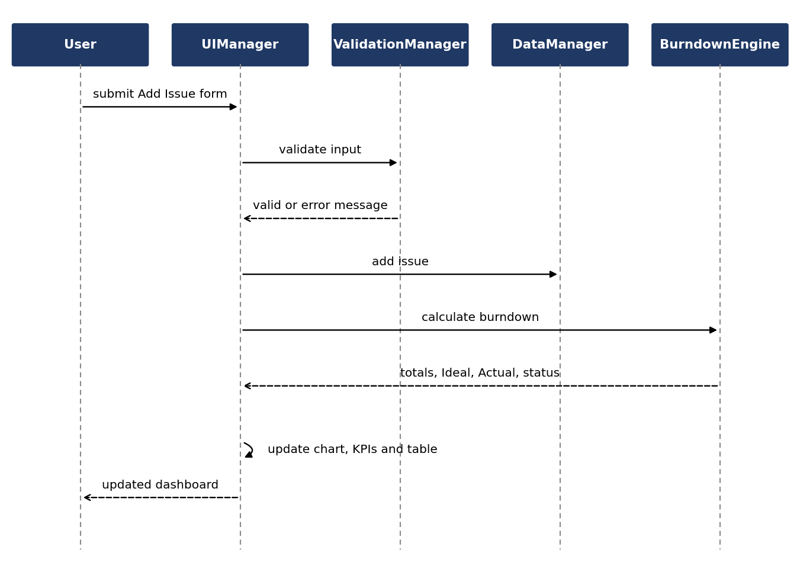
Figure 4: Sequence Diagram - Adding a New Issue (BDC-F-006)
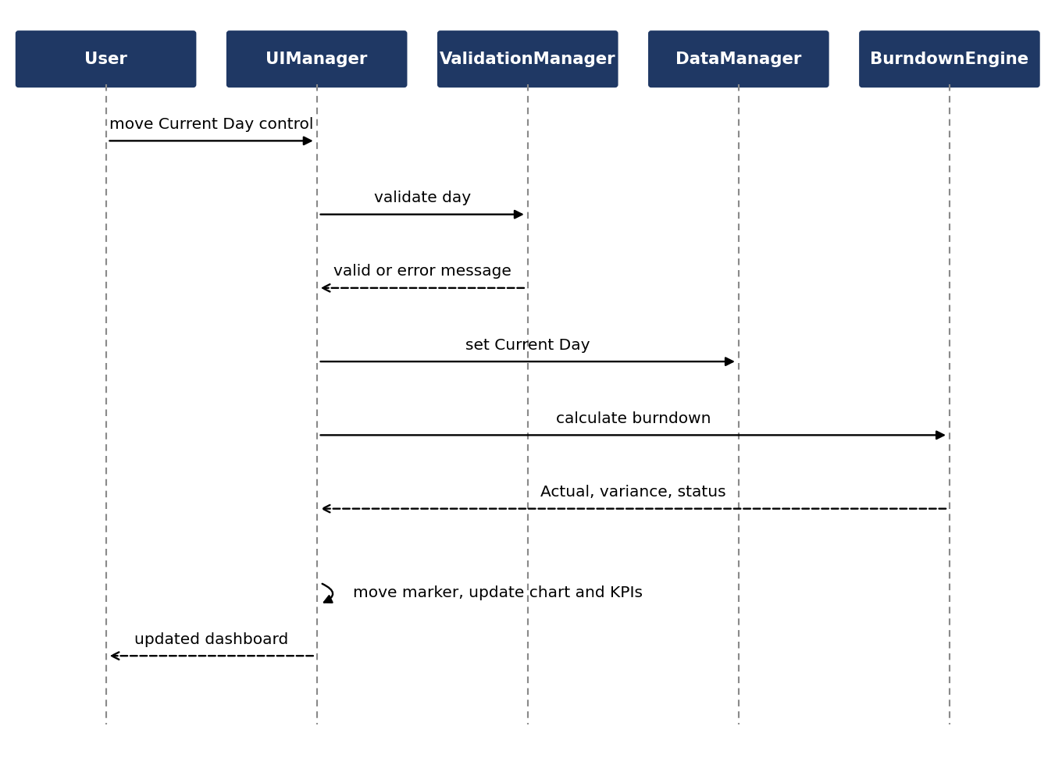
Figure 5: Sequence Diagram - Changing the Current Day (BDC-F-003, BDC-F-014)

4.3 API Design
The interfaces below are logical definitions (SRS 3.5). In the client-side version they are implemented as direct function calls, not network endpoints, so the status codes are logical error categories.
Interface 1: BurndownEngine
Item | Definition
Endpoint | GET /api/sprint/burndown (logical)
Call | BurndownEngine.computeAll(sprint, issues)
Request | {sprint: {durationDays, currentDay}, issues: [{issueKey, storyPoints, status, completedDay}]}
Response | {totalPoints, completedPoints, remainingPoints, daysElapsed, daysLeft, ideal: [{day, value}], actual: [{day, value}], variance, status}  status is "Ahead of Schedule", "On Track" or "Behind Schedule"
Errors | No exception for empty backlog, zero points or invalid duration; returns defined values (no NaN or Infinity)

Interface 2: DataManager (issues)
Endpoint (logical) | Call | Request | Response / errors
POST /api/sprint/issues | DataManager.addIssue(issue) | {issueKey, summary, issueType, storyPoints, status, completedDay?} | {success, issue}  400 empty or duplicate key, empty summary, negative or non-numeric points
POST /api/sprint/issues/{key}/status | DataManager.updateIssue(key, status, completedDay) | {status, completedDay} | {success, issue}  400 completion day missing or out of range  404 issue not found
DELETE /api/sprint/issues/{key} | DataManager.deleteIssue(key) | issueKey | {success}  404 issue not found

Other module interfaces:
Module | Functions
ValidationManager | validateSprint(config), validateIssue(fields, existingKeys), validateStatusUpdate(status, completedDay, currentDay, durationDays), validateCurrentDay(day, durationDays), validateStoredState(obj), encodeText(text). Each returns {valid, errors[]} (encodeText returns the encoded string).
DataManager (state) | loadDefault(), reset(), load(), save(), getSprint(), setSprint(config), setCurrentDay(day)
ChartManager | renderChart(series, currentDay), updateMarker(currentDay)
UIManager | init(), renderTable(), renderKPIs(), showMessage(text, type), and handlers for add, update, delete, Current Day change and reset

4.4 Error Handling, Logging & Monitoring
Errors are shown as clear inline messages next to the control concerned; invalid values are never stored. Unexpected errors show a generic, user-friendly message and never a stack trace.
Condition | System behaviour
Negative or non-numeric story points | Reject; show validation message; do not save
Completion day greater than Current Day or Sprint Duration | Reject the update; show validation message
Empty or duplicate issue key | Reject the input; show validation message
Empty summary | Reject the input; show validation message
Invalid JSON found in localStorage | Discard corrupted data; restore the default dataset
Zero story points on an issue | Allow; handled safely in all calculations
Invalid sprint duration (zero, negative, non-numeric) | Reject the configuration; keep the previous valid configuration
Unexpected application error | Show a generic, user-friendly message; no stack traces
Logging: the application keeps no server logs. Developer diagnostics go only to the browser console and contain no sensitive data.
Monitoring: quality is monitored through the Node.js native test runner (node --test) results in GitHub Actions, defects logged as GitHub Issues, and DevTools timing checks against the 2-second target (BDC-NF-001).

4.5 UX Design
The UI is a single-page dashboard (SRS 3.1) containing the header, sprint configuration form, KPI cards, burndown chart, Current Day control, backlog table, Add Issue form, edit/status controls, delete control, Reset Data control and inline validation messages (Figure 6).
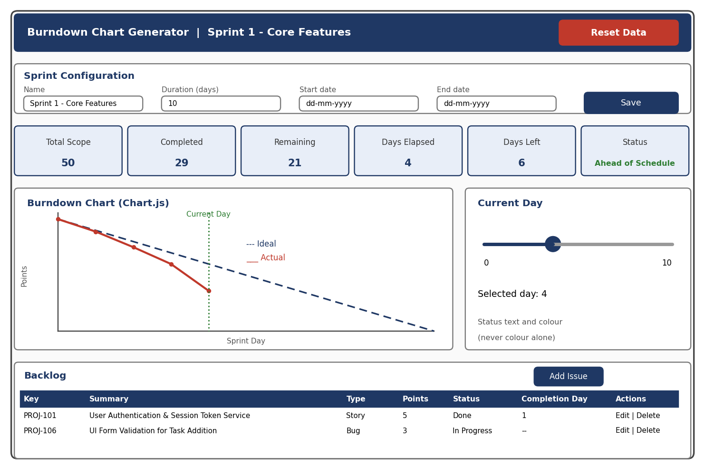
Figure 6: Dashboard Wireframe (default dataset on Day 4)
- Chart: dashed Ideal line, solid Actual line, labelled axes and legend, and a prominent current-day marker that moves without a page reload
- Accessibility (BDC-NF-002): clear labels, keyboard tab order reaching all primary controls, and schedule status shown by text and colour, never colour alone
- Responsive layout usable from about 1024 px to 1920 px width (BDC-NF-004)
- Feedback: invalid input shows an inline message and the previous valid state is kept

4.6 Open Issues & Next Steps
Open issues:
- The default Sprint 1 dataset in SRS Appendix A gives no start and end dates; the team must choose them and record this as a documented deviation
- localStorage persistence is optional in the SRS; the team must decide whether to implement it (BDC-SR-003 applies only if it is)
- Whether CSP can be applied depends on the deployment method (BDC-SR-005); document the outcome
Next steps:
- Sprint 1 (19-23 October 2026): build the core working product and record the 1-minute demo video
- Sprint 2 (26-30 October 2026): remaining features, validation and security hardening, documentation, 2-minute demo video, then freeze development
- Future work, outside Version 1 (SRS 2.7): real Jira API integration and OAuth, cloud persistence, team authentication, velocity analytics, historical sprint comparison, notifications and advanced reporting/export

5. Appendices

5.1 Glossary
Term | Meaning
Sprint | Fixed-length, time-boxed iteration in which a team completes committed backlog items
Story Point | Relative estimate of the effort of a backlog item
Backlog | List of issues planned for the sprint
Ideal Burndown | Straight line from total points on day 0 to zero on the last day
Actual Burndown | Remaining points per day based on issues completed up to the Current Day
Variance | IdealRemaining minus ActualRemaining on the Current Day
KPI | Key Performance Indicator shown on the dashboard
Jira | Issue-tracking tool; simulated locally in this project, not connected
XSS / CSP | Cross-Site Scripting / Content Security Policy
STRIDE | Threat classification model used in Section 3.9

5.2 References
- Burndown Chart Generator SRS v1.0 and STP v1.0
- SE Mini-Project Deliverables Part 2
- IEEE 42010 Systems and software engineering: Architecture description
- OWASP Cross Site Scripting Prevention Cheat Sheet
- Chart.js documentation

5.3 Tools
- Diagrams: Graphviz (class, layered and state diagrams), Matplotlib (sequence diagrams and wireframe)
- Development and testing: Chart.js, Node.js native test runner (node --test), browser DevTools
- Project management and CI: GitHub repository, GitHub Projects, GitHub Issues, GitHub Actions

