**On Your Own Assignment 2**

**Submit this as a source code file on Canvas. For some reason, animation causes webhost to update its hit counter excessively, which can cause them to suspend your account.**

Overview: You are going to make a zombie rush game. The game itself is played on a canvas of slightly larger than 1000 x 800 pixels. The player starts in the middle of the left side of the screen in a rectangular field of 1000 x 800 pixels.

Unless otherwise stated, each animation frame plays for 40 microseconds.

All animation sprites (zombies and the player) are 80 pixels high.

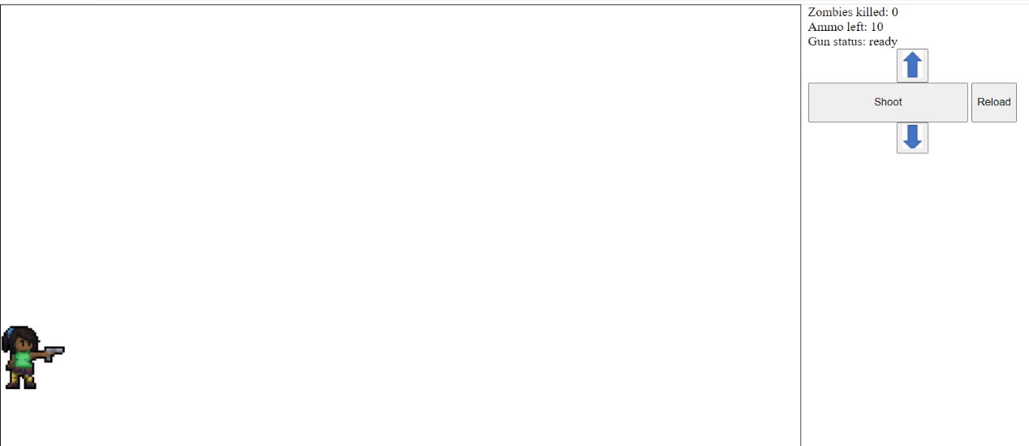

To the right of the game screen are three statistics, Zombies killed, Ammo left and the gun status. Non keyboard controls are also to the right of the game screen.

When nothing else is happening, the player assumes the gun ready position as pictured.

Hitting either the up arrow button or the up or left arrow keys causes the player to move up the screen 80 pixels. This is rendered with an animation of the player walking up and then resuming the gun ready position.

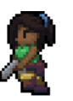

Hitting either the down arrow button or the down or right arrow keys causes the player to move down the screen 80 pixels. This is rendered with an animation of the player walking up and then resuming the gun ready position.

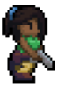

Hitting the shoot button or the space bar causes the player to fire the gun. This causes a gunshot sound to be heard and a gun shooting animation to play.

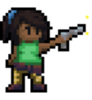

The player’s gun cannot fire continuously. After every shot, there is a cooldown period of 1 second. The player’s gun has 10 bullets. Once all 10 are fired, or the player hits the reload button or the ‘r’ key, the player must reload. Reloading takes 3 seconds, and restores 10 bullets to the player. Reloading and cooldown are not cumulative. The longest the player ever has to wait is 3 seconds.

The state of the gun is presented to the player. There are three possible states- ready, which means the player can fire the gun, cooldown where the player needs to wait 1 second and reloading where the player has to wait 3 seconds.

If a zombie is in a straight line to the right of the player (at any distance) when the player fires, the zombie is killed. This causes a zombie death animation to play, and the player’s zombies killed statistic is incremented by 1. The corpse of the zombie should remain on the field.

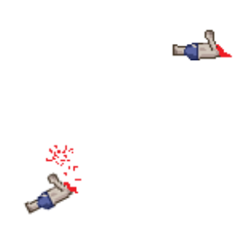

Zombies are generated on the righthand side of the screen. Zombies can be generated in one of 10 lanes spaced every 80 pixels vertically. Each zombie is generated in a random lane. The zombie then begins marching horizontally towards the player.

Zombies move slowly. Each zombie walk frame is rendered every 200 microseconds. The zombie moves 10 pixels to the left every 200 microseconds.

If a zombie reaches 80 pixels to the left of the screen, the game is over. A sound of zombies attacking the player is played, a player death animation plays, and then all animations are cancelled.

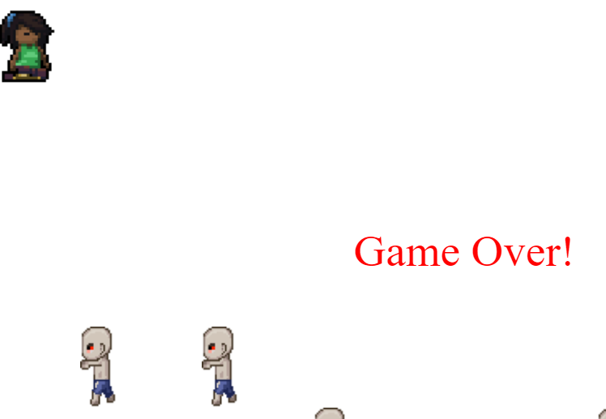

The game over sign is red and begins at coordinates 350 to the left, 380 from the top. The font of the sign increases from 10 pixels to 44 pixels. At 44 pixels, it stops growing.

Zombies are spawned according to the following schedule:

* The first zombie is spawned 1 second after the game starts
* Succeeding zombies are spawned 100 microseconds faster (i.e., the second zombie spawns at 900 microseconds) until a zombie spawns every 700 microseconds.
* At 700 microseconds, zombies are spawned 50 microseconds faster (i.e., the next zombie spawns at 650 microseconds). This occurs until a zombie is spawned every half a second.
* At half a second, zombies are spawned 25 microseconds faster. This occurs until a zombie is spawned at 250 microseconds.
* At 250 microseconds, zombies are spawned 10 microseconds faster. This occurs until a zombie is spawned at 150 microseconds.
* At 150 microseconds, zombies are spawned 1 second faster. This occurs until a zombie is spawned every 100 microseconds. Zombies are never spawned faster than every 100 microseconds.

Scoring (20 marks total):

2 points: Player spawns in the middle of the left of the screen in the gun ready position.

2 points: Moving up works correctly both using the keyboard and the mouse/touchpad. The correct animation plays.

2 points: Moving down works correctly both using the keyboard and the mouse/touchpad. The correct animation plays.

2 points: Firing the gun when the gun is ready produces the correct animation and sound

2 points: Cooldown and reloading work correctly. Nothing happens when the gun is fired during cooldown/reloading

2 points: One and only one zombie is killed if the gun is fired in the correct lane. The zombie death animation plays and the score is incremented. The corpse remains behind.

2 points: Game difficulty is correctly set based on the rules above.

2 points: Reloading works correctly.

2 points: When a zombie reaches the appropriate point, the death and game over animations play. All animations then stop.

2 points: Unexpected things do not happen