Alliance School of Advanced Computing

Course Name: Graph Analytics
Course Code: EITC 302
Assignment No: 1

Name of the Student: NAVYA S

Registration Number: 2411021060373

A. Title of The Problem:
Find Directly Connected Vertices
B. Problem Statement in details:
Write a program that identifies all direct neighbours of a selected vertex in an undirected graph. The program should:
- Accept an undirected graph from the user.
- Store the graph using an adjacency list.
- Ask the user to select a vertex.
- Display all vertices directly connected to it.
- Display the number of direct connections.
C. HackerRank/Leetcode Link of the problem (If applicable):
Not applicable — this is a custom graph theory assignment problem.
D. Student's Github link of report and code upload, along with the readme file:
GitHub Link: github.com/NAVYAS367/Navya_373
E. Solution Steps/Algorithm:
- Step 1: Start.
- Step 2: Read the number of vertices and their names from the user.
- Step 3: Initialize an empty adjacency list (dictionary of lists), one entry per vertex.
- Step 4: Read the number of edges. For each edge (u, v), add v to the adjacency list of u and add u to the adjacency list of v, since the graph is undirected.
- Step 5: Display the complete adjacency list representation of the graph.
- Step 6: Ask the user to select a vertex to inspect.
- Step 7: If the selected vertex exists, retrieve its adjacency list — this gives all directly connected (neighbouring) vertices.
- Step 8: Display the list of directly connected vertices and their count (the length of the adjacency list).
- Step 9: Stop.
F. Code developed:
# Program to find all directly connected vertices (neighbours) of a
# selected vertex in an undirected graph using an Adjacency List.

def build_graph():
"""Accepts an undirected graph from the user and stores it as an
adjacency list using a dictionary of lists."""
graph = {}

n = int(input("Enter the number of vertices: "))
print("Enter vertex names (e.g., A, B, C ...):")
for _ in range(n):
v = input("Vertex: ").strip()
if v not in graph:
graph[v] = []

e = int(input("\nEnter the number of edges: "))
print("Enter each edge as: vertex1 vertex2")
for _ in range(e):
u, v = input("Edge: ").split()
u, v = u.strip(), v.strip()

# Since the graph is undirected, add the connection on both sides
if v not in graph[u]:
graph[u].append(v)
if u not in graph[v]:
graph[v].append(u)

return graph

def show_direct_neighbours(graph, vertex):
"""Displays all vertices directly connected to the given vertex
and the total number of such direct connections."""
if vertex not in graph:
print(f"\nVertex '{vertex}' does not exist in the graph.")
return

neighbours = graph[vertex]
print(f"\nVertices directly connected to '{vertex}': {neighbours}")
print(f"Number of direct connections: {len(neighbours)}")

def main():
print("---- Build the Undirected Graph ----")
graph = build_graph()

print("\nAdjacency List Representation:")
for vertex, neighbours in graph.items():
print(f"{vertex} -> {neighbours}")

selected = input("\nEnter the vertex to inspect: ").strip()
show_direct_neighbours(graph, selected)

if __name__ == "__main__":
main()

G. HackerRank test case passed Screenshot or Output screenshot (Mandatory):
Sample run for the graph with edges: A-B, A-C, B-D, C-D, D-E, and vertex 'D' selected for inspection.
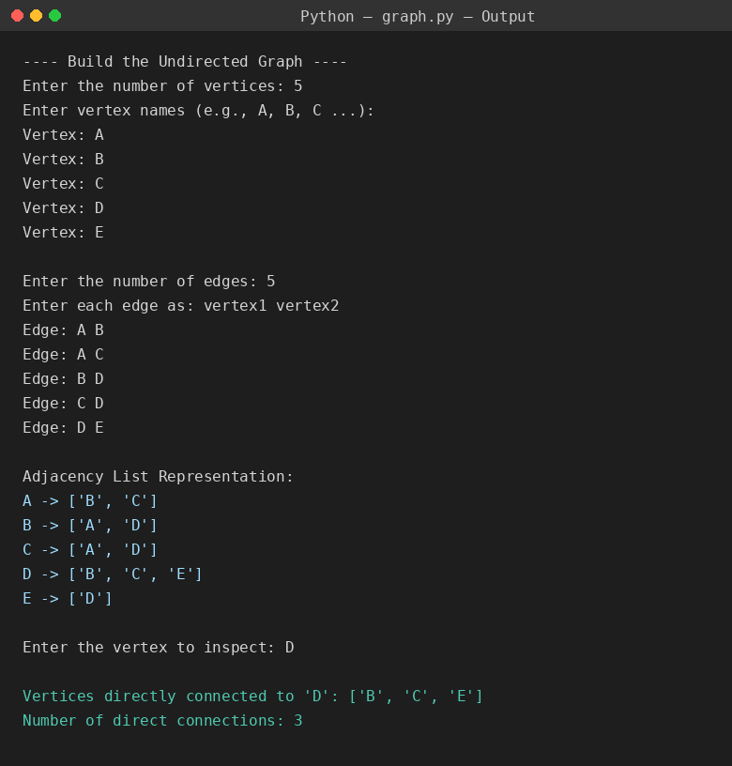
H. Observation:
The program was executed successfully. Storing the graph as an adjacency list made it possible to retrieve the direct neighbours of any vertex in O(1) time (a simple dictionary lookup), instead of scanning every edge. For the sample graph, selecting vertex D correctly returned its three direct neighbours — B, C, and E — confirming that the undirected edges were stored symmetrically on both endpoints during graph construction.

