**Creating Microservices for account and loan**   
  
**SOLUTION (Account):**

**ApplicationController.java:**

**package** com.example.account.controller;

**import** org.springframework.web.bind.annotation.*;

**import** java.util.Map;

@RestController

@RequestMapping("/accounts")

**public** **class** ApplicationController {

@GetMapping("/{number}")

**public** Map<String, Object> getAccountDetails(@PathVariable String number) {

**return** Map.*of*(

"number", number,

"type", "savings",

"balance", 243433

);

}

}

**Main class:**

**package** com.example.account;

**import** org.springframework.boot.SpringApplication;

**import** org.springframework.boot.autoconfigure.SpringBootApplication;

@SpringBootApplication

**public** **class** Application {

**public** **static** **void** main(String[] args) {

SpringApplication.*run*(Application.**class**, args);

}

}

**OUTPUT:**

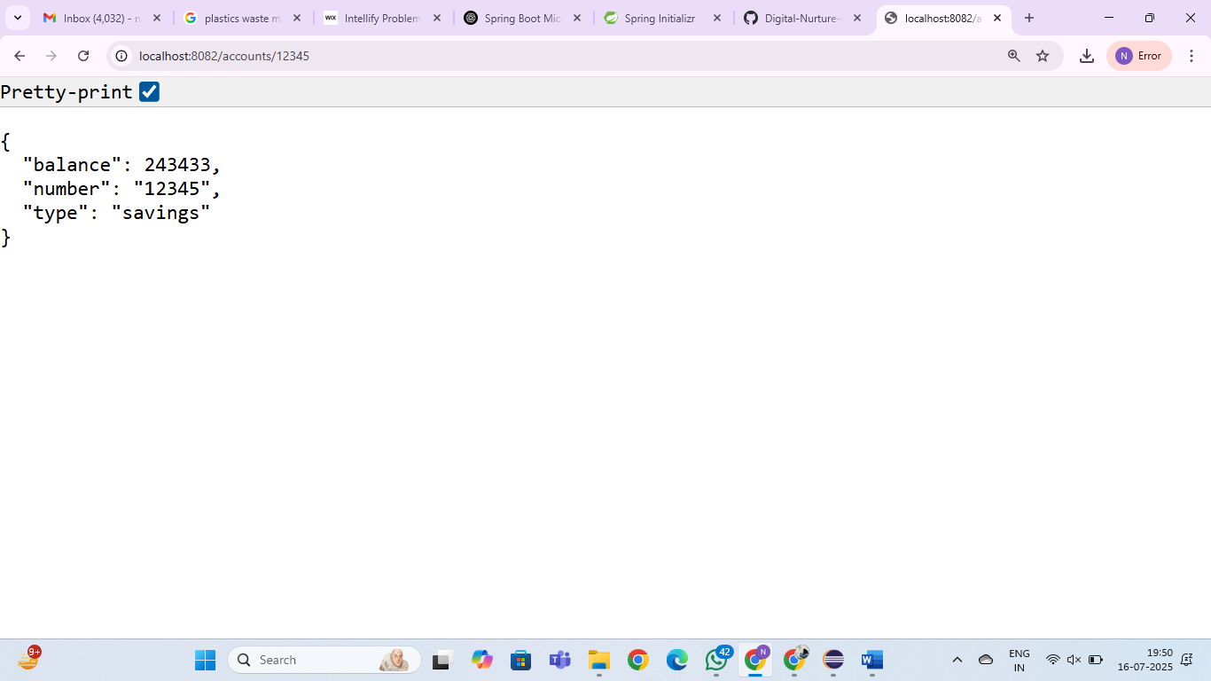

**SOLUTION (LOAN):**

**LoanController.java:**

**package** com.example.loan.controller;

**import** org.springframework.web.bind.annotation.*;

**import** java.util.Map;

@RestController

@RequestMapping("/loans")

**public** **class** LoanController {

@GetMapping("/{number}")

**public** Map<String, Object> getLoanDetails(@PathVariable String number) {

**return** Map.*of*(

"number", number,

"type", "car",

"loan", 400000,

"emi", 3258,

"tenure", 18

);

}

}

**Main Class:**

**package** com.example.loan;

**import** org.springframework.boot.SpringApplication;

**import** org.springframework.boot.autoconfigure.SpringBootApplication;

@SpringBootApplication

**public** **class** LoanApplication {

**public** **static** **void** main(String[] args) {

SpringApplication.*run*(LoanApplication.**class**, args);

}

}

**OUTPUT:**

